Investigating rodent ecology to understand the hazard of Lassa fever spillover in Sierra Leone

*David Simons*

A dissertation submitted in partial fulfilment of the requirements for the degree of

##### Doctor of Philosophy

The Royal Veterinary College, University of London

July 2023

*The copyright in this thesis is owned by the author. Any quotation from the thesis or use of any of the information contained in it must acknowledge this thesis as the source of the quotation or information.*

### Declaration

I certify that:

* The thesis being submitted for examination is my own account of my own research;
* My research has been conducted ethically;
* Where I have drawn on the work, ideas and results of others this has been appropriately cited in the thesis;
* Where any collaboration has taken place with other researchers, I have clearly stated in the thesis my own personal contribution;
* The entirety of the work described in the thesis has been undertaken subsequent to my registration for the higher degree for which I am submitting for examination;
* The thesis submitted is within the required word limit as specified by the RVC.

### Acknowledgements

First of all, I would like to thank my fantastic supervisors: Richard Kock, Deborah Watson-Jones and Kate Jones. I have learnt so much from your expertise, detailed inputs and scientific integrity, and I am deeply grateful for your support and mentorship. I am particularly thankful to Richard for the numerous opportunities you have provided and for bringing me into the PANDORA-ID-NET consortium. I would similarly like to thank Deborah for your support in conducting research in West Africa and assistance integrating a medical perspective into the One Health approach taken throughout my research. I am also thankful to Kate for your methodological expertise, advancing my understanding of ecology and helping me to develop as a scientist. It has been an absolute privilege to work with such inspiring leaders in the fields of Veterinary Epidemiology, Clinical Epidemiology and Ecology. I would also like to thank the London Interdisciplinary Biosciences Consortium, Doctoral Training Programme for funding my PhD and the PANDORA-ID-NET programme for support conducting my research in Sierra Leone.

Thank you also to the communities in Sierra Leone within which I worked. Without the support of the communities of Baiama, Lalehun, Lambayama and Seilama and the wider Kenema Chiefdom this work would not have been possible and I am extremely grateful for how welcome you made me and the field team in the pursuit of this work. Thank you to my collaborators in Sierra Leone: Dianah Sondufu, Joyce Lamin, Michael Dawson, ”Bobby”, Joseph Lahai, ”Coach”, James Koninga, Momoh Jimmy and Rashid Ansumana. I am deeply grateful for your intellectual and practical inputs alongside your humour when things did not go exactly to plan.

Thank you to everyone in the PANDORA-ID-NET consortium, Kate Jones lab at UCL and the Elisabeth Fichet-Calvet lab at BNITM, I have thoroughly enjoyed our discussions which have helped to shape this thesis. I feel lucky to have been part of such dedicated and supportive research groups. In particular heartfelt thanks to Umaru Bangura and Rory Gibb for your invaluable methodological inputs.

Thank you to my family and friends for your love and support through my never-ending journey in education. I would like to express my gratitude to my partner in science and life Olga for her constant encouragement. Without you, this PhD would not have seemed possible and would likely have remained incoherent musings on zoonotic diseases.

## Contents

[Abstract](#_bookmark0) 9

[Thesis outputs](#_bookmark1) 10

[List of Acronyms](#_bookmark2) 12

1. [Introduction](#_bookmark3) 13

[Preface](#_bookmark4) 13

* 1. [Zoonotic infectious diseases](#_bookmark5) 13
  2. [Global climate change and zoonoses](#_bookmark6) 15
  3. [Zoonoses discovery and species afinity: sampling considerations](#_bookmark7) 17
  4. [Focussing in on rodent associated zoonoses](#_bookmark10) 20
  5. [Geographic hotspots for zoonosis risk in the light of varying surveillance activity](#_bookmark11) 22
  6. [Lassa fever: A case study of a rodent associated zoonosis in West Africa](#_bookmark13) 24
     1. [Lassa mammarenavirus and Lassa fever](#_bookmark14) 25
     2. [Lassa fever epidemiology](#_bookmark15) 27
     3. [Rodent hosts of Lassa mammarenavirus](#_bookmark18) 31
  7. [Thesis aims and structure](#_bookmark20) 36

1. [Rodent trapping studies as an overlooked information source for understanding endemic](#_bookmark21) [and novel zoonotic spillover.](#_bookmark21) 39

[Preface](#_bookmark22) 39

* 1. [Abstract](#_bookmark23) 39
  2. [Introduction](#_bookmark24) 40
  3. [Methods](#_bookmark25) 42
     1. [Host and pathogen trapping data](#_bookmark26) 42
     2. [Description of included studies](#_bookmark27) 44
     3. [What is the extent of spatial bias in the rodent trapping data?](#_bookmark29) 45
     4. [What is the difference in rodent host distributions between curated datasets and rodent](#_bookmark32) [trapping studies?](#_bookmark32) 47
     5. [Are rodent trapping derived host-pathogen associations present in a consolidated](#_bookmark33) [zoonoses dataset?](#_bookmark33) 47
     6. [What is the spatial extent of pathogen testing within host ranges?](#_bookmark34) 47
  4. [Results](#_bookmark35) 48
     1. [What is the extent of spatial bias in the rodent trapping data?](#_bookmark36) 48
     2. [What is the difference in rodent host distributions between curated datasets and rodent](#_bookmark38) [trapping studies?](#_bookmark38) 49
     3. [Are rodent trapping derived host-pathogen associations present in a consolidated](#_bookmark41) [zoonoses dataset?](#_bookmark41) 53
     4. [What is the spatial extent of pathogen testing within a host’s range?](#_bookmark44) 56
  5. [Discussion](#_bookmark46) 57

1. [Designing and implementing a longitudinal rodent trapping study to investigate rodent](#_bookmark47) [community structures along a land use gradient in Eastern Sierra Leone](#_bookmark47) 61

[Preface](#_bookmark48) 61

* 1. [Leveraging local support and knowledge](#_bookmark49) 61
  2. [Study design](#_bookmark50) 62
     1. [Study duration](#_bookmark51) 62
     2. [Sampling frequency](#_bookmark52) 62
     3. [Sampling strategy](#_bookmark53) 63
     4. [Village selection](#_bookmark54) 63
     5. [Trapping grids within different land use types](#_bookmark55) 63
     6. [Structure of trap grids and trap locations](#_bookmark56) 64
     7. [Trapping effort](#_bookmark57) 65
     8. [Trap type selection](#_bookmark58) 65
     9. [Bait type selection](#_bookmark59) 66
     10. [Implementation of sampling strategy](#_bookmark60) 67
  3. [Data collection, storage, and processing](#_bookmark61) 67
     1. [Morphological measures](#_bookmark62) 68
     2. [Biological measures](#_bookmark63) 68
     3. [Trap locations](#_bookmark64) 69
  4. [Conclusion](#_bookmark65) 70

1. [Land use gradients drive spatial variation in Lassa fever host communities in the Eastern](#_bookmark66) [Province of Sierra Leone.](#_bookmark66) 72

[Preface](#_bookmark67) 72

* 1. [Abstract](#_bookmark68) 72
  2. [Introduction](#_bookmark69) 73
  3. [Methods](#_bookmark70) 76
     1. [Rodent sampling](#_bookmark71) 76
     2. [Species classification](#_bookmark72) 77
     3. [Description of rodent detection and species community structure](#_bookmark74) 79
     4. [Estimating the effect of land use on species occurrence and richness](#_bookmark75) 79
     5. [Co-occurrence of Mastomys natalensis with sympatric species](#_bookmark84) 81
  4. [Results](#_bookmark86) 82
     1. [Rodent detection and species community structure](#_bookmark87) 82
     2. [Estimating the effect of land use on species occurrence and richness](#_bookmark89) 84
     3. [Co-occurrence of species within land use types](#_bookmark91) 86
  5. [Discussion](#_bookmark93) 88
     1. [Rodent communities are associated with land use type](#_bookmark94) 88
     2. [Evidence for biotic interactions shaping patterns of rodent species diversity](#_bookmark95) 89
     3. [Benefits and challenges of systematic rodent community sampling](#_bookmark96) 90
     4. [Implications for understanding the risk of Lassa fever spillover](#_bookmark97) 91

1. [Contact networks of small mammals highlight potential transmission foci of Lassa mam-](#_bookmark98) [marenavirus.](#_bookmark98) 93

[Preface](#_bookmark99) 93

* 1. [Abstract](#_bookmark100) 93
  2. [Introduction](#_bookmark101) 94
  3. [Methods](#_bookmark102) 97
     1. [Study area](#_bookmark103) 97
     2. [Species identification](#_bookmark105) 99
     3. [Investigating Lassa mammarenavirus seroprevalence within small mammal communities](#_bookmark106) 99
     4. [Describing small mammal community networks](#_bookmark107) 100
     5. [Modelling the probablity of inter- and intra-specific contact rates in *Mastomys natal-*](#_bookmark108)

[*ensis* across a land use gradient](#_bookmark108) 101

* + 1. [Association of *Lassa mammarenavirus* seropositivity and position within a small-](#_bookmark112) [mammal community contact network](#_bookmark112) 103
  1. [Results](#_bookmark114) 104
     1. [Prevalence of Lassa mammarenavirus antibodies within small mammal communities](#_bookmark115) . 104
     2. [Small mammal community contact networks](#_bookmark116) 105
     3. [Describing inter- and intra-specific contact within small mammal communities](#_bookmark118) 107
     4. [The probability of inter- and intraspecific contact rates of Mastomys natalensis across](#_bookmark120)

[a land use gradient](#_bookmark120) 108

* + 1. [Association of *Lassa mammarenavirus* seropositivity and position within a small-](#_bookmark122) [mammal community contact network](#_bookmark122) 111
  1. [Discussion](#_bookmark123) 111

1. [Conclusions and future research directions](#_bookmark124) 116
   1. [Principle findings of the thesis](#_bookmark125) 116
   2. [General strengths and limitations](#_bookmark126) 118
   3. [Implications for Lassa fever epidemiology and future research directions](#_bookmark127) 120
   4. [Concluding remarks](#_bookmark129) 124
2. [Bibliography](#_bookmark130) 125

[A Appendix A](#_bookmark516) 162

* 1. [Published article in PLoS NTD](#_bookmark517) 162
  2. [Published article in International Health](#_bookmark518) 182

1. [Appendix B](#_bookmark519) 186
   1. [Images representative of trapping grid locations](#_bookmark520) 186
   2. [Trapping effort within each trapping grid](#_bookmark521) 190
      1. [Baiama](#_bookmark522) 190
      2. [Lalehun](#_bookmark524) 190
      3. [Lambayama](#_bookmark526) 191
      4. [Seilama](#_bookmark528) 191
   3. [Rodent trapping and laboratory protocol](#_bookmark530) 192
   4. [Schematic of trap location harmonisation](#_bookmark531) 206
   5. [Small mammal taxonomic key](#_bookmark533) 206
   6. [Conceptual model of the association of land use change and rodent species communities](#_bookmark534) 228
2. [Appendix C](#_bookmark536) 229
   1. [Species detection rate by season](#_bookmark537) 229
   2. [Marginal effects of detection parameters](#_bookmark539) 230
3. [Appendix D](#_bookmark543) 233
   1. [Constructed networks from rodent trapping data](#_bookmark544) 233
      1. [Forest networks](#_bookmark545) 233
      2. [Agriculture networks](#_bookmark546) 235
      3. [Village networks](#_bookmark547) 237
   2. [Contact matrices inferred from rodent community networks](#_bookmark548) 239
      1. [Forest contact matrix](#_bookmark549) 239
      2. [Village contact matrix](#_bookmark551) 240

**List of Figures**

* 1. [Number of pathogens associated with each order of Mammalia.](#_bookmark8) 18
  2. [The number of known pathogens associated with the mammalian order Rodentia.](#_bookmark9) 20
  3. [Global Health Security scores for sub-domains associated with zoonosis surveillance.](#_bookmark12) 24
  4. [The Lassa fever endemic region.](#_bookmark16) 28
  5. [Confirmed Lassa fever cases in West Africa 2008-2023.](#_bookmark17) 30
  6. [Prevalence of acute infection with LASV or antibodies to LASV among rodents sampled in](#_bookmark19)

[West Africa.](#_bookmark19) 34

* 1. [Locations of rodent trapping sites in West Africa and the number of trap nights sampled](#_bookmark28) 45
  2. [Relative rodent trapping effort bias across West Africa.](#_bookmark37) 49
  3. [Locations of detection and non-detection sites for rodent species in West Africa.](#_bookmark39) 51
  4. [Host-Pathogen associations detected through acute infection.](#_bookmark42) 54
  5. [Host-Pathogen associations detected through evidence of prior infection.](#_bookmark43) 55
  6. [Village site locations and dates of rodent trapping in Sierra Leone.](#_bookmark73) 78
  7. [Detection rate per 1,000 trap nights of rodent species across different land use types.](#_bookmark88) 83
  8. [Probability of species occurrence across a land use gradient stratified by rural and peri-urban](#_bookmark90) [village study sites for the seven rodent and shrew species.](#_bookmark90) 85
  9. [Spearman’s rank correlations for the modelled probability of occurrence of species pairs in](#_bookmark92) [different land use types.](#_bookmark92) 87
  10. [Locations of rodent trapping study communities within Eastern Province, Sierra Leone.](#_bookmark104) 98
  11. [Degree centrality of individual small mammals stratified by species and land use type.](#_bookmark117) 106
  12. [The proportion of contacts between small mammal species in agricultural land use.](#_bookmark119) 108
  13. [Random effects meta-analysis of ERGMs estimating the odds of a contact being observed for](#_bookmark121)

[*M natalensis*](#_bookmark121)110

|  |  |  |
| --- | --- | --- |
| [6.1](#_bookmark128) | [Risk maps of Lassa fever in West Africa.](#_bookmark128) . . . . . . . . . . . . . . . . . . . . . . . . . . . . . . | 122 |
| [B.1](#_bookmark523) | [Locations of traps in Baiama](#_bookmark523) . . . . . . . . . . . . . . . . . . . . . . . . . . . . . . . . . . . . | 190 |
| [B.2](#_bookmark525) | [Locations of traps in Lalehun](#_bookmark525) . . . . . . . . . . . . . . . . . . . . . . . . . . . . . . . . . . . . | 190 |
| [B.3](#_bookmark527) | [Locations of traps in Lambayama](#_bookmark527) . . . . . . . . . . . . . . . . . . . . . . . . . . . . . . . . . . | 191 |
| [B.4](#_bookmark529) | [Locations of traps in Seilama](#_bookmark529) . . . . . . . . . . . . . . . . . . . . . . . . . . . . . . . . . . . . | 191 |
| [B.5](#_bookmark532) | [Schematic of harmonising trap locations](#_bookmark532) . . . . . . . . . . . . . . . . . . . . . . . . . . . . . . | 206 |
| [B.6](#_bookmark535) | [Conceptual model of the association of land use and rodent communities](#_bookmark535) . . . . . . . . . . . . | 228 |
| [C.1](#_bookmark538) | [Species detection by season](#_bookmark538) . . . . . . . . . . . . . . . . . . . . . . . . . . . . . . . . . . . . . | 229 |
| [C.2](#_bookmark540) | [Marginal effect of rainfall on detection](#_bookmark540) . . . . . . . . . . . . . . . . . . . . . . . . . . . . . . . | 230 |
| [C.3](#_bookmark541) | [Marginal effect of moon phase on detection](#_bookmark541) . . . . . . . . . . . . . . . . . . . . . . . . . . . . | 231 |
| [C.4](#_bookmark542) | [Marginal effect of trapping effort on detection](#_bookmark542) . . . . . . . . . . . . . . . . . . . . . . . . . . . | 232 |
| [D.1](#_bookmark550) | [Proportion of contacts in forest land use](#_bookmark550) . . . . . . . . . . . . . . . . . . . . . . . . . . . . . . | 239 |
| [D.2](#_bookmark552) | [Proportion of contacts in village land use](#_bookmark552) . . . . . . . . . . . . . . . . . . . . . . . . . . . . . | 240 |

## List of Tables

* 1. [Comparison of IUCN, GBIF and rodent trapping ranges for 7 rodent species.](#_bookmark40) 53
  2. [Pathogen sampling among small-mammal host species.](#_bookmark45) 57
  3. [Description of trapped rodents by village and landuse type.](#_bookmark85) 82
  4. [The number of individuals detected and antibodies to Lassa mammarenavirus among those](#_bookmark113) [individuals by species.](#_bookmark113) 104

##### Abstract

Within West Africa endemic zoonoses cause preventable morbidity and mortality, the burden of which is expected to increase under future land use, climate and biodiversity change. Rodents are important hosts of both vectors (e.g., ticks) of zoonotic pathogens and of specific rodent associated zoonoses, an understanding of local scale rodent ecology is vital to quantify the risk of rodent associated zoonotic disease spillover into human populations.

In this thesis I synthesise the available rodent trapping literature to summarise rodent distributions across West Africa and the extent of sampling biases of rodent hosts, their pathogens and host-pathogen associations. I find that current sampling efforts are spatially and taxonomically biased, limiting generalisability and inference able to be drawn from currently available data. I suggest approaches that are required to counteract some of these identified biases.

This review guided the design and implementation of a three-year, systematic study of rodent ecology in a Lassa fever endemic region of Eastern Sierra Leone to investigate the association of land use type on rodent occurrence. I model the composition of rodent communities at fine spatial scale to infer the changing hazard of Lassa fever spillover across anthropogenic land use gradients. I find that the known reservoir species of the Lassa fever virus is more likely to occur in locations of anthropogenic land use conversion. I identify important biotic interactions between the primary reservoir of Lassa fever and other rodent species that lead to reduced occurrence in urbanised settings, which may abate the risk of pathogen spillover in these settings.

Finally, I reconstruct rodent direct and indirect contact networks to investigate the transmission networks of Lassa fever virus among rodent hosts across an anthropogenic land use gradient. I find that hosts of Lassa fever virus have greater rates of contact events in species rich agricultural land use settings compared to within villages. This suggests that contacts between susceptible and infectious rodents in agricultural settings may be maintaining viral prevalence which can then enter village dwelling rodent communities increasing the risk of pathogen spillover into human communities.

This thesis improves current understanding of the distribution of rodent hosts and endemic zoonotic pathogens across West Africa with a focus on the local rodent ecology in maintaining Lassa fever endemism in Sierra Leone. I find that the hazard of zoonotic spillover is governed by biotic processes at a local level and identify future directions to translate knowledge about these dynamic rodent communities into contextually relevant public health interventions using a One Health framework.

##### Thesis outputs

This thesis has produced: peer reviewed papers; preprints; invited talks at academic conferences, workshops and seminars and a web-based application for exploring the data compiled as part of Chapter 2. These outputs are detailed in the following section.

Peer reviewed papers

* **Simons D**, Attfield LA, Jones KE, Watson-Jones D, Kock R. (2023). Rodent trapping studies as an overlooked information source for understanding endemic and novel zoonotic spillover. PLoS Negl Trop Dis 17(1): e0010772. <https://doi.org/10.1371/journal.pntd.0010772>
* **Simons D**. (2023). Lassa fever cases suffer from severe underreporting based on reported fatalities, International Health, ihac076, <https://doi.org/10.1093/inthealth/ihac076>
* Arruda LB, Free HB, **Simons D**, Ansumana R, Elton L, Haider N, … & Kock R. (2023). Current sampling and sequencing biases of Lassa mammarenavirus limit inference from phylogeography and molecular epidemiology in Lassa fever endemic regions. medRxiv, 2023-06. [https://doi.org/10.1101/](https://doi.org/10.1101/2023.06.20.23291686) [2023.06.20.23291686](https://doi.org/10.1101/2023.06.20.23291686)
* Arruda LB, Haider N, Olayemi A, **Simons D**, Ehichioya D, Yinka-Ogunleye A, … & Kock R. (2021). The niche of One Health approaches in Lassa fever surveillance and control. Annals of clinical micro- biology and antimicrobials, 20(1), 29. <https://doi.org/10.1186/s12941-021-00431-0>

In preparation (preprints)

* **Simons D**, Gibb R, Bangura U, Sondufu D, Lamin J, Koninga J, Jimmy M, Dawson M, Lahai J, Ansumana R, Kock R, Watson-Jones D, Jones KE. Land use gradients drive spatial variation in Lassa fever host communities in the Eastern Province of Sierra Leone.
* **Simons D**, Bangura U, Goyal R, Rushton B, Sondufu D, Lamin J, Koninga J, Jimmy M, Dawson M, Lahai J, Ansumana R, Kock R, Watson-Jones D, Jones KE. Contact networks of small mammals highlight potential transmission foci of Lassa mammarenavirus.

Invited talks and presentations

Chapter [2](#_bookmark21) has been presented at the Ecology and Evolution of Infectious Diseases Conference 2021.

Chapter [4](#_bookmark66) has been presented at the Planetary Health Alliance conference 2022, the Ecology and Evolution of Infectious Diseases Conference 2022 and the Hospital for Tropical Diseases Grand Round.

Chapter [5](#_bookmark98) has been presented at the Ecology and Evolution of Infectious Diseases Conference 2023, the

Rodent-borne zoonoses workshop hosted by the Center for Infectious Disease Dynamics, Pennsylvania State University (2023) and the Development of transmissible vaccines workshop hosted by the University of Idaho.

The work contained in this thesis will also be presented at the Ecology Society of America annual meeting (2023) and the American Society of Tropical Medicine and Hygiene annual meeting (2023).

Software

* **Exploring Rodent Trapping Studies in West Africa**: Developed to showcase the data consol- idated in the Chapter [2](#_bookmark21) and the associated publication “Rodent trapping studies as an overlooked information source for understanding endemic and novel zoonotic spillover article”. Link: [https:](https://diddrog11.shinyapps.io/scoping_review_app/)

[//diddrog11.shinyapps.io/scoping\_review\_app/](https://diddrog11.shinyapps.io/scoping_review_app/)

##### List of Acronyms

* AIC - Akaike Information Criterion
* CI - Confidence Interval
* CMR - Capture-mark-recapture
* EDF - Effective Degrees of Freedom
* ELISA - Enzyme-linked Immunosorbent Assay
* ERGM - Exponential-family Random Graph Model
* GADM - Database of Global Administrative Areas
* GAM - Generalised Additive Model
* GBIF - Global Biodiversity Information Facility
* GPS - Global Positioning System
* HRP - Horseradish peroxidase
* IQR - Interquartile Range
* IUCN - The International Union for Conservation of Nature
* km - Kilometers
* LASV - Lassa mammarenavirus
* NCDC - Nigeria Center for Disease Control
* OD - Optical Density
* OR - Odds Ratio
* OSF - Open Science Framework
* PCR - Polymerase Chain Reaction
* PHAROS - Pathogen Harmonised Surveillance
* RNA - Ribonucleic Acide
* SD - Standard Deviation
* SEDAC - Socioeconomic Data and Applications Center
* TMB - 3,3’,5,5’-Tetramethylbenzidine
* TN - Trap night
* TS - Trap success
* UN - United Nations
* UK - United Kingdom
* USA - United States of America
* WHO - World Health Organisation

## Introduction

##### Preface

Sections of this introductory chapter have contributed to first authored and co-authored peer-reviewed articles. The section on Lassa fever case-fatality rate and biases in reporting has been published as a single author manuscript in a modified format in *International Health* ([Simons, 2022b](#_bookmark454)). The section on rodent hosts of LASV has been published in a modified format in *Annals of Clinical Microbiology and Antimicrobials* where I was a co-author and contributed the section on Rodent dynamics and Lassa fever outbreaks ([Arruda *et*](#_bookmark148)[*al.*, 2021](#_bookmark148)). Components of the section on Lassa fever epidemiology and the section on rodent hosts of LASV relating to phylogenetics have been pre-printed on *MedRxiv* and is currently under review ([Arruda *et al.*,](#_bookmark147) [2023](#_bookmark147)).

##### Zoonotic infectious diseases

Zoonotic infectious diseases - or “zoonoses” - in humans are caused by pathogens transmitted either directly (e.g., bites or scratches) or indirectly (e.g., via vectors, environmental or food contamination) from animal hosts, including livestock, wildlife, and pets ([World Health Organization, Food and Agriculture Organization](#_bookmark506) [of the United Nations and World Organisation for Animal Health, 2019](#_bookmark506)). Zoonoses include bacterial, fungal, parasitic and viral microorganisms. Within their animal hosts, zoonotic pathogens do not always cause clinical disease. For example, *Lassa mammarenavirus* (LASV), the causative agent of Lassa fever in humans is not considered to cause significant clinical disease in rodent host species’ as measured through organ dysfunction, weight loss or behavioural change ([Safronetz *et al.*, 2022](#_bookmark441)). However, in humans LASV infection can lead to severe clinical symptoms and death ([Thielebein *et al.*, 2022](#_bookmark474)). In contrast, Highly Pathogenic Avian Influenza, caused by *Influenza A virus* (subtype H5N1), leads to significant morbidity and mortality in some infected bird species (i.e., *Galliformes sp.*), alongside pathogenicity in humans during rare zoonotic spillover events ([Writing Committee of the Second World Health Organization Consultation on Clinical](#_bookmark507) [Aspects of Human Infection with Avian Influenza A (H5N1) Virus, 2008](#_bookmark507); [Haider *et al.*, 2017](#_bookmark273)).

The wider term “zoonotic disease” is often used for a disease that first originated in non-human animals and may continue to be used, even when disease transmission is no longer dependent on an animal reservoir (e.g., HIV, SARS-CoV-2) ([Kock and Caceres-Escobar, 2022](#_bookmark327)). Individual transmission events from vertebrate animal populations into human populations - “spillover events” - can lead to, secondary epidemiological cycles, epidemics and pandemics ([Plowright *et al.*, 2017](#_bookmark427)). This is different to human infection from a zoonosis where in each case the animal transmits the infection to the human causing disease ([Kock and Caceres-](#_bookmark327)

[Escobar, 2022](#_bookmark327)). The patterns of spillover differ across zoonoses. For example, Nipah virus infection (*Nipah henipavirus*) and LASV spillover events from wild animal sources occur at relatively frequent intervals but result in limited, onward human-to-human transmission leading to small-sized, geographically constrained outbreaks of human disease ([Luby *et al.*, 2009](#_bookmark350); [Lo Iacono *et al.*, 2015](#_bookmark346)). However, Nipah virus infection differs importantly from LASV with most human outbreaks associated with direct infection from an amplifying intermediate host, rather than direct infection from the reservoir species. In contrast to both LASV and Nipah virus, Ebola virus disease (*Sudan ebolavirus* and *Zaire ebolavirus*) and mpox (formerly Monkeypox caused by the *Mpox virus*) exhibit sustained human-to-human transmission following spillover, but due to the transmission dynamics of these pathogens, outbreaks are generally constrained to local epidemics ([Fine](#_bookmark237) [*et al.*, 1988](#_bookmark237); [Legrand *et al.*, 2007](#_bookmark335)). In addition, some pathogens may be better adapted to transmission among humans due to their specific properties or similarities between human physiology or immunology and those of the primary vertebrate reservoir (e.g., HIV and SARS-CoV-2). Such pathogens are able to rapidly expand beyond the geographic region of the initial spillover event via human transmission chains and may be described as zoonotic diseases with no further important transmission from wild or domestic animal populations ([Marx, Apetrei and Drucker, 2004](#_bookmark367); [Ye *et al.*, 2020](#_bookmark510)). Spillover may not be limited to a single direction of animal to human transmission and “spillback” (i.e., reverse zoonosis or zooanthroponosis) can potentially play important roles in maintaining pathogen endemicity with subsequent “secondary spillover” into human populations ([Kreuder Johnson *et al.*, 2015](#_bookmark328)). Further, spillback can lead to morbidity and mortality in animal populations ([Fagre *et al.*, 2022](#_bookmark223)).

The different patterns of spillover are observable through phylogenetic analysis of viral sequences from human populations. For example, phylogenetic analysis of the Middle East respiratory syndrome coronavirus (MERS-CoV) suggests initial spillover events into human populations from Dromedary camels, which may be the reservoir host or an intermediate host, with subsequent establishment in the local human population ultimately leading to international epidemics, most notably in 2013 ([Corman *et al.*, 2014](#_bookmark199); [Haagmans *et al.*,](#_bookmark271) [2014](#_bookmark271)). Similarly, the multi-country mpox outbreak in 2022 is proposed to be secondary to human-to-human sustained transmission from a single origin endemic country, either directly linked to a spillover event or cryptic (i.e., unobserved) transmission among local human populations ([Isidro *et al.*, 2022](#_bookmark299)). In contrast, phylogenetic analysis of LASV sequences indicate that the most common recent ancestor of viruses currently circulating in Nigeria originated >1000 years prior, while sequences from Guinea and Sierra Leone suggest a more recent introduction 220 and 150 years ago respectively ([Andersen *et al.*, 2015](#_bookmark145)). The interpretation of studies on LASV phylogenetics are consistent with repeated spillover events into human populations from pathogens circulating within a single or multiple reservoir species ([Andersen *et al.*, 2015](#_bookmark145); [Kafetzopoulou *et al.*,](#_bookmark314)

[2019](#_bookmark314); [Villabona-Arenas, Hanage and Tully, 2020](#_bookmark484)). While the 2022 mpox outbreak and ongoing SARS-CoV-2 pandemic are important examples of zoonoses causing epidemics and pandemics beyond their host species’ ranges, these remain relatively rare events when compared to recurrent spillover events within endemic regions ([Lloyd-Smith *et al.*, 2009](#_bookmark345); [Dudas *et al.*, 2018](#_bookmark215)). The example of LASV highlights the risk of endemic zoonoses leading to recurrent local spillover events into human populations in endemic regions and reinforces the importance of surveillance of known zoonoses.

When considering interventions to reduce the health impact of zoonoses in endemic settings (e.g., through reducing the risk of recurrent local spillover events), an approach that incorporates knowledge of multiple interacting systems are required. Understanding the role of environmental, wildlife and human factors on the risk of spillover events are necessary. This is often termed the “One Health” framework: a “collaborative, multisectoral, and transdisciplinary approach - working at the local, regional, national and global levels - with the goal of achieving optimal health outcomes recognizing the interconnection between people, animals, plants, and their shared environment.” ([*One health | CDC*, 2022](#_bookmark411)). This framework is particularly useful when considering changes in risk from zoonoses occurring in the context of ongoing climate, land use and biodiversity change.

##### Global climate change and zoonoses

Anthropogenic climate change has long been known to modify the risk of zoonoses to human populations through several mechanisms ([Daszak, Cunningham and Hyatt, 2001](#_bookmark204); [Jones *et al.*, 2013](#_bookmark309)). For example, changes in mean temperature and precipitation will alter environmental suitability for both pathogens and hosts leading to expansion or contraction of endemic regions ([Mills, Gage and Khan, 2010](#_bookmark382)). In addition, environmentally transmitted zoonoses such as *Leptospira spp.* (causing Leptospirosis), become better able to persist in the environment under changes that increase ambient temperature in the presence of increased precipitation, leading to higher prevalence and incidence of infection ([Lau *et al.*, 2010](#_bookmark330); [Llop *et al.*, 2022](#_bookmark344)). Vector borne zoonoses such as West Nile Virus are currently demonstrating range expansion as both mosquito vector abundance and occurrence is increased across a larger geographic range, likely due to a combination of warmer winter periods, increased precipitation and a higher prevalence of potential breeding sites ([Hoover](#_bookmark292) [and Barker, 2016](#_bookmark292); [Farooq *et al.*, 2022](#_bookmark226)).

Climate change is occurring in step with anthropogenic land use change. Human driven conversion of natural landscapes towards human dominated use occurs at both a local and global scale through direct and indirect human actions (i.e., agricultural development, natural resource extraction, and urbanisation) ([Gottdenker](#_bookmark263) [*et al.*, 2014](#_bookmark263)). The association of land use change and pathogen transmission is complex, with increasing,

decreasing and no change in pathogen transmission reported from observational studies of pathogen systems ([Gottdenker *et al.*, 2014](#_bookmark263)). Encroachment of human activity into zoonotic host animal ranges, as can occur under conditions of land use change, has been hypothesised to increase the risk of spillover events into human populations, through increasing the animal-human interface and raising the probability of direct and indirect contact with infected hosts of zoonoses ([Murray and Daszak, 2013](#_bookmark393)). Additionally, heightened interactions between wildlife and domesticated animals as a consequence of land use change and progression to intensive livestock production may also increase the risk of subsequent zoonosis into human populations, where wild sylvatic animals are hosts of pathogens that can be amplified in domesticated animals (e.g., Nipah and Hendra virus) ([Epstein *et al.*, 2006](#_bookmark220); [Plowright *et al.*, 2015](#_bookmark426)). In tandem, climate and land use change can also modify species’ home ranges ([Sultaire *et al.*, 2016](#_bookmark467); [Brodie, 2016](#_bookmark180)). As a consequence, an increased frequency of contact events between current and potential future hosts of zoonoses are produced, increasing the potential for cross-species pathogen transmission and the subsequent expansion of a zoonosis’ endemic range ([Carlson *et al.*, 2022](#_bookmark185)). This has been observed with regards to Hendra virus, where Southern range expansion of the black fruit bat (*Pteropus alecto*) has resulted in domesticated horses in Australia being infected, with subsequent spillover events into human populations ([Yuen *et al.*, 2021](#_bookmark514)).

Animal biodiversity (or lack therof) has also been proposed to modulate zoonosis risk, with several mecha- nisms proposed. The “Dilution effect” - initially applied to the Lyme disease system (*Borrelia burgdorferi sensu lato*), which comprises several vectors and animal hosts - hypothesises that in settings of low species diversity (operationalised as species richness), infection rates increase in a host species. The inverse scenario is one in which higher levels of animal biodiversity is protective to human health through reducing the rate of zoonosis into human populations ([Ostfeld and Keesing, 2000](#_bookmark414)). This theory has been supported by stud- ies of several pathogen systems across parasites, bacteria, viruses and fungi ([Keesing *et al.*, 2010](#_bookmark317); [Civitello](#_bookmark193) [*et al.*, 2015](#_bookmark193)). There is ongoing debate as to whether the Dilution effect is a general property of zoonosis systems, with several studies suggesting the inverse. This opposing mechanism, termed the “Amplification effect”, occurs when increasing biodiversity, particularly through introduction of a new or more competent host species can increase the rate of infection in hosts and potentially the risk of zoonosis ([Johnson and](#_bookmark308) [Hoverman, 2012](#_bookmark308); [Halliday *et al.*, 2017](#_bookmark274)). These two effects may exist as a spectrum where dominance of one over the other is dependent on the specific disease context, with limited generalisability between disease systems ([Gómez-Hernández *et al.*, 2023](#_bookmark261)).

Climate, land use and biodiversity change are interacting components within an ecosystem and attributing an effect of each independently to the risk of zoonosis is challenging ([Gibb, Franklinos, *et al.*, 2020](#_bookmark255)). A synthesis of the effect of land use change on biodiversity across multiple spatial scales and zoonosis systems

found that species richness of zoonotic pathogen host species, but not non-host species, increased along an anthropogenic land use gradient ([Gibb, Redding, *et al.*, 2020](#_bookmark257)). It should also be noted that the observed land use changes are occurring at different rates globally, which may complicate current findings. Climate, land use and biodiversity change occurring in regions associated with a greater diversity of known zoonotic pathogens may potentially have a greater impact on the risk of zoonosis than in settings of low diversity of zoonotic pathogens.

##### Zoonoses discovery and species afinity: sampling considerations

The majority of microorganisms are non-pathogenic to humans or animals and provide vital ecosystem services. The small subset of microorganisms (<1%) that are pathogenic are typically able to replicate in multiple hosts ([Cleaveland, Laurenson and Taylor, 2001](#_bookmark195); [Woolhouse, Taylor and Haydon, 2001](#_bookmark502); [Editors,](#_bookmark218) [2011](#_bookmark218)). It has been estimated that 60% of emerging human infectious diseases are associated with known zoonoses; therefore, it is not rare for a human infectious disease to be a zoonosis ([Jones *et al.*, 2008](#_bookmark310)). However, only a minority of these (>200 pathogens) currently fulfil the WHO definition of a zoonosis a “disease or infection that is naturally transmissible from vertebrate animals to humans” ([World Health Organisation,](#_bookmark505) [2023b](#_bookmark505)). The discovery of zoonoses is variable across mammalian taxa, with sampling efforts increased in orders with increased human interaction or of special interest (i.e., primates and livestock species). Zoonoses are known to exist in the majority of terrestrial mammal orders (21/27) with the number of hosts of zoonotic pathogens strongly positively associated with the species richness of these orders ([Han, Kramer and Drake,](#_bookmark276) [2016](#_bookmark276)). A recently compiled dataset (CLOVER) contains an increased number of documented pathogens in Primates, Artiodactyla (ungulates) and Carnivora alongside Rodentia and Chiroptera ([Gibb, Albery, Becker,](#_bookmark252) [*et al.*, 2021](#_bookmark252); [Gibb, Carlson and Farrell, 2021](#_bookmark254)). Figure [1.1](#_bookmark8) shows the number of known pathogens in these mammalian orders. Of these, Rodentia contain the greatest number of pathogens known to be zoonotic ([Han, Kramer and Drake, 2016](#_bookmark276)).

Monotremata Macroscelidea Hyracoidea Peramelemorphia

Bacteria and rickettsia

1

1

1

2

2

1

4

1

2

1

18

4

15

16

10

26

162

116

121

93

Virus

1

4

1

3

2

4

2

7

15

12

26

17

12

222

291

143

172

151

Helminth

1

1

1

2

12

2

22

6

7

8

71

92

97

94

Sirenia Scandentia Dasyuromorphia

Cingulata Proboscidea

Pilosa Eulipotyphla Didelphimorphia Diprotodontia Lagomorpha Perissodactyla Chiroptera Rodentia Carnivora Artiodactyla Primates

Fungi

1

1

1

3

1

1

1

17

17

11

18

19

Others

1

4

5

1

Host order

Monotremata Macroscelidea Hyracoidea Peramelemorphia

Protozoa

1

1

1

1

1

2

2

1

7

7

1

6

23

55

85

72

126

Sirenia Scandentia Dasyuromorphia

Cingulata Proboscidea

Pilosa Eulipotyphla Didelphimorphia Diprotodontia Lagomorpha Perissodactyla Chiroptera Rodentia Carnivora Artiodactyla Primates

1

10 100

1000 1

10 100

1000 1

10 100

1000

Number of pathogens

Figure 1.1: Number of pathogens identified from each Mammalian order. Bars indicate the number of known pathogens within different mammalian orders; the values within the bars indicate the number of species within the order known to host these pathogens. Data obtained from CLOVER (Gibb et al. 2021).

As can be gleaned from Figure [1.1](#_bookmark8), two mammalian taxa, Rodentia and Chiroptera are associated with the greatest number of species that are hosts of zoonoses and overall number of zoonoses ([Han *et al.*, 2015](#_bookmark277)). It is unclear whether these taxa represent special reservoirs that lead to an increased proportion of zoonotic viruses circulating within these species or make them more likely to transmit pathogens to humans, or whether the increased number of zoonoses associated with these taxa is driven by their increased species

richness ([Wolfe, Dunavan and Diamond, 2007](#_bookmark499); [Olival *et al.*, 2012](#_bookmark408); [Luis *et al.*, 2013](#_bookmark351); [Mollentze and Streicker,](#_bookmark385) [2020](#_bookmark385)).

These documented pathogens notwithstanding, the discovery of zoonoses is biased both by our ability to detect them and the sampling effort within different animal species and geographic regions ([Grange *et al.*,](#_bookmark266) [2021](#_bookmark266); [Gibb, Albery, Mollentze, *et al.*, 2021](#_bookmark253)). The discovery rate of viral zoonoses, an important subset of all zoonoses, has increased with improvements in the technical means to detect and identify them ([Woolhouse](#_bookmark501) [*et al.*, 2008](#_bookmark501)). The rate of discovery has exceeded prior expectations of viral biodiversity, but continues to remain taxonomically and geographically biased, thus limiting the inferences that can be made with regardss to, for example, the risk of spillover events drawing on current data sources ([Wille, Geoghegan and Holmes,](#_bookmark496) [2021](#_bookmark496)). Similar limitations are likely for other zoonoses taxa including bacteria, fungi and parasites. The general trend of increasing rates of pathogen discovery over time are shown for Rodentia in Figure [1.2](#_bookmark9).

50

Bacteria and rickettsia

40

30

20

10

0

50

Virus

40

30

20

10

0

50

Helminth

Number of pathogens

40

30

20

10

0

50

Protozoa

40

30

20

10

0

50

Fungi

40

30

20

10

0

1925

1950

Year

1975

2000

Figure 1.2: Number of identified pathogens in the order Rodentia. Discovery of pathogens in rodents, the order containing the greatest number of zoonotic pathogens, has increased over time. Data obtained from CLOVER (Gibb et al. 2021).

##### Focussing in on rodent associated zoonoses

A growing body of evidence is highlighting the importance of rodents as a key reservoir for known and expected zoonoses. Rodents are a diverse, globally distributed mammalian order that provide important and beneficial ecosystem services including pest regulation and seed dispersal ([Fischer *et al.*, 2018](#_bookmark238)). Of the almost 2,600 species, representing 40% of all mammalian species, 282 species (~11%) have been identified to

be reservoirs of 95 known zoonoses, a greater number than other mammal orders ([Han, Kramer and Drake,](#_bookmark276) [2016](#_bookmark276); [D’Elía, Fabre and Lessa, 2019](#_bookmark201); [Ecke *et al.*, 2022](#_bookmark217)). The majority of these zoonoses are viruses (34) and bacteria (26) with the remaining including helminths, protozoa and fungi. As discussed above the high prevalence in this order may be driven by high species richness, rather than any inherent properties of the order Rodentia ([Mollentze and Streicker, 2020](#_bookmark385)).

Within this order, the prevalence of zoonoses are disproportionally high within species that demonstrate “fast” life history strategies, although the effect of sampling biases and confounding effects such as synanthropy may be producing some of this observed effect ([Han *et al.*, 2015](#_bookmark277); [Albery and Becker, 2021](#_bookmark138)). Fast-lived rodent species (i.e., those prioritising reproduction over survival and longevity), are typically small, abundant and are more commonly urban-adapted ([Albery and Becker, 2021](#_bookmark138)). These species favour inexpensive, nonspecific immune defenses, which make them more likely to be hosts of zoonoses, although whether these properties are consistent within genera is unclear and whether these findings are replicated in wild, as opposed to laboratory, animals is unknown ([Martin, Weil and Nelson, 2007](#_bookmark365); [Viney and Riley, 2017](#_bookmark485)).

Irrespective of the causal drivers of high zoonoses prevalence among rodent species, components of their life histories increase the risk of spillover into human populations. Synanthropy describes an organism that lives near and benefits from humans and their environmental modifications, this property is common among rodent species, more so among rodent species known to be reservoirs of zoonoses ([Ecke *et al.*, 2022](#_bookmark217)). Synanthropic species tend to be highly abundant in locations in which they occur, with high population densities and dynamic population fluctuations in response to resource availability, which promotes both fequency- and density-dependent transmission of pathogens among hosts ([Ecke *et al.*, 2022](#_bookmark217)). The high abundance of these species in human dominated landscapes increases the rate of contact with humans providing increased opportunities for both direct- and indirect transmission of rodent associated zoonoses ([Iacono *et al.*, 2016](#_bookmark294); [Morand *et al.*, 2019](#_bookmark390)).

Rodent species that have wide ranges may display heterogeneity across their range in both their biology and behaviour. For example, studies in *Clethrionomys* voles, hosts of Puumala orthohantavirus, have been observed to display different population dynamics across a latitudinal gradient from Northern Finland to Central Europe, affecting pathogen dynamics within these populations ([Turchin and Hanski, 1997](#_bookmark477); [Henttonen](#_bookmark287) [and Wallgren, 2001](#_bookmark287)). Similarly, while the primary reservoir species of LASV, *Mastomys natalensis*, has been observed to have dramatic population fluctuations in the Eastern extent of its range (i.e., Tanzania), the same amplitude of population fluctuations have not been observed in West African populations (i.e., Guinea) where they host LASV ([Leirs *et al.*, 1997](#_bookmark336); [Fichet-Calvet *et al.*, 2008](#_bookmark231)). This may impact the generalisability of studies conducted in specific locations within a rodents range when attempting to understand the broader

geographic risk of rodent associated zoonosis.

##### Geographic hotspots for zoonosis risk in the light of varying surveillance activity

Geographic hotspots of zoonotic disease risk are predicted to occur where mammalian host species richness is greatest, such as in the tropics ([Han, Kramer and Drake, 2016](#_bookmark276)). West Africa is one such location of high mammalian biodiversity ([Ceballos and Ehrlich, 2006](#_bookmark190)). This region is also undergoing significant an- thropogenic change, driven by increasing human populations, agricultural development, urbanisation and resource extraction alongside effects of anthropogenic climate change such as desertification and changes in precipitation dynamics ([Nicholson, Tucker and Ba, 1998](#_bookmark400); [Bongaarts, 2009](#_bookmark166); [Maconachie, 2012](#_bookmark354); [Walther, 2021](#_bookmark487); [Haggblade, Diarra and Traoré, 2022](#_bookmark272)). It has also been the location of several recent zoonosis epidemics and outbreaks, for example, the 2014 Ebola epidemic and ongoing Lassa fever outbreaks.

While the number of zoonotic infectious disease outbreaks and, human morbidity and mortality associated with them, has been observed to rise in West Africa, it is imperative to consider these trends in the local context of anthropogenic change described above, particularly as the number of people at risk of infection is continuing to increase ([Makoni, 2020](#_bookmark356)). Alongside these global changes, improved pathogen discovery in addition to improved access to diagnostics and healthcare, and improved reporting of cases may jointly result in an apparent increase in the burden of zoonotic infectious diseases in the region. An example of intensifying pathogen discovery is the PREDICT program, conducted between 2009 and 2020, which tested in excess of 164,000 samples from animals and humans in 14 African countries and 12 Asian countries identifying 949 novel viruses including 217 known zoonoses ([*About PREDICT. School of veterinary medicine*,](#_bookmark131) [2019](#_bookmark131); [Amman *et al.*, 2020](#_bookmark144)). Projects such as PREDICT can importantly change our understanding of the prevalence and locations of zoonoses, although these pathogens have likely circulated in the region for many years prior to discovery. Improved diagnostics and reporting of zoonoses are evident in the case of Lassa fever, particularly in Nigeria. Here, the Nigeria Center for Disease Control (NCDC) opted to expand the availability of testing. Prior to 2005, molecular diagnosis of Lassa fever infection was not possible in Nigeria with samples transferred to the Lassa fever unit at Kenema General Hospital, Sierra Leone ([Naidoo and](#_bookmark396) [Ihekweazu, 2020](#_bookmark396)). Between 2005 and 2012 testing was established in Lagos and Irrua, Nigeria with further laboratory capacity established at the National Reference Laboratory in Abuja and in Ebonyi state in 2018. The expansion of testing capacity has led to in excess of 20,000 individuals being tested for Lassa fever between 2018 and 2021. As such, any increasing trends in the number of reported cases of Lassa fever from Nigeria need to be considered in light of this ([Dalhat *et al.*, 2022](#_bookmark203)).

The detection of zoonotic infectious disease outbreaks typically relies upon clinical case detection of infected humans within healthcare settings (i.e., real-time surveillance and reporting) rather than monitoring trans- mission among wild or domestic animals (i.e., zoonotic disease surveillance). No public health system has to date implemented active surveillance systems through testing of animal populations in West Africa. Else- where (e.g., in Europe), active surveillance in birds and horses is conducted for West Nile Virus to inform risk assessments of human disease outbreaks ([Gossner *et al.*, 2017](#_bookmark262)). The Global Health Security Index measured activities conducted by countries to assess their ability to respond to a potential emerging outbreak of a zoonotic infectious disease ([Global Health Security Index, 2022](#_bookmark260)). Figure [1.3](#_bookmark12) shows results from two compo- nents of this assessment, highlighting that few African countries have widely implemented real-time human surveillance or zoonotic disease surveillance in animals. Real-time surveillance is generally rated as poor across the African countries, with the notable exception of Nigeria, suggesting that these countries may not be able to rapidly identify outbreaks of endemic zoonotic diseases of epidemic potential (i.e., Ebola, mpox and Lassa fever). Zoonotic disease surveillance among animal host species in West Africa is currently limited to academic or programmatic research which informs local policy and identifies regions at potentially greater risk for spillover events. This information has been used by public health agencies to aid risk stratification of patients that present with symptoms consistent with these diseases, based on when, where, and why they present to local healthcare services ([Leski *et al.*, 2015](#_bookmark340); [Happi *et al.*, 2022](#_bookmark279)). Few countries globally, with none in West Africa, have surveillance systems that combine animal and human data ([Wendt, Kreienbrock and](#_bookmark491) [Campe, 2015](#_bookmark491)).

GHS Index score

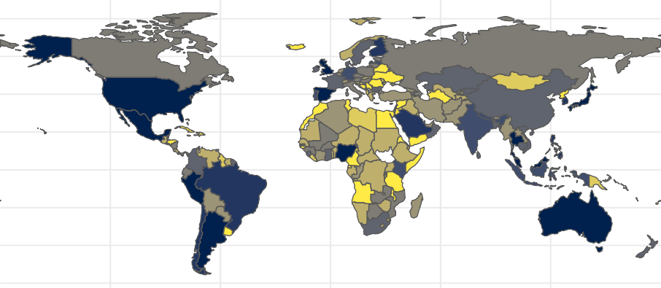

Real−time Surveillance and Reporting

100



75

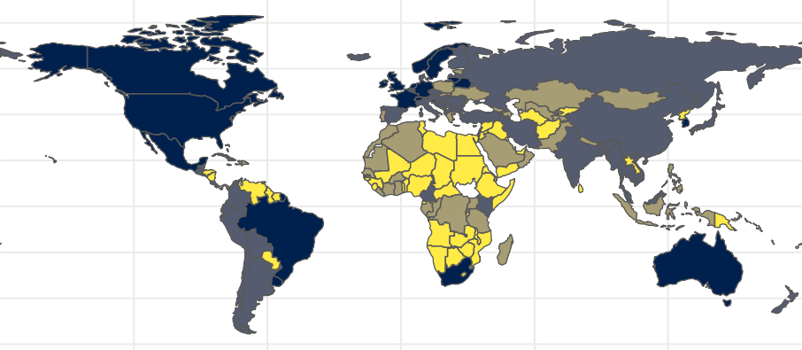

Zoonotic Disease Surveillance − Animals

50

25

0

120W 60W 0 60E 120E

Figure 1.3: Global Health Security Index country scores for the sub-domains of 2.3) Real-time surveillance and reporting (top) and 1.2.2) Zoonotic disease surveillance (bottom). Real-time surveillance and report- ing for epidemics of potential international concern is rated highly in several North and South American countries and countries in East and South East Asia and Oceania. Zoonotic disease surveillance in animals is rated highly in European, North and South American countries and Oceania. Generally surveillance for zoonotic infectious disease is limited across much of Africa, with the notable exception of Nigeria for real-time surveillance and reporting. Data obtained from the Global Health Security Index.

##### Lassa fever: A case study of a rodent associated zoonosis in West Africa

The above sections have introduced zoonotic infectious diseases, the effect of a changing world on potential disease emergence, the role of rodents in zoonotic infectious disease transmission, and the particular risk of

emergence and outbreaks in West Africa. The remainder of this introduction will focus on the case study of this thesis, Lassa fever, in West Africa and more specifically Sierra Leone. Despite the discovery of LASV more than 50 years ago and the expected hundreds of thousands of annual human cases research into this disease system adopting a One Health framework is currently limited. Lassa fever also serves as a useful case study of rodent associated zoonoses given the interaction between multiple small mammal species’, potential roles of climate change and land use change on disease risk and the relatively high frequency of spillover events.

* + 1. ***Lassa mammarenavirus* and Lassa fever**

*Lassa mammarenavirus* (LASV) an enveloped, bisegmented, single stranded RNA virus of the Arenaviridae family. It is a zoonotic pathogen and an established zoonosis, causing Lassa fever in humans. Lassa fever is a potentially lethal viral haemorrhagic fever, first identified from a case series of infected patients seeking healthcare in Jos, Nigeria in 1969, ([Frame *et al.*, 1970](#_bookmark241)). Human LASV infection is caused by spillover of the virus from infected rodents and their excreta, with a limited role of human-to-human secondary transmission ([McCormick *et al.*, 1987](#_bookmark374); [Lo Iacono *et al.*, 2015](#_bookmark346)). Human-to-human transmission is typically reported from nosocomial settings with limited evidence for transmission within households, no transmission chains beyond two cases have been reported (i.e., an index case to another susceptible human) ([Garry, 2023](#_bookmark248)). The reservoir host of LASV has been identified as the multimammate rat (*M. natalensis*) following an outbreak in Sierra Leone between 1970-2 ([Monath *et al.*, 1974](#_bookmark388)). This synanthropic rodent species is found across much of sub-Saharan Africa, however, outside of West Africa, no individuals of this species have been found to be infected with LASV ([Colangelo *et al.*, 2013](#_bookmark198); [Bellocq *et al.*, 2020](#_bookmark158); [Grobbelaar *et al.*, 2021](#_bookmark268)).

*Lassa mammarenavirus* has four confirmed lineages (I-IV) and three additional lineages (V-VII) based on geographic and phylogenetic analysis ([Li, 2023](#_bookmark342)). Lineages I, II, III and VI are located within Nigeria; lineage IV contains all isolates from the Mano River region of Guinea, Liberia and Sierra Leone; lineage V contains samples from Mali and the Ivory Coast; and lineage VII contains recently sampled sequences from Togo ([Andersen *et al.*, 2015](#_bookmark145); [Manning, Forrester and Paessler, 2015](#_bookmark358); [Whitmer *et al.*, 2018](#_bookmark494); [Ehichioya *et al.*, 2019](#_bookmark219)). Lineage I is believed to be the most ancient, originating around 1,000 years ago in the North East of Nigeria, with subsequent radiation and establishment of lineages II and III in the Southern and Central areas of the country, respectively ([Andersen *et al.*, 2015](#_bookmark145); [Ehichioya *et al.*, 2019](#_bookmark219)). Lineage IV represents a Westward expansion of the virus into the Mano River region, dated around 350 years ago ([Andersen *et al.*, 2015](#_bookmark145)).

Host cell entry of the virus is mediated by a trimeric glycoprotein complex that interacts with host cell receptors and leads to fusion of the viral and host membranes, *in vivo* this protein undergoes substantial host-

derived glycosylation, effectively reducing available antibody binding domains ([Hastie and Saphire, 2018](#_bookmark286)). Once within the host cell, the viral nucleoprotein associates with viral RNAs forming ribonucleoprotein complexes facilitating transcription and replication of viral RNA within the host cell cytoplasm ([Hass *et*](#_bookmark284)[*al.*, 2004](#_bookmark284)). The process of viral entry into host cells is expected to lead to the observed tissue tropism in experimental infection models in guinea pigs and *M. natalensis* ([Torriani, Galan-Navarro and Kunz, 2017](#_bookmark475)). Within infected guinea pigs and *M. natalensis*, LASV load was highest transiently in the lymph nodes with sustained high titres in the lungs and spleen ([Jahrling *et al.*, 1982](#_bookmark304); [Safronetz *et al.*, 2022](#_bookmark441)). Minimal pathological changes were observed in guinea pigs or *M. natalensis*, with no evidence of clinical disease in these animals.

Among infected humans with clinical symptoms, the viral incubation period is between 7 and 18 days ([McCormick *et al.*, 1987](#_bookmark374)). Initial symptoms are non-specific with fever, weakness, malaise, cough, sore throat and a typically frontal headache ([Knobloch *et al.*, 1980](#_bookmark326)). The majority of symptomatic patients will go on to develop joint and lumbar pain, a non-productive cough with many developing severe retrosternal chest pain, nausea with vomiting and diarrhoea and abdominal pain ([McCormick and Fisher-Hoch, 2002](#_bookmark373)). Up to a third of hospitalised patients will significantly decline 6-8 days post onset of fever with a minority developing haemorrhagic syndrome with bleeding from the mucosal surfaces. Severe pulmonary oedema and soft tissue oedematous changes in the head and neck are common in fatal cases ([Knobloch *et al.*, 1980](#_bookmark326)). The vast majority of infections, commonly reported as 80%, are asymptomatic although in the absence of long term prospective studies, the proportion of asymptomatic infections is diﬀicult to estimate ([McCormick *et*](#_bookmark374)[*al.*, 1987](#_bookmark374)). There is some limited evidence that disease severity may vary by infecting lineage ([Garry, 2023](#_bookmark248)). There is no evidence on the association of disease severity or pathogenicity in humans with the route of infection.

Treatment options for acute cases of Lassa fever are limited. Ribavirin is the standard of care for treating acute cases although the effectiveness of this treatment is questionable ([Salam *et al.*, 2022](#_bookmark444)). Supportive care therefore remains the mainstay of treatment for hospitalised individuals. There are no currently available vaccinations for Lassa fever, although three candidate vaccines have begun clinical trials ([Salami *et al.*, 2019](#_bookmark445); [Inovio Pharmaceuticals, 2020](#_bookmark295), [2022](#_bookmark296); [Themis Bioscience GmbH, 2022](#_bookmark472); [International AIDS Vaccine Initiative,](#_bookmark297) [2023](#_bookmark297)).

The case-fatality rate of Lassa fever has been reported to be as high as 29.7% although this varies by country and year ([Kenmoe *et al.*, 2020](#_bookmark322)). This estimate is based on a systematic review of the published scientific literature and does not include data from epidemiological reports or WHO bulletins. A recent review and integration of both epidemiological reports and the published literature to derive the case-fatality rate

among confirmed cases in order to estimate the scale of underreporting in Lassa fever produced an estimated case-fatality rate of 16.5% (+/- 5%) among confirmed cases ([Simons, 2022b](#_bookmark454)). Importantly, this estimate is sensitive to biases in reporting and is likely a grossly inflated rate of mortality. Severe cases are more likely to come into contact with healthcare services and be tested for Lassa fever, and these cases are also more likely to result in disease associated mortality skewing confirmed cases to those with severe disease. Therefore, this case-fatality rate should be considered a severe disease case-fatality rate, with the majority of mildly symptomatic cases likely to have a dramatically reduced probability of mortality, which will lower the total case-fatality rate and increase the number of underreported cases. Currently, a lack of disease surveillance and monitoring data prevents the estimation of the infection-fatality rate for Lassa fever.

Survivors of symptomatic Lassa fever may have lasting effects of the disease. Sensorineural hearing loss is reported to occur in up to a third of Lassa fever survivors and potentially causes significant social and public health burden in the region that have not been well studied ([Mateer *et al.*, 2018](#_bookmark368)). Additional neurological sequealae reported in Lassa fever survivors include cerebellar ataxia and visual impairment, although few patients have been assessed for these complications and progression over time is unclear ([Ezeomah *et al.*,](#_bookmark222) [2019](#_bookmark222); [Li *et al.*, 2020](#_bookmark341)). Most hospitalised patients, following recovery, rapidly clear viral RNA (typically within 10 days post-hospitalisation) ([Thielebein *et al.*, 2022](#_bookmark474)). Most patient sera are negative for viral RNA at hospital discharge, however, up to 50% of male survivors have detectable viral loads in seminal fluid at 3 months post-hospitalisation raising concerns that human-to-human sexual transmission may be possible ([Thielebein *et al.*, 2022](#_bookmark474)).

* + 1. Lassa fever epidemiology

Annual Lassa fever incidence is unknown, with estimates ranging between 150,000 to 900,000 cases per year annually ([McCormick *et al.*, 1987](#_bookmark374); [Basinski *et al.*, 2021](#_bookmark153)). The wide uncertainty surrounding these estimates is due to a combination of few serological studies, limited disease surveillance and an overlap between the symptomatology of Lassa fever with other infectious diseases in these endemic regions (e.g., malaria). Lassa fever is currently considered endemic in 8 West African countries: Benin, Ghana, Guinea, Liberia, Mali, Nigeria, Sierra Leone and Togo by the World Health Organisation (WHO), with sporadic cases reported from Burkina Faso and the Ivory Coast (Figure [1.4](#_bookmark16)) ([World Health Organisation, 2022](#_bookmark503)). The endemic region is entirely contained within the range of the reservoir species *M. natalensis*. Imported cases have been reported from non-West African countries such as the United Kingdom, Germany and the United States of America with a limited number of secondary human-to-human transmission events observed outside of the endemic region ([Tuite *et al.*, 2019](#_bookmark476); [Wolf *et al.*, 2020](#_bookmark498)).

25N

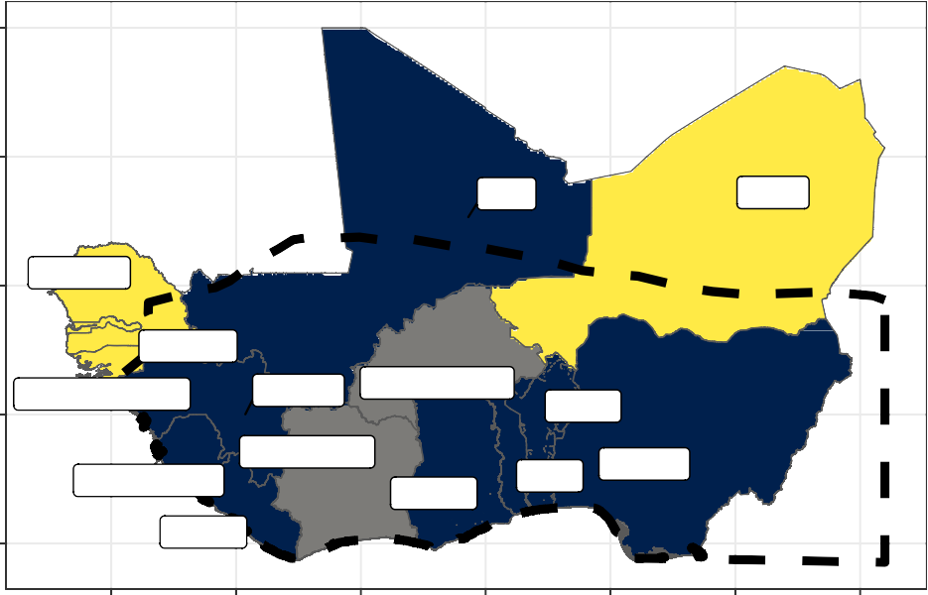

Mali

Niger

Senegal

Gambia

Guinea−Bissau

Guinea

Burkina Faso

Benin

Ivory Coast

Sierra Leone

Nigeria

Ghana

Togo

Liberia

20N

15N

10N

Lassa endemicity Endemic Outbreaks

No cases

5N

15W 10W 5W 0 5E 10E 15E

Figure 1.4: Lassa fever is considered endemic in eight West African countries, sporadic outbreaks have been reported from a further two countries within the region. The black dashed border indicates the range of *Mastomys natalensis* in West Africa, its range extends East and South across the continent (not shown here). Data on Lassa fever endemicity is obtained from the WHO, data on *Mastomys natalensis* range is obtained from the International Union for Conservation of Nature Red List.

Nigeria and Sierra Leone have historically reported the greatest number of Lassa fever cases (Figure [1.5](#_bookmark17)). This is likely driven by increased availability of testing for acute cases in these countries. Human seroepi- demiological surveys in Guinea, Mali and the Ivory Coast - countries that have generally reported few acute cases - report seroprevalence in excess of 20%, which suggests undetected localised transmission of LASV

([Bausch *et al.*, 2001](#_bookmark155); [Akoua-Koﬀi *et al.*, 2006](#_bookmark135); [Kerneis *et al.*, 2009](#_bookmark323); [Sogoba *et al.*, 2016](#_bookmark461); [Safronetz *et al.*,](#_bookmark442) [2017](#_bookmark442)). The number of reported cases across the region declined during the Ebola and SARS-CoV-2 epidemic where changes in healthcare seeking behaviour and availability of Lassa fever testing may have reduced. The number of cases reported in Nigeria has generally increased since data became routinely available in 2012. In contrast, there has been a dramatic fall in cases reported from Sierra Leone since 2012. Whether these trends represent actual changes in the underlying spillover risk remains unclear.

Endemic Benin

60

Endemic Ghana

25

20

Endemic Guinea

8

6

40 15

4

10

20 2

5

0

100

80

Confirmed cases

60

40

20

0

300

0

Endemic Liberia

2

1

0

Endemic Sierra Leone

6

Endemic Mali

Endemic Togo

0

1200

1000

800

600

400

200

0

1

Endemic Nigeria

Outbreaks Combined

Endemic countries Benin

Ghana Guinea Liberia Mali Nigeria

Sierra Leone Togo

Non−endemic countries Ivory Coast

Burkina Faso

200

4

100 2

0

2008 2012 2016 2020

0

2008 2012 2016 2020

0

2008 2012 2016 2020

Figure 1.5: Confirmed Lassa fever cases from countries in West Africa 2008-2023. Confirmed cases show variability by year with the greatest number of cases reported from Nigeria, Sierra Leone and Liberia. Grey shaded regions represent periods of regional or global epidemics which may have affected Lassa fever reporting (i.e., the Ebola epidemic and SARS-CoV-2 pandemic). The yellow shaded region represents 2023 where an incomplete year is shown. Data current as of 2023-07-13. Data compiled from scientific publications, epidemiological reports, ProMED mail and WHO disease outbreak notifications and available online ([Simons,](#_bookmark455) [2022c](#_bookmark455)).

The number of reported confirmed cases of Lassa fever in endemic countries is likely to be significantly underreported. Cases tend to occur in rural and remote locations where healthcare access is generally low, and financial and societal costs of accessing healthcare relatively high while testing facilities are concentrated

in large urban settings ([Bhadelia, 2019](#_bookmark163); [Nnaji *et al.*, 2021](#_bookmark403)). Additionally while clinicians in endemic settings have good awareness of symptoms that may indicate acute Lassa fever infection, access to testing and timely reporting were identified as factors that could lead to diagnostic delay, poor patient outcomes and delayed public health responses to outbreaks ([Olowookere *et al.*, 2014](#_bookmark409); [Rohan, 2022](#_bookmark437)). An estimate of the degree of underreporting was conducted using reported Lassa fever disease associated mortality, assuming a consistent 16.5% case-fatality rate across the region. Using this approach Nigeria was found to report the highest proportion of all expected cases (63%) while countries with generally fewer observed outbreaks reported significantly fewer than expected cases (e.g., Ghana - 17%, Guinea - 25%) ([Simons, 2022b](#_bookmark454)).

Human seroepidemiological studies conducted in several regions of Sierra Leone suggest that despite the observed fall in human cases of disease infection remains prevalent ([Grant *et al.*, 2023](#_bookmark267)).This study in Sierra Leone also suggests that widespread transmission of LASV is occurring outside the traditionally considered endemic region of Eastern Sierra Leone. A large-scale serological study conducted by the Coalition for Epidemic Preparedness Innovations across Benin, Guinea, Liberia, Nigeria and Sierra Leone to understand the prevalence to antibodies against LASV has been implemented and results are awaiting ([Penfold *et al.*,](#_bookmark421) [2023](#_bookmark421)).

* + 1. **Rodent hosts of *Lassa mammarenavirus***

While *M. natalensis* is considered the only reservoir of LASV 11 other rodent species have been found to be acutely infected or have antibodies to the virus ([Monath *et al.*, 1974](#_bookmark388); [Demby *et al.*, 2001](#_bookmark209); [Fichet-Calvet](#_bookmark229) [*et al.*, 2014](#_bookmark229); [Olayemi *et al.*, 2016](#_bookmark406)). The role of the wider rodent species community in viral transmission in endemic areas is not currently well understood. Further, evidence exists for prior exposure to LASV in non-rodent species, including domestic dogs, non-human primates and shrews. The role of these species in the ecology of LASV is even less clear ([Kenmoe *et al.*, 2020](#_bookmark322)).

*Mastomys natalensis* is a synanthropic rodent species, native to Africa. This species is considered a pest species across much of its range, as it lives within and around human communities consuming grain within the fields and in stores ([Swanepoel *et al.*, 2017](#_bookmark468)). The species demonstrates archetypal fast life history traits with rapid sexual maturity (4 months), short life span (<1 year) and large litter sizes (mean of 9 live offspring) ([Coetzee, 1975](#_bookmark197); [Albery and Becker, 2021](#_bookmark138); [Safronetz *et al.*, 2021](#_bookmark440)). The proportion of reproductively active individuals is observed to increase in the late wet season and early dry season with a nadir in the late dry season, leading to a population boom in the late wet season ([Mlyashimbi *et al.*, 2018](#_bookmark383); [Mayamba *et al.*, 2021](#_bookmark370)). Importantly, the majority of population dynamic studies in this species have been conducted in Tanzania, where abundance has been observed to be closely linked to food availability. However, the drivers of these

population dynamics may not be as extreme in West Africa where the population dynamics are less closely linked to rainfall patterns ([Fichet-Calvet *et al.*, 2008](#_bookmark231); [Olayemi *et al.*, 2018](#_bookmark407); [Bangura *et al.*, 2021](#_bookmark151)).

As a synanthropic species *M. natalensis* typically occurs within areas of human habitation and agriculture and is found to be an early invader of land converted to agricultural use ([Makundi, Massawe and Mulungu,](#_bookmark357) [2007](#_bookmark357)). This land use preference is consistent across the entirety of its range with few individuals trapped in forested landscapes ([Coetzee, 1975](#_bookmark197); [Leirs, Verheyen and Verhagen, 1996](#_bookmark339); [Fichet-Calvet *et al.*, 2008](#_bookmark231); [Olayemi](#_bookmark407) [*et al.*, 2018](#_bookmark407); [Bangura *et al.*, 2021](#_bookmark151)). This would suggest that abundance of this species is heterogeneous across its proposed range with expected absence in the forested regions of sub-Saharan Africa. This species is non-territorial, co-existing with conspecifics and other rodent species and with a limited home range of

~30m, although dispersal across greater distances has been observed ([Leirs, Verheyen and Verhagen, 1996](#_bookmark339)). Contact with other rodent species is therefore assumed to be common and this is reflected by the high rodent species richness in locations where *M. natalensis* is detected ([Fichet-Calvet *et al.*, 2008](#_bookmark231); [Bangura *et al.*, 2021](#_bookmark151)). The high frequency of contacts may be potentially important for the transmission of LASV among rodent hosts as it potentially facilitates transmission of the virus across the heterogeneous land use types of the endemic region.

While this species is distributed across sub-Saharan Africa genomic studies suggest that six phylogroups (A-I to A-III and B-IV to B-VI) have formed which correspond to different geographic regions of Africa. The West African clade, A-I is genetically distinct and is found in the endemic region of LASV ([Colangelo *et al.*, 2013](#_bookmark198)). Individuals of the other clades have not been found to be infected with LASV but have tested positive for other Arenaviridae, including Mayo Ranewo (A-II), Dhati Welel (A-III), Gairo (B-IV), Morogoro (B-V), and Mopeia viruses (B-VI) ([Bellocq *et al.*, 2020](#_bookmark158)). The presence of clade specific Arenaviridae may provide cross- immunity between these viruses, preventing of range expansion of LASV. Further, differential susceptibility of the different phylogroups to individual Arenaviridae may explain why the Lassa fever endemic region is constrained to the Western radiation of *M. natalensis* despite it being found throughout sub-Saharan Africa and may limit any future geographic expansion of the virus.

While LASV is considered to primarily infect *M. natalensis* the prevalence of LASV in rodent communities varies importantly across the region and over time. Figure [1.6](#_bookmark19) shows the prevalence of acute infection or antibodies to LASV among sampled *M. natalensis* communities. When detected LASV prevalence varies both within and between countries. In Guinea, LASV was detected in 10 to 55% of trapped individual rodents, from species including *Gerbilliscus kempi*, *Lemniscomys striatus*, *Lophuromys sikapusi*, *Mastomys erythroleucus*, *M. natalensis*, *Mus musculus*, *Mus minutoides*, *Praomys daltoni*, *Praomys rostratus* and *Rattus rattus* ([Demby *et al.*, 2001](#_bookmark209); [Fair *et al.*, 2007](#_bookmark224); [Fichet-Calvet *et al.*, 2014](#_bookmark229); [Olayemi *et al.*, 2016](#_bookmark406); [Mariën *et*](#_bookmark363)

[*al.*, 2020](#_bookmark363)). In a single study conducted in Mali, acute infection was detected in 25% of individuals of *M. natalensis*, while in, Sierra Leone, sampled rodents showed a wide range of prevalence from 1% to 100% among *M. natalensis* ([Monath *et al.*, 1974](#_bookmark388); [McCormick *et al.*, 1987](#_bookmark374); [Safronetz *et al.*, 2010](#_bookmark439); [Leski *et al.*, 2015](#_bookmark340)). However, most of the sampling events in these settings did not detect any acute infection (absence of acute infection not shown in Figure [1.6](#_bookmark19)). The number of individuals tested for acute infection is typically lower than those tested for antibodies due to availability of reagents, cost and laboratory requirements. There are also selection biases in which rodents are tested for acute infection which may increase the proportion of positive samples. For example, testing may only be performed in antibody positive rodents or rodents trapped in the location of a confirmed human case.

NA



Acute infection



Serology

Mastomys natalensis

Mastomys erythroleucus

Mastomys spp.

Rattus rattus

Rattus spp.

Praomys daltoni

Praomys rostratus

Praomys spp.

Mus minutoides

Mus baoulei

Mus musculus

Number assayed

 200

 400

600



800

Country

Benin Guinea Mali Nigeria

Sierra Leone

Hylomyscus pamfi

Lemniscomys striatus

Crocidura spp.

Lophuromys sikapusi

Rodentia spp.

0 25 50 75 100 0 25 50 75 100

Percentage positive

Figure 1.6: Prevalence of acute infection with LASV or antibodies to LASV in rodent species sampled in West Africa. The size of a point relates to the number of samples of that species tested and the colour to the country in which the rodent was sampled. Where possible the rodent species is identified, for individuals only identified to genus level the genera from which samples obtained is shown. Six rodent species have been found to be acutely infected with LASV with 10 species having detectable antibodies. The majority of samples have been obtained from rodents trapped in Guinea and Sierra Leone. Data obtained from: Monath *et al.*, 1974; Wulff *et al.*, 1975; McCormick *et al.*, 1987; Mahy, 1994; Demby *et al.*, 2001; Fair *et al.*, 2007; Safronetz *et al.*, 2010; Fichet-Calvet *et al.*, 2014; Leski *et al.*, 2015; Olayemi *et al.*, 2016; Karan *et al.*, 2019; Yadouleton *et al.*, 2019 and Mariën *et al.*, 2020.

Figure [1.6](#_bookmark19) also highlights the detection of LASV in non-*M. natalensis* species. *Mastomys erythroleucus* a morphologically indistinguishable, closely related species to *M. natalensis* has been found to co-occur with *M.*

*natalensis* in several regions of Guinea, Sierra Leone and Nigeria ([Brouat *et al.*, 2009](#_bookmark182)). The proportion of *M. erythroleucus* individuals found to be infected with LASV was not too dissimilar from *M. natalensis* and may indicate that this species can also be involved in viral transmission in locations where these species co-exist. Three other native rodent species *Mus minutoides*, *Mus baoulei* and *Hylomyscus pamfi* have been found to be acutely infected with LASV although the number of individuals of these tested is small. *Mus minutoides* and *Mus baoulei* are African pygmy mice - i.e., a complex of 17-19 morphologically similar rodents that may contain a number of undescribed subspecies ([Britton-Davidian, Robinson and Veyrunes, 2012](#_bookmark179)). They occupy a wide range of land use types and are not considered synanthropic, with a habitat preference for forest and shrubland habitats, although they are often detected in cultivated landscapes ([Long *et al.*, 2013](#_bookmark347)). Finally, the non-native, invasive rodent species, *Rattus rattus* has been found to be acutely infected with LASV. This synanthropic rodent species has been found to co-occur with *M. natalensis* in locations which it has invaded and may represent a relatively recent host of LASV within the endemic region ([Olayemi *et*](#_bookmark407)[*al.*, 2018](#_bookmark407); [Bangura *et al.*, 2021](#_bookmark151)).

More rodent species have been found to have antibodies to LASV than those found to have acute infection. Whether these species are competent hosts of the virus and are able to produce subsequent rodent-to-rodent or rodent-to-human transmission is not known. Additionally, some of these detections may be due to the presence of cross-reactive antibodies to other Arenaviridae; however, a validated, commercial, ELISA assay used for many of these surveys shows a sensitivity of 97.1% and specificity of 100% to LASV ([Soubrier](#_bookmark462) [*et al.*, 2022](#_bookmark462)). The proportion of all samples that tested positive for LASV antibodies across all species is typically lower, consistent with the greater number of samples assayed and less targeted sampling. Additional species found to have antibodies to LASV include the native rodents *Praomys daltoni*, *Praomys rostratus*, *Lemniscomys striatus*, *Lophuromys sikapusi*, *Mus musculus* and *Gerbilliscus kempii*. Of these species, only

*P. daltoni* and the invasive *M. musculus*, are considered synanthropic, typically found in villages and nearby agricultural areas in West Africa ([Nicolas *et al.*, 2008](#_bookmark401); [Diagne *et al.*, 2017](#_bookmark211); [Lippens *et al.*, 2017](#_bookmark343); [Mikula *et al.*,](#_bookmark380) [2020](#_bookmark380)). *P. rostratus* and *L. sikapusi* are more commonly found in forested or fragmented forest, shrubland and agricultural habitats ([Iyawe, 1988](#_bookmark303); [Akpatou *et al.*, 2018](#_bookmark136)). *L. striatus* and *G. kempii* are considered savannah rodents, rarely detected within villages but often detected in forested habitats, shrubland and agriculture ([Davis, 1949](#_bookmark206); [Lourie *et al.*, 1975](#_bookmark349); [Hoffmann and Klingel, 2001](#_bookmark290)). Finally, non-rodent, small mammal species found to have antibodies to LASV include individuals of the species rich insectivorous shrew order (*Crocidura*). As morphological identification to species level is typically not performed, the grouping is at the order level.

Two invasive rodent species, *Mus musculus* and *R. rattus* are increasingly common in West Africa. These species have been introduced through human activity, typically in coastal regions, beginning in the 15th

century with subsequent expansion into the interior of countries along human transport networks ([Dalecky](#_bookmark202) [*et al.*, 2015](#_bookmark202); [Lippens *et al.*, 2017](#_bookmark343)). Populations of these species have been found to establish communities in areas of human habitation demonstrating their synanthropic properties ([Hima *et al.*, 2019](#_bookmark291); [Puckett, Orton](#_bookmark429) [and Munshi-South, 2020](#_bookmark429)). These species appear to have potentially different effects on local rodent species richness following establishment, with *M. musculus* but not *R. rattus* leading to reduced rodent species richness in locations in which it is detected ([Dalecky *et al.*, 2015](#_bookmark202)). This may have important implications for the prevalence of LASV in the endemic region: if displacement of the primary reservoir by these invasive species that are potentially less competent hosts of viral transmission the risk of Lassa fever outbreaks may subsequently decrease.

Sampling of rodent species and locations of confirmed human cases have been used to produce risk maps of Lassa fever outbreaks. Risk maps may be based on human cases, *M. natalensis* occurrence or a combination of both. These risk maps consistently identify the Mano River region and Nigeria as hotspots of risk ([Fichet-](#_bookmark235) [Calvet and Rogers, 2009](#_bookmark235); [Mylne *et al.*, 2015](#_bookmark394); [Redding *et al.*, 2016](#_bookmark435); [Basinski *et al.*, 2021](#_bookmark153)). The studies are conducted at the regional scale and are not able to incorporate the heterogeneity of rodent species occurrence or abundance that has been observed in rodent sampling studies. The potential contribution of wider rodent communities to viral transmission or maintenance is not incorporated in these models as they all consider

*M. natalensis* as the sole reservoir of LASV.

Importantly, sampling of rodents and LASV in West Africa is biased taxonomically and geographically with increased sampling effort in locations reporting historical outbreaks of Lassa fever ([Beck *et al.*, 2014](#_bookmark156); [Klitting](#_bookmark325) [*et al.*, 2022](#_bookmark325)). Limiting sampling to these locations may be artificially biasing risk towards these regions, with a study accounting for some of these biases suggesting that risk is more evenly distributed across West Africa than what has historically been reported ([Peterson, Moses and Bausch, 2014](#_bookmark423)). A better understanding of sampling biases in both small mammal communities and pathogen sampling will assist in identifying regions in which additional sampling is required. Further, predicting future change in risk that could ensue from ongoing global change will be limited by data suffering from these biases ([Boria *et al.*, 2014](#_bookmark171); [Wille, Geoghegan](#_bookmark496) [and Holmes, 2021](#_bookmark496)).

##### Thesis aims and structure

To better understand the current and future risk of Lassa fever zoonosis in West Africa, biases in available data need to be characterised and systematic sampling of the entire rodent community is required. This thesis aimed to address some of the critical gaps in understanding of LASV transmission among rodent communities in endemic settings, whether there is a need to move away from the current single reservoir

species paradigm and the effect of anthropogenic change on the structure of rodent communities and how this may modulate Lassa fever spillover risk.

The first part of this thesis (Chapter [2](#_bookmark21)) attempts to understand a key problem in the sampling of both rodents and their pathogens across West Africa. The research question Chapter [2](#_bookmark21) seeks to address is whether the sampling bias of rodents and associated pathogens can be quantified and mitigated against. To achieve this, a review of rodent trapping studies in West Africa was conducted. Data from included studies were synthesised and assessed for spatial biases, identifying regions that have been relatively under-sampled and therefore locations in which inference my be limited based on available datasets. This dataset was subsequently compared with a commonly used resource, the Global Biodiversity Information Facility (GBIF), to explore the benefit of incorporating primary rodent trapping data within this larger, consolidated dataset. The results presented in this chapter and the planned incorporation of this data into GBIF will aid researchers attempting to model risks of rodent associated zoonoses in West Africa and the effect of future anthropogenic change on rodent distributions across the region.

The second part of this thesis (Chapter [4](#_bookmark66) and [5](#_bookmark98)) present the results of a systematic study of rodent ecology and LASV prevalence in an endemic region of Eastern Sierra Leone. Following primary data collection in the form of a two-and-half-year longitudinal rodent trapping study, comprising in excess of 43,000 trap nights, the design of which is described in depth in Chapter [3](#_bookmark47). Chapter [4](#_bookmark66) describes the composition of rodent communities in the Eastern Province of Sierra Leone and aims to address the question as to whether rodent species richness and diversity vary along an anthropogenic land use gradient. This study explores the biotic interactions between rodent species to infer the risk of LASV transmission among rodent communities along a land use gradient using species occupancy models which account for incomplete detection. Chapter [5](#_bookmark98) expands on this work to explicitly model potential contact networks among individual rodents in different land use types to investigate the interactions within these rodent communities. The key research question addressed is whether the primary reservoir is more likely to interact with members of the same species and what consequences this may have for viral transmission. I use Exponential-family Random Graph Models fitted to produced networks of rodent contacts based on rodent trapping data to assess the probability of inter- and intra-specific contact rates to understand viral transmission within rodent communities. This chapter describes the prevalence of antibodies to LASV to gauge the risk of Lassa fever spillover in these settings.

The thesis concludes with a discussion of how insights from this body of work enhance our understanding of the risk of rodent associated zoonoses in West Africa in general, and Lassa fever emergence in Sierra Leone in particular. Future directions of study required to better quantify this dynamic risk are discussed,

alongside how dynamic risk estimates can guide timely public health interventions to reduce disease associated morbidity and mortality.

## Rodent trapping studies as an overlooked information source for understanding endemic and novel zoonotic spillover.

##### Preface

I conceived of the study with Richard Kock, Deborah Watson-Jones and Kate E. Jones. I designed the search strategy, study protocol and data extraction tool. I conducted the search and compared returned records against the inclusion and exclusion criteria, extracting data from included studies. Lauren A. Attfield performed double-checking against inclusion and exclusion criteria and reviewed data extraction for accuracy. I performed statistical analysis, interpreted the model outputs and wrote the initial draft of the chapter. All co-authors contributed to and approved the final version of the chapter.

This chapter has been published as a peer-reviewed article in a modified format in *PLoS NTD*, the typeset version of this manuscript is available as Appendix [A.1](#_bookmark517) ([Simons *et al.*, 2023](#_bookmark459)).

##### Abstract

Rodents, a diverse, globally distributed and ecologically important order of mammals are nevertheless impor- tant reservoirs of known and novel zoonotic pathogens. Ongoing anthropogenic land use change is altering these species’ abundance and distribution, which among zoonotic host species may increase the risk of zoonoses spillover events. A better understanding of the current distribution of rodent species is required to guide attempts to mitigate against potentially increased zoonotic disease hazard and risk. However, avail- able species distribution and host-pathogen association datasets (e.g. IUCN, GBIF, CLOVER) are often taxonomically and spatially biased. Here, we synthesise data from West Africa from 127 rodent trapping studies, published between 1964-2022, as an additional source of information to characterise the range and presence of rodent species and identify the subgroup of species that are potential or known pathogen hosts. We identify that these rodent trapping studies, although biased towards human dominated landscapes across West Africa, can usefully complement current rodent species distribution datasets and we calculate the dis- crepancies between these datasets. For five regionally important zoonotic pathogens (Arenaviridae spp., Borrelia spp., *Lassa mammarenavirus*, Leptospira spp. and *Toxoplasma gondii*), we identify host-pathogen associations that have not been previously reported in host-association datasets. Finally, for these five pathogen groups, we find that the proportion of a rodent hosts range that have been sampled remains small with geographic clustering. A priority should be to sample rodent hosts across a greater geographic range to better characterise current and future risk of zoonotic spillover events. In the interim, studies of spatial pathogen risk informed by rodent distributions must incorporate a measure of the current sampling biases.

The current synthesis of contextually rich rodent trapping data enriches available information from IUCN, GBIF and CLOVER which can support a more complete understanding of the hazard of zoonotic spillover events.

##### Introduction

There is increasing awareness of the global health and economic impacts of novel zoonotic pathogen spillover, driven by the ongoing SARS-CoV-2 pandemic and previous HIV/AIDs and Spanish Influenza pandemics ([Bernstein *et al.*, 2022](#_bookmark162)). The number of zoonotic disease spillover events and the frequency of the emergence of novel zoonotic pathogens from rodents are predicted to increase under intensifying anthropogenic pres- sure driven by increased human populations, urbanisation, intensification of agriculture and climate change leading to altered rodent species assemblages ([Allen *et al.*, 2017](#_bookmark140); [Hassell *et al.*, 2017](#_bookmark285); [McMahon, Morand and](#_bookmark375) [Gray, 2018](#_bookmark375); [García-Peña *et al.*, 2021](#_bookmark246)). The impact of endemic zoonoses meanwhile remains underestimated ([Maudlin, Eisler and Welburn, 2009](#_bookmark369)). Endemic zoonoses disproportionally affect those in the poorest sec- tions of society, those living in close contact with their animals and those with limited access to healthcare ([Molyneux *et al.*, 2011](#_bookmark386); [Halliday *et al.*, 2015](#_bookmark275); [Judson and Rabinowitz, 2021](#_bookmark312)).

Rodents along with bats contribute the greatest number of predicted novel zoonotic pathogens and known endemic zoonoses ([Han *et al.*, 2015](#_bookmark277); [Gibb, Albery, Mollentze, *et al.*, 2021](#_bookmark253)). Of 2,220 extant rodent species, 244 (10.7%) are described as reservoirs of 85 zoonotic pathogens ([Han *et al.*, 2015](#_bookmark277)). Most rodent species do not provide a direct risk to human health and all species provide important and beneficial ecosystem services including pest regulation and seed dispersal ([Fischer *et al.*, 2018](#_bookmark238)). Increasing risks of zoonotic spillover events are driven by human actions rather than by rodents, for example, invasive rodent species being introduced to novel ranges through human transport routes. Rodents typically demonstrate “fast” life histories which allow them to exploit opportunities provided by anthropogenic disturbance ([Dobson and Oli, 2007](#_bookmark212)). Within rodents, species level traits such as early maturation and short gestation times are associated with increased probabilities of being zoonotic reservoirs ([Han *et al.*, 2015](#_bookmark277); [Albery and Becker, 2021](#_bookmark138)). Rodent species with these traits are able to thrive in human dominated landscapes, displacing species less likely to be reservoirs of zoonotic pathogens ([Gibb, Redding, *et al.*, 2020](#_bookmark257)). The widespread occurrence of reservoir species and their proximity to human activity make the description of rodent species assemblages and host-pathogen associations vitally important to understanding the hazard of zoonotic disease spillover and novel zoonotic pathogen emergence ([Han, Kramer and Drake, 2016](#_bookmark276)).

Despite the importance of understanding these complex systems, current evidence on host-pathogen asso- ciations is considerably affected by taxonomic and geographical sampling biases ([Gibb, Franklinos, *et al.*,](#_bookmark255)

[2020](#_bookmark255); [Gibb, Albery, Mollentze, *et al.*, 2021](#_bookmark253)). Curated biodiversity datasets such as the Global Biodiversity Information Facility (GBIF) and resources produced by the International Union for Conservation of Nature (IUCN) suffer from well described spatial and temporal sampling biases ([Boakes *et al.*, 2010](#_bookmark164); [Bowler *et al.*,](#_bookmark176) [2022](#_bookmark176)). These data are typically obtained from museum specimen collections and non-governmental organisa- tion surveys. These sampling biases can importantly distort produced species distribution models that are used to infer risk of zoonotic disease spillover ([Beck *et al.*, 2014](#_bookmark156)). Datasets on host-pathogen associations (i.e., CLOVER) also can suffer from biases introduced from literature selection criteria and taxonomic discrepan- cies resulting in differential likelihood of accurate host-pathogen attribution by host species. These biases are important because identification of potential geographic hotspots of zoonotic disease spillover and novel pathogen emergence are often produced from these types of host species distributions and host-pathogen associations ([Plowright *et al.*, 2019](#_bookmark425); [Carlson *et al.*, 2021](#_bookmark186)). For example, systematically increased sampling, over-representation of certain habitats and clustering around areas of high human population could lead to an apparent association between locations and hazard that is driven by these factors rather than underlying host-pathogen associations ([Redding *et al.*, 2017](#_bookmark434); [Gibb, Albery, Mollentze, *et al.*, 2021](#_bookmark253); [Wille, Geoghegan](#_bookmark496) [and Holmes, 2021](#_bookmark496)). Predictions of zoonotic disease spillover and novel zoonotic pathogen emergence must account for these biases to understand the future hazard of zoonotic diseases ([Carlson *et al.*, 2021](#_bookmark186)).

West Africa has been identified as a region at increased risk for rodent-associated zoonosis disease spillover events, the probability of these events are predicted to increase under different projected future land-use change scenarios ([Grace *et al.*, 2012](#_bookmark265); [García-Peña *et al.*, 2021](#_bookmark246)). Currently within West Africa, some rodent species are known to be involved in the transmission of multiple endemic zoonoses with large burdens on human health, these pathogens include Lassa fever, Schistosomiasis, Leptospirosis and Toxoplasmosis ([Meerburg, Singleton and Kijlstra, 2009](#_bookmark376); [Galeh *et al.*, 2020](#_bookmark244)). The presence of other species within shared habitats may mitigate the spread of these pathogens through the “dilution effect”, where ongoing loss of biodiversity may further increase the risk to human populations ([McMahon, Morand and Gray, 2018](#_bookmark375)). Understanding of the distribution of these zoonoses are limited by biases in consolidated datasets. Rodent trapping studies provide contextually rich information on when, where and under what conditions rodents were trapped, potentially enriching consolidated datasets ([Bovendorp, McCleery and Galetti, 2017](#_bookmark175)). Studies have been conducted in West Africa to investigate the distribution of rodent species, their species assemblages, the prevalence of endemic zoonoses within rodent hosts (e.g., Lassa fever, Schistosomiasis) and to identify emerging and novel zoonotic pathogens ([Fichet‐Calvet *et al.*, 2010](#_bookmark236); [Catalano *et al.*, 2019](#_bookmark189); [USAID, 2021](#_bookmark478)). However, individual level data from these studies have not previously been synthesised for inclusion in assessments of zoonotic disease spillover and novel zoonotic pathogen emergence.

Here, we synthesise rodent trapping studies conducted across West Africa published between 1964-2022. First, we use this dataset to investigate the geographic sampling biases in relation to human population density and land use classification. Second, we compare this to curated host datasets (IUCN and GBIF) to understand differences in reported host geographic distributions. Third, we compare identified host-pathogen associations with a consolidated dataset (CLOVER) to explore discrepancies in rodent host-pathogen associations and report the proportion of positive assays for pathogens of interest. Finally, within our dataset we investigate the spatial extent of current host-pathogen sampling to identify areas of sparse sampling of pathogens within their host ranges. We expect that rodent trapping studies provide an important additional source of high- resolution data that can be used to enrich available consolidated datasets to better understand the hazard of zoonotic disease spillover and novel zoonotic pathogen emergence across West Africa.

##### Methods

* + 1. Host and pathogen trapping data

To identify relevant literature, we conducted a search in Ovid MEDLINE, Web of Science (Core collection and Zoological Record), JSTOR, BioOne, African Journals Online, Global Health and the pre-print servers, BioRxiv and EcoEvoRxiv for the following terms as exploded keywords: (1) Rodent OR Rodent trap\* AND (2) West Africa, no date limits were set. We also searched other resources including the UN Oﬀicial Documents System, Open Grey, AGRIS FAO and Google Scholar using combinations of the above terms. Searches were run on 2022-05-01, and returned studies conducted between 1964-2021.

We included studies for further analysis if they met all of the following inclusion criteria; i) reported findings from trapping studies where the target was a small mammal, ii) described the type of trap used or the length of trapping activity or the location of the trapping activity, iii) included trapping activity from at least one West African country, iv) recorded the genus or species of trapped individuals, and v) were published in a peer-reviewed journal or as a pre-print on a digital platform or as a report by a credible organisation. We excluded studies if they met any of the following exclusion criteria: i) reported data that were duplicated from a previously included study, ii) no full text available, iii) not available in English. One author screened titles, abstracts and full texts against the inclusion and exclusion criteria. At each stage; title screening, abstract screening and full text review, a random subset (10%) was reviewed by a second author.

We extracted data from eligible studies using a standardised tool that was piloted on 5 studies. Data was abstracted into a Google Sheets document, which was archived on completion of data extraction ([Simons,](#_bookmark452) [2022a](#_bookmark452)). We identified the aims of included studies, for example, whether it was conducted as a survey of small

mammal species or specifically to assess the risk of zoonotic disease spillover. we extracted data on study methodology, such as, the number of trap nights, the type of traps used and whether the study attempted to estimate abundance. For studies not reporting number of trap nights we used imputation based on the number of trapped individuals, stratified by the habitat type from which they were obtained. This was performed by multiplying the total number of trapped individuals within that study site by the median trap success for study sites with the same reported habitat type. Stratification was used as trap success varied importantly between traps placed in or around buildings (13%, IQR 6-24%) compared with other habitats (3%, IQR 1-9%).

We also recorded how species were identified within a study and species identification was assumed to be accurate. The number of individuals of these species or genera was extracted with taxonomic names mapped to GBIF taxonomy ([GBIF: The Global Biodiversity Information Facility, 2021b](#_bookmark250)). We expanded species detection and non-detection records by explicitly specifying non-detection at a trap site if a species was recorded as detected at other trapping locations within the same study.

Geographic locations of trapping studies were extracted using GPS locations for the most precise location presented. Missing locations were found using the National Geospatial-Intelligence Agency GEOnet Names Server ([National Geospatial-Intelligence Agency, 2023](#_bookmark397)) based on place names and maps presented in the study. All locations were converted to decimal degrees. The year of rodent trapping was extracted alongside the length of the trapping activity to understand seasonal representativeness of trapping activity. The habitats of trapping sites were mapped to the IUCN Habitat Classification Scheme (Version 3.1). For studies reporting multiple habitat types for a single trap, trap-line or trapping grid, a higher order classification of habitat type was recorded.

For included studies with available data we extracted information on all microorganisms and known zoonotic pathogens tested and the method used (e.g., molecular or serological diagnosis). Where assays were able to identify the microorganism to species level this was recorded, for non-specific assays higher order attribution was used (e.g., to family level). A broad definition of known zoonotic pathogen was used, a species of microorganism carried by an animal that may transmit to humans and cause illness. We do not include evolved pathogens acquired originally through zoonotic pathways in our definition (i.e., HIV). The term microorganism is used where either the microorganism is not identified to species level, in which case it remains unclear whether it is a zoonotic pathogen (i.e., Arenaviridae), or the species is not known to be a zoonotic pathogen (i.e., *Candidatus Ehrlichia senegalensis*). We recorded the species of rodent host tested, the number of individuals tested and the number of positive and negative results. For studies reporting summary results all testing data were extracted, this may introduce double counting of individual rodents,

for example, if a single rodent was tested using both molecular and serological assays. Where studies reported indeterminate results, these were also recorded.

* + 1. Description of included studies

Out of 4,692 relevant citations, we identified 127 rodent trapping studies. Of these, 55 (43%) were conducted to investigate rodent-associated zoonoses, with the remaining 77 (57%) conducted for ecological purposes (i.e., population dynamics, distribution) in rodents, including those known to be hosts of zoonotic pathogens. The earliest trapping studies were conducted in 1964, with a trend of increasing numbers of studies being performed annually since 2000. The median year of first trapping activity was 2007, with the median length of trapping activity being 1 year (IQR 0-2 years). Studies were conducted in 14 West African countries, with no studies reported from The Gambia or Togo, at 1,611 trap sites (Figure [2.1](#_bookmark28) A.).

Included studies explicitly reported on 601,184 trap nights, a further 341,445 trap nights were imputed from studies with no recording of trapping effort based on trap success, leading to an estimate of 942,629 trap nights (Figure [2.1](#_bookmark28) B.). A minority of studies trapped at a single study site (30, 24%), with 46 (36%) trapping at between two and five sites, the remaining 51 studies (40%) trapped at between six and 93 study sites.

In total 76,275 small mammals were trapped with 65,628 (90%) identified to species level and 7,439 (10%) identified to genus, with the remaining classified to higher taxonomic level. The majority of the 132 identified species were Rodentia (102, 78%), of which Muridae (73, 72%) were the most common family. Soricomorpha were the second most identified order of small mammals (28, 21%). 57 studies tested for 32 microorganisms, defined to species or genus level that are known or potential pathogens. Most studies tested for a single microorganism (48, 84%). The most frequently assayed microorganisms were *Lassa mammarenavirus* or Arenaviridae (21, 37%), *Borrelia sp.* (9, 16%), *Bartonella sp.* (4, 7%) and *Toxoplasma gondii* (4, 7%). Most studies used Polymerase Chain Reaction (PCR) to detect microorganisms (37, 65%), with fewer studies using serology-based tests (11, 19%) or histological or direct visualisation assays (11, 21%). From 32,920 in- dividual rodent samples we produced 351 host-pathogen pairs. With *Rattus rattus*, *Mus musculus*, *Mastomys erythroleucus*, *Mastomys natalensis* and *Arvicanthis niloticus* being assayed for at least 18 microorganisms.

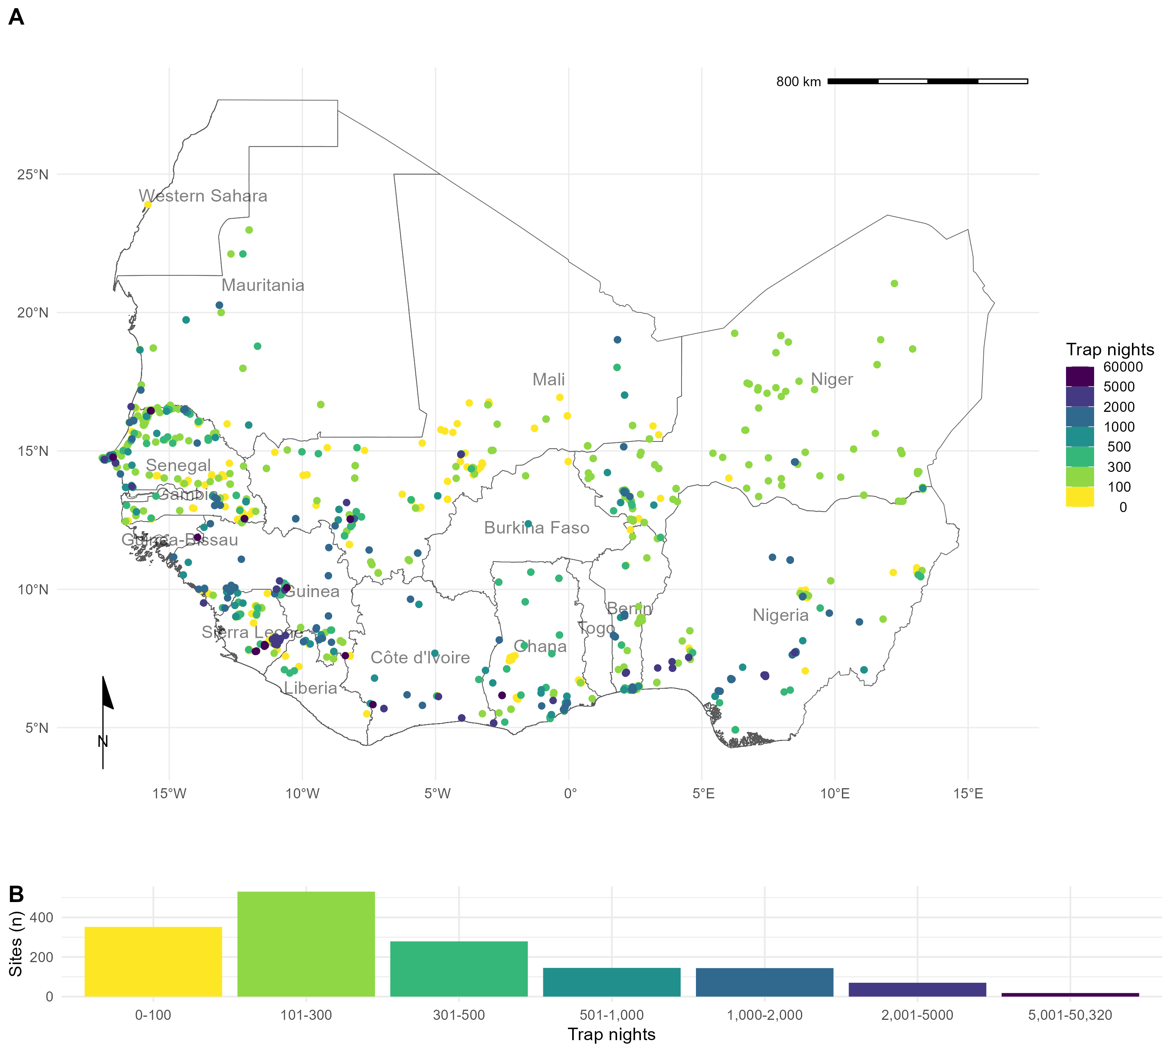

Figure 2.1: Rodent trapping sites across West Africa. A) The location of trapping sites in West Africa. No sites were recorded from Togo or The Gambia. Heterogeneity is observed in the coverage of each country by trap night (colour) and location of sites. For example, Senegal, Mali and Sierra Leone have generally good coverage compared to Guinea and Burkina Faso. B) Histogram of trap nights performed at each study site, a median of 248 trap nights (IQR 116-500) was performed at each site. Basemap shapefile obtained from GADM 4.0.4 (GADM, 2022)

* + 1. What is the extent of spatial bias in the rodent trapping data?

To investigate the extent of spatial bias in the rodent trapping data, we calculated trap-night (TN) density within each West African level-2 administrative region. The sf package in the R statistical language (R ver- sion 4.1.2) was used to manipulate geographic data, administrative boundaries were obtained from GADM

4.0.4 ([Pebesma, 2018](#_bookmark418); [R Core Team, 2021](#_bookmark431); [Database of Global Administrative Areas, 2022](#_bookmark205)). Trap-night density (TNdensity) was calculated by dividing the number of trap nights by the area of a level-2 admin-

istrative area (Rarea). For studies not reporting trap nights imputation was used as previously described. Human population density was obtained for the closest year (2005) to the median year of trapping (2007) from Socioeconomic Data and Applications Center (SEDAC) gridded population of the world v4 at ~ 1km resolution (Pdensity) ([Socioeconomic Data and Applications Center, 2021](#_bookmark460)). Median population density was then calculated for each level-2 administrative region. Land cover classification was obtained from the Coper- nicus climate change service at ~300m resolution ([European Space Agency Climate Change Initiative, 2022](#_bookmark221)). The proportion of cropland, shrubland, tree cover (𝜓tree) and urban land cover (𝜓urban) within a level-2 administrative region in 2005 was calculated.

We investigated the association between relative trapping effort, measured as TN density, and the proportion of urban, cropland, tree cover and human population density using Generalised Additive Models (GAM) incorporating a spatial interaction term (longitude and latitude, *X* and *Y* ) ([Pedersen *et al.*, 2019](#_bookmark419)). Spatial aggregation of relative trapping effort was modelled using an exponential dispersion distribution (Tweedie) ([Kendal, 2002](#_bookmark321)). The models were constructed in the mgcv package ([Wood, 2017](#_bookmark500)). Selection of the most parsimonious model was based on Deviance explained and the Akaike Information Criterion (AIC) for each model (Equations ([2.1](#_bookmark30))-([2.5](#_bookmark31)) below). Relative trapping effort was then predicted across West Africa using these covariates. We performed two sensitivity analyses, first, by removing sites with imputed trapping effort, second, by associating trap locations to ~1km pixels rather than level-2 administrative areas.

TNdensity ∼ Tweedie(𝑋 ∗ 𝑌 ) (2.1)

TNdensity ∼ Tweedie(Pdensity + (𝑋 ∗ 𝑌 )) (2.2)

TNdensity ∼ Tweedie(Pdensity + Rarea + (𝑋 ∗ 𝑌 )) (2.3)

TNdensity ∼ Tweedie(Pdensity + 𝜓tree + 𝜓urban + (𝑋 ∗ 𝑌 )) (2.4)

TNdensity ∼ Tweedie(Pdensity + Rarea + 𝜓urban + (𝑋 ∗ 𝑌 )) (2.5)

* + 1. What is the difference in rodent host distributions between curated datasets and rodent trapping studies?

We assessed the concordance of curated rodent host distributions from IUCN and GBIF with observed rodent presence and absence from rodent trapping studies for seven species with the most trap locations (*M. natalensis*, *R. rattus*, *M. erythroleucus*, *M. musculus*, *A. niloticus*, *Praomys daltoni* and *Cricetomys gambianus*). We obtained rodent species distribution maps as shapefiles from the IUCN red list and translated these to a ~20km resolution raster ([IUCN, 2021](#_bookmark300)). Distributions were cropped to the study region for globally distributed rodent species. We obtained rodent presence locations from GBIF as point data limited to the study region ([GBIF: The Global Biodiversity Information Facility, 2021a](#_bookmark249)). Presence locations were associated to cells of raster with a ~20km resolution produced for the study region.

For each of the seven species, we first calculated the area of the IUCN expected range, and then the percentage of this range covered by presence detections in GBIF, and from detections in the rodent trapping data. We then calculated the area of both GBIF and rodent trapping detections outside of the IUCN expected range. For rodent trapping data, we additionally calculated the area of non-detections within the IUCN expected area. Finally, we calculated the combined area of detection from both GBIF and rodent trapping data.

* + 1. Are rodent trapping derived host-pathogen associations present in a consolidated zoonoses dataset?

To examine the usefulness of rodent trapping studies as an additional source of data we compared identified host-pathogen associations from trapping studies investigating zoonoses with a consolidated zoonoses dataset (CLOVER) ([Gibb, Albery, Mollentze, *et al.*, 2021](#_bookmark253); [Gibb, Carlson and Farrell, 2021](#_bookmark254)). CLOVER is a synthesis of four host-pathogen datasets (GMPD2, EID2, HP3 and ([Shaw *et al.*, 2020](#_bookmark451))) and was released in 2021, it contains more than 25,000 host-pathogen associations for Bacteria, Viruses, Helminth, Protozoa and Fungi. We compared the host-pathogen networks across the two datasets, where the CLOVER data was subset for host species present in the rodent trapping data.

For host-pathogen pairs with assay results consistent with acute or prior infection, we calculated the propor- tion positive and identify those absent from CLOVER.

* + 1. What is the spatial extent of pathogen testing within host ranges?

We use the sampled area of three pathogen groups and two pathogens (Arenaviridae, Borreliaceae, Lep- tospiraceae, *Lassa mammarenavirus* and *Toxoplasma gondii*) to quantify the bias of sampling within their hosts ranges. For each pathogen, we first describe the number of host species assayed, for the five most

commonly tested species we associate the locations of sampled individuals to ~20km pixels and calculate the proportion of the IUCN range of the host in which sampling has occurred. We compare this figure to the total area in which the host has been detected to produce a measure of relative completeness of sampling within the included rodent trapping studies.

Data and code to reproduce all analyses are available in an archived Zenodo repository ([Simons, 2022a](#_bookmark452)).

##### Results

* + 1. What is the extent of spatial bias in the rodent trapping data?

We found non-random, spatial clustering of rodent trapping locations across the study region, suggestive of underlying bias in the sampling or rodents across West Africa. Trap sites were situated in 256 of 1,450 (17.6%) level-2 administrative regions in 14 West African nations. The regions with the highest TN density included the capitals and large cities of Niger (Niamey), Nigeria (Ibadan), Ghana (Accra), Senegal (Dakar), Ghana (Accra) and Benin (Cotonou). Outside of these cities, regions in, Northern Senegal, Southern Guinea, Edo and Ogun States in Nigeria and Eastern Sierra Leone had the greatest TN density (Figure [2.1](#_bookmark28) A).

The most parsimonious GAM model (adjusted R2 = 0.3, Deviance explained = 48.7%) reported significant non-linear associations between relative trapping effort bias and human population densities (Effective De- grees of Freedom (EDF) = 7.13, *p* < 0.001), proportion of urban landscape (EDF = 1.92, *p* < 0.002) and region area (EDF = 3.63, *p* < 0.001), alongside significant spatial associations (EDF = 27.3, *p* < 0.001). Greatest trapping effort bias peaked at population densities between 5,000-7,500 individuals/km2, propor- tion of urban landscape >10% and region areas < 1,000km2. Increased trapping effort was found in North West Senegal, North and East Sierra Leone, Central Guinea and coastal regions of Nigeria, Benin and Ghana; in contrast South East Nigeria, Northern Nigeria and Burkina Faso had an observed bias towards a reduced trapping effort (Figure [2.2](#_bookmark37)). In sensitivity analysis, excluding sites with imputed trap nights, Mauritania, Northern Senegal and Sierra Leone remained as regions trapped at higher rates, with Nigeria being trapped at lower than expected rates. In pixel-based sensitivity analysis spatial coverage was reduced with similar patterns of bias observed to the primary analysis.

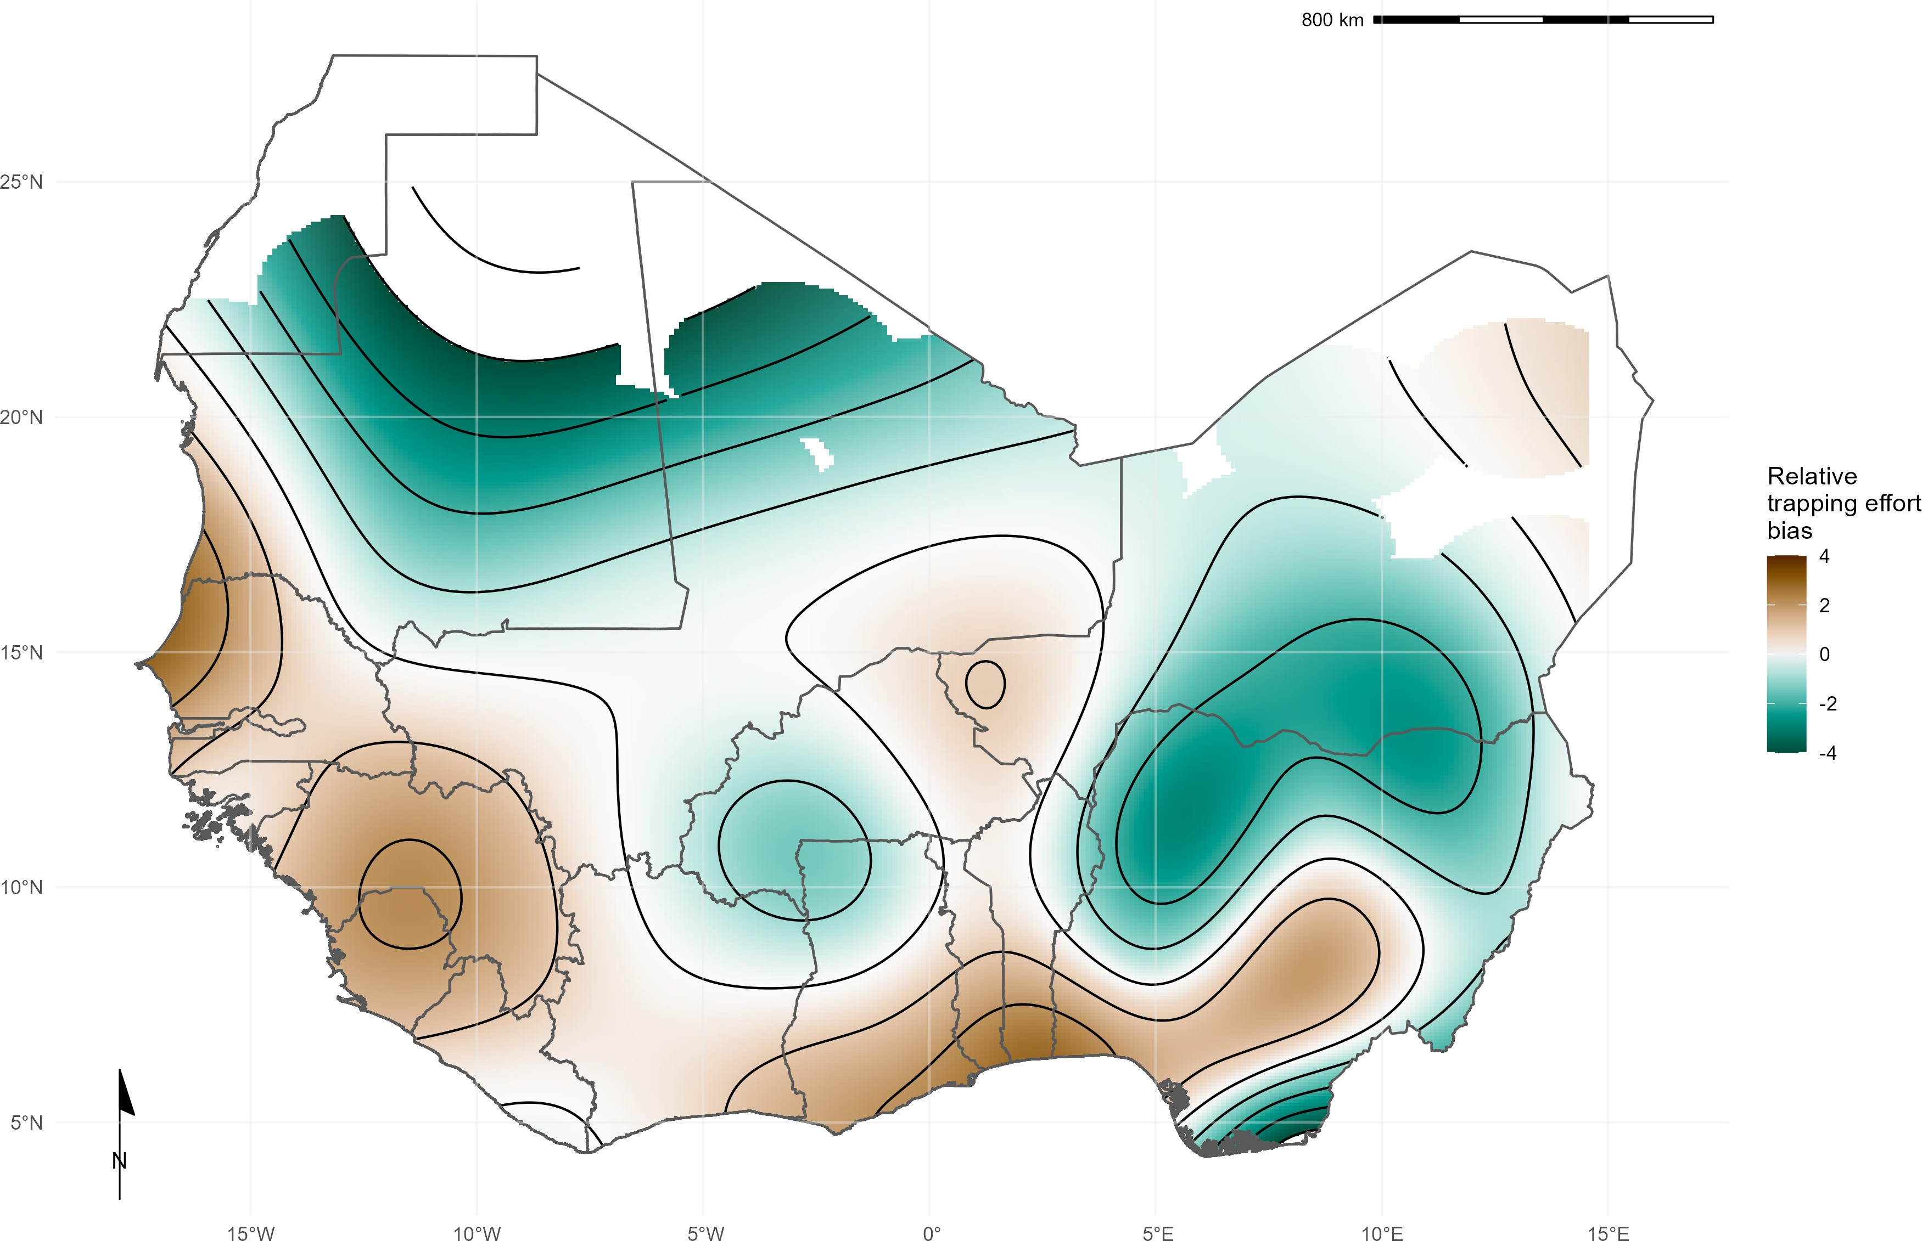

Figure 2.2: Relative rodent trapping effort bias across West Africa. Modelled relative trapping effort bias adjusted for human population density, proportion urban land cover and area of the administrative region. Brown regions represent areas with a bias towards increased trapping effort (e.g., North West Senegal), Green regions represent areas with a bias towards reduced trapping effort (e.g., Northern Nigeria). Basemap shapefile obtained from GADM 4.0.4 (GADM, 2022)

* + 1. What is the difference in rodent host distributions between curated datasets and rodent trapping studies?

We found that for six of the seven most frequently detected rodent species (*M. natalensis*, *R. rattus*, *M. erythroleucus*, *M. musculus*, *A. niloticus* and *P. daltoni*), trapping studies provided more distinct locations of detection and non-detection than were available from GBIF. For the endemic rodent species (*M. natalensis*, *M. erythroleucus*, *A. niloticus*, *P. daltoni* and *C. gambianus*) IUCN ranges had good concordance to both trapping studies and GBIF, however, individuals of *A. niloticus* and *P. daltoni* were detected outside of IUCN ranges. In contrast, the non-native species *R. rattus* and *M. musculus* were detected across much

greater ranges than were expected from IUCN distributions. Comparisons for *M. natalensis*, *R. rattus* and

*M. musculus* are shown in Figure [2.3](#_bookmark39).

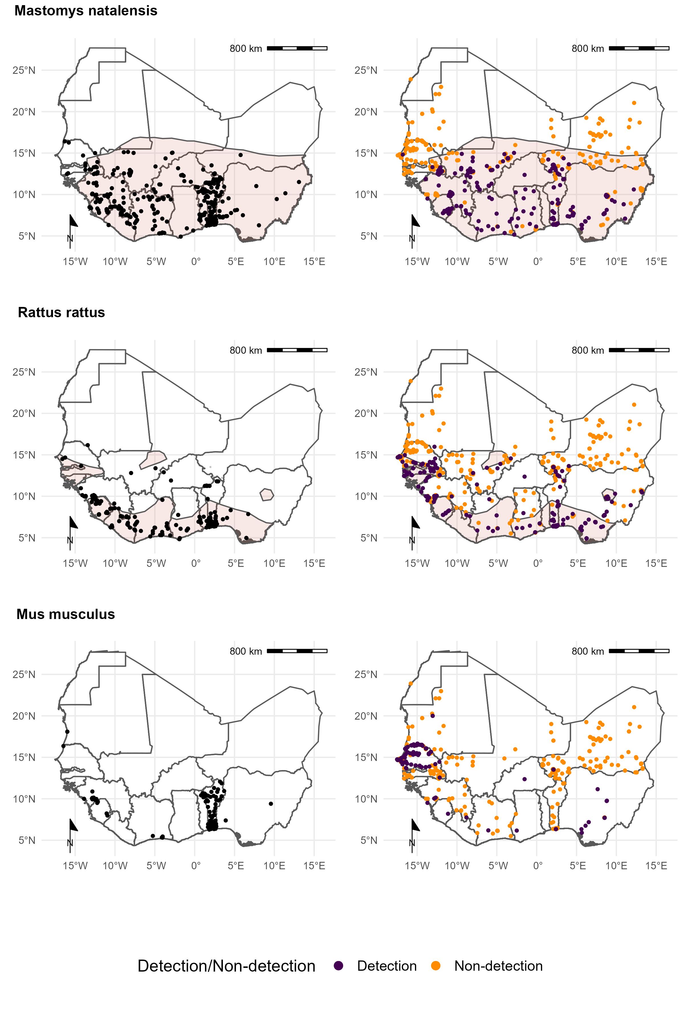

Figure 2.3: Locations of detection and non-detection sites for rodent species in West Africa. Each row corresponds to a single rodent species. L) Presence recorded in GBIF (black points) overlaid on IUCN species range (red-shaded area). R) Detection (purple) and non-detection (orange) from rodent trapping studies overlaid on IUCN species ranges. *M. musculus* has no IUCN West African range. Basemap shapefile obtained from GADM 4.0.4 (GADM, 2022)

Comparison of the proportion of a species IUCN range in which detections and non-detections occurred showed that sampling locations of these seven species within GBIF covered between 0.09-0.26% of expected ranges (Table [2.1](#_bookmark40)), compared to 0.03-0.24% for rodent trapping data. Detections occurred outside IUCN ranges for all species in both the GBIF and rodent trapping data, most noticeably for *A. niloticus* and *R. rattus*.Combining GBIF and rodent trapping data increased the sampled area by a mean of 1.6 times compared to the GBIF area alone, demonstrating limited overlap between the locations providing information to either dataset. Non-detection of a species occurred across species ranges (mean = 0.11%, SD = 0.03%), suggestive of spatial heterogeneity of presence within IUCN ranges.

Table 2.1: Comparison of IUCN, GBIF and rodent trapping ranges for 7 rodent species.

|  |  |  |  |  |  |  |  |  |  |  |  |
| --- | --- | --- | --- | --- | --- | --- | --- | --- | --- | --- | --- |
|  | IUCN |  |  | GBIF |  |  | Trapping studies |  |  | Combined |  |
| Species | Range |  | Area | Area |  | Area | Area | Non- |  | Detection |  |
|  |  |  | inside range | outside range |  | inside range | outside range | detection inside |  | area |  |
| *Mastomys natalensis* | 3,257 |  | 6.83 | 0.19 |  | 4.4 | 0.17 | 3.12 |  | 12.73 |  |

area range

|  |  |  |  |  |  |  |  |
| --- | --- | --- | --- | --- | --- | --- | --- |
|  | | (0.21%) |  | (0.14%) |  | (0.1%) | (0.33%) |
| *Rattus rattus* | 1,019 | 2.61 | 0.52 | 2.42 | 1.21 | 1.3 | 5.72 |
| *Mastomys erythroleucus* | 3,735 | (0.26%)  4.48 | 0.04 | (0.24%)  3.24 | 0.12 | (0.13%)  4.35 | (0.48%)  11 (0.2%) |
| *Mus musculusa* | NA | (0.12%) NA | 2.15 | (0.09%) NA | 1.85 | (0.12%) NA | 3.94 |
| *Arvicanthis niloticus* | 1,829 | 1.69 | 2.41 | 1.98 | 0.34 | 3.09 | 5.96 |
| *Praomys daltoni* | 2,658 | (0.09%)  4.03 | 0.29 | (0.11%)  2.03 | 0.15 | (0.17%)  2.78 | (0.2%)  8.21 |
|  |  | (0.15%) |  | (0.08%) |  | (0.1%) | (0.22%) |
| *Cricetomys gambianus* | 2,476 | 5 (0.2%) | 0.17 | 0.75 | 0.06 | 2.99 | 8.37 |
|  |  |  |  | (0.03%) |  | (0.12%) | (0.23%) |

*Note:*

Areas are reported in 1,000’s km2

% refers to percentage of a species IUCN range

a Mus musculus does not have an IUCN range in West Africa

* + 1. Are rodent trapping derived host-pathogen associations present in a consolidated zoonoses dataset?

We found potentially important differences between the host-pathogen networks produced from included rodent trapping studies and the consolidated CLOVER dataset. When limited to taxonomic classification of both pathogen and host to species level we identified 25 host-pathogen pairs among 14 rodent and 6 pathogen species (Figure [2.4](#_bookmark42) and Figure [2.5](#_bookmark43)). We identified negative associations (non-detection through specific assays) for 45 host-pathogen pairs among 35 rodent and 7 pathogen species. CLOVER contained 10 (40%) of our identified host-pathogen associations, the remaining 15 (60%) were not found to be present in CLOVER, additionally CLOVER recorded positive associations for 4 (9%) of the negative associations produced from the rodent trapping data.

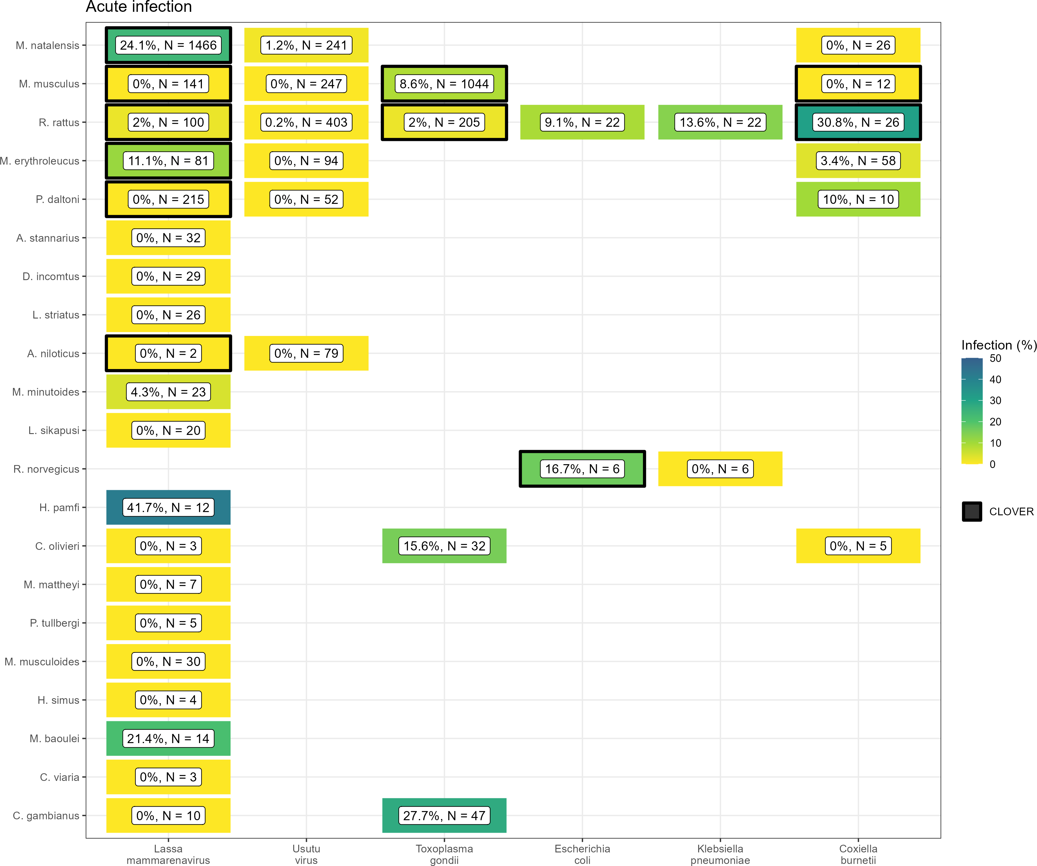

Figure 2.4: Host-Pathogen associations detected through acute infection. Identified species level host- pathogen associations through detection of acute infection (i.e. PCR, culture). Percentages and colour relate to the proportion of all assays that were positive, the number of individuals tested for the pathogen is labelled N. Associations with a black border are present in the CLOVER dataset.

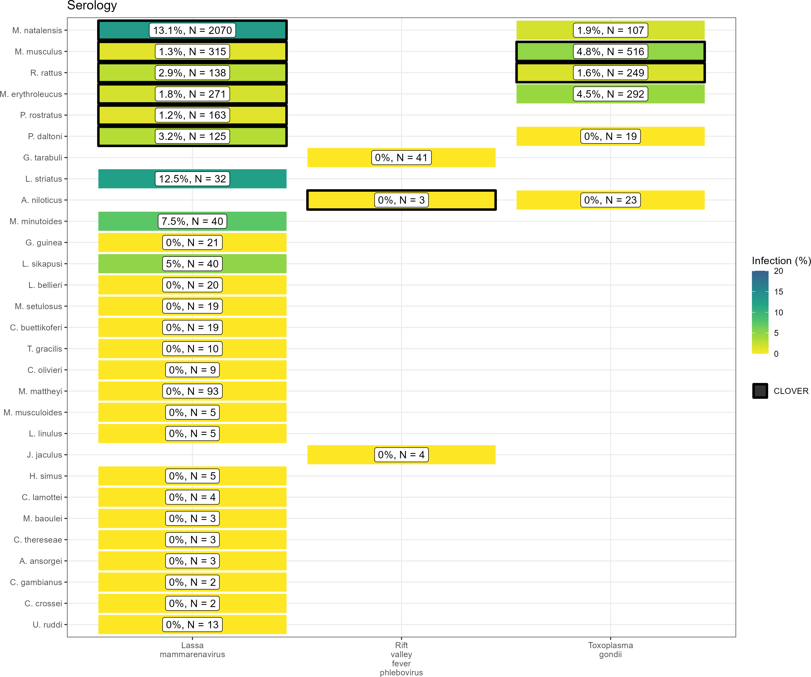

Figure 2.5: Host-Pathogen associations detected through evidence of prior infection. Identified species level host-pathogen associations through serological assays (i.e. ELISA). Percentages and colour relate to the proportion of all assays that were positive, the number of individuals tested for the pathogen is labelled N. Associations with a black border are present in the CLOVER dataset.

CLOVER included an additional 492 host-pathogen associations we do not observe in rodent trapping studies. The majority of these 392 (80%) pairs are from species with global distributions (*M. musculus*, *R. rattus* and *R. norvegicus*), or from those with wide ranging distributions in sub-Saharan Africa (38, 8%) (i.e., *A. niloticus*, *M. natalensis* and *Atelerix albiventris*).

For pathogens not identified to species level (i.e., family or higher taxa only), we identified 148 host-pathogen pairs among 32 rodent species and 25 pathogen families, with CLOVER containing 66 (45%) of these asso- ciations.

Rodent trapping studies identified additional rodent host species for six pathogens; *Lassa mammarenavirus*

(5), *Toxoplasma gondii* (4), Usutu virus (2), *Coxiella burnetii* (2), *Escherichia coli* and *Klebsiella pneumoniae*

(both 1), that were not present in this consolidated host-pathogen association dataset.

* + 1. What is the spatial extent of pathogen testing within a host’s range?

The five most widely sampled pathogen species/families in included studies were Arenaviridae, Borreliaceae, *Lassa mammarenavirus*, Leptospiraceae and *Toxoplasma gondii* (Table [2.2](#_bookmark45)). Assays to identify Arenaviridae infection were performed in 44 rodent species with evidence of viral infection in 15 species. *Lassa mam- marenavirus* was specifically tested for in 43 species with 10 showing evidence of viral infection. The most commonly infected species for both Arenaviridae, generally, and *Lassa mammarenavirus* specifically, were

*M. natalensis* and *M. erythroleucus*. These species were assayed across between 10-20% of their trapped area, equating to ~0.02% of their IUCN range.

Infection with species of Borreliaceae was assessed in 42 species, with evidence of infection in 17 rodent species. The greatest rates of infection were among *A. niloticus* (16%), *Mastomys huberti* (11%) and *M. erythroleucus* (9%). Testing was more widespread than for Arenviruses with coverage between 15-34% of their trapped area, however, this remains a small area in relation to their IUCN ranges (<0.05%). Leptospiraceae and *Toxoplasma gondii* was assessed in 8 species, with evidence of infection in 5 and 6 rodent species respectively. The spatial coverage of testing for these pathogens was more limited within IUCN host species ranges (~0.01%).

Table 2.2: Pathogen sampling among small-mammal host species.

Species Tested Positive Pathogen testing area

Percentage area within trapped area

Percentage area within IUCN area

|  |  |  |  |  |  |
| --- | --- | --- | --- | --- | --- |
| **Arenaviridae sp.**  *Mastomys natalensis* | 2,841 | 104 (4%) | 0.61 | 13.45% | 0.02% |
| *Praomys daltoni* | 854 | 6 (1%) | 0.42 | 19.43% | 0.02% |
| *Mastomys erythroleucus* | 398 | 20 (5%) | 0.40 | 11.97% | 0.01% |
| *Rattus rattus* | 396 | 4 (1%) | 0.38 | 10.5% | 0.04% |
| *Praomys rostratus* | 310 | 5 (2%) | 0.13 | 12.53% | 0.02% |
| **Borrelia sp.**  *Mastomys erythroleucus* | 1,586 | 140 (9%) | 1.14 | 33.94% | 0.03% |
| *Arvicanthis niloticus* | 1,551 | 253 (16%) | 0.66 | 28.48% | 0.03% |
| *Mastomys natalensis* | 733 | 54 (7%) | 0.69 | 15.08% | 0.02% |
| *Mastomys huberti* | 731 | 83 (11%) | 0.23 | 29.83% | 0.04% |
| *Mus musculus* | 686 | 26 (4%) | 0.45 | 24.54% | NA |
| **Lassa mammarenavirus**  *Mastomys natalensis* | 3,199 | 580 (18%) | 1.03 | 22.65% | 0.03% |
| *Mastomys erythroleucus* | 352 | 14 (4%) | 0.36 | 10.63% | 0.01% |
| *Rattus rattus* | 177 | 2 (1%) | 0.34 | 9.26% | 0.03% |
| *Praomys rostratus* | 163 | 2 (1%) | 0.27 | 27.02% | 0.04% |
| *Mus musculus* | 147 | 0 (0%) | 0.04 | 2.29% | NA |
| **Leptospira sp.**  *Rattus rattus* | 646 | 65 (10%) | 0.40 | 11.1% | 0.04% |
| *Arvicanthis niloticus* | 221 | 10 (5%) | 0.02 | 0.9% | <0.01% |
| *Crocidura olivieri* | 141 | 14 (10%) | 0.34 | 25.16% | NA |
| *Mastomys natalensis* | 136 | 26 (19%) | 0.36 | 7.91% | 0.01% |
| *Rattus norvegicus* | 79 | 19 (24%) | 0.21 | 40.08% | NA |
| **Toxoplasma gondii**  *Mus musculus* | 1,548 | 115 (7%) | 0.62 | 33.64% | NA |
| *Rattus rattus* | 428 | 8 (2%) | 0.36 | 9.77% | 0.03% |
| *Mastomys erythroleucus* | 292 | 13 (4%) | 0.37 | 11.06% | 0.01% |
| *Mastomys natalensis* | 107 | 2 (2%) | 0.08 | 1.83% | <0.01% |
| *Cricetomys gambianus* | 47 | 13 (28%) | 0.06 | 7.6% | <0.01% |

*Note:*

Areas are reported in 1,000’s km2

Mus musculus does not have an IUCN range in West Africa

##### Discussion

Endemic rodent zoonoses and novel pathogen emergence from rodent hosts are predicted to have an increasing burden in West Africa and globally ([Han *et al.*, 2015](#_bookmark277)). Here we have synthesised data from 126 rodent trapping studies containing information on more than 72,000 rodents, from at least 132 species of small mammals (Rodentia = 102, Soricidae = 28, Erinaceidae = 2), across 1,611 trap sites producing an estimated 942,669 trap nights from 14 West African countries. Locations studied are complementary to curated datasets (e.g., IUCN, GBIF), incorporation of our synthesised dataset when assessing zoonosis risk based on host distributions could counteract some of the biases inherent to these curated datasets ([Boakes *et al.*, 2010](#_bookmark164)). Most assayed rodents were not found to be hosts of known zoonotic pathogens. We identified 25 host-

pathogen pairs reported from included studies, 15 of these were not included in a consolidated host-pathogen dataset. Generally, the number of different species tested for a microorganism and the spatial extent of these sampling locations were limited. These findings highlight a number of sampling bias, supporting calls for further microorganism sampling across diverse species in zoonotic hotspots ([Harvey and Holmes, 2022](#_bookmark283)).

We found that rodent trapping data, like biodiversity data, showed important spatial biases ([Beck *et al.*,](#_bookmark156) [2014](#_bookmark156)). Relative trapping effort bias was greater in Benin, Guinea, Senegal and Sierra Leone driven by long-standing research collaborations investigating the invasion of non-native rodent species (*M. musculus* and *R. rattus*) and the hazard of endemic zoonosis outbreaks (e.g., *Lassa mammarenavirus*). In addition to identifying point locations of prior rodent and pathogen sampling (Figure [2.1](#_bookmark28)), additional information on the trapping effort (density of trap-nights), human population density and land use type have been incorporated to produce a value of relative effort that will assist researchers in identifying specific locations where predictions based on these underlying data sources may suffer from effects of sampling bias. This approach improves the ease of identifying under sampled locations, for example, Figure [2.1](#_bookmark28) may suggest that South East Senegal, Southern Mali and Southern Niger are well sampled based on locations of trapping sites. When the number of trap nights, human population density and land use of these regions are taken into account (Figure [2.2](#_bookmark37)) and compared with better sampled locations (i.e., Western Senegal, Eastern Sierra Leone) these areas are found to be relatively under sampled and would benefit from further sampling effort. This contrasts to North West Nigeria where no trapping has occurred (Figure [2.1](#_bookmark28)), our modelling approach has perhaps highlighted this region as an immediate priority for sampling of rodents and their pathogens given high human population densities and a human dominated landscape.

Much of West Africa remains relatively under sampled, particularly Burkina Faso, Côte d’Ivoire, Ghana and Nigeria, despite these countries facing many of the same challenges. For example, annual outbreaks of Lassa fever are reported in Nigeria and there are potentially 60,000 unrecognised cases of Lassa fever every year in Côte d’Ivoire and Ghana ([Basinski *et al.*, 2021](#_bookmark153)). Our estimates of the proportion of a rodent species range that have been sampled, along with pathogen testing within their sampled range, are sensitive to our choice of raster cell size. Smaller area cells will reduce the reported coverage while larger cells will have the opposite effect. Despite this, the observed patterns are unlikely to importantly change, with the finding of sparse sampling of both rodents and their pathogens remaining present across cell scales. Rodent sampling should be targeted towards currently under sampled regions to reduce the potential impact of current biases and improve our understanding of both the distribution of rodent hosts and the prevalence of pathogens within their populations. This will allow for better estimation of risk from endemic and novel zoonoses.

Rodent trapping studies provide geographic and temporally contextualised data on both species detection

and non-detection which are not available from curated datasets. Non-detection data can improve models of species distributions, unfortunately, high levels of missing data on trapping effort will continue to confound the allocations of non-detections as true absences ([Václavík and Meentemeyer, 2009](#_bookmark479)). Models of host species occurrence and abundance, improved by incorporating species absence, are important to assess the effect of land use and climate change on endemic zoonosis spillover to human populations and direct limited public health resources towards regions at greatest risk ([Zeimes *et al.*, 2012](#_bookmark515); [Judson *et al.*, 2018](#_bookmark311)).

Currently available consolidated datasets on host-pathogen associations (e.g., CLOVER, EID2 and GMPD2) do not include spatial or temporal components ([Gibb, Albery, Becker, *et al.*, 2021](#_bookmark252)). The current synthesis of rodent trapping studies has highlighted that pathogens have been sparsely sampled within a host’s range. Current zoonosis risk models dependent on these sources of data are therefore not able to incorporate spatial heterogeneity in pathogen prevalence across the host range. Additional uncertainty in current models of zoonotic disease risk arises from host-pathogen associations that have not been reported in these consolidated datasets. For example, *Hylomyscus pamfi* infected with *Lassa mammarenavirus* and *R. rattus* infected with *Coxiella burnetii*, will not be included when solely based on consolidated host-pathogen datasets. Further, detection of zoonotic pathogens in multiple, co-occurring, host species supports the adoption of multi-species approach to better understand the potential range of endemic zoonoses ([Wilkinson *et al.*, 2019](#_bookmark495)).

Few studies stratified detection and non-detection of hosts or pathogen prevalence by time, therefore limiting inference of temporal changes in host and pathogen dynamics. This limitation prevents calculation of inci- dence of infection and the abundance of infectious rodents which potentially varies by both time and space ([Fichet-Calvet *et al.*, 2016](#_bookmark234)). Understanding temporal changes in viral burden and shedding for endemic zoonoses is required to accurately predict current and future risk of pathogen spillover.

Finally, due to data sparsity, we were unable to account for temporal change over the six decades of rodent trapping studies. Land use change and population density have changed dramatically over this period in West Africa ([Herrmann *et al.*, 2020](#_bookmark288)). We attempted to mitigate against this by using the median year of trapping to understand the spatial and land use biases in trapping activity. It is possible that land use and population density at trapping sites varied importantly between when rodent trapping was conducted and the conditions in 2005. Despite this limitation, the finding that trapping is biased towards high density, human dominated landscapes is unlikely to substantially change.

We have shown that synthesis of rodent trapping studies to supplement curated rodent distributions can counteract some of the inherent biases in these data and that they can add further contextual data to host- pathogen association data. Together this supports their inclusion in efforts to model endemic zoonotic risk

and novel pathogen emergence. Contribution of rodent trapping studies as data sources can be improved by adopting reporting standards and practices consistent with Open Science, namely sharing of disaggregated datasets alongside publication ([Foster and Deardorff, 2017](#_bookmark240)).

Future rodent trapping studies should be targeted towards regions that are currently under-studied. Further information on rodent presence and abundance across West Africa will aid the modelling of changing endemic zoonosis risk and the potential for novel pathogen emergence. Sharing of disaggregated data alongside research publications should be promoted with adoption of data standards to support ongoing data synthesis. Specifically, inclusion of exact locations of trapping sites, trapping effort and the dates at which trapping occurred would support more detailed inference of the spatio-temporal dynamics of host populations and the risk of endemic zoonosis spillover events. Despite these challenges we propose that rodent trapping studies can provide an important source of data to supplement curated datasets on rodent distributions to quantify the risk of endemic zoonosis spillover events and the hazard of novel pathogen emergence.

## Designing and implementing a longitudinal rodent trapping study to investigate rodent community structures along a land use gradient in Eastern Sierra Leone

##### Preface

Unbiased estimates of small-mammal species presence and absence are required to model the association of species occupancy with land use type ([Peterson *et al.*, 2011](#_bookmark424); [Stolar and Nielsen, 2015](#_bookmark464)). Available rodent trap- ping data from the Eastern Province of Sierra Leone was not amenable to these analyses, as rodent sampling has generally been conducted as opportunistic surveillance to measure LASV prevalence or for cataloguing rodent species as part of environmental impact assessments for resource extraction or construction ([Fraser](#_bookmark242) [*et al.*, 1974](#_bookmark242); [Monath *et al.*, 1974](#_bookmark388); [Keenlyside *et al.*, 1983](#_bookmark316); [Barnett *et al.*, 2000](#_bookmark152); [Bonner *et al.*, 2007](#_bookmark167); [Decher,](#_bookmark207) [Norris and Fahr, 2010](#_bookmark207)). Therefore, I designed and implemented a longitudinal rodent trapping study to investigate whether rodent species richness and diversity vary along a land use gradient (results reported in Chapter [4](#_bookmark66)) and whether rodent species involved in LASV transmission have increased contact rates to other individuals capable of pathogen maintenance (results reported in Chapter [5](#_bookmark98)).

This methodology chapter draws on current best-practice in small-mammal sampling in West Africa in addition to reporting novel methodological developments. Specifically, this chapter provides 1) information about how local support and knowledge were leveraged to inform the design of the study protocol and 2) technical details on the sampling strategy, data collection tools, biological sample processing, data cleaning and management steps. It is envisioned that documenting and providing evidence for decisions taken in designing this study will aid in the harmonisation and reproducibility of rodent trapping studies across the region.

##### Leveraging local support and knowledge

For any rodent trapping study in village communities, it is vital to ensure that local communities support the study. This is particularly important for longitudinal studies with repeat visits. I was aware that study activities could be associated with stigma (i.e., sampling wildlife for viral pathogens); it was therefore important that study villages considered this prior to providing permission for us to begin sampling. To optimise the continuing support received from the local communities, the study protocol was described in detail to the local chieftain and the village committee. All concerns about the risk to the local community from our activities and the impact we may have on their activities were addressed and we committed to

employing community members during our sampling activities. An exit interview was scheduled where we shared our findings with the villages (conducted in February 2023). During these interviews, we explored the positive and negative impact of our sampling activities. All villages reported no adverse effects of our trapping activity and were keen to continue in the study, were additional funding to be acquired.

In addition, data on local LASV outbreaks are sparse. Therefore, the local communities have vital knowledge of lived experience of potential LASV outbreaks that may not be captured by the scientific literature or public health agencies. Given the sparsity of data in the Eastern Province of Sierra Leone, drawing on the knowledge of local leaders helped to guide the design of the study protocol.

##### Study design

This was a longitudinal rodent trapping study with repeated measurements nested within different land use types, nested within villages.

* + 1. Study duration

The study was designed to be conducted over 3 years (the duration of the PhD funding). This study duration was expected to yield a suﬀicient sample size for the planned analyses (not time-varying), based on previous research in the same country. Delays to the start of the project due to COVID-19 travel restrictions resulted in a shortened timeline of two-and-a-half years.

* + 1. Sampling frequency

With regards to the sampling frequency over the 3-year study period, we opted for quarterly sampling (i.e., four times annually). This was guided by several factors. First, this study was designed in the context of investigating LASV transmission, where high intensity sampling is required to ensure detection of transmis- sion were it to occur. LASV virus is expected to be cleared 40 days post-infection. Therefore, substantially longer periods between sampling activities could result in transmission episodes being missed ([Safronetz *et*](#_bookmark441)[*al.*, 2022](#_bookmark441)). In addition, the lifespan of rodents in these settings is less than one year. Therefore, longer time periods between visits could result in a different population of rodents being sampled than those that were alive at the time during pathogen transmission ([Leirs, Verhagen and Verheyen, 1993](#_bookmark337); [Safronetz *et al.*, 2022](#_bookmark441)).

Second, data from Guinea and Nigeria suggest a strong seasonal component to LASV incidence among rodents and humans ([Fichet-Calvet *et al.*, 2007](#_bookmark232); [Olayemi *et al.*, 2016](#_bookmark406)). Importantly different pathogen prevalence between the rainy and dry seasons was thus expected and meant that estimates of prevalence were needed from multiple time points during the year.

Finally, as trapped rodents were euthanised and removed from the population, we did not want to affect the population structure of the small-mammal communities studied. Quarterly sampling was therefore used to balance the conflicting demands of detecting transmission and not substantially altering the studied population. This was considered an appropriate balance based on a study investigating the impact of removal trapping on rodent abundance and population dynamics in Guinea, which suggested rebound of rodent populations over short time periods ([Mariën *et al.*, 2019](#_bookmark362)).

* + 1. Sampling strategy

Next, we considered the sampling strategy required for obtaining unbiased estimates of rodent occurrence and abundance. Particularly important is the selection of the sites to sample rodents from (e.g., traps nested within trap grids set in different land use types, nested within villages) and the sampling effort (i.e., number of traps and trap nights) at each site ([Stolar and Nielsen, 2015](#_bookmark464); [Stryjek, Kalinowski and Parsons, 2019](#_bookmark466)). The following section outlines the rationale for the village, grid and trap site selection and the respective sampling effort.

* + 1. Village selection

Lassa fever is endemic in the Eastern Province of Sierra Leone, with the area surrounding Kenema consid- ered to have the greatest incidence of human infection ([Kelly *et al.*, 2013](#_bookmark320)). However, data on the village locations of incident infections are largely undocumented ([Shaffer *et al.*, 2021](#_bookmark450)). To better understand the local epidemiology of Lassa fever, I met with the provincial Paramount Chief and regional elders, in addition to the chief medical oﬀicer at a local hospital (Panguma District Hospital), which covers a large rural catch- ment area. These meetings aimed to identify villages that had previously experienced Lassa fever outbreaks (not necessarily documented by public health authorities) in addition to locations where no outbreaks had been experienced. The selection of villages with experienced and no experienced outbreaks was considered important to ensure that we were not conditioning the sampling based on expected Lassa fever incidence. This led to the inclusion of two villages where Lassa fever had not previously been experienced (Seilama and Baiama) and two villages where it had been experienced (Lalehun and Lambayama).

* + 1. Trapping grids within different land use types

To estimate the occurrence of rodent species along a land use gradient in our study region, we aimed to conduct rodent trapping representative of the main land use types in Eastern Province, Sierra Leone. Land use types were grouped into villages/urban, agriculture, and forest. We therefore discounted water, marsh, and shrub land in our study. Land use type rasters of the region were produced from remote sensing data and

were ground-truthed to field observations ([Jung *et al.*, 2020](#_bookmark313)). Remote sensing data has several limitations in this region of West Africa. First, the transient nature of agriculture practices in the region (i.e., slash- and-burn) makes it challenging to train classification models to identify land used for agriculture, when compared to classification in regions with industrialised agricultural practices ([Thenkabail, 1999](#_bookmark473); [Kusimi,](#_bookmark329) [2008](#_bookmark329)). Second, mixed use of land within the region (e.g., crops interspersed within plantations or plantations in forest settings) can lead to the misclassification of land use based solely on remote sensing ([Alabi *et al.*,](#_bookmark137) [2022](#_bookmark137)). Finally, cloud cover in the region limits the number of satellite images that can be aggregated for a defined location, thus impacting the sensitivity of classification. Therefore, a combination of remote sensing and ground-truthed observations were used to select trap grids representative of forest, agriculture, and village land use. To approximate representativeness of trapping effort weighted to the area of these different land uses and human activity within them, we opted for the following setup at each of the four selected villages: a single grid in forest, four grids in agriculture (two in settings proximal to the village and two in more distal locations) and two within the villages (one in outdoor and one in indoor settings).

The selection of exact trap grid locations within the villages was guided by several factors. First, it was important that the trapping grids could be accessed in all weather conditions. Sierra Leone has a dry and a rainy season, with substantial amounts of precipitation in the rainy season degrading roads and tracks. This makes access to remote sites challenging during the rainy season. Second, areas of forest around villages may be locations of special community importance, such as gravesites or locations of ceremonies for secret societies ([Lebbie and Guries, 1995](#_bookmark332); [Martin *et al.*, 2011](#_bookmark366); [Ménard, 2017](#_bookmark377)). The selection of trap grids was therefore conducted in close collaboration with the local communities, to ensure that sites would be accessible throughout the study period. Finally, due to the transient nature of farming practices in the region, it was important to ensure that trap grids would not be converted to different land use types during our study (e.g., conversion of forest to agriculture or agriculture left to fallow). We therefore discussed the locations of planned trap grids with the local communities to ensure these locations were not identified for significant land use conversion.

* + 1. Structure of trap grids and trap locations

Once the trap grid sites had been selected, the structure of the grids placed within these locations must be chosen. Trap lines, trap grids, trap webs, and sporadic placement of traps have all been previously used in published rodent trapping studies. In the present study, it was important that the local habitats for each individual trap did not substantially vary within a single land use type. This meant that trap lines (which often span multiple land use types due to their length) were not considered appropriate. In addition, as

we aimed to infer contacts between individually trapped rodents based on the proximity of the locations at which they were detected, it was key that trapping effort was evenly distributed across the entire area of the trap grid. This meant that trap webs were not considered appropriate. We therefore opted for a cartesian trap grid structure.

To allow comparison between sampling at grid sites during repeated visits, the GPS coordinates of the outer boundaries of the trapping grid were recorded with a Garmin GPSMAP 66i.

* + 1. Trapping effort

The number of individual traps placed within a grid constitutes one aspect of the trapping effort. In the present study, the number of traps per grid was governed by practical rather than scientific considerations, including the number of available traps in the study team’s possession and the time requirement to setup, record and bait the traps for the local study team. A total of 49 traps per grid (7 by 7 traps) was selected. Individual traps within each grid were placed approximately 7m apart, with a view to sampling an area of 2,401m2 within each grid. It was not feasible to ensure that individual traps were placed at the exact locations of traps at previous visits.

Finally, the number of trap nights to be conducted at each village was selected following a review of the rodent trapping studies identified in Chapter [2](#_bookmark21). Studies typically reported 1-4 trap nights conducted at each location, following discussions with the local study team four nights were selected as optimal.

* + 1. Trap type selection

Commercial rodent traps were selected for use over locally produced traps. An important consideration was to ensure the ethical handling of captured rodents. Typically, locally produced traps would take the form of “snap-traps”. These aim to incapacitate a trapped rodent with a spring powered mechanism that breaks the neck of the rodent triggering the trap. However, these traps can injure the individual rather than killing them, which could result in prolonged suffering for the trapped rodent ([Hice and Velazco, 2013](#_bookmark289)). Further, as opposed to commercially produced traps, the sensitivity of the trap triggering mechanism within locally produced traps cannot be standardised, which could result in differences in the sensitivity of each trap, leading to different capture rates across individual traps ([Nicolas and Colyn, 2006](#_bookmark402)). Commercially produced traps allow the sensitivity of closure mechanisms to be altered in the field if it is noticed that the traps are not functioning as required. Finally, commercial live-capture traps do not aim to kill the trapped rodent, which allowed us to adopt humane methods of rodent killing (i.e., cervical dislocation after anaesthesia), although arguments have been made that confining individual rodents within a trap only to later euthanise them is

less ethical than a quick death through a well functioning snap-trap ([Nattrass, Stephens and Loubser, 2019](#_bookmark398)).

Next, the selection of a specific design of commercial rodent trap impacts the detection of species. For example, the size of the trap may prevent larger rodents, such as squirrels, entering the trap and being caught ([Harkins, Keinath and Ben-David, 2019](#_bookmark282)). We therefore selected the dimensions of the traps based on our target population of rodents and shrews (7.62cm x 8.89cm x 22.86cm). Commercial traps may be designed for single capture or multiple capture. We were interested in assaying trapped rodents for evidence of acute infection; it was therefore important that we did not allow individuals to come into contact under conditions in which viral transmission could occur. To prevent this, we selected single capture traps. Several commercially available traps met these requirements; however, Sherman traps were selected after reviewing the studies identified in Chapter [2](#_bookmark21), as these were the most commonly used commercial traps in West Africa. In addition, the study team already had access to a substantial number of Sherman traps and replacement parts, thus reducing the resource needed for the traps. Local expertise in using Sherman traps already existed, which eased the implementation of the study protocol. An additional advantage of the Sherman traps was the ease at which they could be decommissioned during the day and activated at night to prevent unintended captures.

* + 1. Bait type selection

The composition of bait used within traps will impact the species of small mammals trapped. No studies in dietary preference have been conducted within the rodent and shrew communities of Sierra Leone. However, data from other locations in sub-Saharan Africa are available for *M. natalensis*, *R. rattus* and *M. minutoides*, in both wild and captive populations. The studies report a preferential consumption of raw crops, insects, and processed foods, with processed food contributing a substantial proportion of the diet when individuals are detected within human households ([Iwuala, Braide and Maduka, 1980](#_bookmark302); [Mbise, Kilonzo and Kinabo, 1995](#_bookmark372); [Odhiambo *et al.*, 2008](#_bookmark404); [Mulungu *et al.*, 2014](#_bookmark391); [Mlyashimbi *et al.*, 2018](#_bookmark383)).

Previous studies conducted in the region did typically not describe the composition of bait placed in traps. Where reported, bait that has been shown to be effective in the region include combinations of peanut paste, palm oil and dried fish ([Fichet-Calvet *et al.*, 2005](#_bookmark230); [Mariën *et al.*, 2017](#_bookmark361); [Bonwitt *et al.*, 2017](#_bookmark168)). During the piloting of the study protocol, I compared the trap success using a bait comprised of peanut paste, palm oil and dried fish with one of peanut paste, palm oil and goat meat. No difference in trap success was observed between these two baits and so dried fish was used throughout the remainder of the study. Bait ingredients were purchased locally at each study site and combined following a standard recipe (10 parts peanut paste, 1 part palm oil, 1 part dried fish). Traps were re-baited each day to ensure the amount of bait within the

trap was equivalent between trap nights.

This bait also attracted insects and off-target animals (e.g., frogs) to the traps. Off-target species were released at the site of the trap during the re-baiting process. Insects attracted to the traps likely had an impact on the detection of insectivorous shrew species within our study region (i.e., *Crocidura sp.*). Shrew species were not considered off-target small mammals as the spatial interaction between these species and rodents within our study setting was expected to alter rodent species occurrence. Previous studies have shown that shrews are potentially infected with LASV, although their ability to maintain transmission is not known ([Fichet-Calvet *et al.*, 2007](#_bookmark232); [Kerneis *et al.*, 2009](#_bookmark323); [Kenmoe *et al.*, 2020](#_bookmark322)). Therefore, sampling shrew populations in conjunction with our rodent primary targets would improve understanding of the structure of the small-mammal community potentially involved in LASV transmission.

A further consideration in the selection of bait is the availability of alternative food sources within the environment of the trap. For example, in areas of human habitation or agricultural settings, the high availability of alternate food sources may lead to a reduced need for rodents to enter traps, overcoming their fear of novel environments (i.e., neophobia) ([Stryjek, Kalinowski and Parsons, 2019](#_bookmark466)). We did not measure the availability of alternate food sources and so were unable to disentangle the potential impact of this on the probability of detection of a rodent within a trap.

* + 1. Implementation of sampling strategy

To ensure the study protocol was implemented as intended, a trap-check form was set up to facilitate rapid entry of the status of each trap the morning after each trap night. The form was used to record whether traps were missing bait (i.e., the sensitivity of trap closure was too low), were closed but empty (i.e., the sensitivity of trap closure was too high) or contained a small-mammal or other animal.

##### Data collection, storage, and processing

Data collected in the field were recorded in real-time. Initially, paper data entry forms were used. These forms were trialled during the pilot and improved following feedback from the field team. The forms required digitisation, which could lead to data entry errors and delays in reviewing for accuracy and completeness. To counter this and allow for remote support in data entry, a digital data capture tool was subsequently adopted. The OpenDataKit (ODK) is an open-source software that has been constructed to support offline data entry through powerful forms and allow multi-media data entry, including photos ([Open Data Kit,](#_bookmark412) [2023](#_bookmark412)). The ability to store data locally when offline for it to be subsequently uploaded to dedicated servers when a network connection is found is particularly valuable when conducting research in remote regions.

The data entry forms could be completed on any smart device. Initially, the field team was provided with tablets. However, they preferred to use their own smartphones for data entry as these were more portable and faster to use. The forms were accessed through a mobile ODK application (ODK Collect) with users given access to the forms required for their role ([ODK Collect, 2023](#_bookmark405)). Data were encrypted locally after form completion and sent securely to an ODK Central server hosted by the London School of Hygiene and Tropical Medicine. Data were then downloaded from this server using the ruODK R client for the ODK Central API ([Mayer, 2023](#_bookmark371)). The instant availability of data allowed real-time support to the field team to be provided.

Data on the following measures were obtained from all trapped rodents and shrews: age group, sex, mor- phological measures, biological measures, and the precise location of where the individual was trapped. Additional detail about the morphological and biological measures and the precise location of where the individual was trapped is provided below.

* + 1. Morphological measures

Data were obtained for all individuals on standard morphological measurements including weight and length of body, head, ear, hind foot and tail, in addition to the sex and reproductive status of individuals. These measurements, alongside more general characteristics, including pelage colour supported classification using the produced taxonomic key (Appendix [B.5](#_bookmark533)). Morphological measurements and reproductive status were also used to age stratify individuals into juvenile or adult age classes. Eye lenses were obtained from rodents with the aim to further classify by age using standardised eye-lens weight growth charts for species where this was available ([Hardy, Quy and Huson, 1983](#_bookmark281); [Fichet-Calvet *et al.*, 2008](#_bookmark231)).

Several rodent and all shrew species were not able to be differentiated based on the taxonomic key; for these species, additional molecular identification was required. Sequencing of Cytochrome b has previously been used for rodent and shrew species in West Africa and has been shown to be able to discriminate between these cryptic species ([Bradley and Baker, 2001](#_bookmark178); [Lecompte *et al.*, 2002](#_bookmark334)). While some rodent species could be unambiguously classified using the taxonomic key, molecular sequencing was performed on all individuals to improve confidence in field-based identification and reduce the impact of misclassification on subsequent analysis.

* + 1. Biological measures

Biological samples (i.e., blood, tissue) were collected following established protocols for rodents and shrews ([Mills *et al.*, 1995](#_bookmark381); [Fichet-Calvet, 2014](#_bookmark228)). Blood sampling was performed through cardiac puncture, as captured individuals had been euthanised. Cardiac puncture is expected to result in greater volumes of

blood sampled compared to non-lethal techniques, such as capillary eye blood and tail vein sampling ([Mills](#_bookmark381) [*et al.*, 1995](#_bookmark381)). However, for very small individuals, cardiac puncture can result in insuﬀicient volumes of blood. Therefore, for very small individuals (those that weighed <=10g), we collected blood on filter paper and obtained heart tissue samples. Filter paper samples have lower sensitivity for antibody and viral detection, which may be related to methods of elution from the filter paper ([Amini *et al.*, 2021](#_bookmark143); [Soubrier *et al.*, 2022](#_bookmark462)). This could result in systematic biases in detection of antibodies and virus in samples from low body weight.

Samples were stored in appropriate storage media (i.e., formalin or ethanol) and placed in cool boxes on ice packs to maintain a cold chain. Ideally, samples would be stored in liquid nitrogen at the point of processing; however, this was not feasible, as liquid nitrogen is not readily available in Sierra Leone. To reduce the time that samples were stored outside of an effective cold chain, we partnered with Panguma District Hospital and Kenema General Hospital to store samples in -20°C freezers at the end of each sampling day. Long term storage of samples was within our local collaborator’s lab, located in Mercy Hospital, Bo. At Mercy Hospital, back-up power banks were able to maintain a cold chain during the daily episodes of disrupted electricity supply. However, at several points during our study, municipal power was not available for prolonged periods. It is likely that this led to samples temporarily increasing above -20°C, although it is not expected that this would have a significant impact on the degradation of antibodies during the short period they were stored prior to analysis ([Amini *et al.*, 2021](#_bookmark143)). However, sample degradation may limit the possibility of these samples being re-used in future work.

All sample processing and analysis (i.e., LASV serology and Cytochrome b PCR) was conducted in-country within Sierra Leone. The final stage of the analysis pipeline could not be conducted in Sierra Leone, as there were no available Sanger sequencing machines. Therefore, following sample processing, the PCR products were shipped to Germany for sequencing. Conducting all laboratory analysis in Sierra Leone was a deliberate choice to improve local ownership of the research project and to consolidate the knowledge and skills of the local workforce in the processing of biological samples. In addition, where possible, students from local higher education institutes were included in the steps of sample analysis to improve training. All samples remain in Sierra Leone for future use by the local research community and international collaborators.

* + 1. Trap locations

A trap setup form collected information on the environmental conditions of specific traps and their GPS coordinates. Photographs were used to document the habitat type where it did not meet the pre-specified options in the data collection tool.

The detection of rodents at trap locations in the presence of imperfect detection were used to model occupancy

of small-mammal species across a land use gradient, as described in Chapter [4](#_bookmark66). The probability of detection of a species were it to be present within a land use type was not expected to be constant across repeated study visits ([Springer *et al.*, 2016](#_bookmark463)). For example, changes in rodent activity would alter the probability of detection. To account for this we collated data on factors that could contribute to differences in the rate of detection (i.e., light level, precipitation and trapping effort). Rodents and shrews have been found to have variable activity in different conditions of ambient light in response to predation pressure ([Paise and Vieira,](#_bookmark415) [2006](#_bookmark415); [Williams *et al.*, 2014](#_bookmark497)). We were unable to accurately measure ambient light levels at individual trap locations during the sampling period and therefore used a proxy measure of moon fraction (i.e., proportion of full moon) to approximate ambient light levels. This approach may not adequately measure light level at the exact time and locations of rodent activity. Particularly, within forests light levels may be lower than in agriculture due to cover by foliage. Increased cloud cover during the rainy season may also have impacted ambient light levels compared to the dry season where higher ambient light levels may occur at ground level.

Data cleaning was performed to correct inaccuracies in data entry, including missing data. Most data inaccuracies were related to the entry of GPS coordinates, which could be remedied by asking the field team to take photographs of the GPS recorder. Other common errors included misallocating study grid numbers or visit numbers, which could be corrected using other sources of information (i.e., coordinates of traps or date of form entry).

To support subsequent spatial analysis of the trapping data, individual traps were aggregated within grid cells. We constructed a regular grid across the trapping grids, with each cell measuring 49m2. Individual traps were allocated to a single cell with the centroid of these cells providing a standardised location of traps placed within the cells. Where multiple traps were placed within a single cell, the traps were aggregated (Appendix [B.4](#_bookmark531)).

To facilitate the data cleaning, scripts were written in R. This allowed the original data to remain unmodified while also producing a reproducible and automated data cleaning pipeline. All code to perform data cleaning are available in a GitHub repository that reproduces the data used for analysis from the raw data uploaded to ODK Central ([Simons, 2022d](#_bookmark456)). Finally, the availability of this R code and data entry forms can be used by other researchers to aid data collection in small-mammal sampling studies.

##### Conclusion

This chapter summarises the decisions taken to design the longitudinal rodent trapping study that generated the data for the remaining chapters. I have described the steps in selecting the traps, bait and locations

in which the study was conducted alongside considerations in making these decisions. I go on to describe approaches taken throughout to improve confidence in generated data and to produce a transparent pipeline from data acquisition through to data analysis.

## Land use gradients drive spatial variation in Lassa fever host communities in the Eastern Province of Sierra Leone.

##### Preface

I conceived of the study with Richard Kock, Deborah Watson-Jones and Kate E. Jones. I designed the rodent trapping methodology, study protocol and formulated the data collection tool. I designated the locations of the rodent trapping grids, compiled the taxonomic keys and trained the local fieldwork collaborators on the study processes. The local fieldwork team, including Dianah Sondufu, Joyce Lamin, Michael Dawson, Momoh Jimmy and James Koninga conducted repeat sampling at previously designated locations under my direct and indirect supervision. Umaru Bangura trained me on the molecular identification of rodent and shrew species and provided remote support to this work conducted in Sierra Leone. I trained Joseph Lahai in Sierra Leone on DNA extraction from rodent and shrew samples and he prepared samples for sequencing under my direct and indirect supervision. I performed statistical analysis and interpreted model outputs with support from Rory Gibb. I received support for my work in Sierra Leone from Rashid Ansumana. I wrote this chapter and Rory Gibb, Richard Kock, Deborah Watson-Jones and Kate E. Jones contributed to and approved the final version.

This chapter in modified format is being prepared for submission to a peer-reviewed journal.

##### Abstract

The natal multimammate mouse (*Mastomys natalensis*) is the reservoir host species of the zoonosis, Lassa fever (*Lassa mammarenavirus*). The spatial occurrence and abundance of this rodent species is regulated by the human environment and biotic interactions within small mammal communities. However, little is known about these effects even in highly endemic areas of Lassa fever. Here, we conducted a rodent trapping study in a Lassa endemic region within the Eastern Province, Sierra Leone to understand how *M. natalensis* is distributed across a gradient of landuse types and how its distribution may be influenced by the small mammal community structure. Using data from 43,226 trap nights from four village sites between 2020- 2023, we developed a Bayesian multiple species occupancy model, accounting for imperfect detection, to show that, locally within study sites, *M. natalensis* occupancy increased along a gradient from less to more human dominated habitats (i.e., from forest through agriculture to village), but that this effect did not hold at broader spatial scales, with lower occupancy in peri-urban than rural study sites. Interactions with invasive rodent species within the small mammal community appeared to regulate the occupancy of *M. natalensis*, with the presence of *Mus musculus*, but not *Rattus rattus* associated with a reduced probability of occupancy

of *M. natalensis*. This finding may help to explain prior observations of lower-than-expected human cases of Lassa fever from urban settings in endemic regions. Our findings highlight that land use drives spatial heterogeneity in rodent reservoir populations, through impacting both habitat and small mammal community dynamics, with implications for the hazard of Lassa fever outbreaks. Therefore, to quantify public health risk and effectively allocate limited healthcare resources more accurate characterisation of rodent communities is required in regions at risk of Lassa fever outbreaks.

##### Introduction

Global mammalian biodiversity is declining, with varied direct effects of biodiversity change on the risk of zoonosis to human populations ([Sala *et al.*, 2000](#_bookmark443); [Mantyka-Pringle *et al.*, 2015](#_bookmark359); [IPBES, 2020](#_bookmark298)). Land use change is identified as a key driver in the decline of multiple measures of mammalian species biodiversity including; taxonomic diversity (the number and relative abundance of taxa), functional biodiversity (an increase in the abundance of generalist, synanthropic animals) and interaction diversity (the biotic interac- tions among species) ([Naeem, Duffy and Zavaleta, 2012](#_bookmark395); [Glidden *et al.*, 2021](#_bookmark259)). Specifically, within rodent associated zoonoses systems, conversion of natural habitats to agricultural or urban ecosystems preferen- tially favours, generalist, synanthropic species, more likely to be hosts of zoonoses increasing the potential prevalence of pathogens within human dominated environments ([Young *et al.*, 2014](#_bookmark511); [Gibb, Redding, *et al.*,](#_bookmark257) [2020](#_bookmark257)).

The role of mammalian community structure in zoonosis spillover risk is complex. The “Dilution effect” posits that increased species taxonomic diversity reduces pathogen prevalence within a system, therefore reducing spillover risk ([Keesing, Holt and Ostfeld, 2006](#_bookmark318)). In contrast, the “Amplification effect” proposes that infectious disease transmission may be increased in species rich systems ([Randolph and Dobson, 2012](#_bookmark432)). A greater mechanistic understanding of the association of biodiversity, beyond species richness, incorporating community structure, biotic interactions between species and differential responses to anthropogenic land use change is required ([Salkeld, Padgett and Jones, 2013](#_bookmark446); [Glidden *et al.*, 2021](#_bookmark259)). These approaches have only been taken for a few rodent associated zoonoses.

Rodents are identified as an important mammalian host taxa for zoonotic diseases ([Han *et al.*, 2015](#_bookmark277); [Mendoza](#_bookmark378) [*et al.*, 2019](#_bookmark378)). Rodent associated zoonoses where the mechanistic contribution of community structure, biotic interactions between species and the effect of land use change includes Lyme disease (caused by *Borrelia burgdorferi sensu lato*). Here, reduction in predation pressure - driven by land use change - on rodent species’ has led to increased abundance of the rodent reservoir species, subsequently increasing pathogen abundance and spillover risk ([Ostfeld and Holt, 2004](#_bookmark413)). The effect of land use change on rodent communities has also been

investigated in an East African setting, where conversion to agricultural land was associated with a reduction in small mammal diversity, but no general trend in the prevalence of multiple zoonotic pathogens ([Young,](#_bookmark512) [McCauley, *et al.*, 2017](#_bookmark512)). These examples, along with others, suggest an idiosyncratic response to zoonotic disease risk in response to land use change ([Mendoza *et al.*, 2019](#_bookmark378)). The effect of land use change on rodent communities in the Lassa fever disease system in West Africa has only been explored in a limited geographic area of the endemic region, with most studies focusing on the role of the rodent reservoir ([Fichet-Calvet *et*](#_bookmark230)[*al.*, 2005](#_bookmark230), [2014](#_bookmark229); [Fichet-Calvet *et al.*, 2009](#_bookmark233); [Olayemi *et al.*, 2018](#_bookmark407); [Arruda *et al.*, 2021](#_bookmark148)).

Lassa fever, caused by *Lassa mammarenavirus* (LASV) is an endemic zoonosis in eight West African countries (Nigeria, Guinea, Sierra Leone, Liberia, Mali, Benin, Ghana and Togo) ([World Health Organisation, 2022](#_bookmark503)). There burden of this zoonosis on human communities is unclear with large uncertainties around estimates of the annual number human of infections between 100,000-900,00 ([McCormick *et al.*, 1987](#_bookmark374); [Basinski *et al.*,](#_bookmark153) [2021](#_bookmark153)). Most infections remain undetected and it is estimated that up-to 80% of these infections are pauci- or asymptomatic ([McCormick *et al.*, 1987](#_bookmark374)). Few infections are expected to lead to clinically severe cases but outcomes in confirmed clinical cases remain poor, with a reported case fatality rate of 16.5% ([Simons,](#_bookmark454) [2022b](#_bookmark454)). Within the endemic region locations of disease outbreaks are spatially heterogeneous, the cause of this is not well understood ([Gibb *et al.*, 2017](#_bookmark256); [Agbonlahor *et al.*, 2021](#_bookmark133); [Grant *et al.*, 2023](#_bookmark267)).

A potential driver of the observed spatial heterogeneity in Lassa fever outbreaks may be the distribution of the the reservoir host, *Mastomys natalensis*. This commensal, synanthropic rodent species is found in 13 of 14 continental West African nations (the species has not been reported from The Gambia) and in all other sub-Saharan African countries ([IUCN, 2016](#_bookmark301)). It is abundant in and around areas of human-dominated landscapes where it is considered a pest species ([Leirs, Verhagen and Verheyen, 1993](#_bookmark337)). The introduction of invasive commensal rodent species (i.e., *Rattus rattus* and *Mus musculus*) has led to increased competition for resources and displacement of *M. natalensis* from some locations within its natural range ([Garba *et*](#_bookmark245)[*al.*, 2014](#_bookmark245); [Cuypers *et al.*, 2017](#_bookmark200)). Population dynamics within this reservoir species have been shown to be associated with resource availability and rainfall pulses (with increased abundance at the beginning of the dry season) ([Leirs *et al.*, 1996](#_bookmark338); [Leirs *et al.*, 1997](#_bookmark336)). These environmental factors are closely associated with outbreaks of Lassa fever in human populations ([Redding *et al.*, 2021](#_bookmark433)). However, this does not explain the spatial discontinuity of these outbreaks and a dearth of longitudinal, high intensity rodent trapping studies incorporating rodent community structure limits understanding of the fine scale spatial distribution of *M. natalensis* ([Basinski *et al.*, 2021](#_bookmark153); [Simons *et al.*, 2023](#_bookmark459)).

*Mastomys natalensis* occurs within species rich settings in West Africa ([Fichet-Calvet *et al.*, 2009](#_bookmark233)). Biotic interactions between this species and other native and invasive rodents within communities and how this

structure may regulate *M. natalensis* occurrence are not well described in the Lassa fever endemic region ([Garba *et al.*, 2014](#_bookmark245); [Hima *et al.*, 2019](#_bookmark291)). Outside of the endemic region the invasion of *R. rattus* and *M. musculus* have been shown to alter rodent communities leading to local exclusion of native rodent species ([Dalecky *et al.*, 2015](#_bookmark202); [Lippens *et al.*, 2017](#_bookmark343)). If these processes occur within the LASV endemic region this may have important implications for pathogen prevalence, and therefore the subsequent risk of observed disease outbreaks, as competent hosts of LASV are replaced by less competent hosts. Further, land use change may facilitate establishment of these invasive species promoting restructuring of these communities ([Jeffrey, 1977](#_bookmark305); [Wells, Lakim and O’Hara, 2014](#_bookmark490); [Benedek and Sîrbu, 2018](#_bookmark159)).

Sierra Leone is associated with frequent outbreaks of Lassa fever in human populations, with evidence of outbreaks beyond the traditionally accepted endemic region ([Grant *et al.*, 2023](#_bookmark267)). Studies of rodent ecology within Sierra Leone have generally focused solely on the occurrence of *M. natalensis* through targeted (i.e., in response to a human outbreak of Lassa fever) or opportunistic rodent trapping ([Monath *et al.*, 1974](#_bookmark388); [Keenlyside *et al.*, 1983](#_bookmark316); [McCormick *et al.*, 1987](#_bookmark374); [Bonner *et al.*, 2007](#_bookmark167)). The structure of rodent communities in this region is not well understood and there is limited evidence of the spatial occurrence of invasive rodent species ([Bonwitt *et al.*, 2017](#_bookmark168); [Bangura *et al.*, 2021](#_bookmark151)). Within this setting the association of anthropogenic land use change on the composition of rodent communities has not been described, limiting the ability to infer the effect of land use change on current and future disease risk. There is therefore a pressing need for systematic rodent community studies to better characterise the spatial occurrence of *M. natalensis* within the wider rodent community to improve models of LASV host distributions.

Here, we conducted repeated, systematic, rodent trapping in the Eastern Province of Sierra Leone, along a land use gradient to model the association of land use and occurrence of *M. natalensis* and more generally small mammal communities. We aimed to investigate the following questions. First, what is the diversity of rodent communities in varied land use types in Eastern Sierra Leone? Second, how do patterns of land use affect the occupancy of *M. natalensis* and other sympatric rodents? Finally, is there evidence that the local spatial distribution of *M. natalensis* is regulated by biotic interactions with co-occurring species? We expect these analyses to further understanding of rodent community structures that may explain observed patterns of Lassa fever spillover within this context and the wider endemic region.

##### Methods

* + 1. Rodent sampling

We conducted rodent trapping surveys between October 2020-April 2023 within and around four village study sites (Baiama; latitude = 7.8375, longitude = -11.2683, Lalehun; latitude = 8.1973, longitude = - 11.0803, Lambayama; latitude = 7.8505, longitude = -11.1969, and Seilama; latitude = 8.1224, longitude =

-11.1936) in the Lassa fever endemic zone of the Eastern Province of Sierra Leone (Figure [4.1](#_bookmark73) A). Surveys were conducted within trapping grids along a land use gradient of anthropogenic disturbance comprising, forest, agriculture (including fallow and currently in-use areas), and villages (within and outside of permanent structures) (see Appendix [B.1](#_bookmark520) for images representative of trapping grid locations). Trapping grids were designated during the initial trapping survey session, one grid was deployed in forest land use, three to four grids were deployed in agricultural land with two grids deployed in village land use. For one village study site, Lambayama, there were no local forest areas, so this land use type was omitted (see Appendix [B.2](#_bookmark521)). Trapping survey sessions within each village occurred four times annually with two trapping surveys in each of the rainy and dry seasons (May to November and December to April, respectively), giving a total of 10 trapping sessions over the study period (Figure [4.1](#_bookmark73) B).

Village study sites and trapping grids within the village study sites were selected to be representative of land use in the Eastern Province of Sierra Leone and based on accessibility to the sites during all seasons and acceptability of the study protocol to the village study site communities (Chapter [3](#_bookmark47) and Appendix [B.3](#_bookmark530)). The trapping protocol was as follows: at each trapping grid 49 Sherman traps (7.62cm x 8.89cm x 22.86cm) (H.B. Sherman Traps, Tallahasee, USA), were placed in a 7 trap by 7 trap grid, traps were placed 10 metres apart in a regular grid conforming to the local landscape (median trapping grid area = 4,813m2). For traps placed within permanent structures trap placement varied from this grid structure. Permanent structures were selected semi-randomly at each visit from a grid projected over the village area, with four traps placed within each structure. The location of each individual trap within trapping grids was geolocated for subsequent data processing. Traps were baited with a locally produced mixture of oats, palm oil and dried fish. Each morning the traps were checked and closed for the day prior to re-baiting during the evening. Each trapping survey session consisted of four consecutive trap-nights (TN) at each trapping grid within the village study site.

The location data of individual traps were harmonised to standardised trapping grid cells. First, a convex hull of a trapping grid across all trapping survey sessions was produced. Second, a regular grid was constructed to overlay this area with a grid cell size of 49m2, individual traps were allocated to these grid cells if they

were contained within its borders. This produced 2,068 unique 49m2 trapping grid cells that individual traps were allocated to for all subsequent analysis (see Appendix [B.4](#_bookmark531) for a schematic of this process). The sf package in the R statistical computing language (R version 4.1.2) was used for geospatial manipulation and analysis ([Pebesma, 2018](#_bookmark418); [R Core Team, 2021](#_bookmark431)). The four consecutive trap-nights obtained from each trap during a single survey are pooled as a single replicate for the subsequent statistical analysis.

All rodent handling was performed by trained researchers, rodents were sedated with halothane and eu- thanised prior to obtaining morphological measurements and samples of blood and tissue following published protocols ([Fichet-Calvet, 2014](#_bookmark228)). The study protocol was approved by the Clinical Research Ethical Review Board and Animal Welfare Ethical Review Board of the Royal Veterinary College, United Kingdom (URN: 2019 1949-3), and Njala University, Sierra Leone. The rodents’ sex was determined based on external and in- ternal genitalia. Images were obtained of rodents dorsal and ventral aspects. Age estimation was performed through description of each individual’s reproductive status (identification of perforate or imperforate vagina, scarring from prior embryo development, current pregnancy status or descent of testes and seminal vesicle development) and weighing of dried eye lenses. Carcasses were destroyed through incineration to eliminate the risk of onward pathogen transmission.

* + 1. Species classification

Species identification was performed in the field based on external characteristics using a taxonomic key, in- cluding external morphological measurements and characteristics, following Kingdon and Happold ([Kingdon](#_bookmark324) [and Happold, 2013](#_bookmark324)) and Monadjem *et al.* ([Monadjem *et al.*, 2015](#_bookmark387)) (Appendix [B.5](#_bookmark533)). Morphological iden- tification alone is unable to distinguish some small-mammal species within the study area at species level. Therefore, molecular identification was performed on whole blood, tissue or dried blood spots. Samples were stored at -20°C until processing, genomic DNA was extracted using QIAGEN DNAeasy kits as per the manufacturers instructions ([QIAGEN, 2023](#_bookmark430)) (Appendix [B.3](#_bookmark530)). DNA extracts were amplified using platinum *Taq* polymerase (Invitrogen) and cytochrome B primers ([Bangura *et al.*, 2021](#_bookmark151)). DNA amplification was assessed through gel electrophoreisis with successful amplification products undergoing Sanger sequencing. Attribution of obtained sequences to rodent species was through the BLAST programme comparing NCBI species records for rodent cytochrome B to our sample sequences ([Altschul *et al.*, 1990](#_bookmark142)) (Appendix [B.3](#_bookmark530)).

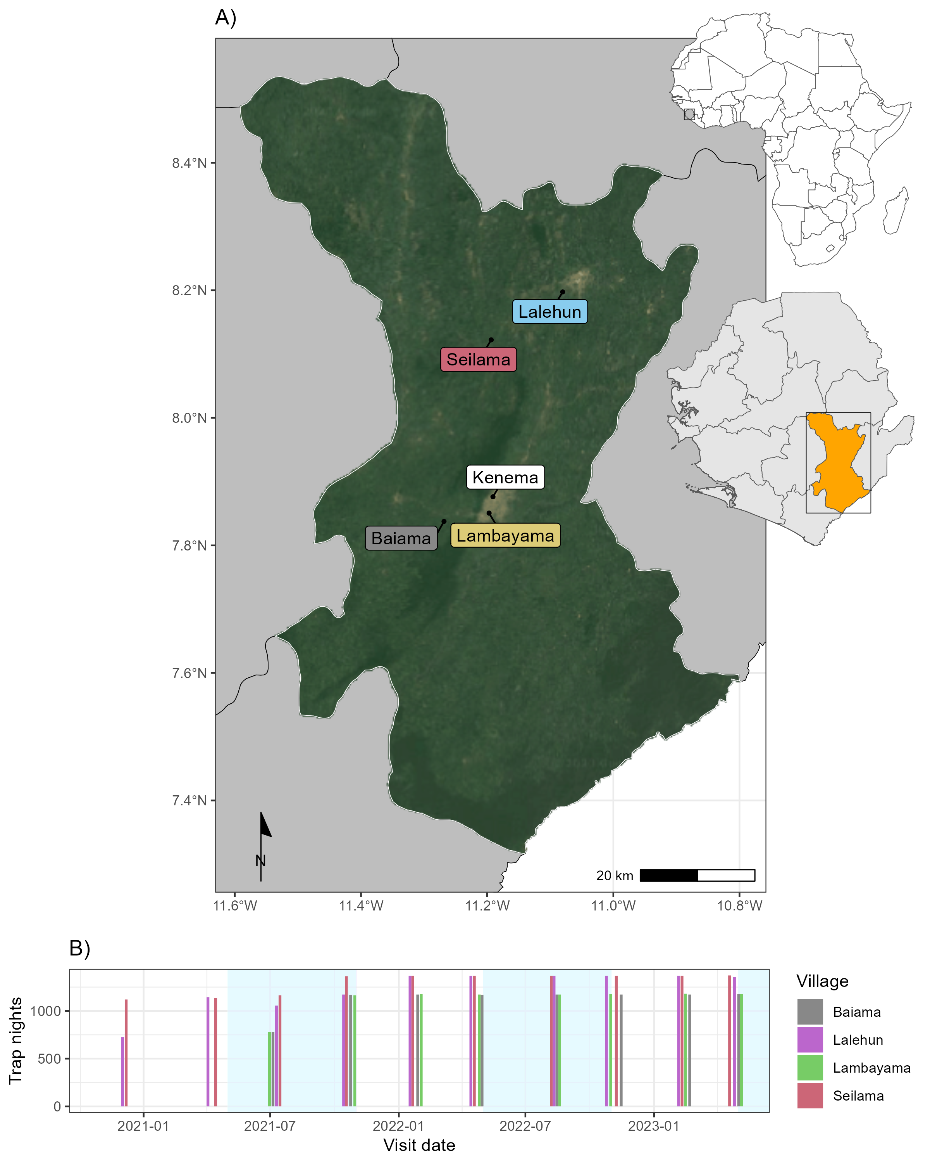

Figure 4.1: Village site locations and dates of rodent trapping in Sierra Leone. A) Location of village study sites (coloured labels), in the Eastern Province of Sierra Leone, Kenema, the major city of the province is shown with a white label. The inset map shows the location of Sierra Leone in West Africa. B) Number of trap nights obtained from each study village, orange shaded regions represent the rainy season in Sierra Leone.

* + 1. Description of rodent detection and species community structure

Adequacy of sampling effort was assessed using species accumulation curves produced for each village study site and each land use type within a village study site, suggesting suﬀicient effort to detect the expected rodent species within these categories. We constructed detection/non-detection histories for each grid cell and rodent species, assigning “1” when the species was detected and “0” otherwise. We describe species communities at multiple spatial scales. First, all species identified across all village sites and land use types. Second, all species identified within a village study site. Third, all species identified within a single land use type within a single village study site. We report species richness and Shannon diversity at these different spatial scales.

* + 1. Estimating the effect of land use on species occurrence and richness

To adjust for differential probabilities of detection that may be driven by environmental conditions and trapping effort during the trapping study and between species, we use a Bayesian spatial latent factor multi- species occupancy model that incorporates residual species correlations, imperfect detection and spatial autocorrelation. Variable selection was informed by a pre-specified conceptual model (Appendix [B.6](#_bookmark534)). Models were defined using the sfMsPGOcc function in the spOccupancy package in the R statistical computing language ([Doser *et al.*, 2022](#_bookmark213)). This approach defines the true presence or absence (𝑧) of a species (𝑖), at grid cell (𝑗) as arising from a Bernoulli process (Equation ([4.1](#_bookmark76))). Where 𝜓𝑗 is the probability of occurrence of a species at a grid cell. This is modelled using a logit link where 𝛽𝑖 are the species-specific regression coeﬀicients

of the site-specific covariates (𝑥⊤) and a latent process w∗

. This latent process incorporates residual species

𝑗 𝑖,𝑗

correlations through a small number of latent spatial factors and latent variables representing unmeasured grid cell covariates (Equation ([4.2](#_bookmark77))). Latent spatial factors account for spatial autocorrelation using a Nearest Neighbour Gaussian Process.

𝑧𝑖,𝑗 ∼ Bernoulli (𝜓𝑖,𝑗) (4.1)

logit (𝜓𝑖,𝑗) = 𝑥⊤𝛽𝑖 + w∗

(4.2)

𝑗 𝑖,𝑗

The species-specific regression coeﬀicients (𝛽𝑖) are specified as random effects arising from a common com- munity level distribution (Equation ([4.3](#_bookmark78))). Where 𝜇𝛽 represents the community level mean effect for each occurrence covariate effect and 𝑇 𝛽 is a diagonal matrix representing the variability of these among the species

in the community.

𝛽𝑖 ∼ Normal(𝜇𝛽, 𝑇 𝛽) (4.3)

The detection component estimates the unobserved 𝑧𝑖,𝑗. Here, 𝑦𝑖,𝑗,𝑘 is the observed detection or non-detection of a species 𝑖, at site 𝑗, during replicate 𝑘 (Equation ([4.4](#_bookmark79))). This is approached as arising from a Bernoulli process conditional on the true latent occurrence process 𝑝𝑖,𝑗,𝑘. The probability of a species being detected at a grid cell, during a replicate (given it is present at grid cell 𝑗), is a function of grid cell and replicate specific covariates 𝑣 and a set of species-specific regression coeﬀicients 𝛼𝑖 (Equation ([4.5](#_bookmark80))).

𝑦𝑖,𝑗,𝑘 ∼ Bernoulli (𝑝𝑖,𝑗,𝑘𝑧𝑖,𝑗) (4.4)

logit (𝑝𝑖,𝑗,𝑘) = 𝑣⊤ 𝛼𝑖 (4.5)

𝑖,𝑗,𝑘

Similarly to Equation ([4.3](#_bookmark78)), these coeﬀicients are specified as random effects arising from a common com- munity level distribution, where 𝜇𝛼 represents the community level mean effect for each detection covariate effect and 𝑇 𝛼 is a diagonal matrix representing the variability of these among species in the community (Equation ([4.6](#_bookmark81))).

𝛼𝑖 ∼ Normal(𝜇𝛼, 𝑇 𝛼) (4.6)

Minimally informative priors were specified for community and species level coeﬀicients (𝛼 and 𝛽, a normal prior of mean = 0, variance = 2.72) and for community level occurrence and detection variance parameters (𝑇 𝛼 and 𝑇 𝛽, 0.1 for the scale and shape parameters of the inverse Gamma prior).

We included covariates in the model based on a pre-specified conceptual model and after assessing for co- linearity (defined as strong correlation >0.8) among variables. Continuous variables were standardised by scaling values between 0-1. The fully specified model is defined in Equation ([4.7](#_bookmark82)) and ([4.8](#_bookmark83)) and using a single latent spatial factor.

Probability of occurrence ∼ Land use type+Village+scale(Distance to permanent structure)+scale(Elevation)

(4.7)

Probability of detection ∼ scale(Monthly precipitation) + Moon fraction + scale(Number of trap nights)

(4.8)

Model checks, including mixing patterns of the MCMC sampler and posterior predictive checks were per- formed as an assessment of goodness of fit. Bayesian p-values were produced at the community level and species level with values greater than 0.1 and less than 0.9 suggestive of adequate model fit. The Widely Applicable Information Criterion (WAIC) was used to guide final model selection ([Watanabe, 2010](#_bookmark489)). Using this model, we estimate occupancy probability for each species in different land use types. Only estimates for species with at least 25 detections are included to avoid inference from limited data.

We drew posterior samples from the most parsimonious Bayesian occupancy model incorporating spatial autocorrelation to estimate the probability of occurrence of a species within a trapping grid cell.

* + 1. **Co-occurrence of *Mastomys natalensis* with sympatric species**

To investigate the presence of competitive exclusion of the reservoir host of Lassa fever by other rodent species within these communities we examined the correlation of the probability of occupancy of species pairs. The predicted probability of occupancy at each of the grid cells from our spatial multi-species occupancy model was obtained. We stratified these by land use type and calculated the Spearman rank correlation coeﬀicient (𝜌), conducting a two-sided test for statistical significance with a null hypothesis of no correlation between the probability of occupancy for these species. We constrain this analysis to species pairs that were detected in the land use setting in the observed data informing our model to limit inference from sparse data. Further, due to multiple statistical tests we use a conservative value of statistical significance where *p* <=

0.005 represents a statistically significant association to minimise the reporting of false positive associations ([Benjamin *et al.*, 2018](#_bookmark160)). A statistically significant positive correlation was interpreted as species one being more likely to occur in a grid cell of the specific land use type if species two were present. A statistically significant negative correlation was interpreted as species one being less likely to occur in a grid cell of the specific land use type if species two were present. The causal mechanism and direction behind any observed correlations cannot be inferred from our current analysis.

Table 4.1: Description of trapped rodents by village and landuse type.

|  |  |  |  |  |
| --- | --- | --- | --- | --- |
| Landuse N1 TN2 | | | Richness3 | Diversity4 |
| **All villages** | | |  |  |
| Village | 261 | 11,516 (2.3%) | 12 | 1.67 |
| Agriculture | 379 | 26,400 (1.4%) | 17 | 2.19 |
| Forest | 44 | 5,350 (0.8%) | 10 | 1.78 |
| **Baiama**  Village | 73 | 2,716 (2.7%) | 8 | 1.11 |
| Agriculture | 45 | 4,696 (1%) | 9 | 1.94 |
| Forest | 3 | 1,568 (0.2%) | 2 | 0.64 |
| Combined | 121 | 8,980 (1.3%) | 12 | 1.73 |
| **Lalehun**  Village | 54 | 2,824 (1.9%) | 9 | 1.65 |
| Agriculture | 98 | 7,608 (1.3%) | 13 | 2.18 |
| Forest | 5 | 1,862 (0.3%) | 3 | 1.05 |
| Combined | 157 | 12,294 (1.3%) | 13 | 2.21 |
| **Lambayama**  Village | 93 | 2,736 (3.4%) | 4 | 0.42 |
| Agriculture | 50 | 6,260 (0.8%) | 6 | 1.19 |
| Combined | 143 | 8,996 (1.6%) | 6 | 1.03 |
| **Seilama**  Village | 41 | 3,240 (1.3%) | 8 | 1.54 |
| Agriculture | 186 | 7,836 (2.4%) | 13 | 1.97 |
| Forest | 36 | 1,920 (1.9%) | 8 | 1.51 |
| Combined | 263 | 12,996 (2%) | 14 | 2.07 |

1 Number of rodents detected (N)

2 Number of trap-nights (TN) and trap success expressed as a percentage of TN (%)

3 Species richness within land use type, i.e., number of species

4 Shannon diversity within land use type

##### Results

* + 1. Rodent detection and species community structure

During the study period 684 individuals were detected from 43,266 trap-nights across the four village study sites (1.6% trap-success (TS)). The greatest number of individuals, highest species richness and Shannon diversity values were obtained in the agricultural areas, meanwhile, TS was greatest within village settings (i.e., within and outside of permanent structures) (Table [4.1](#_bookmark85)). The Seilama study site had the highest overall TS, species’ richness and Shannon diversity and unlike the three other study sites had the greatest TS in agricultural areas. Species richness in Seilama was twice that of the peri-urban village study site (Lambayama) and had high Shannon diversity across all land use types. The sole peri-urban village study site (Lambayama) located within the expanding boundaries of Kenema city, had the lowest species’ richness and Shannon diversity with the majority of rodents detected within the village area.

The most commonly detected rodent species across all land use types was *M. natalensis* (N = 113, 16.5%), followed by *Praomys rostratus* (N = 102, 14.9%), *M. musculus* (N = 90, 13.2%), *R. rattus* (N = 88, 12.9%)

and *Lophuromys sikapusi* (N = 57, 8.3%). The insectivorous shrew species *Crocidura olivieri* was the most commonly detected non-rodent species (N = 105, 15.4%). *Mastomys natalensis* and *R. rattus* were detected at all village study sites, although *M. natalensis* was not detected in areas (Figure [4.2](#_bookmark88)). The invasive rodent species *M. musculus* was only detected in the Lambayama study site. The detection rate (the number of individuals detected per 1,000 TN) varied by species, landuse type and village study site. The greatest rate of detection was for *M. musculus* in the Lambayama village study site, with the other commensal species *M. natalensis* and *R. rattus* having high detection rates across multiple village study sites within village land use types. *P. rostratus.* had the highest detection rates in forest and agricultural areas.

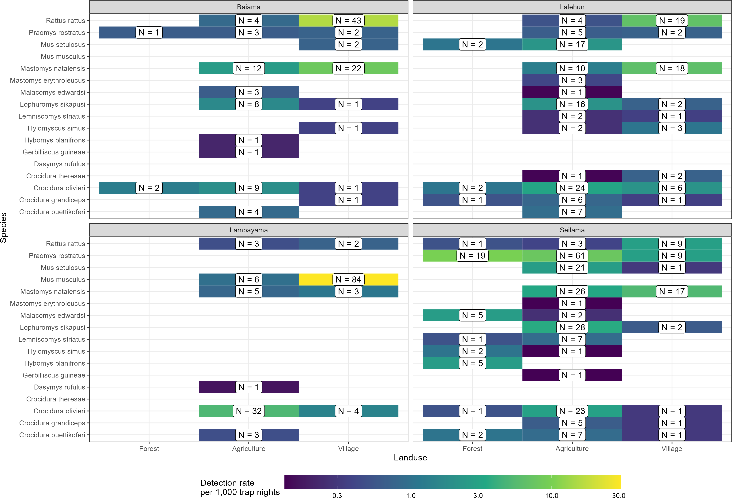

Figure 4.2: Detection rate per 1,000 trap nights of rodent species across different land use types. The plots are panelled by village study site. The absolute number of detections of each species in each land use type at each study site is shown in the label. The colour of the tile corresponds to the detection rate per 1,000 trap nights.

There was some observed variation in species detection by season. Although, the prevalence of a species (measured as the rate of detections per 1,000 TN), not accounting for incomplete detection, did not show a single trend for all species (Appendix [C.1](#_bookmark537)). *Mus musculus* had a greater detection rate in the rainy season than dry. Conversely, *L. sikapusi*, and *Mus setulosus* had greater detection rates in the dry season. The other

species had similar detection rates across both seasons. There was some further variation when stratified by landuse type. *Mastomys natalensis* had greater detection rates in villages compared to agricultural areas in the rainy season while in the dry season it was detected at similar rates in village and agricultural areas. *Praomys rostratus* had greater detection rates in forests during the dry season compared with the rainy season. No other species had important variations by season stratified by land use type.

* + 1. Estimating the effect of land use on species occurrence and richness

We found three patterns of probability of occurrence (𝜓) within a trapping grid cell for the seven included species (Figure [4.3](#_bookmark90). and, marginal effects of the detection parameters shown in Appendix [C.2](#_bookmark539)). First, *M. natalensis*, *R. rattus* and *M. musculus* had greatest probabilities of occurrence in villages with lower occur- rence probabilities in agricultural and forest areas. *Mastomys natalensis* differed from the two commensal, invasive species (*R. rattus* and *M. musculus*) as their probability of occurrence in agricultural settings was generally high. Second, *P. rostratus* had high probability of occurrence in forests with lower probabilities in agricultural areas and villages. Finally, *C. olivieri*, *L. sikapusi* and *M. setulosus* had their highest proba- bilities of occurrence in agricultural areas with lower probabilities of occurrence in forests and villages. No species showed high probability of occurrence across all land use types, consistent with species being adapted to distinct ecological niches.

The probability of occurrence within a trapping grid cell, within the same land use type showed wide variability for some species. For example, the narrow range of probabilities for *M. natalensis* in forests (0- 13%) is suggestive that the probability of this species occurring within forests is low. This compares to the wide variability for *P. rostratus* in agricultural areas, here, the probability of occurrence ranged from 0-90% is suggestive that additional environmental factors other than land use type are affecting their occurrence.

To further explore these factors we stratified village study sites by human population density into rural and peri-urban (rural <= 500 individuals per 1km2) (Figure [4.3](#_bookmark90)). The probability of occurrence of *M. natalensis* was importantly different between these settings, with high probability of occurrence in both agricultural and village settings in rural areas but substantially lower probability in peri-urban study sites. The same pattern was observed for *R. rattus*. For the rodent species predicted to have lower probability of occurrence in village settings, namely, *P. rostratus*, *L. sikapusi* and *M. setulosus* probabilities of occurrence were greater in all landuse types in rural areas compared to peri-urban areas. Shrew species were predicted to have similar probabilities of occurrence in rural and peri-urban areas. Human population density itself or other associated environmental factors may therefore be importantly contributing to rodent species occurrence.

In contrast to species found throughout our study area, *M. musculus* was predicted to have a low probability

of occurrence in all landuse types in rural areas, with high values only for village settings in peri-urban areas. The occurrence probabilities for the three commensal species (*M. natalensis*, *R. rattus* and *M. musculus*) suggest that competition may be reducing the occurrence of *M. natalensis* and *R. rattus* in the presence of

*M. musculus* as in it’s absence these two species have high occurrence probabilities in villages.

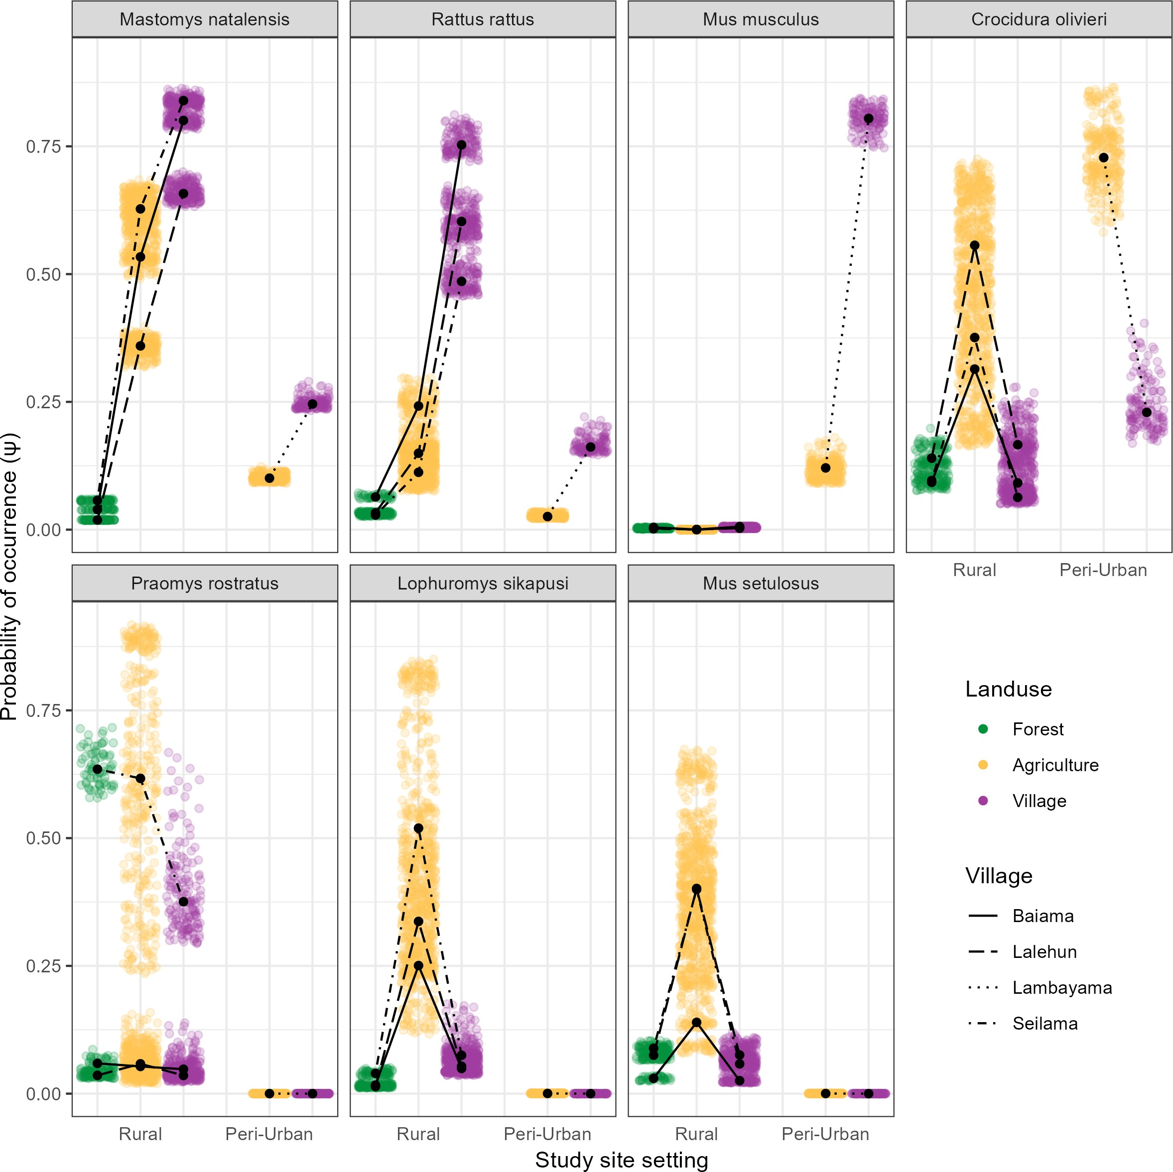

Figure 4.3: Probability of species occurrence (𝜓) across a land use gradient stratified by rural and peri-urban village study sites for the seven rodent and shrew species. Each coloured point is the median of the predicted probability of occurrence for a species obtained from the posterior distribution at a trapping grid cell, colours correspond to the different land use types. Predictions were obtained for each of the 2,068 trapping grid cells. Black points represent the median probability of occurrence within a land use type grouped by village, with lines connecting within villages for different land use types.

* + 1. Co-occurrence of species within land use types

Our tests for species correlations supported our prior hypothesis that the local spatial distribution of *M. natalensis* is regulated by biotic interactions with co-occurring species (Figure [4.4](#_bookmark92)). We observed that in land use types where both *M. natalensis* and *M. musculus* co-occurred the presence of one species led to a reduction in the probability of occurrence at a grid cell level of the other with a statistically significant negative correlation observed in agricultural (Spearman’s 𝜌 = -0.67, *p* < 0.001) and village (𝜌 = -0.35, *p* < 0.001) settings. This negative relationship was not observed between *M. natalensis* and the other commensal, invasive rodent *R. rattus*, where a positive correlation between probabilities of occurrences in both agricultural (𝜌 = 0.51, *p* < 0.001) and village (𝜌 = 0.36, *p* < 0.001) settings was observed.

Generally, within villages, high probabilities for the presence of *M. musculus* was associated with lower probabilities for all other rodent species. This was not replicated for *M. natalensis* and *R. rattus*, which were positively associated with the co-occurrence of other native rodent species *P. rostratus*, *L. sikapusi* and *M. setulosus*. Across all landuse types, the presence of the shrew species *C. olivieri* had a negative correlation with the presence of rodent species’.

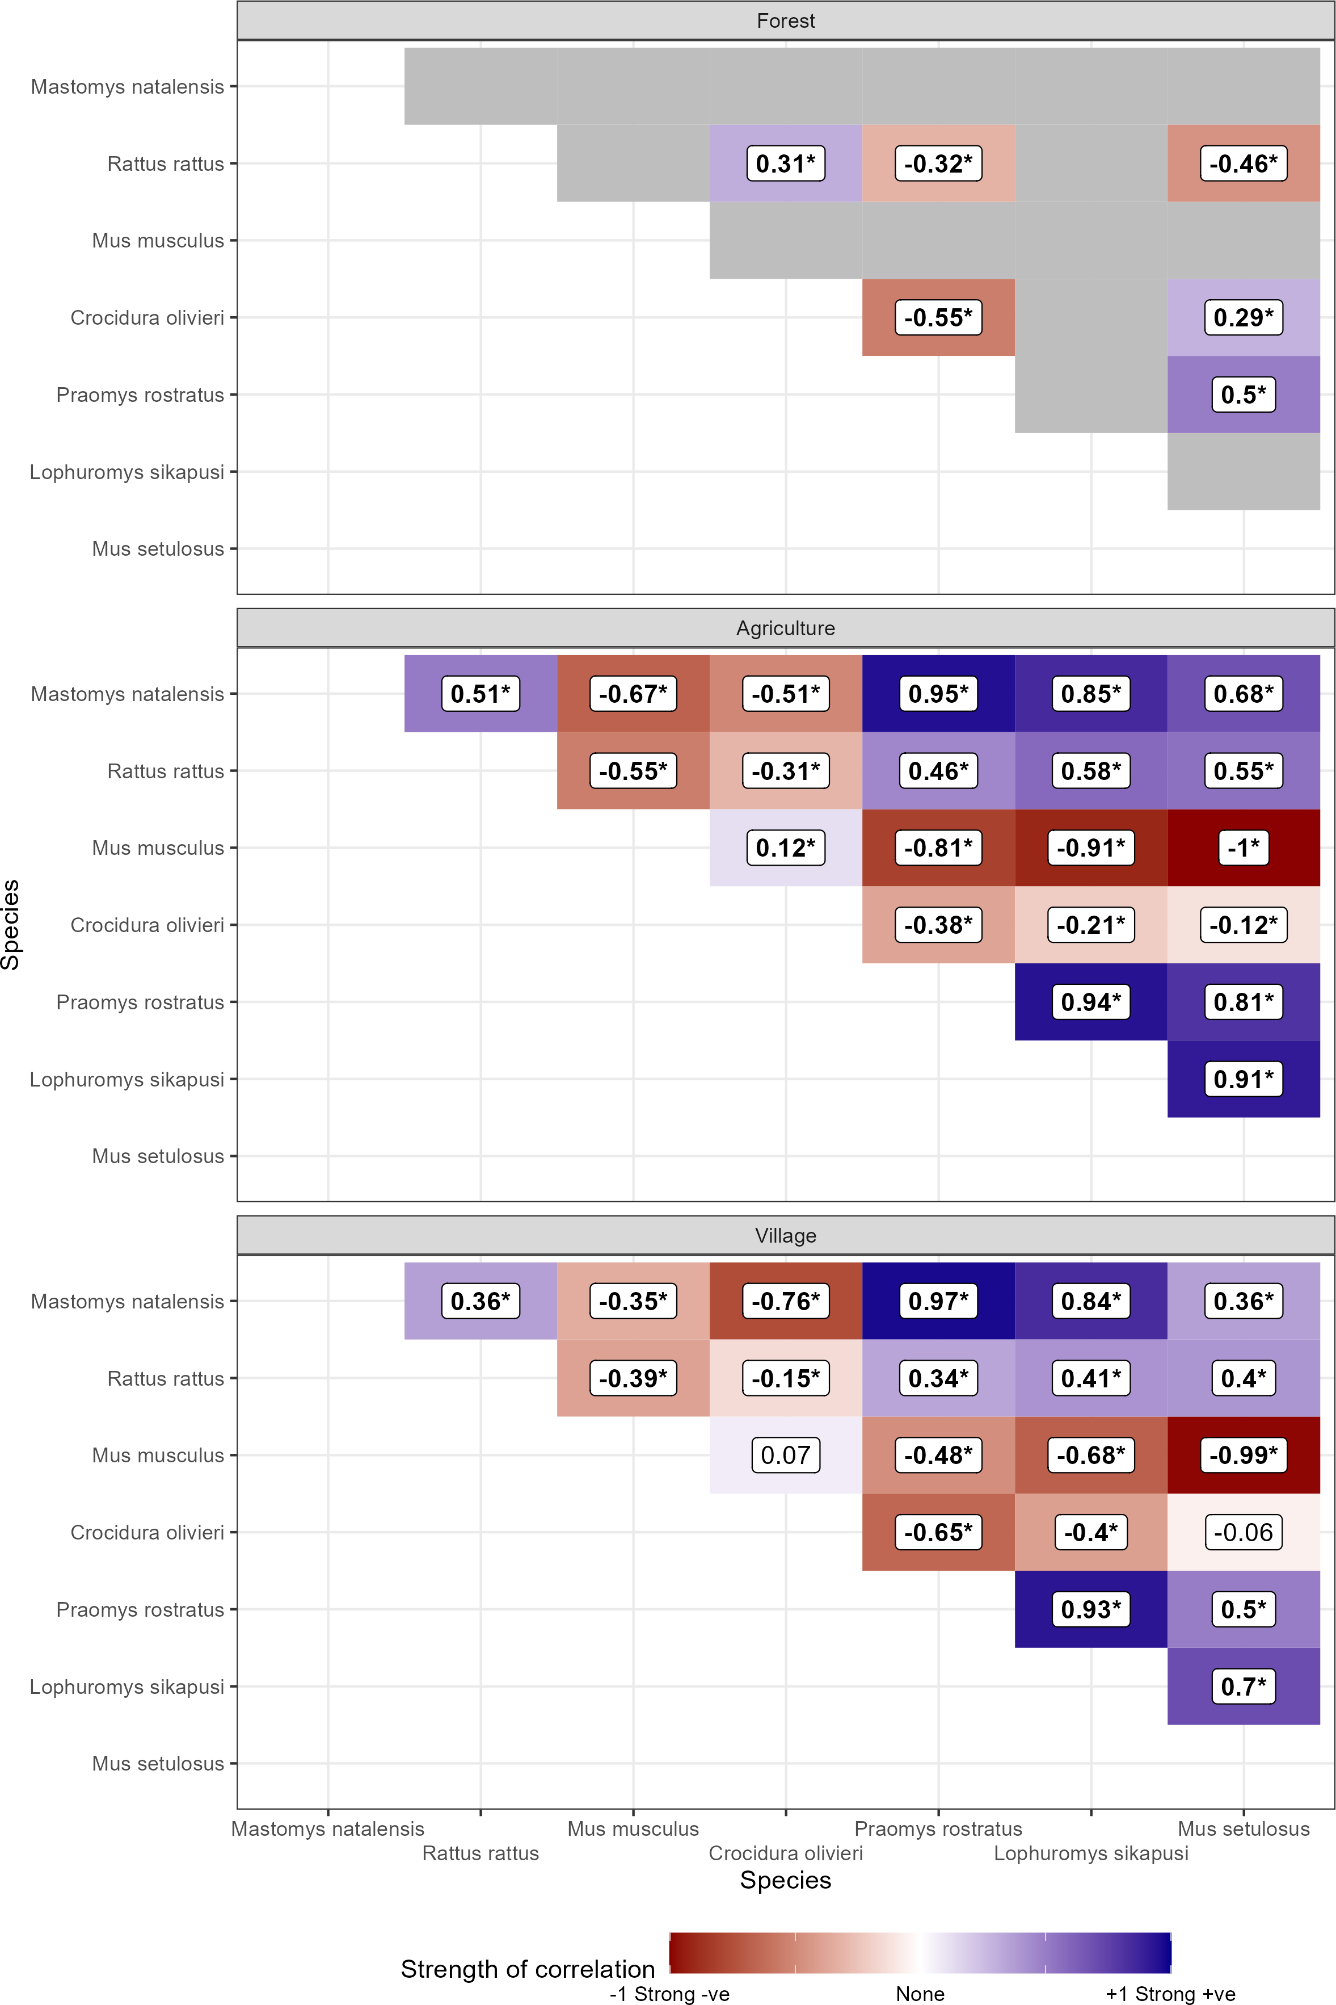

Figure 4.4: Spearman’s rank correlations for the modelled probability of occurrence of species pairs in different land use types. Positive values (blue shades) represent positive correlation coeﬀicients between the occurrence of two species. Negative values (red shades) represent negative correlation between the occurrence of two species. Numbers in bold typeface and indicated with an asterisk (\*) are statistically significant at a level of *p* <= 0.005. Grey tiles are used where no detections of the species pair in the landuse type were observed and therefore excluded from analysis.

##### Discussion

Our analysis presented the results of a systematic small-mammal trapping study in the Eastern Province of Sierra Leone investigating rodent species communities across a land use gradient in a Lassa fever endemic region. First, we found similar species richness and diversity to rodent sampling from other regions of the Lassa fever endemic zone in Guinea, Nigeria and Sierra Leone ([Fichet-Calvet *et al.*, 2014](#_bookmark229); [Olayemi *et al.*,](#_bookmark407) [2018](#_bookmark407); [Bangura *et al.*, 2021](#_bookmark151)). We found that species richness and diversity was highest in agricultural land use settings with reduced richness in both forests and villages. There was important variation of species richness and diversity between different land use types in peri-urban and rural settings. Second, the reservoir host of LASV, *M. natalensis* showed a response to human dominated land use with the highest probability of occupancy in villages, followed by agricultural settings and likely absence from forests. We observed similar patterns of occurrence for the two invasive, commensal, rodent species *M. musculus* and *R. rattus*. Following stratification by human population density, we found that the probability of occurrence of *M. natalensis* was lower in peri-urban settings where *M. musculus* has replaced *M. natalensis* as the dominant commensal rodent species. Finally, we assessed for correlations in the probability of co-occurrence. We found a negative association between the probability of occupancy of *M. natalensis* and *M. musculus* within villages that could have important implications for the understanding of risk of spillover of Lassa fever in endemic regions.

* + 1. Rodent communities are associated with land use type

Rodent species richness was found to be greatest in agricultural settings. In these settings both synanthropic and non-synanthropic species were found, resulting in increased species richness and diversity. Agricultural land use may thus provide greater opportunity for LASV transmission among species within diverse rodent communities.

There is some evidence for a role of the wider rodent community in LASV transmission. Current or prior infection with LASV (through detection of virus or antibodies), has been identified in 11 additional small mammal species, whether these represent incidental infections or competent chains of viral transmission are not known ([Monath *et al.*, 1974](#_bookmark388); [Demby *et al.*, 2001](#_bookmark209); [Fichet-Calvet *et al.*, 2014](#_bookmark229); [Olayemi *et al.*, 2016](#_bookmark406); [Simons *et al.*, 2023](#_bookmark459)). It is possible that viral sharing within rodent communities is greatest in these species rich agricultural settings, allowing introduction or re-introduction of the pathogen into isolated commensal species populations following extinction ([Bordes, Blasdell and Morand, 2015](#_bookmark169)). This may be particularly important for maintaining viral persistence in spatially isolated *M. natalensis* populations, as rapid depletion of susceptible individuals is expected in isolated well mixed populations ([Goyens *et al.*, 2013](#_bookmark264)). The spatial isolation of communities of this species is support by this study and previous studies finding absence within

forested regions and limited geographic dispersal ([Leirs, Verheyen and Verhagen, 1996](#_bookmark339); [Denys *et al.*, 2005](#_bookmark210); [Mariën *et al.*, 2018](#_bookmark364)). The role of the wider rodent community in translocating LASV between *M. natalensis* populations needs further investigation.

We did not observe that *M. natalensis* was more prevalent in village settings during the dry season, as has been reported from elsewhere in Sierra Leone and Guinea ([Fichet-Calvet *et al.*, 2007](#_bookmark232); [Bangura *et al.*,](#_bookmark151) [2021](#_bookmark151)). Our finding of similar or increased prevalence of *M. natalensis* between seasons, not accounting for imperfect detection, were consistent across our village study sites. It is possible that in this region different agricultural processes or food storage practices by village communities results in different rodent behaviour to elsewhere in its range ([Kelly *et al.*, 2013](#_bookmark320); [Leach *et al.*, 2017](#_bookmark333)). Alternatively, increased trap-shyness during periods of increased abundance may mask replication of previous findings. Additional rodent community studies, incorporating local human community behaviour and practices, over longer time periods, and across different geographic regions, would be informative to ascertain seasonal habitat preferences of these rodents. It has been suggested that prevalence of *M. natalensis* within households is the proximal driver of the risk of Lassa fever spillover into human populations driven by the potentially increased rate of human-rodent host contact within households ([Bonwitt *et al.*, 2017](#_bookmark168); [Mariën *et al.*, 2020](#_bookmark363)). Therefore, migration from species rich agricultural settings to within households by hosts of LASV may be an important component of Lassa fever outbreaks.

* + 1. Evidence for biotic interactions shaping patterns of rodent species diversity

The finding that rodent species displayed a segregation into distinct ecological niches of human dominated (village and agriculture) or non-human dominated (forest) land use types suggests an important role for biotic factors in species occurrence. The high predicted occupancy of both *M. natalensis* and *R. rattus* in human dominated landscapes and positive correlation in co-occurrence is consistent with another study conducted elsewhere in Sierra Leone ([Bangura *et al.*, 2021](#_bookmark151)). This suggests that these two rodent species do not directly compete for resources and that the presence of one species does not preclude the other. This may not be true for interactions between *M. musculus* with both *R. rattus* and *M. natalensis*. The probability of occurrence of *M. musculus* within villages was negatively correlated with the co-occurrence of both *M. natalensis* and *R. rattus*. *Mus musculus* was also absent in village land use types in rural settings where *R. rattus* and *M. natalensis* had high probabilities of occurring. This trend was replicated for *M. musculus* with all other rodent species in village settings. It is not possible to ascertain from the current study whether

M. musculus is expanding into rural settings and what effect this may have on rodent communities and LASV transmission. To identify the causal processes of changes in rodent species community structures

in response to invasive species’ range expansion longer term monitoring of rodent communities would be beneficial, similar to that conducted in Senegal ([Dalecky *et al.*, 2015](#_bookmark202)).

* + 1. Benefits and challenges of systematic rodent community sampling

Systematic investigation of rodent communities requires a greater amount of sampling effort compared to targeted sampling of a rodent species’ within selected habitats. In this study we had a low overall trap success rate compared to other studies focused on synanthropic rodent species’ ([Olayemi *et al.*, 2018](#_bookmark407); [Bangura *et*](#_bookmark151)[*al.*, 2021](#_bookmark151); [Happi *et al.*, 2022](#_bookmark279)). Our obtained trap success rate of 3.3% within villages is comparable to the 3% obtained from a study conducted in Bo, Sierra Leone, but is substantially lower than the 17% and 14% reported from Nigeria and Guinea respectively ([Fichet-Calvet *et al.*, 2007](#_bookmark232); [Bangura *et al.*, 2021](#_bookmark151); [Happi *et*](#_bookmark279)[*al.*, 2022](#_bookmark279)). Detection rates of *M. natalensis* within its Western radiation of Nigeria, Guinea and Sierra Leone are also lower than that obtained from Tanzania where trap success rates around 24% are reported from agricultural settings ([Mulungu *et al.*, 2013](#_bookmark392)). Whether this represents different behaviour within the species based on food availability is not known, although environmental food availability is known to be associated with trap-shyness ([Taylor, Hammond and Quy, 1974](#_bookmark470); [Stryjek, Kalinowski and Parsons, 2019](#_bookmark466)). Despite the increased trapping effort required to obtain the necessary number detections for statistical inference, adopting this approach will mitigate some of the biases in rodent species and viral detection introduced by targeted sampling.

Comparison between studies using different sampling techniques and study designs presents several challenges. Previous studies on rodent communities in the Lassa fever endemic region have used trap success rates as an indirect measure of rodent abundance in the absence of capture-mark-recapture studies ([Fichet-Calvet *et*](#_bookmark233)[*al.*, 2009](#_bookmark233); [Olayemi *et al.*, 2018](#_bookmark407); [Bangura *et al.*, 2021](#_bookmark151)). Our analysis, using a model incorporating imperfect detection, suggests estimating abundance from trap success may not be applicable across different land use types and species (Appendix [C.2](#_bookmark539)). For example, we found that the probability of detection of *M. musculus* and *R. rattus* were higher than native species given a consistent amount of trapping effort. Detection rate as a measure of relative abundance has been shown to poorly replicate using combined live-trapping and camera- trapping approaches in the USA ([Parsons, Clark and Kays, 2022](#_bookmark417)). Drivers of variability in detection may include trap-shyness (i.e., neophobia) of non-synanthropic species, the availability of resources in the local environment and the placement locations of traps, the contribution of these factors on detection require further study in our setting ([Stryjek, Kalinowski and Parsons, 2019](#_bookmark466)). Improved harmonisation of rodent sampling designs particularly incorporating systematic rodent community sampling will facilitate direct comparison of rodent species communities and pathogen prevalence across the Lassa fever endemic region.

There are several limitations to the current study. Rodent sampling was limited to a relatively short period, less than three years, it is possible that rodent populations in these settings have important multi-year varia- tions in abundance that could not be captured in our model and therefore the probability of occurrence may be under-estimated for species that were at low abundance during our survey period. Sampling over a longer time period would allow any potential temporal changes in probability of occurrence to be better identified. Similarly, land use in Sierra Leone, particularly agricultural land, goes through multi-year cycles of use. It would be informative to study a single location in the typical transition from forested, to agricultural, to long term fallow and to degraded forest land use to better characterise changes in rodent communities within these settings of land management. Unobserved characteristics of our study villages also likely contributed to the composition of rodent communities, suggested by the wide posterior distributions for some rodent species, expanding this study to sample more villages would be beneficial to allow further generalisation of our findings over the wider region.

* + 1. Implications for understanding the risk of Lassa fever spillover

The lower levels of occurrence of *M. natalensis* in agricultural and forest land use is consistent with increasing evidence of LASV prevalence heterogeneity across the endemic region ([Mariën *et al.*, 2020](#_bookmark363)). In some village communities within the endemic region no evidence of current LASV transmission has been observed within the rodent populations, despite prior human cases or serological evidence of outbreaks, suggesting important temporal and spatial variation in pathogen prevalence ([McCormick *et al.*, 1987](#_bookmark374); [Leski *et al.*, 2015](#_bookmark340); [Bangura](#_bookmark151) [*et al.*, 2021](#_bookmark151)). As discussed above it may be that transmission among the rodent community is short lived with rapid local extinction of LASV ([Goyens *et al.*, 2013](#_bookmark264)). This phenomena may implicate non-*M. natalensis* species as being important for transferring the pathogen between communities of *M. natalensis* resident in villages separated by forest, leading to pathogen re-introduction ([Guzzetta *et al.*, 2017](#_bookmark270)). Several species found to occur in forest settings have been found to have antibodies against LASV, namely *Praomys rostratus*, *M. setulosus*, *Malacomys edwardsi* and *L. striatus* ([Monath *et al.*, 1974](#_bookmark388); [Demby *et al.*, 2001](#_bookmark209); [Fichet-Calvet *et*](#_bookmark229)[*al.*, 2014](#_bookmark229); [Olayemi *et al.*, 2016](#_bookmark406); [Simons *et al.*, 2023](#_bookmark459)). To understand the temporal and spatial variability in LASV prevalence rodent sampling across the wider land use gradient are required.

Finally, current disease models of Lassa fever risk do not account for the involvement of multiple rodent species or biotic interactions between species ([Fichet-Calvet and Rogers, 2009](#_bookmark235); [Olugasa *et al.*, 2014](#_bookmark410); [Mylne](#_bookmark394) [*et al.*, 2015](#_bookmark394); [Redding *et al.*, 2016](#_bookmark435); [Basinski *et al.*, 2021](#_bookmark153); [Klitting *et al.*, 2022](#_bookmark325)). Our finding of interactions between *M. natalensis* and primarily *M. musculus* may indicate that Lassa fever risk could be reduced in settings where *M. musculus* is present. Further research exploring the competence of *M. musculus* as a host

of LASV are required, as evidence of prior infection, through serological assays has been reported ([Demby *et*](#_bookmark209)[*al.*, 2001](#_bookmark209)). If *M. musculus* is not a competent host of LASV this may go some way to explain why Lassa fever is more typically reported from rural locations in the endemic region rather than cities, where this invasive species may have displaced more competent viral hosts. Further work systematically sampling across the urban-rural gradient will be required to test this hypothesis which will have implications for estimates of future Lassa fever risk. West Africa continues to undergo large population growth and rapid urbanisation, the expansion of *M. musculus* may therefore moderate the risk of increasing numbers of Lassa fever outbreaks.

1. **Contact networks of small mammals highlight potential trans- mission foci of *Lassa mammarenavirus*.**

##### Preface

I conceived of the study with Richard Kock, Deborah Watson-Jones and Kate E. Jones. I designed the rodent trapping methodology, study protocol and formulated the data collection tool. I designated the locations of the rodent trapping grids, compiled the taxonomic keys and trained the local fieldwork collaborators on the study processes. The local fieldwork team, including Dianah Sondufu, Joyce Lamin, Michael Dawson, Momoh Jimmy and James Koninga conducted repeat sampling at previously designated locations under my direct and indirect supervision. Umaru Bangura trained me on the use of the BLACKBOX® ELISA kit and provided remote support to this work conducted in Sierra Leone. I trained Joyce Lamin in Sierra Leone on ELISA serology for rodent and shrew samples and she conducted this under my direct and indirect supervision. I performed statistical analysis and interpreted model outputs with support from Ravi Goyal. I received support for my work in Sierra Leone from Rashid Ansumana. I wrote this chapter and Ravi Goyal, Richard Kock, Deborah Watson-Jones and Kate E. Jones contributed to and approved the final version.

This chapter in modified format is being prepared for submission to a peer-reviewed journal.

##### Abstract

Lassa fever, caused by *Lassa mammarenavirus* (LASV), is an endemic zoonosis in several West African countries. Human infection is caused by spillover from rodent hosts, the reservoir species is *Mastomys natalensis*, a synanthropic rodent. In addition to the reservoir species a further 11 rodent and shrew species have been found to be acutely infected or to have evidence of prior infection with LASV. Within Sierra Leone species rich, small-mammal communities are structured along land use gradients. These community structures are expected to moderate the risk of Lassa fever disease spillover into human populations. Here, we use a rodent trapping study, conducted over 43,266 trap nights, detecting 684 individual rodents and shrews to reconstruct contact networks within the Lassa fever endemic Eastern Province, Sierra Leone. We found that small-mammal communities were larger in village and agricultural settings compared to forests, although contact rates were similar across these habitats. The structure of these networks differed by land use with villages containing more disconnected networks than agricultural settings. Specifically, we found an increased odds of intra-specific contact among *M. natalensis* within agricultural settings compared to villages. Our results suggest, that among these small-mammal communities, LASV transmission may occur differentially within agricultural settings compared to villages. Finally, we report a LASV seroprevalence of

5.7% among these small-mammal communities with antibodies detected from nine rodent and shrew species. Expanding rodent trapping to incorporate these different pathogen transmission settings in villages and agricultural habitats may elucidate the rodent and shrew species that are important for the maintenance of viral populations and the subsequent risk of zoonosis to human populations.

##### Introduction

Lassa fever caused by *Lassa mammarenavirus* (LASV) is a rodent associated endemic zoonosis, estimated to cause 100,000-900,000 annual infections across West Africa ([McCormick *et al.*, 1987](#_bookmark374); [Basinski *et al.*,](#_bookmark153) [2021](#_bookmark153)). Compared to regular outbreaks in Nigeria cases are only sporadically reported from the Lassa fever endemic countries of Guinea, Liberia and Sierra Leone ([Bausch *et al.*, 2001](#_bookmark155); [Shaffer *et al.*, 2021](#_bookmark450); [Jetoh](#_bookmark306) [*et al.*, 2022](#_bookmark306)). Within Sierra Leone disease outbreaks commonly go undetected. This is consistent with recent findings of up to 80% seropositivity to LASV among human communities in regions of the country previously not considered endemic for Lassa fever ([Grant *et al.*, 2023](#_bookmark267)). Human infections are typically caused by pathogen spillover from rodent hosts, with limited subsequent human-to-human transmission ([Lo](#_bookmark346) [Iacono *et al.*, 2015](#_bookmark346)). Therefore, characterising the interactions within small-mammal communities through which pathogen transmission occurs and is maintained are vital to understanding LASV transmission in the endemic setting.

The reservoir host of LASV, *Mastomys natalensis* is a native, commensal rodent species, which occurs throughout sub-Saharan Africa. Pathogen challenge studies conducted on captive and natural *M. natalensis* colonies have found that acute infection does not result in significantly altered rodent behaviour or cause clinical pathology ([Walker *et al.*, 1975](#_bookmark486); [Mariën *et al.*, 2017](#_bookmark361); [Safronetz *et al.*, 2022](#_bookmark441)). LASV is transmitted between infected and susceptible individuals at low infectious doses, which supports the hypothesised trans- mission routes being through both direct contact (i.e., a superficial wound caused by an infected conspecific) or indirect contact (i.e., through exposure to an environmental contaminant) ([Safronetz *et al.*, 2022](#_bookmark441)). Within the rodent host viral RNA is detectable 3 days post-infection, peaking within 1 to 2 weeks and resolving within 40 days ([Safronetz *et al.*, 2022](#_bookmark441)). RNA persistence is observed in *M. natalensis* testes beyond this 40- day period suggesting that prolonged sexually mediated transmission may exist in natural settings ([Mariën](#_bookmark361) [*et al.*, 2017](#_bookmark361)). The relatively short period of acute infection is one reason why many studies have focussed on detecting antibodies to LASV rather than circulating virus ([Demby *et al.*, 2001](#_bookmark209); [Kerneis *et al.*, 2009](#_bookmark323); [Fichet-Calvet *et al.*, 2014](#_bookmark229)).

The dynamics of antibody responses in infected rodents are not currently known. Based on a similar are- navirus (Morogoro virus), seroconversion is expected to occur 7 days post infection, with detectable antibod-

ies (i.e., IgG) remaining beyond the point where circulating RNA has declined (i.e., 40 days post-infection) ([Borremans *et al.*, 2015](#_bookmark174)). Most rodents infected with LASV are assumed to develop lifelong immunity to dis- ease following development of LASV specific antibodies ([Mariën *et al.*, 2017](#_bookmark361); [Safronetz *et al.*, 2022](#_bookmark441)). Whether these rodents are still able to participate in transmission networks despite this immunity is not currently known. Antibody based studies are therefore an imperfect tool, but the higher prevalence of seropositivity than acute infections is helpful for characterising the dynamics of LASV in the endemic region. A recent study conducted in Bo district, Sierra Leone reported a 2.8% prevalence of LASV antibodies while the preva- lence of LASV acute infection (using PCR) was only 0.3% highlighting the challenges of detecting acute infection in these rodent populations ([Bangura *et al.*, 2021](#_bookmark151)).

While *M. natalensis* is considered the sole reservoir species of LASV, 11 further rodent species have been identified to be acutely or previously infected with LASV in endemic regions ([Monath *et al.*, 1974](#_bookmark388); [Fichet-](#_bookmark229) [Calvet *et al.*, 2014](#_bookmark229); [Olayemi *et al.*, 2016](#_bookmark406); [Simons *et al.*, 2023](#_bookmark459)). The contribution of these additional species to pathogen spillover into human populations, and viral transmission or maintenance among rodent communities is unknown. Direct and indirect contact between rodents in species rich environments may produce incidental infections of non-reservoir species which are subsequently detected through surveillance activities, despite having little impact on viral transmission or maintenance ([Gilbert *et al.*, 2013](#_bookmark258)). Alternatively, these species may facilitate transfer of this pathogen across the landscape, linking geographically isolated *M. natalensis* populations and causing reintroduction of virus into populations of the reservoir species ([Caron *et al.*, 2015](#_bookmark187); [Cardenas *et al.*, 2022](#_bookmark184)). There is increasing awareness that multi-species host systems exist for many zoonoses ([Keesing and Ostfeld, 2021](#_bookmark319)). To understand the prevalence and dynamics of of rodent associated zoonoses among hosts in their natural environment it is therefore important to expand sampling to the entire rodent community rather than focusing on a single species ([Albery *et al.*, 2021](#_bookmark139)).

Host network structure can determine the dynamics of pathogens. Pathogens are more likely to persist in dense, well-connected networks where frequency dependent transmission dominates ([Begon *et al.*, 1999](#_bookmark157)). In segmented or discontinuous networks, pathogens with limited environmental transmission will become locally extinct as the number of susceptible individuals is rapidly depleted ([Swinton *et al.*, 1998](#_bookmark469); [Almberg](#_bookmark141) [*et al.*, 2012](#_bookmark141)). Networks containing individuals that are particularly important (i.e., high node betweenness), can have an inflated role on pathogen transmission and maintenance within discontinuous networks (i.e., super-spreaders) ([Clay *et al.*, 2009](#_bookmark194); [VanderWaal and Ezenwa, 2016](#_bookmark481)).

The composition of rodent contact networks in Lassa fever endemic regions has not been systematically reported. Previous studies have produced summary descriptions of wider rodent populations which cannot be readily transformed into contact networks ([Fichet‐Calvet *et al.*, 2010](#_bookmark236); [Bangura *et al.*, 2021](#_bookmark151); [Happi *et al.*,](#_bookmark279)

[2022](#_bookmark279)). However, the rich geolocation and temporal data provided by systematic rodent trapping allows the estimation of direct or indirect rodent contacts by inferring shared space utilisation over short time periods ([Perkins *et al.*, 2009](#_bookmark422); [Clay *et al.*, 2009](#_bookmark194)). Contact networks produced from wildlife data have previously been used to study pathogen transmission and is particularly amenable to investigating the importance of community structure or the effect of contact rate heterogeneity between species in multi-host pathogen systems ([Böhm, Hutchings and White, 2009](#_bookmark165); [Drewe *et al.*, 2011](#_bookmark214); [White, Forester and Craft, 2017](#_bookmark493)).

Rodent communities are structured along anthropogenic land use gradients in the Lassa fever endemic region (Chapter [4](#_bookmark66) and Fichet-Calvet *et al.* ([2014](#_bookmark229))). The risk of LASV spillover into human populations is also expected to follow this gradient ([Klitting *et al.*, 2022](#_bookmark325); [Grant *et al.*, 2023](#_bookmark267); [Longet *et al.*, 2023](#_bookmark348)). The prevalence of typically synanthropic rodent hosts of LASV within human dominated land use types is expected to be higher in response to increased food availability, shelter availability and reduced predation pressure ([Ecke](#_bookmark217) [*et al.*, 2022](#_bookmark217)). These factors also moderate rodent abundance and population dynamics which may promote increased pathogen persistence, as has been reported in several rodent associated zoonoses systems ([Sauvage](#_bookmark448) [*et al.*, 2003](#_bookmark448); [Laverty and Adler, 2009](#_bookmark331); [Salkeld *et al.*, 2010](#_bookmark447)). Understanding whether rodent contact networks, like rodent occurrence and abundance, vary along these anthropogenic land use gradients can elucidate the potentially different pathogen transmission networks in these settings. We therefore, hypothesised that rodent contact rates, underlying pathogen transmission networks, are greater in anthropogenically dominated habitats where nutritional resources are more concentrated.

Specific contact network properties can promote pathogen persistence within a population. For example, networks containing nodes with high betweenness (i.e., nodes that are focal points in pathways between other nodes) have the potential to become disconnected if these nodes are removed, leading to limited pathogen transmission due to the creation of disconnected sub-networks ([VanderWaal *et al.*, 2014](#_bookmark480)). However, if these nodes instead are infectious there is a greater potential for the pathogen to transmit through the entire network ([Chen *et al.*, 2014](#_bookmark191)). Further, if most contacts are within competent intra-specific contacts (i.e, between two members of the same species) pathogen transmission can occur at greater rates ([Faust *et al.*,](#_bookmark227) [2017](#_bookmark227); [Young, Parker, *et al.*, 2017](#_bookmark513)). In this study, we characterise potential interactions within our small- mammal community as a network, which we refer to as small-mammal contact networks. The nodes of a network represent individual rodents or shrews and the potential interactions are represented as connections (or edges) between these individuals. We hypothesised that spatial clustering of conspecifics and the increased abundance of commensal species in anthropogenically dominated settings will result in greater intra-specific contact rates compared to inter-specific contact rates within our communities.

Here, we use rodent and shrew trapping data from a three-year study conducted in a Lassa fever endemic

region, the Eastern Province of Sierra Leone, to reconstruct the contact networks of small-mammal commu- nities. We investigate contact rates within species across an anthropogenic land use gradient. We use these networks to understand which species’ encounter each other and how this varies across the land use gradient. We then model the rates of contact within the small mammal networks with a particular focus on inter- and intra-specific contact rates of the rodent host of LASV (*M. natalensis*). Finally, we report the prevalence of antibodies against LASV among individual small mammals in our study region, exploring the association of contact rates with seropositivity.

##### Methods

* + 1. Study area

Rodent trapping surveys were conducted between October 2020-April 2023 within and around four village study sites (Baiama; latitude = 7.8375, longitude = -11.2683, Lalehun; latitude = 8.1973, longitude = - 11.0803, Lambayama; latitude = 7.8505, longitude = -11.1969, and Seilama; latitude = 8.1224, longitude =

-11.1936) in the Lassa fever endemic zone of the Eastern Province of Sierra Leone (Figure [5.1](#_bookmark104)). Surveys were conducted within trapping grids along a land use gradient of anthropogenic disturbance comprising, forest, agriculture (including fallow and currently in-use areas), and villages (within and outside of permanent structures). Trapping survey sessions occurred four times annually with two trapping surveys in each of the rainy and dry seasons (May to November and December to April, respectively), producing a total of 10 trapping sessions over the study period.

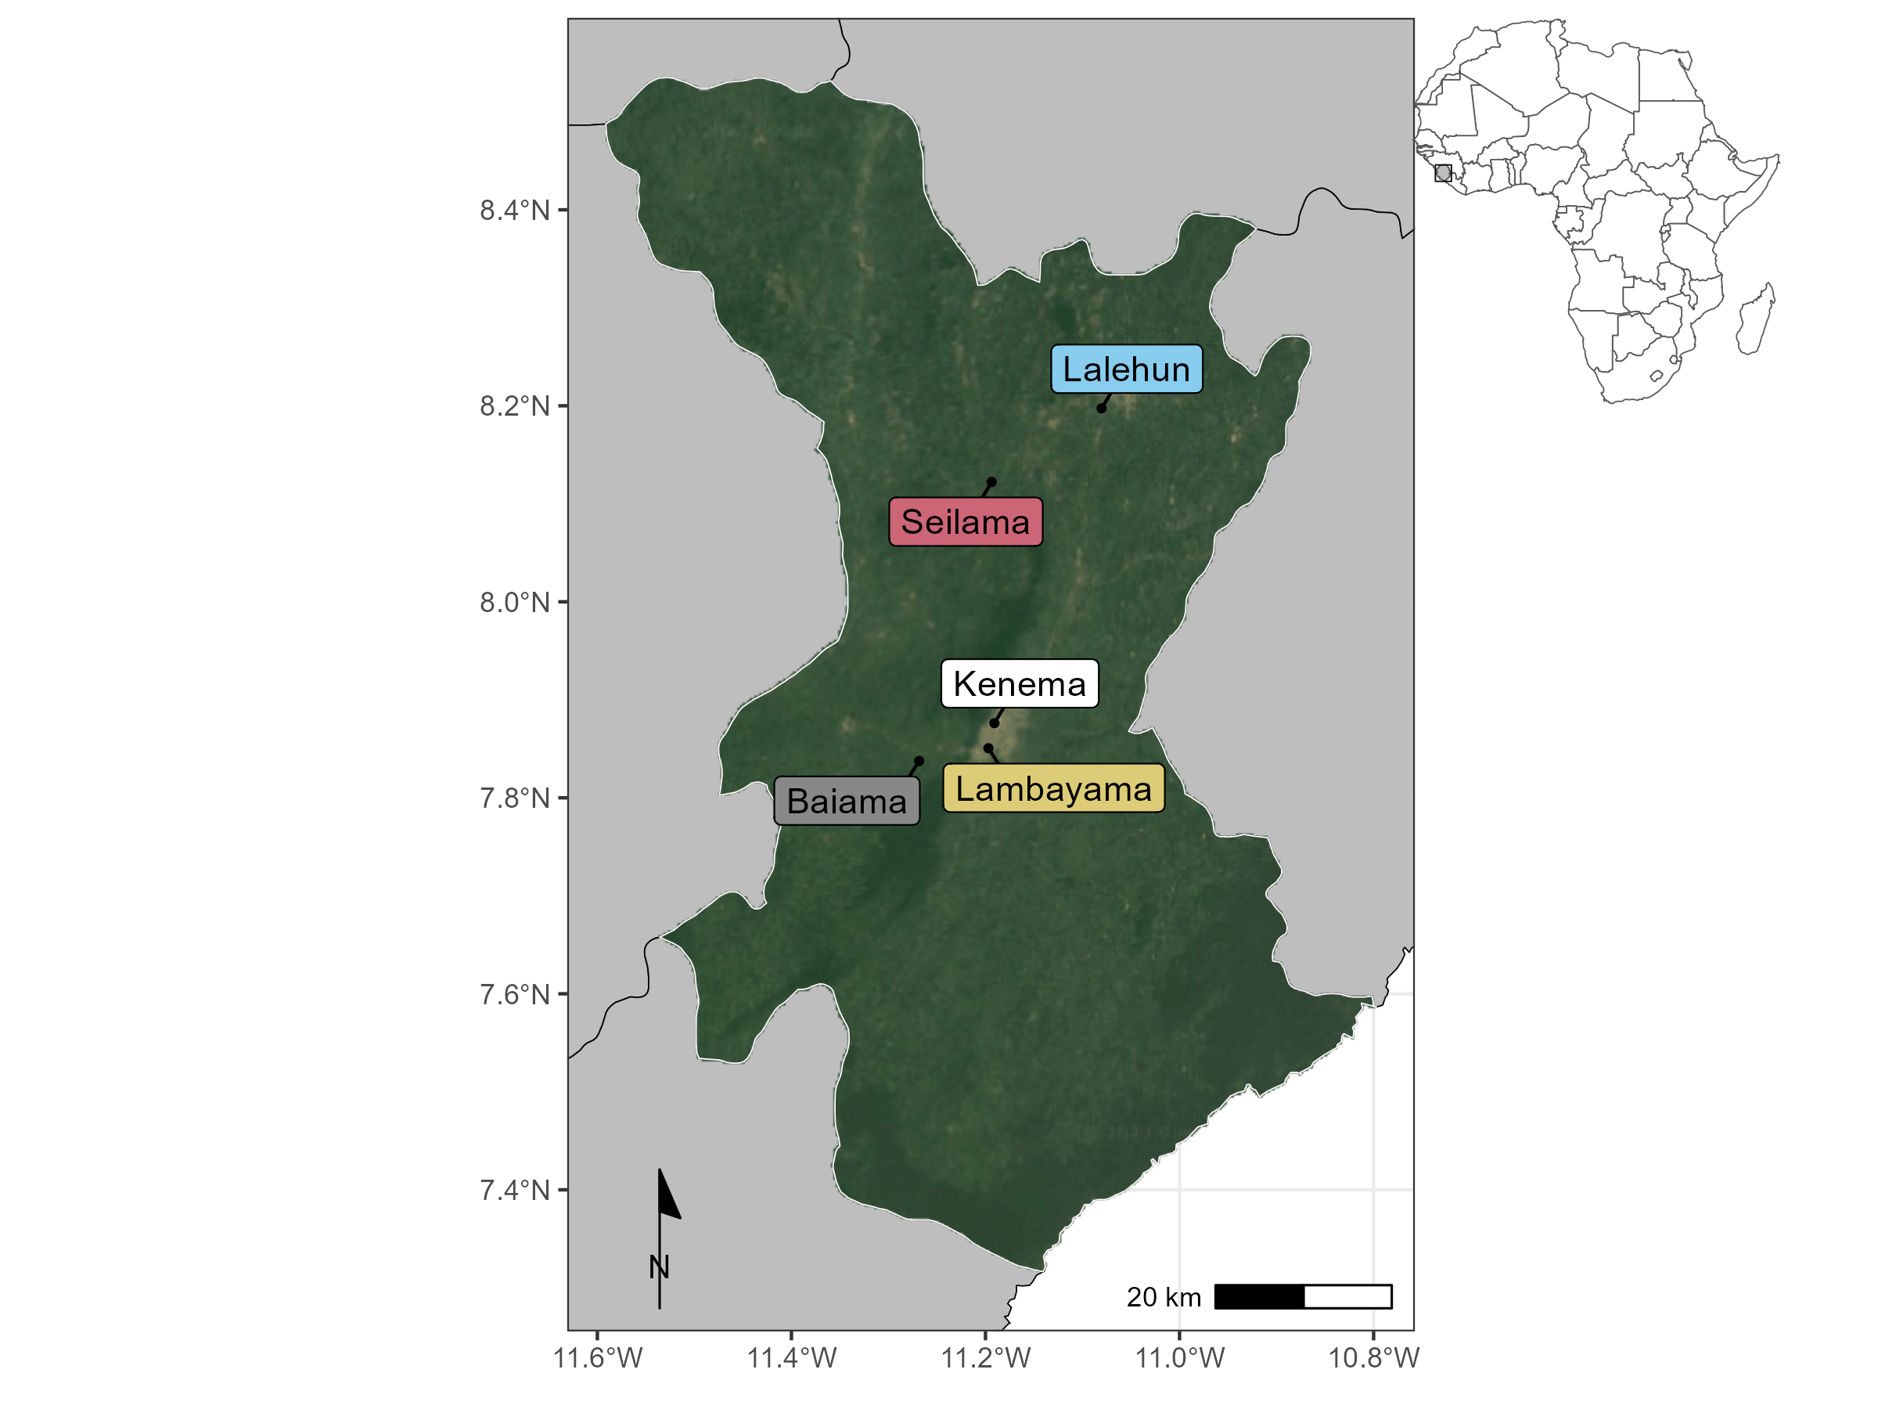

Figure 5.1: Locations of rodent trapping study communities within Eastern Province, Sierra Leone. Satellite imagery copyright of TerraMetrics 2023

Study sites were selected to be representative of land use in the Eastern Province of Sierra Leone and based on accessibility to the sites during all seasons alongside acceptability of the study protocol to the village study site communities (Chapter [3](#_bookmark47) and Appendix [B.3](#_bookmark530)). Briefly, at each trapping grid 49 Sherman traps (7.62cm x 8.89cm x 22.86cm) (H.B. Sherman Traps, Tallahasee, USA), were placed in a 7 trap by 7 trap grid, traps were placed 10 metres apart in a grid conforming to the local landscape (median trapping grid area = 4,813m2). For traps placed within permanent structures trap placement deviated from the grid structure. Permanent structures were selected randomly at each visit from a grid projected over the village area, with four traps placed within each structure. The location of each individual trap within trapping grids was geolocated. Traps were baited with a locally produced mixture of oats, palm oil and dried fish. Each morning the traps were checked and closed for the day prior to re-baiting during the evening. Each trapping survey session consisted of four consecutive trap-nights (TN) at each trapping grid within the village study site. Trapped rodents and shrews were associated with the coordinates of the trap they were detected in. The sf package in the R statistical computing language (R version 4.1.2) was used for geospatial manipulation and analysis ([Pebesma, 2018](#_bookmark418); [R Core Team, 2021](#_bookmark431)).

All small-mammal handling was performed by trained researchers. Rodents and shrews were sedated with

halothane and euthanised prior to obtaining morphological measurements and samples of blood and tissue fol- lowing published guidance ([Fichet-Calvet, 2014](#_bookmark228)). The study protocol was approved by the Clinical Research Ethical Review Board and Animal Welfare Ethical Review Board of the Royal Veterinary College, United Kingdom (URN: 2019 1949-3), and by the Research Ethics Committee of Njala University, Sierra Leone. Carcasses were incinerated after sample collection to eliminate the risk of onward pathogen transmission.

* + 1. Species identification

Species identification was performed in the field based on external characteristics using a taxonomic key, in- cluding external morphological measurements and characteristics, following Kingdon and Happold ([Happold](#_bookmark280) [and Kingdon, 2013](#_bookmark280)) and Monadjem *et al.* ([Monadjem *et al.*, 2015](#_bookmark387)) (Appendix [B.5](#_bookmark533)) Morphological identi- fication alone is unable to distinguish some small-mammal species within the study area at species level. Therefore, molecular identification was performed on whole blood, tissue or dried blood spots. Samples were stored at -20°C until processing, genomic DNA was extracted using QIAGEN DNAeasy kits as per the manufacturers instructions ([QIAGEN, 2023](#_bookmark430)) (Appendix [B.3](#_bookmark530)). DNA extracts were amplified using platinum *Taq* polymerase (Invitrogen) and cytochrome B primers ([Bangura *et al.*, 2021](#_bookmark151)). DNA amplification was assessed through gel electrophoreisis with successful amplification products undergoing Sanger sequencing. Attribution of obtained sequences to rodent species was through the BLAST programme comparing NCBI species records for rodent cytochrome B to our sample sequences ([Altschul *et al.*, 1990](#_bookmark142)) (Appendix [B.3](#_bookmark530)).

* + 1. **Investigating *Lassa mammarenavirus* seroprevalence within small mammal communities**

The BLACKBOX® LASV IgG ELISA Kit (Diagnostics Development Laboratory, Bernhard Nocht Institute for Tropical Medicine), validated for rodent samples was used to determine serological status of trapped rodents and shrews ([Gabriel *et al.*, 2018](#_bookmark243); [Soubrier *et al.*, 2022](#_bookmark462)). The full protocol is available in Appendix [B.3](#_bookmark530). Briefly, 1µL of whole blood was inactivated by mixing with the provided sample dilution buffer (1:50). Where whole blood was unavailable, blood was extracted from dried blood spots stored on filter paper by incubating with phosphate-buffered saline containing 0.08% Sodium Azide and 0.05% Tween-20 ([Grüner, Stambouli and](#_bookmark269) [Ross, 2015](#_bookmark269)). Samples, alongside negative and positive controls, were incubated on the provided ELISA plates for 24 hours at 4-8 °C in a wet chamber. Following incubation, the plates were washed and incubated for a further hour with 1:10,000 diluted HRP-labelled streptavidin. A final wash was performed prior to the addition of 100µL of 3,3’,5,5’-Tetramethylbenzidine (TMB) substrate to wells, with incubation for 10 minutes. The colorimetric reaction was stopped by adding 100µL of a stop solution.

A deviation from the kit protocol occurred due to the capabilities of local ELISA plate readers. We measured

the optical density (OD) at 450nm and 630nm, as opposed to 450nm and 620nm, this was not expected to have an important effect on absorbance patterns, as advised by the manufacturer The index value was produced from the OD difference (OD450-OD630) divided by the cut-off values (the mean values of the negative controls + 0.150). Samples were considered positive with index values greater or equal to 1.1, negative results less than or equal to 0.9, and inconclusive results when the index value lay between 0.9 and

1.1. Inconclusive results were repeated as advised by the kit manufacturers.

* + 1. Describing small mammal community networks

Species contact networks were reconstructed from the trapping data. Capture-mark-recapture (CMR) meth- ods have previously been used to identify space-sharing by individuals ([Carslake *et al.*, 2005](#_bookmark188); [Clay *et al.*,](#_bookmark194) [2009](#_bookmark194); [Wanelik and Farine, 2022](#_bookmark488)). Within our study system a CMR design was not possible due to the risk of releasing an infected individual back into a human community. We therefore consider that rodents expe- rience direct or indirect contacts with other individuals through detections at trapping locations co-located in time and space ([Perkins *et al.*, 2009](#_bookmark422)). We assumed these potential contacts were suﬀicient to transmit LASV if they were trapped within a buffer zone of 30m radius (2,828 m2) from the location of the trap during the same 4 trap night session. A 30m radius was selected to encompass the potential home range of an individual. A strong assumption underlying this approach is that an individual was trapped at the center of their home range ([Wanelik and Farine, 2022](#_bookmark488)). This buffer was applied to all species, further assuming that each species shared the same size home range.

We assessed the appropriateness of the choice of 30m as our buffer radius using the HomeRange R package (version 1.0.2) ([Broekman *et al.*, 2023](#_bookmark181)). This software contains a dataset on the home ranges of 960 species, including 265 rodent and 17 shrew species. Four of these rodent species are included in our trapping data namely, *M. natalensis* our primary species of interest, *Lemnisomys striatus*, *Mus musculus* and *Rattus rattus*. For these species a 30m buffer is expected to contain the entirety of *M. natelensis* home ranges (mean home range = 419m2) and greater than 50% of the area of the home range of the remaining species (*L. striatus* = 83%, *M. musculus* = 92%, *R. rattus* = 52%). To assess the importance of the assumption of buffer radius defining contacts and subsequent analyses we performed sensitivity analyses using buffer areas of 15m and 50m.

Networks were constructed from observed individuals (nodes) and the presence or absence of contacts between them (edges). Data were aggregated for land use type and sampling visit producing a potential 32 distinct networks from 201 trapping grid, village and visit combinations. However, as there were no detected rodents in three of the networks produced from forest sites, only 29 networks were used in subsequent analysis.

We first explore these network properties stratified by land use type, reporting species richness (number of different species), the number of nodes, the number of edges, mean node degree (i.e., the number of connections to other nodes in the network), and mean betweenness centrality (i.e., the number of times a node lies on the shortest path between other nodes) (Appendix [D.1](#_bookmark544)). Descriptions of degree are reported at the global (i.e., network-level) and node-level (i.e., degree centrality). We then describe these contact networks stratified by small mammal species, reporting the degree distribution of contacts by species and investigating differences across a land use gradient. We finally explore these species level network characteristics by reporting the proportion of contacts each species has with other species (i.e., proportion of total inter- and intra-specific contacts) stratified by land use.

* + 1. Modelling the probablity of inter- and intra-specific contact rates in *Mastomys natal- ensis* across a land use gradient

To investigate whether land use and species are associated with the probability of a contact between two individuals we model these contacts as Exponential-family Random Graphs (ERGM) ([Hunter *et al.*, 2008](#_bookmark293)). We limit this analysis to *Mastomys natalensis*, the rodent host of LASV. Estimation of ERGM parameters provide an Odds Ratio (OR) for the probability of an edge in a network based on network properties included in the model and nodal attributes. Within our trapping grids only a subset of all individuals are detected in traps. Including unobserved individuals, and therefore unobserved contacts between these individuals aids interpretation of network models, by providing a measure of the total population size that our analytic sample is derived from.

* + - 1. **Incorporating unobserved individuals for modelling inter- and intra-specific *Mastomys natalensis* contacts** Prior analysis of our study system suggests a probability of detection at each trap of less than 10% for 4 trap nights if the species is present in the trapping grid (Chapter [4](#_bookmark66)). Therefore to estimate the abundance of individuals of each species within a trapping grid we modelled abundance (total population size) from repeated count data using an N-mixture model implemented in the unmarked R package (version 1.2.5) ([Royle, 2004](#_bookmark438); [Fiske and Chandler, 2011](#_bookmark239)). The latent abundance distribution can be modelled as a Poisson, negative binomial or zero-inflated Poisson random variable. The abundance distribution was modelled with the number of trap nights and season as replicate dependent detection covariates in addition to location (whether a site was based in a rural or peri-urban setting) and land use type (forest, agriculture or village) as occurrence covariates.

To select the most appropriate model for each species, the Akaike Information Criterion (AIC) of each of the Poisson, negative binomial or zero-inflated Poisson abundance distribution models were compared, with

the best fitting model used to derive the estimated abundance. The median estimated abundance from the produced distribution at a trapping grid was then used to generate the unobserved individuals within each network aggregated to land use type. The number of observed individuals was then subtracted from the abundance to derive the number of unobserved individuals of each species. These unobserved individuals were explicitly set to have missing (i.e., unobserved) edge values.

Finally, the constructed adjacency matrices were converted to networks using the network R package (version 1.13.0.1) for subsequent ERGM modelling ([Butts, 2008](#_bookmark183)).

* + - 1. **Network models to estimate the probability of inter- and intra-specific contact rates** ERGMs were specified for each of our inferred contact networks to compare the probabilities of edges forming based on rodent characteristics (i.e., species). The general model is shown in Equation ([5.1](#_bookmark109)):

P (Y = y) ∝ exp (𝜃1𝑔1 (y) + 𝜃2𝑔2 (y) + ... + 𝜃𝑝𝑔𝑝 (y)) (5.1)

Where 𝑝 is the number of terms in the model, the values of the coeﬀicients 𝜃 represent the size and direction of the effects of the covariates 𝑔(y) on the overall probability of an edge being present in the network. At the edge level the expression for the probability of the entire graph can be re-expressed as the conditional log-odds of a single edge between two nodes (a contact between two rodents) as in Equation ([5.2](#_bookmark110)).

logit (P (Y𝑖𝑗 = 1|y𝑐 )) = 𝜃′𝛿 (y ) (5.2)

𝑖𝑗 𝑖𝑗

Here Y𝑖𝑗 is the random variable for the state of the node pair 𝑖𝑗 and 𝑦𝑐

𝑖,𝑗

signifies all dyads in the network

other than 𝑦𝑖,𝑗. 𝜃′ is the coeﬀicient for the change production of an edge between the two nodes conditional on all other dyads remaining the same (𝛿(y𝑖𝑗)).

ERGMs are implemented using the ergm package (version 4.3.2) in R ([Handcock *et al.*, 2022](#_bookmark278)). Three terms were included in the final ERGM to model the probability of the formation of ties (Equation ([5.3](#_bookmark111))). The first term (edges), describes the density of the network and is the probability of a tie being observed in the network. The second term (species), is the conditional probability of a tie forming conditional on the species of the nodes. The third term (species homophily), is the conditional probability of a tie forming accounting for intraspecific tie formation among rodent individuals (i.e., the conditional probability of two individuals of the same species forming a tie). To reduce linear dependency of the nodal terms and due to data sparsity within our inferred networks all non-*M. natalensis* are grouped as “Other species” through the levels term

of the nodal covariates for the analysis of the effect of land use on the probability of inter- or intra-specific contacts for *M. natalensis*.

P (Y = y) ∝ exp (𝜃edges𝑔edges (y) + 𝜃species𝑔species (y) + 𝜃homophily𝑔homophily (y)) (5.3)

ERGMs were implemented on the individual networks for each land use type at each visit. We pooled the effect sizes of each model through random-effects meta-analysis stratified by land use to produce a land use specific summary effect size for each coeﬀicient ([Riley, Higgins and Deeks, 2011](#_bookmark436)). Inclusion in meta-analysis was limited to ERGMs producing stable estimates for each of the model terms (i.e., suﬀicient detections of *M. natalensis* within the network). Random-effects models were conducted using the metafor package (version 4.0.0) in R ([Viechtbauer, 2010](#_bookmark483)). The amount of heterogeneity was assessed using the 𝑄-test for heterogeneity and restricted maximum-likelihood estimator (𝜏 2) with a prediction interval for the true outcomes produced ([Cochran, 1954](#_bookmark196); [Riley, Higgins and Deeks, 2011](#_bookmark436)). Weights for each network included in meta-analysis were assigned using inverse-variance weights ([Borenstein *et al.*, 2010](#_bookmark170)). The presence of influential networks was assessed using Cook’s distance, for models including influential networks leave-one-out sensitivity analysis were performed ([Cheung, 2019](#_bookmark192)). Forest plots were produced to visualise the summary OR of the probability of a tie for each model term stratified by land use type.

Models with unstable estimates for the species homophily term were not included in the random-effects meta-analysis. No contact networks from forest land use contributed to meta-analysis as no *M. natalensis* were detected in these settings. Five models from agricultural settings and eight from village settings were included in meta-analysis.

* + 1. Association of *Lassa mammarenavirus* seropositivity and position within a small- mammal community contact network

To investigate pathogen transmission within our networks using our proxy of seropositivity for prior exposure we first report the small-mammal species found contain individuals seropositive for LASV. We then compared the nodal degree of seropositive and seronegative individuals using a Wilcoxon rank sum test with continuity correction ([Bauer, 1972](#_bookmark154)). We repeated this analysis stratifying by species to investigate if contact rates are associated with an individual being seropositive. Finally, we compared the node-level betweenness of seropositive and seronegative individuals to investigate whether an individuals position within a structured contact network was associated with prior exposure to LASV.

Table 5.1: The number of individuals detected and antibodies to Lassa mammarenavirus among those individuals by species.

|  |  |  |  |
| --- | --- | --- | --- |
|  | | (%) | individuals |
| *Mastomys natalensis* | 113 | 11 (9.7%) | 28.2% |
| *Crocidura olivieri* | 105 | 8 (7.6%) | 20.5% |
| *Lophuromys sikapusi* | 57 | 8 (14%) | 20.5% |
| *Rattus rattus* | 88 | 4 (4.5%) | 10.3% |
| *Mus setulosus* | 43 | 3 (7%) | 7.7% |
| *Praomys rostratus* | 102 | 2 (2%) | 5.1% |
| *Malacomys edwardsi* | 11 | 1 (9.1%) | 2.6% |
| *Hybomys planifrons* | 7 | 1 (14.3%) | 2.6% |
| *Mastomys erythroleucus* | 4 | 1 (25%) | 2.6% |
| *Mus musculus* | 90 | 0 (0%) | 0% |
| *Crocidura buettikoferi* | 23 | 0 (0%) | 0% |
| *Crocidura grandiceps* | 15 | 0 (0%) | 0% |
| *Lemniscomys striatus* | 11 | 0 (0%) | 0% |
| *Hylomyscus simus* | 9 | 0 (0%) | 0% |
| *Crocidura theresae* | 3 | 0 (0%) | 0% |
| *Gerbilliscus guineae* | 2 | 0 (0%) | 0% |
| *Dasymys rufulus* | 1 | 0 (0%) | 0% |

Species N1 LASV Antibody detected Percentage of all positive

*Note:*

The consensus result of antibody testing is reported for samples producing equivocal results.

1 Number of rodents tested (N)

##### Results

Overall 684 small mammals were trapped from 43,266 trap-nights. Seventeen species were identified, 13 of which were rodent species (76%) with four species of insectivorous shrews identified (24%). *M. natalensis* was the most commonly detected species (N = 113, 16.5%), followed by *Crocidura olivieri* (N = 105, 15.3%) and *Praomys rostratus* (N = 102, 15%) (Table [5.1](#_bookmark113)).

* + 1. **Prevalence of *Lassa mammarenavirus* antibodies within small mammal communities**

Antibodies to LASV were identified in 39 rodents (39/684, 5.7%) from 9 species, including *M. natalensis* (11/39, 28%), 5 *C. olivieri* (8/39, 21%), 8 *Lophuromys sikapusi* (8/39, 21%) and 4 *Rattus rattus* (4/39, 10%) (Table [5.1](#_bookmark113)). The highest proportion of positivity was observed in *Mastomys erythroleucus* (1/4, 25%), *Hybomys planifrons* (1/7, 14.3%), *L. sikapusi* (8/57, 14%) and *M. natalensis* (11/113, 10%).

Rodents with antibodies to LASV were detected in three of the study villages, Lalehun (N = 18, 46%), Seilama (N = 12, 31%) and Baiama (N = 9, 23%). Lalehun had the highest percentage of antibody positive rodents (18/157, 12%), followed by Baiama (9/121, 7%) and Seilama (12/263, 5%), no positive rodents were detected in the most urbanised village Lambayama.

Antibody positive rodents were detected in all land use types, most positive rodents were trapped in agri- cultural (24/39, 62%), followed by village (13/39, 33%) and forest (2/39, 5%) settings. The proportion of antibody positive individuals among all rodents trapped were similar across forest (2/44, 4.5%), agricultural (24/379, 6.3%) and village (13/261, 5%) land use types. Antibody positive rodents were detected during all study visits except visit 9 (2023-February), the proportion of rodents seropositive individuals were sig- nificantly greater in the rainy season (23/240, 9.6%) than the dry season (16/444, 3.6%) (𝜒2 = 9.28, *p* = 0.002).

* + 1. Small mammal community contact networks

Networks constructed from rodents trapped in agricultural land use contained the highest species richness (12), followed by villages (9) and forests (6). More individuals (nodes) were detected in agricultural land use (N = 379) than villages (261) and forests (44). The mean global degree within a network was positively associated with the number of nodes within the network. Networks in village settings had the highest global degree (mean degree = 6.2, standard deviation (SD) = 4.6) compared to forest and agricultural settings (mean = 5.1, SD 3.3 and mean = 4.9, SD = 5.4 respectively). Agricultural and village settings contained the individual nodes with the highest degree centrality (24 and 20 respectively). Mean betweenness centrality, followed an anthropogenic land use gradient, it was highest in villages (mean betweenness = 3.06, standard deviation (SD) = 10.2), followed by agriculture (mean = 0.46, SD = 2.6) and forest (mean = 0.07, SD = 0.16).

There was substantial variability in degree centrality within detected rodents and shrew species. Species more commonly found in agricultural settings had the highest number of detected contacts. Individuals from *L. sikapusi*, *M. setulosus*, *P. rostratus* and *C. olivieri*, three native rodent species and a shrew species had a degree centrality of up to 24, although most individuals of these species had a lower degree (Table 1. and Figure 2.). Within villages *Mus musculus*, an invasive, synanthropic rodent species had a degree centrality of up to 20 and a high median degree across all individuals of the species. Interestingly, *M. natalensis*, while commonly detected in both agricultural and village settings had a lower maximum degree centrality of 12 in villages and 9 in agriculture. The median degree centrality was similar across village and agricultural settings (5 and 4 respectively).

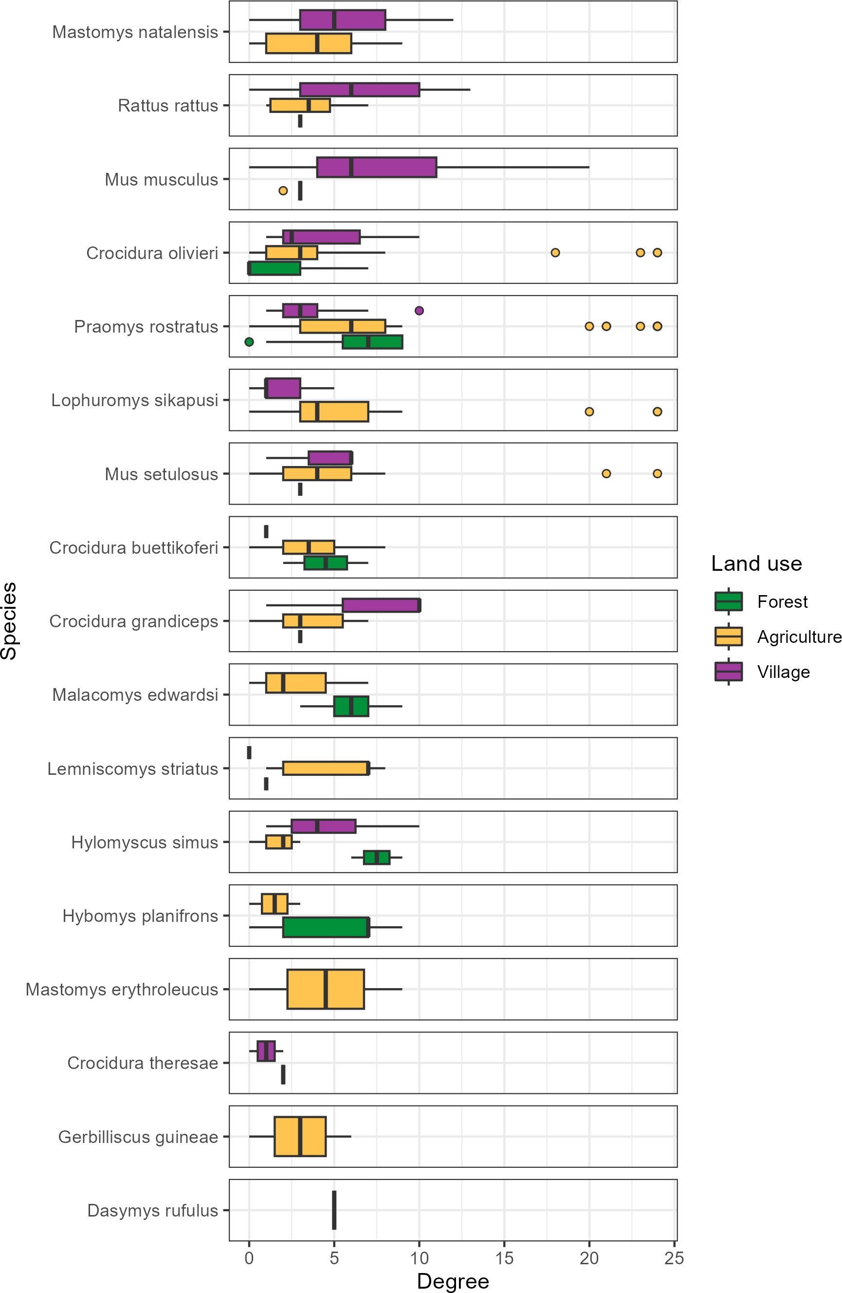

Figure 5.2: The degree centrality of individual small mammals stratified by species and land use type. Boxes contain the median and inter-quartile range of the degree distribution. Whiskers include the upper and lower quartile with outliers shown as points.

There was no consistent trend across all species of degree centrality varying with a land use gradient (Figure

[5.2](#_bookmark117)). For commensal species including *M. natalensis*, *Rattus rattus* and *M. musculus* median nodal degree was increased in villages but for *M. natalensis* and *R. rattus* there was no statistically significant difference between the degree distribution stratified by land use.

* + 1. Describing inter- and intra-specific contact within small mammal communities

Generally, species with more detected individuals had a greater number of contacts with other species (*r(15)*

= 0.62, *p* = 0.007). For example, the frequently detected species, *M. natalensis*, *P. rostratus* and *R. rattus* had contact with more than 13 other species. *M. musculus* is an important outlier to this trend, it was the fourth most observed species but only had observed contacts with four other species (Figure [5.3](#_bookmark119) and Appendix [D.2](#_bookmark548)).

Intra-specific contacts were common for most species. However, there was some important difference across land use type. *Mastomys natalensis* had contact with 13 other species in agricultural land use, but 45% of all observed contacts to this species were from other individuals of the same species (Figure 3.). However, in villages where fewer other species were contacted (9), the percentage of intra-specific contacts was lower at 31% (Appendix [D.2](#_bookmark548)). Not all species were observed to have a majority of intra-specific contacts. In compar- ison, *L. sikapusi* in agricultural settings also had contact with 13 other species, but a similar proportion of contacts to individuals of this species came from *P. rostratus* (27%) as from other individuals of *L. sikapusi* (26%).

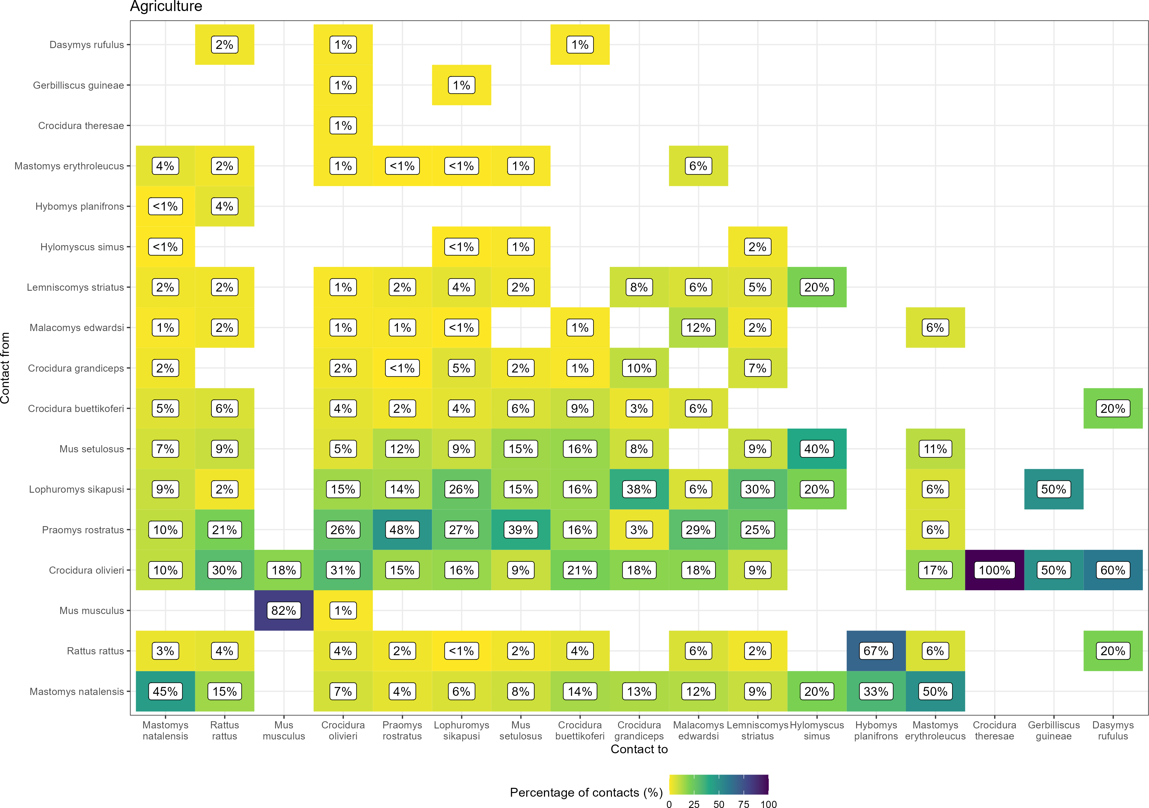

Figure 5.3: The proportion of contacts between small mammal species in agricultural land use. Darker colours indicate increasing proportions of observed contacts to a species from named a species. Percentages in the cells correspond to the proportion of contacts to a species from a named species.

* + 1. The probability of inter- and intraspecific contact rates of *Mastomys natalensis* across a land use gradient

Limiting our analysis of the probability of a contact being observed to the reservoir species of LASV, *M. natalensis*, resulted in 12 ERGM models of the constructed networks being suitable for random effects meta- analysis. The odds of a contact being observed in these networks were generally low with similar odds across both agricultural (Odds Ratio = 0.14, 95% Confidence Interval = 0.09-0.23, *p* < 0.001) and village land use (OR = 0.24, 95% C.I. = 0.17-0.36, *p* < 0.001) (Figure [5.4](#_bookmark121)A). There were high levels of heterogeneity in the odds of a contact being observed between networks from different visits for both agricultural and village settings (𝜏a2griculture = 0.26, 𝑄 = 112, *p* < 0.001 and 𝜏v2illage = 0.23, 𝑄 = 54, *p* < 0.001). Compared to other rodent species *M. natalensis* formed fewer contacts.

*Mastomys natalensis* had a non-statistically significant reduced odds of having contact with a different species (i.e., an inter-specific contact) in agricultural (OR = 0.49, 95% C.I. = 0.24-1.01, *p* = 0.054) and village settings (OR = 0.74, 95% C.I. = 0.55-1.01, *p* = 0.055) when compared to inter-specific contacts among other species in these communities (Figure [5.4](#_bookmark121)B). There were high levels of heterogeneity in the odds of inter-specific contacts being observed between networks (𝜏a2griculture = 0.59, 𝑄 = 31, *p* < 0.001 and 𝜏v2illage = 0.09, 𝑄 =

15, *p* = 0.03). *Mastomys natalensis* did not importantly differ from other species in their probability for inter-specific contacts, with no observed effect of land use.

Finally, *M. natalensis* had a statistically significantly increased odds of forming contacts with other *M. natalensis* individuals (i.e., an intra-specific contact) in agricultural (OR = 7.5, 95% C.I. = 3.42-16.5, *p* < 0.001) but not in village settings (OR = 1.69, 95% C.I. = 0.85-3.36, *p* = 0.13) when compared to inter- specific contacts among non-*M. natalensis* species (Figure [5.4](#_bookmark121)C). There was no substantial heterogeneity in the analysis of the odds of intra-specific contacts (𝜏a2griculture = 0.22, 𝑄 = 5.6, *p* = 0.23 and 𝜏v2illage = 0.39, 𝑄

= 12, *p* = 0.1) in both land use types. *Mastomys natalensis* compared to other small mammal species was

more likely to have intra-specific contacts within communities in agricultural but not village settings.

In the first sensitivity analysis, altering the radius in which a contact was defined, there was no change in direction of the effect sizes for the random-effects meta-analysis. There were no important changes in effect size direction or magnitude in leave-one-out sensitivity testing for meta-analyses containing influential networks. The results of these sensitivity analyses suggest that our results are robust to our assumption of contact buffer range and changes to the rodent community over study visits.

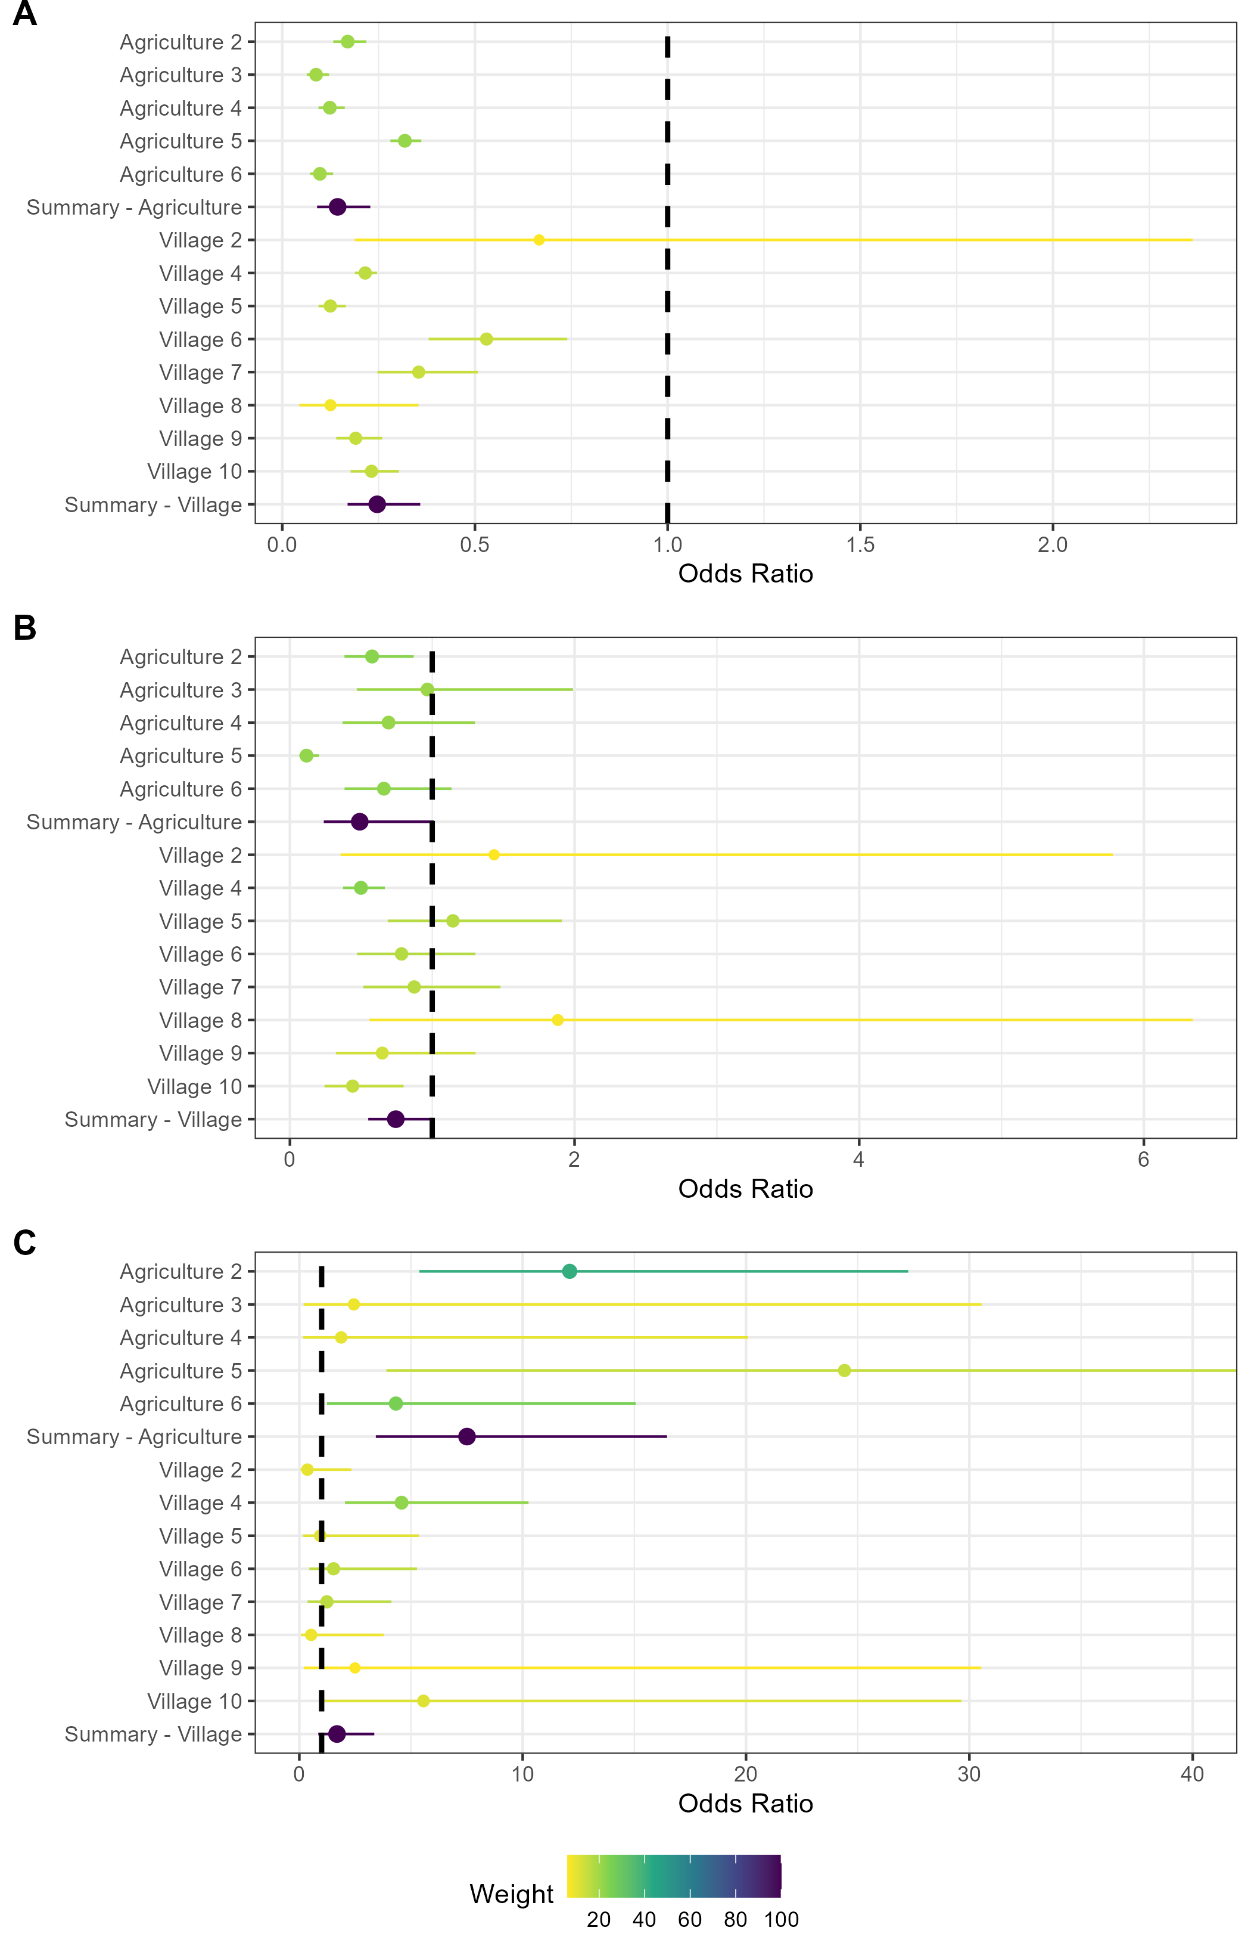

Figure 5.4: Random effects meta-analysis of ERGMs estimating the odds of a contact being observed for *M natalensis*. Points represent the weighted estimate of the pooled effect size, whiskers encompass the 95% Confidence Interval. A) The odds ratio of a contact being observed for *M. natalensis* in Agricultural or Village land use types. B) The odds ratio of a contact being observed between *M. natalensis* and an individual of a different rodent species. C) The odds ratio of a contact being observed between *M. natalensis* and another *M. natalensis*.

* + 1. Association of *Lassa mammarenavirus* seropositivity and position within a small- mammal community contact network

The mean degree centrality of LASV seropositive rodents and shrews (mean = 3.7, SD = 2.9) was statistically significantly lower than the seronegative mean degree (mean = 5.5, SD = 5.1) (W = 9834.5, *p* = 0.049). Statistical tests to investigate the degree of seropositive and seronegative individuals stratified by species were only performed for three species with more than five seropositive individuals (i.e., *M. natalensis*, *L. sikapusi* and *C. olivieri*). There was no statistically significant difference in the degree centrality of LASV seropositive and seronegative individuals for *M. natalensis* (W = 160.5, *p* = 0.51) or *C. olivieri* (W = 0.98, *p* = 0.43) but seropositive *L sikapusi* had statistically significantly lower degree centrality than seronegative individuals (W = 92, *p* = 0.02).

There was no statistically significant difference in the betweenness centrality of seropositive and seronegative individuals, nor when compared between seropositive and seronegative individuals within species for those with more than five seropositive individuals.

##### Discussion

In our study within the Eastern Province of Sierra Leone, we found that small-mammal community contact networks while generally larger in village and agricultural settings had similar rates of contact across a land use gradient from forest, through agriculture to villages. We found that while some individual rodents and shrews had a high number of contacts, most had fewer than 5 contacts, indicating sparse networks. There was no clear difference in degree centrality by species across different land use types. For *M. natalensis* specifically, we observed a high probability of the formation of intra-specific contacts preferentially occurring within agricultural settings. The finding of increased intra-specific contact rates among the reservoir species in agricultural settings may suggest that these locations are the foci of LASV transmission. Finally, we found low prevalence of seropositivity to LASV within these small-mammal communities in four villages in the Eastern Province of Sierra Leone. Antibodies to LASV were detected in 9 rodent and shrew species with the majority of seropositive individuals belonging to *M. natalensis*. We found that seropositive individuals had reduced degree centrality, but that this population-wide association wasn’t replicated at the species-level for most species.

We hypothesised that rodent contact rates would be greater in anthropogenically dominated habitats. Our findings did not support this, with an equivalent global degree observed across a land use gradient. However, the individuals with the highest degree centrality were detected in village and agricultural settings. The

node-level heterogeneity of these networks is masked when only considering aggregated global descriptive metrics.

Small-mammal communities were found to have higher species richness in agricultural land. Species detected within these settings encountered a greater number of distinct species and had a generally higher propor- tion of inter-specific contacts. Several native rodent species (e.g., *P. rostratus*), particularly in agricultural settings, appeared to contain individuals that were members of more densely connected sub-components of the networks within these small-mammal communities, evidenced by high degree centrality for specific individuals. It may be that contact rates within species are heterogeneous and species-level measurements will mask the individual-level differences in contact rates ([Farine and Whitehead, 2015](#_bookmark225)).

The idiosyncratic nature of these networks is also shown through their different structures across the land use gradient. For example, we found higher betweenness centrality in villages, compared to agricultural or forest settings. This indicates that these networks have a structure that is more discontinuous and fragmented than those in other land use settings. The high betweenness centrality in village settings, will moderate pathogen transmission through the network as some individuals are more influential in bridging sub-components of the network.

The results of our descriptive network analysis suggest that contact within small mammal communities occurs at similar rates across different land use types but that networks within villages are more discontinuous. Agricultural habitats provide opportunities for synanthropic and sylvatic species to interact, as evidenced by the high proportion of inter-specific contacts for most species in these locations. This, combined with the low betweenness centrality of nodes in agricultural land suggest that a pathogen (i.e., LASV) would be effectively transmitted among competent hosts within these well-connected networks.

*Mastomys natalensis* was found to have fewer contacts than the other rodent species within small-mammal communities in agricultural and village settings. When contacts were observed for this species in agricultural settings, they had a higher odds of being intra-specific contacts. This was not replicated in village settings where inter-specific contacts were more common. This is supported by prior research showing that *M. natalensis* does not exhibit strong territorial responses, similar to *R. rattus* but in contrast to *M. musculus* ([Anderson, 1961](#_bookmark146); [Whisson, Quinn and Collins, 2007](#_bookmark492); [Borremans *et al.*, 2014](#_bookmark172)).

Homophily in contacts of *M. natalensis* (i.e., intra-specific contacts) may be important for viral transmission if other species are not as effective hosts for LASV replication and transmission ([Luis, Kuenzi and Mills,](#_bookmark352) [2018](#_bookmark352)). For example, if an infected individual *M. natalensis* resides in an agricultural setting it will have higher odds of transmitting LASV to a contact capable of maintaining a chain of transmission (i.e., another

individual of *M. natalensis*), compared to an individual that was located in a village that would have higher odds of contacting a non-*M. natalensis* individual. This may result in different pathogen dynamics by land use type. This is an important avenue for future research as such differences could impact the effectiveness of rodent control interventions to reduce zoonosis risk ([Garry, 2023](#_bookmark248)).

Local pathogen extinction may be more likely in agricultural settings following viral introduction. High connectivity within the networks in these settings could lead to a greater force-of-infection where a single infected individual leads to an increased number of secondary infections ([Keeling and Eames, 2005](#_bookmark315)). If this transmission were to occur at a faster rate than population births (i.e., replenishment of susceptible individ- uals), population level immunity would be rapidly reached, leading to local pathogen extinction ([Messinger](#_bookmark379) [and Ostling, 2009](#_bookmark379); [Guzzetta *et al.*, 2017](#_bookmark270)). The same may not be the case in village settings where an infected rodent will have fewer contacts, thus LASV transmission may be at a rate below the rate of replenishment of susceptible individuals ([Peel *et al.*, 2014](#_bookmark420)). In this scenario, the pathogen would be maintained in the population. This may be complicated further by migration of individuals between agricultural and village settings based on resource availability as has been reported elsewhere in the Lassa fever endemic region ([Mari](#_bookmark360) [Saez *et al.*, 2018](#_bookmark360)). The risk of Lassa fever outbreaks in human communities is therefore likely governed by dynamic contacts among susceptible and infectious rodents in the local environment.

The number and proportion of seropositive rodents and shrews detected in the current study, while low (5.7%), was similar (2.8%) to that reported by another study that sampled small-mammal populations in Eastern Sierra Leone ([Bangura *et al.*, 2021](#_bookmark151)). Comparison of these studies is limited by different sampling design, for example, the current study sampled rodents in forest environments and locations more distant from areas of human habitation. The proportion of all seropositive individuals that were *M. natalensis* (28%) was lower in our study than in the study conducted in the neighbouring district (75%) although the proportion of all *M. natalensis* that were antibody positive was more similar (9.7% compared to 8%). We similarly identified antibodies in other rodent species including, *L. sikapusi* and *R. rattus*. Antibodies to LASV were identified in four further rodent and shrew species, *C. olivieri*, *M. setulosus*, *Hybomys planifrons* and *Mastomys erythroleucus* that were not reported from the Bangura study ([Bangura *et al.*, 2021](#_bookmark151)). Antibodies to LASV have not previously been reported in *M. setulosus*, although they have been detected in other pygmy mice species (e.g., *Mus musculoides*) ([Bangura *et al.*, 2021](#_bookmark151)). Our results support previous studies’ findings that evidence of prior acute infection is present in multiple species simultaneously within small-mammal communities in the Lassa fever endemic region ([Demby *et al.*, 2001](#_bookmark209); [Agbonlahor *et al.*, 2017](#_bookmark134); [Bangura *et al.*,](#_bookmark151) [2021](#_bookmark151)).

We did not detect a suﬀicient number of seropositive individuals to directly model the transmission networks

of LASV through our small-mammal communities in these different land use settings. Ideally transmission networks would be developed from acute infection data rather than seroprevalence, given the time varying structure of dynamic contact networks. Based on studies suggesting that fewer individuals will be PCR positive than seropositive, it is unlikely that suﬀicient data would be available to parameterise models of transmission networks without substantially increasing the number of sampling periods and locations ([Demby](#_bookmark209) [*et al.*, 2001](#_bookmark209); [Olayemi *et al.*, 2016](#_bookmark406); [Bangura *et al.*, 2021](#_bookmark151)). Future studies in the Eastern Province of Sierra Leone will benefit from recent studies, including this one, when estimating sample sizes required to parameterise transmission models.

Several important assumptions were made that must be considered when contextualising the results of this research. First, we were unable to explicitly observe direct and indirect contacts among rodents in our study. To infer these contacts, we utilised co-location of trapped individuals in time and space ([Perkins *et*](#_bookmark422)[*al.*, 2009](#_bookmark422)). This assumed that individuals were detected at the centroid of their home range and that they spend an equivalent amount of time at all points within the area of their home range ([Wanelik and Farine,](#_bookmark488) [2022](#_bookmark488)). It is unlikely that this assumption holds true in our study system and this will lead to different contact rates than we infer in our networks ([Wanelik and Farine, 2022](#_bookmark488)). Modifications to the current study design to explore the impact of these assumptions could include radio tagging or fluorescent marking to monitor rodent contacts in real-time ([Mohr *et al.*, 2007](#_bookmark384); [Clay *et al.*, 2009](#_bookmark194); [Borremans *et al.*, 2017](#_bookmark173)). Second, only a small proportion of rodents and shrews active within a study site would be detected by our trapping activity ([Parmenter *et al.*, 2003](#_bookmark416); [Moore and Swihart, 2005](#_bookmark389)). We account somewhat for the impact this will have on our network models by inferring the total abundance of species within these sites ([Silk and Fisher,](#_bookmark453) [2017](#_bookmark453); [Vega Yon, Slaughter and Haye, 2021](#_bookmark482)). However, if individuals that were detected display importantly different behaviours than those not detected then inferring across these populations may be problematic. For example, if trap shyness is associated with inter- or intra-specific space sharing then detection of less trap shy individuals may overestimate the number of contacts individuals of a species are likely to make. It would be illustrative to replicate the findings of this study on small-mammal networks elsewhere in the Lassa fever endemic region to assess the impact of these assumptions among others.

In conclusion this study has highlighted the variability of inter- and intra-specific contact rates between different rodent and shrew species in different land use types in a setting of rodent associated zoonosis risk. We propose that the wider small-mammal community produces a more complex transmission network for LASV than previously assumed. These findings may highlight the mechanism through which the wide variety of rodent and shrew species found to be seropositive for LASV may have been infected. This could have important implications for the control of Lassa fever risk to human populations as there is likely to be a

complex interaction between pathogen transmission within differently structured rodent networks in areas of human habitation and the wider landscape.

## Conclusions and future research directions

This thesis provides new insights into the role of rodent ecology on LASV transmission and subsequent spillover into human populations in Sierra Leone through examining the association of anthropogenic land use change with rodent community structure. The methods used in this thesis to address the research questions included a literature review and synthesis of publicly available data from rodent trapping studies across West Africa and primary data collection through systematic rodent trapping in a Lassa fever endemic region of Eastern Sierra Leone. This final chapter summarises the key findings from the thesis and reflects on the general strengths and limitations of the work, with more detailed issues pertaining to each study covered at the end of each chapter. The final sections of this chapter focus on the implications of the work conducted for the understanding of Lassa fever epidemiology and provide suggestions for future research.

##### Principle findings of the thesis

Limited primary data from rodent trapping studies conducted in Sierra Leone hinders our understanding of the Lassa fever disease system ([Monath *et al.*, 1974](#_bookmark388); [McCormick *et al.*, 1987](#_bookmark374); [Mahy, 1992](#_bookmark355); [Barnett *et*](#_bookmark152)[*al.*, 2000](#_bookmark152); [Leski *et al.*, 2015](#_bookmark340); [Bangura *et al.*, 2021](#_bookmark151)). Few comprehensive rodent ecological studies have been designed to investigate the role of the broader rodent community in LASV transmission ([Demby *et al.*, 2001](#_bookmark209); [Fichet-Calvet *et al.*, 2005](#_bookmark230); [Mariën *et al.*, 2018](#_bookmark364); [Mariën *et al.*, 2020](#_bookmark363)). Much of the available data come from opportunistic sampling of rodents following Lassa fever outbreaks in human communities ([Monath *et al.*,](#_bookmark388) [1974](#_bookmark388); [Wulff, Fabiyi and Monath, 1975](#_bookmark508); [Safronetz *et al.*, 2010](#_bookmark439); [Yadouleton *et al.*, 2019](#_bookmark509); [Happi *et al.*, 2022](#_bookmark279)). Therefore, Chapter [2](#_bookmark21) set out to conduct a scoping review and quantitative synthesis of existing trapping studies to assess the current state of rodent and rodent-associated pathogen sampling across West Africa. The data from the included studies were compiled into a database, made available for reuse by the scientific and public health community ([Simons, 2022a](#_bookmark452)). The scoping review found that primary rodent trapping studies are needed to can effectively complement existing datasets (i.e., IUCN and GBIF) by expanding the geographic areas sampled. It also identified regions and host-pathogen associations that have been relatively under-sampled, thus limiting the inference that can be drawn from available datasets. Furthermore, the developed measure of relative sampling bias generated as part of the scoping review in Chapter [2](#_bookmark21) can be used to adjust for spatial and taxonomic biases in future dynamical systems models, improving the prediction of zoonosis emergence risk.

The findings from Chapter [2](#_bookmark21) and the previous literature, indicate that multiple rodent host species likely contribute to LASV transmission and maintenance among rodent populations ([Wulff, Fabiyi and Monath,](#_bookmark508) [1975](#_bookmark508); [Demby *et al.*, 2001](#_bookmark209); [Fichet-Calvet *et al.*, 2014](#_bookmark229); [Olayemi *et al.*, 2016](#_bookmark406); [Yadouleton *et al.*, 2019](#_bookmark509)). However,

data remain limited regarding the structure of these rodent populations within multi-species communities, particularly with regards to how the structure of these communities may change across anthropogenic land use gradients. To address this knowledge gap, a two-and-a-half-year rodent trapping study was designed and implemented in a Lassa fever endemic region of Eastern Province, Sierra Leone (Chapter [3](#_bookmark47). This longitudinal study aimed to sample rodent communities across a land use gradient ranging from natural forest settings to agriculture areas and human habitation, with a view to characterise the rodent communities within these habitats. Sampling was conducted at a high temporal resolution to account for expected seasonal dynamics in rodent occupancy and abundance. The findings from the longitudinal study presented in Chapters [4](#_bookmark66) and [5](#_bookmark98) are summarised below.

Chapter [4](#_bookmark66) found that the reservoir host of LASV (*M. natalensis*) had a high probability of occurrence in areas of human habitation and agricultural settings, while being effectively absent from less anthropogenically disturbed forest habitats. However, in locations of high human population density, this species was found to occur at much lower rates than previously expected. If occurrence of *M. natalensis* generates the greatest risk of subsequent human infection with LASV (as suggested by available evidence prior to this study), the risk of LASV spillover from rodent communities would be expected to increase along an anthropogenic gradient from forest to villages ([Bonwitt *et al.*, 2017](#_bookmark168)). However, as indicated by the findings in Chapter [4](#_bookmark66), the magnitude of this risk may be substantially reduced in highly urbanised settings due to the low prevalence of the rodent reservoir host species.

Furthermore, important biotic interactions between species were observed within these rodent communities. For example, the presence of an invasive rodent species (*M. musculus*), exclusively detected in areas with high human population density, exhibited a negative association with the occurrence of *M. natalensis* and other native rodent species. In contrast, the association between another invasive rodent (*R. rattus*) and native rodent species showed common co-occurrence patterns. As supported by long-term studies in Senegal, these findings may be interpreted to suggest that the ongoing range expansion of these invasive species in West Africa will lead to biotic interactions that could influence the distribution of native rodent species across the region ([Dalecky *et al.*, 2015](#_bookmark202); [Lippens *et al.*, 2017](#_bookmark343)). While there is some evidence of LASV infection in both *M. musculus* and *R. rattus*, the contribution to onward transmission among rodents by these two species is currently unknown but expected to be minimal compared with *M. natalensis* ([Demby *et al.*, 2001](#_bookmark209)). Therefore, potential changes in rodent community structure due to land use changes and invasive species range expansion are likely to alter LASV pathogen dynamics within the endemic region and have important implications for the risk of Lassa fever outbreaks.

Chapter [5](#_bookmark98) highlights the heterogenous contact rates within rodent communities in Sierra Leone, which has

an impact on pathogen transmission. The analysis showed that rodent contact networks across the anthro- pogenic land use gradient exhibit characteristics of sparse networks, with a similar number of contacts for each individual rodent. However, there is significant heterogeneity in network structure within and between land use types. Specifically, *M. natalensis* was found to have a higher likelihood of forming intra-specific contacts compared with inter-specific contacts. These differential contact rates could promote pathogen transmission if other species were to be less competent hosts ([Luis, Kuenzi and Mills, 2018](#_bookmark352)). Intra-specific contacts among *M. natalensis* were more prevalent within agricultural settings than in areas of human habi- tation, suggesting that while human infection primarily occurs in human habitation settings, transmission among rodent populations could predominantly occur in agricultural settings. This finding could have impor- tant implications for public health interventions aiming to control the transmission of LASV among rodent populations if rodent control is solely focussed on villages.

Lastly, Chapter [5](#_bookmark98) found lower than expected prevalence of antibodies to LASV in the sampled rodent communities within an area of Sierra Leone considered a highly endemic area for Lassa fever. A total of 684 rodents were trapped over 43,266 trap nights, among which a prevalence of antibodies to LASV of 5.7% was found. This is substantially lower than has been detected elsewhere in the region (e.g., up to 67% in Guinea and 76% in Nigeria) although it must be noted that the methodologies of these studies varied greatly ([Fichet-Calvet *et al.*, 2007](#_bookmark232); [Adesina *et al.*, 2023](#_bookmark132)). Previous studies in Sierra Leone and Nigeria have typically relied on opportunistic trapping of rodents in locations during a known outbreak ([Monath *et al.*, 1974](#_bookmark388); [Wulff,](#_bookmark508) [Fabiyi and Monath, 1975](#_bookmark508); [Happi *et al.*, 2022](#_bookmark279)). In contrast, longer term studies in Guinea have found high rodent seroprevalence in locations that do not typically report human Lassa fever cases ([Fichet-Calvet *et*](#_bookmark232)[*al.*, 2007](#_bookmark232)). Therefore, the findings from Chapter 4 underscore the challenges in understanding the complex interplay between rodent and pathogen ecology. The low levels of LASV observed in the present study are likely indicative of multi-year cycles of pathogen transmission, and if this study were conducted over a substantially longer time period (i.e., a decade), periods of elevated LASV transmission among the rodent community would likely be observed.

##### General strengths and limitations

This thesis has several strengths. First, the adoption of Open Science practices constitutes a key strength ([Foster and Deardorff, 2017](#_bookmark240); [Powers and Hampton, 2019](#_bookmark428)). Throughout this thesis, I have produced and archived study protocols, data collection tools, raw and processed data, pre-processing and analytic code and pre-printed manuscripts on Open Science platforms (e.g., The Open Science Framework). Taking this approach will allow researchers to obtain the information that matters to them from my research outputs

and build onto these, thus limiting research waste and facilitating scientific progress ([Simons, 2023](#_bookmark458)). For example, to support re-use of the dataset in Chapter [2](#_bookmark21), I produced an accompanying web-based application to allow researchers to visualise the processed data and associated meta-data with the aim of promoting uptake of this novel datasource ([Simons, 2022e](#_bookmark457)). In addition, the rodent trapping data, presented in Chapters [4](#_bookmark66) and [5](#_bookmark98) have been deposited on the Pathogen Harmonised Surveillance (PHAROS) database, an open-access repository produced by the Verena Institute ([The Verena Institute, 2023](#_bookmark471)). This will allow researchers to re-use the data while the manuscripts generated from Chapters [4](#_bookmark66) and [5](#_bookmark98) proceed through the peer-review prcoess.

Second, a methodological strength of this thesis is the systematic approach taken to sampling rodents across a land use gradient. The design of the rodent trapping study presented in Chapter [3](#_bookmark47) was selected to limit the impact of known sampling biases on inference of habitat occupancy by rodent species within diverse commu- nities. The approach taken within this thesis will be of use to other rodent ecology researchers, particularly those conducting rodent-associated disease research in West Africa. The adoption of the study protocol and data collection tools by other researchers interested in similar questions can improve harmonisation of study designs, thus supporting meta-analysis of rodent ecology studies across geographic regions. To raise awareness of the availability of these study protocols and tools, I have presented the study design and results from Chapters [4](#_bookmark66) and [5](#_bookmark98) at scientific workshops and conferences within the field of disease ecology and beyond.

Third, the work in this thesis benefited from strong integration within the communities in which the research was conducted, as described in Chapter [3](#_bookmark47). Throughout the study design and implementation stages, informal consultations were conducted with local researchers and village communities within the Eastern Province of Sierra Leone. These consultations guided the selection of research questions, study design (e.g., the selection of trap sites) and data collection methods (e.g., real-time data entry including photographs on study acquired smartphones), incorporating valuable local knowledge. Study protocols were piloted within the village communities and revised following input from field workers and community members to improve acceptability and accuracy of data collection. The success of the rodent trapping study would not have been possible without the strong support received from our local collaborators. This thesis highlights the importance of integrating local knowledge early in the research process.

Finally, throughout the research process, I was able to directly contribute to the training and development of local researchers in Sierra Leone. The training sessions on rodent trapping, sampling and laboratory analysis led me to reconsider the role of training and development within international collaborations. The existing skills of local researchers are not always acknowledged and training as part of individual projects do not appear to promote sustainable career progression by supporting researchers to advance beyond technical

competence. Local researchers would benefit from support to develop into independent scientists. To support my collaborators develop the qualifications required to attract research funds, I have assisted in acquiring individual funding to enrol in higher education degrees at international universities.

Several general limitations of the thesis are also important to highlight. First, the thesis had a narrow geographic scope and the applicability of my findings on the structure of rodent communities and the interactions between them may not apply to the wider endemic region of Lassa fever. Additional work is required to replicate the longitudinal trapping study in other regions of Sierra Leone and within West Africa to assess whether these are local effects or if the findings are replicable across geographic scales.

A second important limitation is the method of trapping used. In designing the rodent trapping study, I balanced the need to obtain unbiased estimates of rodent occurrence with the requirement to be able to construct space sharing interactions between individual rodents. To achieve this, I adopted a grid-based approach with trapping occurring in four-night sessions. Other researchers have adopted line- and web- based trapping, which are able to survey a greater area but would introduce diﬀiculties in assessing space sharing ([Perkins *et al.*, 2009](#_bookmark422); [Wanelik and Farine, 2022](#_bookmark488)). The number of trap-nights required to adequately sample a habitat is also not known, with individual researchers adopting different numbers based on funding availability, timelines and the expected behaviour of local rodent populations. Whether my decision to adopt grid-based trapping or to trap for four nights may have biased the obtained data is diﬀicult to assess without comparable studies in Sierra Leone.

Finally, I did not assess for acute infection with LASV in the samples obtained from the rodent trapping study. The primary reason for this was the low expected yield of positive results. Unpublished research from a rodent trapping study conducted in Eastern Sierra Leone suggested an incidence of acute infection of ~1% (Moses, L. personal communication). This prevalence estimate matches with data showing an incidence of 0.3% in the same region ([Bangura *et al.*, 2021](#_bookmark151)). A second reason was lack of financial resources available to perform viral PCR alongside serology; therefore, serology only was prioritised. Samples have been stored in conditions that would allow subsequent investigation for acute LASV infection and I am currently exploring collaborations that would allow this.

##### Implications for Lassa fever epidemiology and future research directions

Current dynamic risk models of Lassa fever are limited by the spatial and temporal biases in the sampling of rodent, pathogen and human populations. Figure [6.1](#_bookmark128) shows the outputs from four models of Lassa fever risk in human populations based on contemporaneously available data ([Fichet-Calvet and Rogers, 2009](#_bookmark235);

[Mylne *et al.*, 2015](#_bookmark394); [Redding *et al.*, 2016](#_bookmark435); [Basinski *et al.*, 2021](#_bookmark153)). While these approaches modelled slightly different outcomes (i.e., predicted risk, predicted zoonotic niche, number of spillover events and number of infections) findings were generally consistent with observed human case data indicating that the risk of Lassa fever is concentrated in two geographic clusters of Guinea, Liberia and Sierra Leone (cluster 1) and Nigeria (cluster 2). The increased risk in Nigeria compared to the Western cluster is due to the comparatively high human population density in Nigeria leading to both an increased number of spillover events and number of infections. However, these risk maps do not consistently match with reported human epidemiology. A recent illustrative example from an outbreak of Lassa fever in Accra, Ghana, identified 27 acute cases in February-March 2023 in a region not previously considered endemic and considered at low risk by most of the spatial models of Lassa fever risk ([Ghana Health Services, 2023](#_bookmark251)). In addition, case numbers reported from the Western cluster are substantially lower than expected from these models ([Simons, 2022b](#_bookmark454)).

A potential cause of the limited predictive ability of current spatial risk models are the non-systematic approaches previously taken to both rodent and human sampling which introduce selection biases that hamper inference from these data ([Peterson, Moses and Bausch, 2014](#_bookmark423); [Johnson, Escobar and Zambrana-](#_bookmark307) [Torrelio, 2019](#_bookmark307)). This thesis has developed methodology that produces data on the distribution of rodent communities and pathogen prevalence that is less susceptible to sampling biases. This systematic approach will be particularly useful for future statistical and mathematical model parameterisation, ultimately helping to produce a better understanding of the true spatial distribution of Lassa fever risk across the region. This will further support the development of eﬀicacious interventions such as rodent control or raising awareness within human communities ([Garry, 2023](#_bookmark248)).

Improving access to Lassa fever diagnostics in endemic regions is key to developing a better understanding vi- ral transmission in animal and human populations. Chapter [1](#_bookmark3) highlights current epidemiological uncertainty in the number of cases caused by limited surveillance in countries considered to be endemic and non-endemic ([Simons, 2022b](#_bookmark454)). A novel species-agnostic antigen based assay on the Luciferase Immunoprecipitation System (LIPS) is underway, it is hoped that this assay can improve the availability of diagnostic tools for humans, in addition to allowing investigation of LASV transmission among non-human and non-rodent species for which there are no validated serological assays limiting understanding in their role in viral transmission (e.g., cats) ([Berguido *et al.*, 2016](#_bookmark161)).

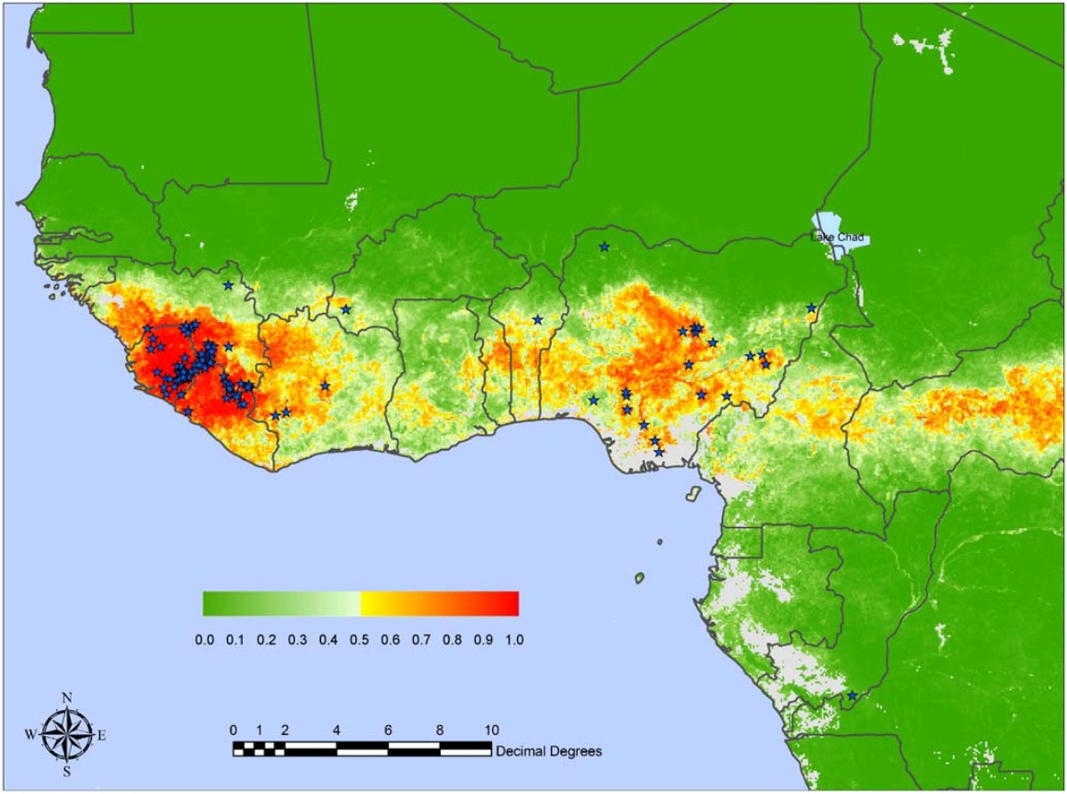 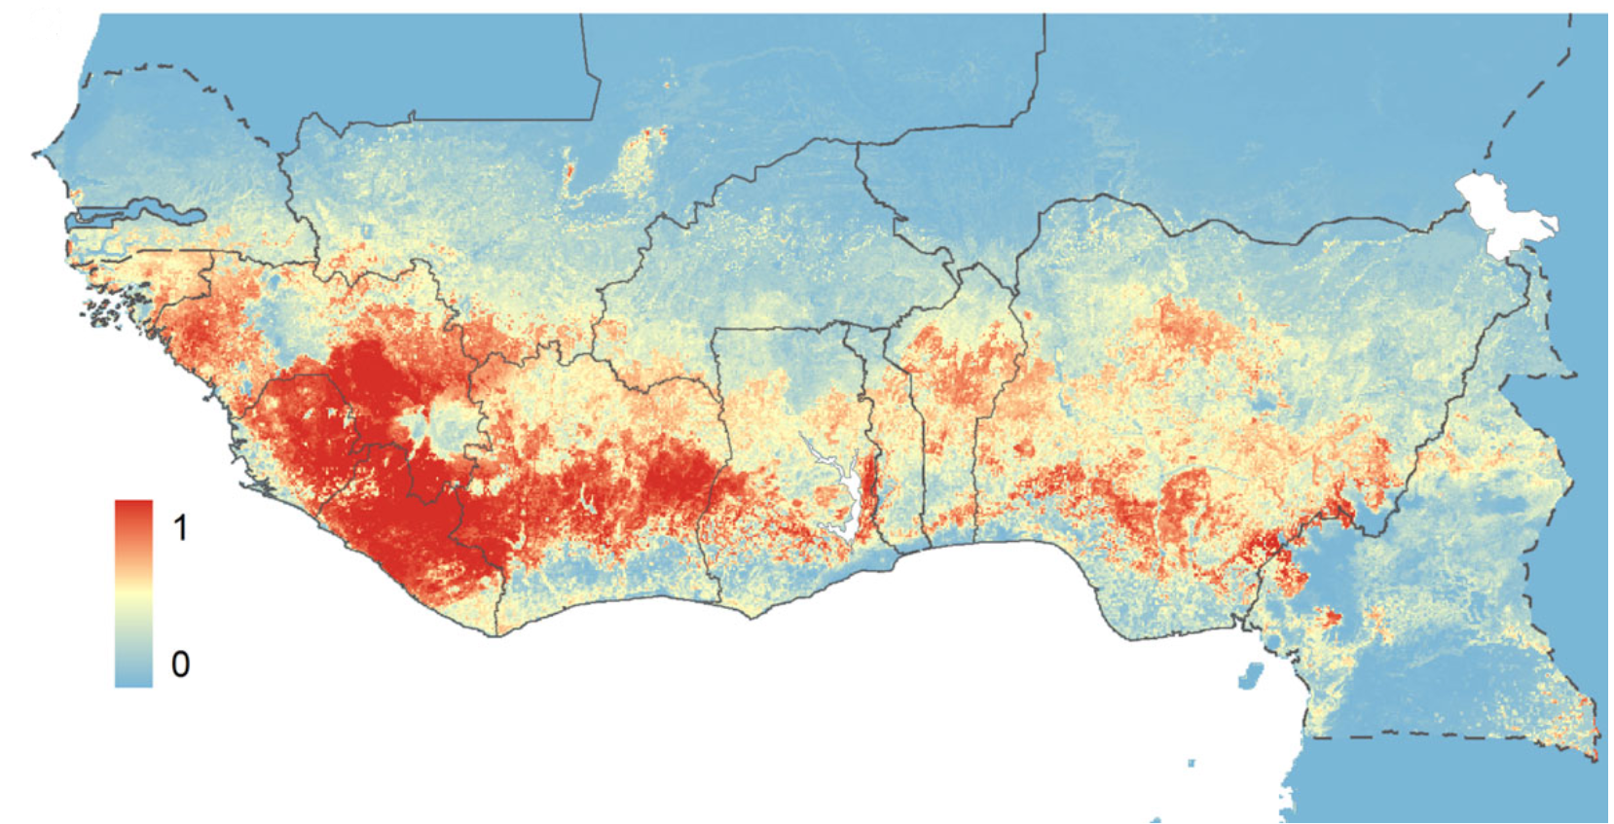

(a) (b)

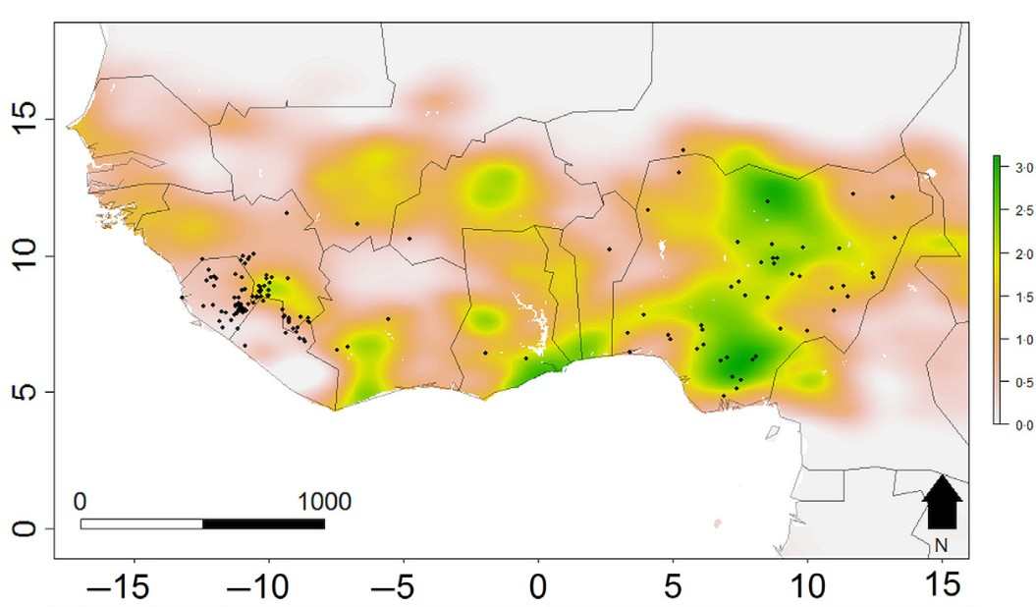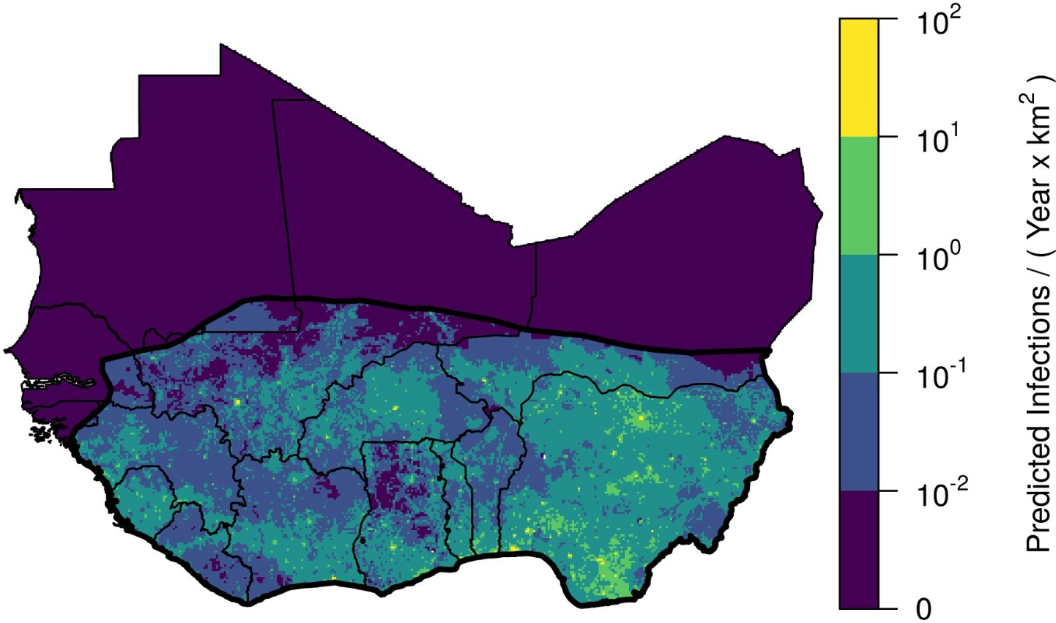

(c) (d)

Figure 6.1: Risk maps of Lassa fever in West Africa, images reproduced from (a) Fichet-Calvet & Rogers, 2009, (b) Mylne *et al.*, 2015, (c) Redding *et al.*, 2016, (d) Basinski *et al.*, 2021

The rodent trapping study conducted as part of this thesis has highlighted the need for long-term rodent surveys in the Lassa fever endemic region. To understand the risk to human communities from Lassa fever spillover, there is a need for unbiased data on the multi-year dynamics of LASV prevalence within rodent communities. Previous studies have shown substantial asynchrony in rodent and human infection. For example, a low prevalence of rodent infection has been found in the context of high human seroprevalence or incidence of infection, suggesting a temporal lag ([Lukashevich, Clegg and Sidibe, 1993](#_bookmark353); [Demby *et al.*, 2001](#_bookmark209)). In contrast, some studies have identified substantial transmission among rodent populations but few human cases of Lassa fever ([Fichet-Calvet *et al.*, 2005](#_bookmark230), [2007](#_bookmark232)). Combining LASV, rodent and human studies over longer time scales (i.e., several years) at high sampling frequency (i.e., monthly) will help to elucidate whether these previous observations have been driven by biased geographic and temporal sampling or whether these trends are driven by underlying dynamics and temporal lags within the host-pathogen system. This study design would require significant resources and have not yet been performed.

Further, the dynamic interplay between pathogen, rodent and human factors driving Lassa fever spillover events occurs across different time scales. At the rapid end of the time scale is the infectious period of LASV in individual rodents (1-2 months) and rodent life expectancy (<1 year), while the protracted end of the spectrum includes changes in rodent community structure due to land use change or invasive species (decades) and human longevity (i.e., life expectancy in Sierra Leone is 60 years) ([Leirs, Verhagen and Verheyen, 1993](#_bookmark337); [Wells, Lakim and O’Hara, 2014](#_bookmark490); [Dalecky *et al.*, 2015](#_bookmark202); [Safronetz *et al.*, 2022](#_bookmark441); [World Health Organisation,](#_bookmark504) [2023a](#_bookmark504)). The age at which humans are infected with LASV is also thought to be associated with the severity of disease and is expected to lead to long-term immunity ([Duvignaud *et al.*, 2021](#_bookmark216); [Strampe *et al.*, 2021](#_bookmark465); [Garry, 2023](#_bookmark248)). Although whether a single acute infection leads to lifelong immunity in humans is not known. In addition, the force-of-infection from rodent to human populations will dictate the age-stratified infection risk in humans ([Davis and Calvet, 2005](#_bookmark208); [Arthur *et al.*, 2017](#_bookmark149)). For example, in the study system sampled as part of this thesis the low prevalence of LASV antibodies suggests minimal current transmission within the rodent population and therefore the annual probability of a human being infected in these setting is likely low. This is expected to lead to human infections occurring in older age groups, with these individuals developing more severe disease. However, our study also shows that most of the rodents remain susceptible to infection which, were they to be exposed to LASV, would promote LASV transmission and an outbreak within rodent populations, which could shift the risk of infection in humans to younger age groups who are expected to develop less severe disease. Therefore, similar to the suggestion in the above paragraph, multi-year studies of LASV and rodents would be beneficial to understand these complex dynamics.

Finally, there is an increasing drive for data consolidation to support “big data” approaches to zoonosis risk prediction and preparedness ([Carlson *et al.*, 2021](#_bookmark186)). These approaches typically consolidate data from multiple studies or public repositories of data and often span disciplinary boundaries ([Garine-Wichatitsky](#_bookmark247) [*et al.*, 2022](#_bookmark247)). The increasing availability of repositories (e.g., GBIF) for raw and processed data should be embraced by the research community to accelerate the volume of data that are available for analysis. This ought to be balanced with appropriate attribution for researchers involved in the primary data collection ([Bahlai *et al.*, 2019](#_bookmark150); [Carlson *et al.*, 2021](#_bookmark186)). Importantly, the data must be shared with adequate meta-data to support appropriate secondary analyses. As discussed above, the development and adoption of protocol harmonisation and reporting standards of rodent and pathogen sampling studies is needed and would help ensure that important meta-data are available, as has been adopted in several biomedical disciplines (i.e., CONSORT) ([Schulz *et al.*, 2010](#_bookmark449)). Improving reporting standards also supports the adoption of risk-of- bias tools (e.g., “Risk-Of-Bias In studies of Temporal Trends in ecology” (ROBITT)), which facilitates the adjustment for geographic, temporal and sampling biases within the contributing datasets ([Navarro *et al.*,](#_bookmark399)

[2021](#_bookmark399); [Boyd *et al.*, 2022](#_bookmark177)).

##### Concluding remarks

A greater understanding of rodent community ecology is required to design public health interventions against Lassa fever in endemic regions. This thesis aimed to gain a better understanding of how rodent communities are structured along anthropogenic land use gradients with a view to informing interpretation of human Lassa fever epidemiology. This was achieved through a scoping review and synthesis of published rodent trapping studies across West Africa and primary data collection through a two-and-a-half-year rodent trapping study. Current biases in sampling of rodent hosts and their pathogens across West Africa limit the inference able to be drawn from available data on the current and future risks of zoonotic disease emergence. Results from the rodent trapping survey characterised the structure of rodent communities within the Lassa fever endemic region of Eastern Sierra Leone and informed the contact networks pathogens such as LASV will transmit through. These findings can be used to inform the design of combined rodent and human epidemiological studies of Lassa fever and to guide the development of public health interventions.

## Bibliography

*About PREDICT. School of veterinary medicine* (2019). Available at: [https://ohi.sf.ucdavis.edu/programs-](https://ohi.sf.ucdavis.edu/programs-projects/predict-project/about) [projects/predict-project/about](https://ohi.sf.ucdavis.edu/programs-projects/predict-project/about) (Accessed: 5 May 2023).

Adesina, A.S., Oyeyiola, A., Obadare, A., Igbokwe, J., Abejegah, C., Akhilomen, P., Bangura, U., Asogun, D., Tobin, E., Ayodeji, O., Osoniyi, O., Davis, C., Thomson, E.C., Pahlmann, M., Günther, S., Fichet- Calvet, E. and Olayemi, A. (2023) ‘Circulation of lassa virus across the endemic edo-ondo axis, nigeria, with cross-species transmission between multimammate mice’, *Emerging Microbes & Infections*, 12(1), p. 2219350. doi:[10.1080/22221751.2023.2219350](https://doi.org/10.1080/22221751.2023.2219350).

Agbonlahor, D.E., Akpede, G.O., Happi, C.T. and Tomori, O. (2021) ‘52 years of lassa fever uutbreaks in nigeria, 1969–2020: An epidemiologic analysis of the temporal and spatial trends’, *The American Journal* *of Tropical Medicine and Hygiene*, -1. doi:[10.4269/ajtmh.20-1160](https://doi.org/10.4269/ajtmh.20-1160).

Agbonlahor, D.E., Erah, A., Agba, I.M., Oviasogie, F.E., Ehiaghe, A.F., Wankasi, M., Eremwanarue, O.A., Ehiaghe, I.J., Ogbu, E.C., Iyen, R.I., Abbey, S., Tatfeng, M.Y. and Uhunmwangho, J. (2017) ‘Prevalence of lassa virus among rodents trapped in three south-south states of nigeria’, *Journal of Vector Borne Dis- eases*, 54(2), p. 146. Available at: [http://www.jvbd.org/article.asp?issn=0972-9062;year=2017;volume=](http://www.jvbd.org/article.asp?issn=0972-9062%3Byear%3D2017%3Bvolume%3D54%3Bissue%3D2%3Bspage%3D146%3Bepage%3D150%3Baulast%3DAgbonlahor%3Btype%3D0) [54;issue=2;spage=146;epage=150;aulast=Agbonlahor;type=0](http://www.jvbd.org/article.asp?issn=0972-9062%3Byear%3D2017%3Bvolume%3D54%3Bissue%3D2%3Bspage%3D146%3Bepage%3D150%3Baulast%3DAgbonlahor%3Btype%3D0) (Accessed: 26 January 2023).

Akoua-Koﬀi, C., Ter Meulen, J., Legros, D., Akran, V., Aïdara, M., Nahounou, N., Dogbo, P. and Ehouman,

A. (2006) ‘[[Detection of anti-lassa antibodies in the western forest area of the ivory coast]](https://www.ncbi.nlm.nih.gov/pubmed/17201291)’, *Medecine* *tropicale*, 66(5), pp. 465–468.

Akpatou, B.K., Bohoussou, K.H., Kadjo, B. and Nicolas, V. (2018) ‘Terrestrial small mammal di- versity and abundance in taï national park, côte d’ivoire’, *Nature Conservation Research*, 3. doi:[10.24189/ncr.2018.067](https://doi.org/10.24189/ncr.2018.067).

Alabi, T.R., Adewopo, J., Duke, O.P. and Kumar, P.L. (2022) ‘Banana mapping in heterogenous small- holder farming systems using high-resolution remote sensing imagery and machine learning models with implications for banana bunchy top disease surveillance’, *Remote Sensing*, 14(20), p. 5206. doi:[10.3390/rs14205206](https://doi.org/10.3390/rs14205206).

Albery, G.F. and Becker, D.J. (2021) ‘Fast-lived hosts and zoonotic risk’, *Trends in Parasitology*, 37(2), pp.

117–129. doi:[10.1016/j.pt.2020.10.012](https://doi.org/10.1016/j.pt.2020.10.012).

Albery, G.F., Becker, D.J., Brierley, L., Brook, C.E., Christofferson, R.C., Cohen, L.E., Dallas, T.A., Eskew, E.A., Fagre, A., Farrell, M.J., Glennon, E., Guth, S., Joseph, M.B., Mollentze, N., Neely, B.A., Poisot, T., Rasmussen, A.L., Ryan, S.J., Seifert, S., Sjodin, A.R., Sorrell, E.M. and Carlson, C.J. (2021) ‘The science of the host–virus network’, *Nature Microbiology*, 6(12), pp. 1483–1492. doi:[10.1038/s41564-021-00999-5](https://doi.org/10.1038/s41564-021-00999-5).

Allen, T., Murray, K.A., Zambrana-Torrelio, C., Morse, S.S., Rondinini, C., Di Marco, M., Breit, N., Oli- val, K.J. and Daszak, P. (2017) ‘Global hotspots and correlates of emerging zoonotic diseases’, *Nature* *Communications*, 8(1), p. 1124. doi:[10.1038/s41467-017-00923-8](https://doi.org/10.1038/s41467-017-00923-8).

Almberg, E.S., Cross, P.C., Dobson, A.P., Smith, D.W. and Hudson, P.J. (2012) ‘Parasite invasion following host reintroduction: A case study of yellowstone’s wolves’, *Philosophical Transactions of the Royal Society* *B: Biological Sciences*, 367(1604), pp. 2840–2851. doi:[10.1098/rstb.2011.0369](https://doi.org/10.1098/rstb.2011.0369).

Altschul, S.F., Gish, W., Miller, W., Myers, E.W. and Lipman, D.J. (1990) ‘Basic local alignment search tool’, *Journal of Molecular Biology*, 215(3), pp. 403–410. doi:[10.1016/S0022-2836(05)80360-2](https://doi.org/10.1016/S0022-2836(05)80360-2).

Amini, F., Auma, E., Hsia, Y., Bilton, S., Hall, T., Ramkhelawon, L., Heath, P.T. and Doare, K.L. (2021) ‘Reliability of dried blood spot (DBS) cards in antibody measurement: A systematic review’, *PLOS ONE*, 16(3), p. e0248218. doi:[10.1371/journal.pone.0248218](https://doi.org/10.1371/journal.pone.0248218).

Amman, B.R., Bird, B.H., Bakarr, I.A., Bangura, J., Schuh, A.J., Johnny, J., Sealy, T.K., Conteh, I., Koroma, A.H., Foday, I., Amara, E., Bangura, A.A., Gbakima, A.A., Tremeau-Bravard, A., Belaganahalli, M., Dhanota, J., Chow, A., Ontiveros, V., Gibson, A., Turay, J., Patel, K., Graziano, J., Bangura, C., Kamanda, E.S., Osborne, A., Saidu, E., Musa, J., Bangura, D., Williams, S.M.T., Wadsworth, R., Turay, M., Edwin, L., Mereweather-Thompson, V., Kargbo, D., Bairoh, F.V., Kanu, M., Robert, W., Lungai, V., Guetiya Wadoum, R.E., Coomber, M., Kanu, O., Jambai, A., Kamara, S.M., Taboy, C.H., Singh, T., Mazet, J.A.K., Nichol, S.T., Goldstein, T., Towner, J.S. and Lebbie, A. (2020) ‘Isolation of angola-like marburg virus from egyptian rousette bats from west africa’, *Nature Communications*, 11(1), p. 510. doi:[10.1038/s41467-020-14327-8](https://doi.org/10.1038/s41467-020-14327-8).

Andersen, K.G., Shapiro, B.J., Matranga, C.B., Sealfon, R., Lin, A.E., Moses, L.M., Folarin, O.A., Goba,

A., Odia, I., Ehiane, P.E., Momoh, M., England, E.M., Winnicki, S., Branco, L.M., Gire, S.K., Phelan,

E., Tariyal, R., Tewhey, R., Omoniwa, O., Fullah, M., Fonnie, R., Fonnie, M., Kanneh, L., Jalloh, S.,

Gbakie, M., Saffa, S., Karbo, K., Gladden, A.D., Qu, J., Stremlau, M., Nekoui, M., Finucane, H.K., Tabrizi, S., Vitti, J.J., Birren, B., Fitzgerald, M., McCowan, C., Ireland, A., Berlin, A.M., Bochicchio, J., Tazon-Vega, B., Lennon, N.J., Ryan, E.M., Bjornson, Z., Milner, D.A.J., Lukens, A.K., Broodie, N., Rowland, M., Heinrich, M., Akdag, M., Schieffelin, J.S., Levy, D., Akpan, H., Bausch, D.G., Rubins, K., McCormick, J.B., Lander, E.S., Gunther, S., Hensley, L., Okogbenin, S., Consortium, V.H.F., Schaffner, S.F., Okokhere, P.O., Khan, S.H., Grant, D.S., Akpede, G.O., Asogun, D.A., Gnirke, A., Levin, J.Z., Happi, C.T., Garry, R.F. and Sabeti, P.C. (2015) ‘Clinical sequencing uncovers origins and evolution of lassa virus’, *Cell*, 162(4), pp. 738–750. doi:[10.1016/j.cell.2015.07.020](https://doi.org/10.1016/j.cell.2015.07.020).

Anderson, P.K. (1961) ‘Density, social structure, and nonsocial environment in house-mouse populations and the implications for regulation of numbers’, *Transactions of the New York Academy of Sciences*, 23, pp.

447–451. doi:[10.1111/j.2164-0947.1961.tb01373.x](https://doi.org/10.1111/j.2164-0947.1961.tb01373.x).

Arruda, L.B., Free, H.B., Simons, D., Ansumana, R., Elton, L., Haider, N., Honeyborne, I., Asogun, D., McHugh, T.D., Ntoumi, F., Zumla, A. and Kock, R. (2023) ‘Current sampling and sequencing biases of lassa mammarenavirus limit inference from phylogeography and molecular epidemiology in lassa fever endemic regions’. preprint. doi:[10.1101/2023.06.20.23291686](https://doi.org/10.1101/2023.06.20.23291686).

Arruda, L.B., Haider, N., Olayemi, A., Simons, D., Ehichioya, D., Yinka-Ogunleye, A., Ansumana, R., Thomason, M.J., Asogun, D., Ihekweazu, C., Fichet-Calvet, E. and Kock, R.A. (2021) ‘The niche of one health approaches in lassa fever surveillance and control’, *Annals of Clinical Microbiology and Antimi-* *crobials*, 20(1), p. 29. doi:[10.1186/s12941-021-00431-0](https://doi.org/10.1186/s12941-021-00431-0).

Arthur, R.F., Gurley, E.S., Salje, H., Bloomfield, L.S.P. and Jones, J.H. (2017) ‘Contact structure, mobility, environmental impact and behaviour: The importance of social forces to infectious disease dynamics and disease ecology’, *Philosophical Transactions of the Royal Society B: Biological Sciences*, 372(1719), p. 20160454. doi:[10.1098/rstb.2016.0454](https://doi.org/10.1098/rstb.2016.0454).

Bahlai, C.A., Bartlett, L.J., Burgio, K.R., Fournier, A.M.V., Keiser, C.N., Poisot, T. and Whitney, K.S. (2019) ‘Open science isn’t always open to all scientists: Current efforts to make research more accessible and transparent can reinforce inequality within STEM professions’, *American Scientist*, 107(2), pp. 78–83. doi:[10.1511/2019.107.2.78](https://doi.org/10.1511/2019.107.2.78).

Bangura, U., Buanie, J., Lamin, J., Davis, C., Bongo, G.N., Dawson, M., Ansumana, R., Sondufu, D., Thom- son, E.C., Sahr, F. and Fichet-Calvet, E. (2021) ‘Lassa virus circulation in small mammal populations in bo district, sierra leone’, *BIOLOGY-BASEL*, 10(1). doi:[10.3390/biology10010028](https://doi.org/10.3390/biology10010028).

Barnett, A.A., Read, N., Scurlock, J., Low, C., Norris, H. and Shapley, R. (2000) ‘Ecology of rodent communities in agricultural habitats in eastern sierra leone: Cocoa groves as forest refugia’, *Tropical* *Ecology*, p. 17. Available at: <http://www.tropecol.com/pdf/open/PDF_41_2/kp41201.pdf>.

Basinski, A.J., Fichet-Calvet, E., Sjodin, A.R., Varrelman, T.J., Remien, C.H., Layman, N.C., Bird, B.H., Wolking, D.J., Monagin, C., Ghersi, B.M., Barry, P.A., Jarvis, M.A., Gessler, P.E. and Nuismer,

S.L. (2021) ‘Bridging the gap: Using reservoir ecology and human serosurveys to estimate lassa virus spillover in west africa’, *PLOS Computational Biology*. Edited by A. Wesolowski, 17(3), p. e1008811. doi:[10.1371/journal.pcbi.1008811](https://doi.org/10.1371/journal.pcbi.1008811).

Bauer, D.F. (1972) ‘Constructing confidence sets using rank statistics’, *Journal of the American Statistical* *Association*, 67(339), pp. 687–690. doi:[10.1080/01621459.1972.10481279](https://doi.org/10.1080/01621459.1972.10481279).

Bausch, D.G., Demby, A.H., Coulibaly, M., Kanu, J., Goba, A., Bah, A., Condé, N., Wurtzel, H.L., Cavallaro,

K.F., Lloyd, E., Baldet, F.B., Cissé, S.D., Fofona, D., Savané, I.K., Tolno, R.T., Mahy, B., Wagoner, K.D., Ksiazek, T.G., Peters, C.J. and Rollin, P.E. (2001) ‘Lassa fever in guinea: I. Epidemiology of

human disease and clinical observations’, *Vector Borne and Zoonotic Diseases (Larchmont, N.Y.)*, 1(4),

pp. 269–281. doi:[10.1089/15303660160025903](https://doi.org/10.1089/15303660160025903).

Beck, J., Böller, M., Erhardt, A. and Schwanghart, W. (2014) ‘Spatial bias in the GBIF database and its effect on modeling species’ geographic distributions’, *Ecological Informatics*, 19, pp. 10–15. doi:[10.1016/j.ecoinf.2013.11.002](https://doi.org/10.1016/j.ecoinf.2013.11.002).

Begon, M., Hazel, S.M., Baxby, D., Bown, K., Cavanagh, R., Chantrey, J., Jones, T. and Bennett, M. (1999) ‘Transmission dynamics of a zoonotic pathogen within and between wildlife host species’, *Pro- ceedings of the Royal Society of London. Series B: Biological Sciences*, 266(1432), pp. 1939–1945. doi:[10.1098/rspb.1999.0870](https://doi.org/10.1098/rspb.1999.0870).

Bellocq, J.G.D., Bryjová, A., Martynov, A.A. and Lavrenchenko, L.A. (2020) ‘Dhati welel virus, the miss- ing mammarenavirus of the widespread mastomys natalensis’, *Journal of Vertebrate Biology*, 69(2), p. 20018.1. doi:[10.25225/jvb.20018](https://doi.org/10.25225/jvb.20018).

Benedek, A.M. and Sîrbu, I. (2018) ‘Responses of small mammal communities to environment and agriculture in a rural mosaic landscape’, *Mammalian Biology*, 90(1), pp. 55–65. doi:[10.1016/j.mambio.2018.02.008](https://doi.org/10.1016/j.mambio.2018.02.008). Benjamin, D.J., Berger, J.O., Johannesson, M., Nosek, B.A., Wagenmakers, E.-J., Berk, R., Bollen, K.A., Brembs, B., Brown, L., Camerer, C., Cesarini, D., Chambers, C.D., Clyde, M., Cook, T.D., De Boeck, P., Dienes, Z., Dreber, A., Easwaran, K., Efferson, C., Fehr, E., Fidler, F., Field, A.P., Forster, M., George, E.I., Gonzalez, R., Goodman, S., Green, E., Green, D.P., Greenwald, A.G., Hadfield, J.D., Hedges, L.V., Held, L., Hua Ho, T., Hoijtink, H., Hruschka, D.J., Imai, K., Imbens, G., Ioannidis, J.P.A., Jeon,

M., Jones, J.H., Kirchler, M., Laibson, D., List, J., Little, R., Lupia, A., Machery, E., Maxwell, S.E., McCarthy, M., Moore, D.A., Morgan, S.L., Munafó, M., Nakagawa, S., Nyhan, B., Parker, T.H., Pericchi, L., Perugini, M., Rouder, J., Rousseau, J., Savalei, V., Schönbrodt, F.D., Sellke, T., Sinclair, B., Tingley, D., Van Zandt, T., Vazire, S., Watts, D.J., Winship, C., Wolpert, R.L., Xie, Y., Young, C., Zinman, J. and Johnson, V.E. (2018) ‘Redefine statistical significance’, *Nature Human Behaviour*, 2(1), pp. 6–10. doi:[10.1038/s41562-017-0189-z](https://doi.org/10.1038/s41562-017-0189-z).

Berguido, F.J., Bodjo, S.C., Loitsch, A. and Diallo, A. (2016) ‘Specific detection of peste des petits rumi- nants virus antibodies in sheep and goat sera by the luciferase immunoprecipitation system’, *Journal of* *Virological Methods*, 227, pp. 40–46. doi:[10.1016/j.jviromet.2015.10.008](https://doi.org/10.1016/j.jviromet.2015.10.008).

Bernstein, A.S., Ando, A.W., Loch-Temzelides, T., Vale, M.M., Li, B.V., Li, H., Busch, J., Chapman, C.A., Kinnaird, M., Nowak, K., Castro, M.C., Zambrana-Torrelio, C., Ahumada, J.A., Xiao, L., Roehrdanz, P., Kaufman, L., Hannah, L., Daszak, P., Pimm, S.L. and Dobson, A.P. (2022) ‘The costs and benefits of primary prevention of zoonotic pandemics’, *Science Advances* [Preprint]. doi:[10.1126/sciadv.abl4183](https://doi.org/10.1126/sciadv.abl4183).

Bhadelia, N. (2019) ‘Understanding lassa fever’, *Science*, 363(6422), pp. 30–30. doi:[10.1126/science.aav8958](https://doi.org/10.1126/science.aav8958).

Boakes, E.H., McGowan, P.J.K., Fuller, R.A., Chang-qing, D., Clark, N.E., O’Connor, K. and Mace, G.M. (2010) ‘Distorted views of biodiversity: Spatial and temporal bias in species occurrence data’, *PLOS* *Biology*, 8(6), p. e1000385. doi:[10.1371/journal.pbio.1000385](https://doi.org/10.1371/journal.pbio.1000385).

Böhm, M., Hutchings, M.R. and White, P.C.L. (2009) ‘Contact networks in a wildlife-livestock host com- munity: Identifying high-risk individuals in the transmission of bovine TB among badgers and cattle’, *PLOS ONE*, 4(4), p. e5016. doi:[10.1371/journal.pone.0005016](https://doi.org/10.1371/journal.pone.0005016).

Bongaarts, J. (2009) ‘Human population growth and the demographic transition’, *Philosophical Transactions* *of the Royal Society B: Biological Sciences*, 364(1532), pp. 2985–2990. doi:[10.1098/rstb.2009.0137](https://doi.org/10.1098/rstb.2009.0137).

Bonner, P.C., Schmidt, W.-P., Belmain, S.R., Oshin, B., Baglole, D. and Borchert, M. (2007) ‘[Poor housing](https://www.ncbi.nlm.nih.gov/pubmed/17620650) [quality increases risk of rodent infestation and lassa fever in refugee camps of sierra leone](https://www.ncbi.nlm.nih.gov/pubmed/17620650)’, *American* *Journal of Tropical Medicine & Hygiene*, 77(1), pp. 169–175.

Bonwitt, J., Sáez, A.M., Lamin, J., Ansumana, R., Dawson, M., Buanie, J., Lamin, J., Sondufu, D., Borchert, M., Sahr, F., Fichet-Calvet, E. and Brown, H. (2017) ‘At home with mastomys and rattus: Human-rodent interactions and potential for primary transmission of lassa virus in domestic spaces’, *The American* *Journal of Tropical Medicine and Hygiene*, 96(4), pp. 935–943. doi:[10.4269/ajtmh.16-0675](https://doi.org/10.4269/ajtmh.16-0675).

Bordes, F., Blasdell, K. and Morand, S. (2015) ‘Transmission ecology of rodent-borne diseases: New frontiers’,

*Integrative Zoology*, 10(5), pp. 424–435. doi:[10.1111/1749-4877.12149](https://doi.org/10.1111/1749-4877.12149).

Borenstein, M., Hedges, L.V., Higgins, J.P.T. and Rothstein, H.R. (2010) ‘A basic introduction to fixed- effect and random-effects models for meta-analysis’, *Research Synthesis Methods*, 1(2), pp. 97–111. doi:[10.1002/jrsm.12](https://doi.org/10.1002/jrsm.12).

Boria, R.A., Olson, L.E., Goodman, S.M. and Anderson, R.P. (2014) ‘Spatial filtering to reduce sampling bias can improve the performance of ecological niche models’, *Ecological Modelling*, 275, pp. 73–77. doi:[10.1016/j.ecolmodel.2013.12.012](https://doi.org/10.1016/j.ecolmodel.2013.12.012).

Borremans, B., Hughes, N.K., Reijniers, J., Sluydts, V., Katakweba, A.A.S., Mulungu, L.S., Sabuni, C.A., Makundi, R.H. and Leirs, H. (2014) ‘Happily together forever: Temporal variation in spatial patterns and complete lack of territoriality in a promiscuous rodent’, *Population Ecology*, 56(1), pp. 109–118. doi:[10.1007/s10144-013-0393-2](https://doi.org/10.1007/s10144-013-0393-2).

Borremans, B., Reijniers, J., Hughes, N.K., Godfrey, S.S., Gryseels, S., Makundi, R.H. and Leirs, H. (2017) ‘Nonlinear scaling of foraging contacts with rodent population density’, *Oikos*, 126(6), pp. 792–800. doi:[10.1111/oik.03623](https://doi.org/10.1111/oik.03623).

Borremans, B., Vossen, R., Becker-Ziaja, B., Gryseels, S., Hughes, N., Van Gestel, M., Van Houtte, N., Günther, S. and Leirs, H. (2015) ‘Shedding dynamics of morogoro virus, an african arenavirus closely related to lassa virus, in its natural reservoir host mastomys natalensis’, *Scientific Reports*, 5(1), p. 10445.

doi:[10.1038/srep10445](https://doi.org/10.1038/srep10445).

Bovendorp, R.S., McCleery, R.A. and Galetti, M. (2017) ‘Optimising sampling methods for small mammal communities in neotropical rainforests’, *Mammal Review*, 47(2), pp. 148–158. doi:[10.1111/mam.12088](https://doi.org/10.1111/mam.12088).

Bowler, D.E., Callaghan, C.T., Bhandari, N., Henle, K., Benjamin Barth, M., Koppitz, C., Klenke, R., Winter, M., Jansen, F., Bruelheide, H. and Bonn, A. (2022) ‘Temporal trends in the spatial bias of species occurrence records’, *Ecography*, n/a, p. e06219. doi:[10.1111/ecog.06219](https://doi.org/10.1111/ecog.06219).

Boyd, R.J., Powney, G.D., Burns, F., Danet, A., Duchenne, F., Grainger, M.J., Jarvis, S.G., Martin, G., Nilsen, E.B., Porcher, E., Stewart, G.B., Wilson, O.J. and Pescott, O.L. (2022) ‘ROBITT: A tool for assessing the risk-of-bias in studies of temporal trends in ecology’, *Methods in Ecology and Evolution*, 13(7), pp. 1497–1507. doi:[10.1111/2041-210X.13857](https://doi.org/10.1111/2041-210X.13857).

Bradley, R.D. and Baker, R.J. (2001) ‘A test of the genetic species concept: Cytochrome-b sequences and mammals’, *Journal of mammalogy*, 82(4), pp. 960–973. doi:10.1644/1545-1542(2001)082<0960:ATOTGS>2.0.CO;2.

Britton-Davidian, J., Robinson, T.J. and Veyrunes, F. (2012) ‘Systematics and evolution of the african pygmy mice, subgenus nannomys: A review’, *Acta Oecologica*, 42, pp. 41–49. doi:[10.1016/j.actao.2012.01.001](https://doi.org/10.1016/j.actao.2012.01.001).

Brodie, J.F. (2016) ‘Synergistic effects of climate change and agricultural land use on mammals’, *Frontiers* *in Ecology and the Environment*, 14(1), pp. 20–26. doi:[10.1002/16-0110.1](https://doi.org/10.1002/16-0110.1).

Broekman, M.J.E., Hoeks, S., Freriks, R., Langendoen, M.M., Runge, K.M., Savenco, E., Harmsel, R. ter, Huijbregts, M.A.J. and Tucker, M.A. (2023) ‘HomeRange: A global database of mammalian home ranges’, *Global Ecology and Biogeography*, 32(2), pp. 198–205. doi:[10.1111/geb.13625](https://doi.org/10.1111/geb.13625).

Brouat, C., Tatard, C., Bâ, K., Cosson, J.-F., Dobigny, G., Fichet-Calvet, E., Granjon, L., Lecompte, E., Loiseau, A., Mouline, K., Piry, S. and Duplantier, J.-M. (2009) ‘Phylogeography of the guinea multi- mammate mouse (mastomys erythroleucus): A case study for sahelian species in west africa’, *Journal of* *Biogeography*, 36(12), pp. 2237–2250. doi:[10.1111/j.1365-2699.2009.02184.x](https://doi.org/10.1111/j.1365-2699.2009.02184.x).

Butts, C.T. (2008) ‘**Network** : A package for managing relational data in *r*’, *Journal of Statistical Software*,

24(2). doi:[10.18637/jss.v024.i02](https://doi.org/10.18637/jss.v024.i02).

Cardenas, N.C., Sykes, A.L., Lopes, F.P.N. and Machado, G. (2022) ‘Multiple species animal movements: Network properties, disease dynamics and the impact of targeted control actions’, *Veterinary Research*, 53(1), p. 14. doi:[10.1186/s13567-022-01031-2](https://doi.org/10.1186/s13567-022-01031-2).

Carlson, C.J., Albery, G.F., Merow, C., Trisos, C.H., Zipfel, C.M., Eskew, E.A., Olival, K.J., Ross, N. and Bansal, S. (2022) ‘Climate change increases cross-species viral transmission risk’, *Nature*, 607(7919), pp. 555–562. doi:[10.1038/s41586-022-04788-w](https://doi.org/10.1038/s41586-022-04788-w).

Carlson, C.J., Farrell, M.J., Grange, Z., Han, B.A., Mollentze, N., Phelan, A.L., Rasmussen, A.L., Albery, G.F., Bett, B., Brett-Major, D.M., Cohen, L.E., Dallas, T., Eskew, E.A., Fagre, A.C., Forbes, K.M.,

Gibb, R., Halabi, S., Hammer, C.C., Katz, R., Kindrachuk, J., Muylaert, R.L., Nutter, F.B., Ogola, J., Olival, K.J., Rourke, M., Ryan, S.J., Ross, N., Seifert, S.N., Sironen, T., Standley, C.J., Taylor, K., Venter, M. and Webala, P.W. (2021) ‘The future of zoonotic risk prediction’, *Philosophical Transactions* *of the Royal Society B: Biological Sciences*, 376(1837), p. 20200358. doi:[10.1098/rstb.2020.0358](https://doi.org/10.1098/rstb.2020.0358).

Caron, A., Cappelle, J., Cumming, G.S., Garine-Wichatitsky, M. de and Gaidet, N. (2015) ‘Bridge hosts, a missing link for disease ecology in multi-host systems’, *Veterinary Research*, 46(1), p. 83. doi:[10.1186/s13567-015-0217-9](https://doi.org/10.1186/s13567-015-0217-9).

Carslake, D., Bennett, M., Bown, K., Hazel, S., fer, S. and Begon, M. (2005) ‘Space–time clustering of cowpox virus infection in wild rodent populations’, *Journal of Animal Ecology*, 74(4), pp. 647–655. doi:[10.1111/j.1365-2656.2005.00966.x](https://doi.org/10.1111/j.1365-2656.2005.00966.x).

Catalano, S., Ba, K., Diouf, N.D., Leger, E., Verocai, G.G. and Webster, J.P. (2019) ‘Rodents of senegal and their role as intermediate hosts of hydatigera spp. (Cestoda: taeniidae).’, *Parasitology*, 146(3), pp. 299–304. doi:[10.1017/S0031182018001427](https://doi.org/10.1017/S0031182018001427).

Ceballos, G. and Ehrlich, P.R. (2006) ‘Global mammal distributions, biodiversity hotspots, and conservation’, *Proceedings of the National Academy of Sciences*, 103(51), pp. 19374–19379. doi:[10.1073/pnas.0609334103](https://doi.org/10.1073/pnas.0609334103).

Chen, S., White, B.J., Sanderson, M.W., Amrine, D.E., Ilany, A. and Lanzas, C. (2014) ‘Highly dy- namic animal contact network and implications on disease transmission’, *Scientific Reports*, 4, p. 4472. doi:[10.1038/srep04472](https://doi.org/10.1038/srep04472).

Cheung, M.W.-L. (2019) ‘A guide to conducting a meta-analysis with non-independent effect sizes’, *Neu-* *ropsychology Review*, 29(4), pp. 387–396. doi:[10.1007/s11065-019-09415-6](https://doi.org/10.1007/s11065-019-09415-6).

Civitello, D.J., Cohen, J., Fatima, H., Halstead, N.T., Liriano, J., McMahon, T.A., Ortega, C.N., Sauer, E.L., Sehgal, T., Young, S. and Rohr, J.R. (2015) ‘Biodiversity inhibits parasites: Broad evidence for the dilution effect’, *Proceedings of the National Academy of Sciences*, 112(28), pp. 8667–8671. doi:[10.1073/pnas.1506279112](https://doi.org/10.1073/pnas.1506279112).

Clay, C.A., Lehmer, E.M., Previtali, A., St. Jeor, S. and Dearing, M.D. (2009) ‘Contact heterogeneity in deer mice: Implications for sin nombre virus transmission’, *Proceedings of the Royal Society B: Biological* *Sciences*, 276(1660), pp. 1305–1312. doi:[10.1098/rspb.2008.1693](https://doi.org/10.1098/rspb.2008.1693).

Cleaveland, S., Laurenson, M.K. and Taylor, L.H. (2001) ‘Diseases of humans and their domestic mammals: Pathogen characteristics, host range and the risk of emergence’, *Philosophical Transactions of the Royal Society of London. Series B: Biological Sciences*. Edited by M.E.J. Woolhouse and C. Dye, 356(1411),

pp. 991–999. doi:[10.1098/rstb.2001.0889](https://doi.org/10.1098/rstb.2001.0889).

Cochran, W.G. (1954) ‘The combination of estimates from different experiments’, *Biometrics*, 10(1), pp.

101–129. doi:[10.2307/3001666](https://doi.org/10.2307/3001666).

Coetzee, C.G. (1975) ‘The biology, behaviour, and ecology of mastomys natalensis in southern africa’, *Bul- letin of the World Health Organization*, 52(4), pp. 637–644. Available at: [https://www.ncbi.nlm.nih.gov/](https://www.ncbi.nlm.nih.gov/pmc/articles/PMC2366655/) [pmc/articles/PMC2366655/](https://www.ncbi.nlm.nih.gov/pmc/articles/PMC2366655/) (Accessed: 21 October 2020).

Colangelo, P., Verheyen, E., Leirs, H., Tatard, C., Denys, C., Dobigny, G., Duplantier, J.-M., Brouat, C., Granjon, L. and Lecompte, E. (2013) ‘A mitochondrial phylogeographic scenario for the most widespread african rodent, mastomys natalensis’, *Biological Journal of the Linnean Society*, 108(4), pp. 901–916. doi:[10.1111/bij.12013](https://doi.org/10.1111/bij.12013).

Corman, V.M., Ithete, N.L., Richards, L.R., Schoeman, M.C., Preiser, W., Drosten, C. and Drexler,

J.F. (2014) ‘Rooting the phylogenetic tree of middle east respiratory syndrome coronavirus by char- acterization of a conspecific virus from an african bat’, *Journal of Virology*, 88(19), pp. 11297–11303. doi:[10.1128/jvi.01498-14](https://doi.org/10.1128/jvi.01498-14).

Cuypers, L.N., Cuypers, W.L., Gildemyn-Blomme, A., Abraham, L., Aertbeliën, S., Massawe, A.W., Borre- mans, B., Gryseels, S. and Leirs, H. (2017) ‘No evidence for avoidance of black rat scent by the presumably less competitive natal multimammate mouse in a choice experiment’, *African Zoology*, 52(2), pp. 119–123. doi:[10.1080/15627020.2017.1307139](https://doi.org/10.1080/15627020.2017.1307139).

D’Elía, G., Fabre, P.-H. and Lessa, E.P. (2019) ‘Rodent systematics in an age of discovery: Recent advances and prospects’, *Journal of Mammalogy*, 100(3), pp. 852–871. doi:[10.1093/jmammal/gyy179](https://doi.org/10.1093/jmammal/gyy179).

Dalecky, A., Ba, K., Piry, S., Lippens, C., Diagne, C.A., Kane, M., Sow, A., Diallo, M., Niang, Y., Konecny, A., Sarr, N., Artige, E., Charbonnel, N., Granjon, L., Duplantier, J.-M. and Brouat, C. (2015) ‘Range ex- pansion of the invasive house mouse mus musculus domesticus in senegal, west africa: A synthesis of trap- ping data over three decades, 1983-2014’, *Mammal Review*, 45(3), pp. 176–190. doi:[10.1111/mam.12043](https://doi.org/10.1111/mam.12043). Dalhat, M.M., Olayinka, A., Meremikwu, M.M., Dan-Nwafor, C., Iniobong, A., Ntoimo, L.F., Onoh, I., Mba, S., Ohonsi, C., Arinze, C., Esu, E.B., Nwafor, O., Oladipupo, I., Onoja, M., Ilori, E., Okonofua, F., Ochu, C.L., Igumbor, E.U. and Adetifa, I. (2022) ‘Epidemiological trends of lassa fever in nigeria, 2018–2021’,

*PLOS ONE*, 17(12), p. e0279467. doi:[10.1371/journal.pone.0279467](https://doi.org/10.1371/journal.pone.0279467).

Daszak, P., Cunningham, A.A. and Hyatt, A.D. (2001) ‘Anthropogenic environmental change and the emergence of infectious diseases in wildlife’, *Acta Tropica*, 78(2), pp. 103–116. doi:[10.1016/S0001-](https://doi.org/10.1016/S0001-706X(00)00179-0) [706X(00)00179-0](https://doi.org/10.1016/S0001-706X(00)00179-0).

Database of Global Administrative Areas (2022) *GADM*. Available at: <https://gadm.org/index.html> (Ac- cessed: 25 April 2021).

Davis, D.H.S. (1949) ‘The aﬀinities of the south african gerbils of the genus tatera.’, *Proceedings of the Zoological Society of London*, 118(4), pp. 1002–1018. doi:[10.1111/j.1096-3642.1949.tb00417.x](https://doi.org/10.1111/j.1096-3642.1949.tb00417.x).

Davis, S. and Calvet, E. (2005) ‘Fluctuating rodent populations and risk to humans from rodent-borne zoonoses’, *Vector-Borne & Zoonotic Diseases*, 5(4), pp. 305–314. doi:[10.1089/vbz.2005.5.305](https://doi.org/10.1089/vbz.2005.5.305).

Decher, J., Norris, R.W. and Fahr, J. (2010) ‘Small mammal survey in the upper seli river valley, sierra leone’, *Mammalia*, 74(2), pp. 163–176. doi:[10.1515/MAMM.2010.026](https://doi.org/10.1515/MAMM.2010.026).

Demby, A.H., Inapogui, A., Kargbo, K., Koninga, J., Kourouma, K., Kanu, J., Coulibaly, M., Wagoner, K.D., Ksiazek, T.G., Peters, C.J., Rollin, P.E. and Bausch, D.G. (2001) ‘Lassa fever in guinea: II. Distribution and prevalence of lassa virus infection in small mammals’, *Vector-Borne and Zoonotic Diseases*, 1(4), pp. 283–297. doi:[10.1089/15303660160025912](https://doi.org/10.1089/15303660160025912).

Denys, C., Lecompte, E., Calvet, E., Camara, M.D., Doré, A., Koulémou, K., Kourouma, F., Soropogui, B., Sylla, O., Allali-Kouadio, B., Kouassi-Kan, S., Akoua-Koﬀi, C., Ter Meulen, J. and Koivogui, L. (2005) ‘Community analysis of muridae (mammalia, rodentia) diversity in guinea: A special emphasis on mastomys species and lassa fever distributions’, in Huber, B. A., Sinclair, B. J., and Lampe, K.-H., *African biodiversity*. Boston, MA: Springer US, pp. 339–350. doi:[10.1007/0-387-24320-8\_34](https://doi.org/10.1007/0-387-24320-8_34).

Diagne, C.A., Charbonnel, N., Henttonen, H., Sironen, T. and Brouat, C. (2017) ‘Serological survey of zoonotic viruses in invasive and native commensal rodents in senegal, west africa’, *Vector Borne and* *Zoonotic Diseases*, 17(10), pp. 730–733. doi:[10.1089/vbz.2017.2135](https://doi.org/10.1089/vbz.2017.2135).

Dobson, F.S. and Oli, M.K. (2007) ‘Fast and slow life histories of rodents’, *Rodent societies: an ecological* *and evolutionary perspective*, pp. 99–105. Available at: <https://www.jstor.org/stable/42902037>.

Doser, J.W., Finley, A.O., Kéry, M. and Zipkin, E.F. (2022) ‘spOccupancy: An r package for single-species, multi-species, and integrated spatial occupancy models’, *Methods in Ecology and Evolution* [Preprint]. doi:[10.1111/2041-210X.13897](https://doi.org/10.1111/2041-210X.13897).

Drewe, J.A., Eames, K.T.D., Madden, J.R. and Pearce, G.P. (2011) ‘Integrating contact network struc- ture into tuberculosis epidemiology in meerkats in south africa: Implications for control’, *Preventive* *Veterinary Medicine*, 101(1), pp. 113–120. doi:[10.1016/j.prevetmed.2011.05.006](https://doi.org/10.1016/j.prevetmed.2011.05.006).

Dudas, G., Carvalho, L.M., Rambaut, A. and Bedford, T. (2018) ‘MERS-CoV spillover at the camel-human interface’, *eLife*. Edited by N.M. Ferguson, 7, p. e31257. doi:[10.7554/eLife.31257](https://doi.org/10.7554/eLife.31257).

Duvignaud, A., Jaspard, M., Etafo, I.C., Gabillard, D., Serra, B., Abejegah, C., Gal, C. le, Abidoye, A.T., Doutchi, M., Owhin, S., Séri, B., Vihundira, J.K., Bérerd-Camara, M., Schaeffer, J., Danet, N., Augier, A., Ogbaini-Emovon, E., Salam, A.P., Ahmed, L.A., Duraffour, S., Horby, P., Günther, S., Adedosu, A.N., Ayodeji, O.O., Anglaret, X., Malvy, D., Alabi, J.F., Adedokun, M.A., Akinpelu, A.O., Oyegunle, O.O., Sule, T.D., Etafo, J., Dede, A.O., Onyechi, M.N., Ireneh, M.U., Gbenga-Ayeni, O., Fadiminiyi,

K.G., Ehigbor, P.I., Ouattara, E., Karcher, S., N’guessan-Koﬀi, L., Ahyi, I., Amani, E., Diabaté, M., Siloué, B., Levy-Marchal, C., Issaley, K. and Mushenvula, J.-P. de B. (2021) ‘Lassa fever outcomes and

prognostic factors in nigeria (LASCOPE): A prospective cohort study’, *The Lancet Global Health*, 9(4),

pp. e469–e478. doi:[10.1016/S2214-109X(20)30518-0](https://doi.org/10.1016/S2214-109X(20)30518-0).

Ecke, F., Han, B.A., Hörnfeldt, B., Khalil, H., Magnusson, M., Singh, N.J. and Ostfeld, R.S. (2022) ‘Pop- ulation fluctuations and synanthropy explain transmission risk in rodent-borne zoonoses’, *Nature Com-* *munications*, 13(1), p. 7532. doi:[10.1038/s41467-022-35273-7](https://doi.org/10.1038/s41467-022-35273-7).

Editors (ed.) (2011) ‘Microbiology by numbers’, *Nature Reviews Microbiology*, 9(9), pp. 628–628. doi:[10.1038/nrmicro2644](https://doi.org/10.1038/nrmicro2644).

Ehichioya, D.U., Dellicour, S., Pahlmann, M., Rieger, T., Oestereich, L., Becker-Ziaja, B., Cadar, D., Igho- dalo, Y., Olokor, T., Omomoh, E., Oyakhilome, J., Omiunu, R., Agbukor, J., Ebo, B., Aiyepada, J., Ebhodaghe, P., Osiemi, B., Ehikhametalor, S., Akhilomen, P., Airende, M., Esumeh, R., Muoebonam, E., Giwa, R., Ekanem, A., Igenegbale, G., Odigie, G., Okonofua, G., Enigbe, R., Omonegho Yerumoh, E., Pallasch, E., Bockholt, S., Kafetzopoulou, L.E., Duraffour, S., Okokhere, P.O., Akpede, G.O., Okog- benin, S.A., Odia, I., Aire, C., Akpede, N., Tobin, E., Ogbaini-Emovon, E., Lemey, P., Adomeh, D.I., Asogun, D.A. and Günther, S. (2019) ‘Phylogeography of lassa virus in nigeria’, *Journal of Virology*, 93(21), pp. e00929–19. doi:[10.1128/JVI.00929-19](https://doi.org/10.1128/JVI.00929-19).

Epstein, J.H., Field, H.E., Luby, S., Pulliam, J.R.C. and Daszak, P. (2006) ‘Nipah virus: Impact, origins, and causes of emergence’, *Current Infectious Disease Reports*, 8(1), pp. 59–65. doi:[10.1007/s11908-006-](https://doi.org/10.1007/s11908-006-0036-2) [0036-2](https://doi.org/10.1007/s11908-006-0036-2).

European Space Agency Climate Change Initiative (2022) *Land cover classification gridded maps from 1992 to present derived from satellite observations*. Available at: [https://cds.climate.copernicus.eu/cdsapp#!/](https://cds.climate.copernicus.eu/cdsapp%23!/dataset/satellite-land-cover?tab=overview) [dataset/satellite-land-cover?tab=overview](https://cds.climate.copernicus.eu/cdsapp%23!/dataset/satellite-land-cover?tab=overview) (Accessed: 3 March 2022).

Ezeomah, C., Adoga, A., Ihekweazu, C., Paessler, S., Cisneros, I., Tomori, O. and Walker, D. (2019) ‘Se- quelae of lassa fever: Postviral cerebellar ataxia’, *Open Forum Infectious Diseases*, 6(12), p. ofz512. doi:[10.1093/ofid/ofz512](https://doi.org/10.1093/ofid/ofz512).

Fagre, A.C., Cohen, L.E., Eskew, E.A., Farrell, M., Glennon, E., Joseph, M.B., Frank, H.K., Ryan, S.J., Carlson, C.J. and Albery, G.F. (2022) ‘Assessing the risk of human-to-wildlife pathogen transmission for conservation and public health’, *Ecology Letters*, 25(6), pp. 1534–1549. doi:[10.1111/ele.14003](https://doi.org/10.1111/ele.14003).

Fair, J., Jentes, E., Inapogui, A., Kourouma, K., Goba, A., Bah, A., Tounkara, M., Coulibaly, M., Garry,

R.F. and Bausch, D.G. (2007) ‘Lassa virus-infected rodents in refugee camps in guinea: A looming threat to public health in a politically unstable region’, *Vector-Borne and Zoonotic Diseases*, 7(2), pp. 167–171. doi:[10.1089/vbz.2006.0581](https://doi.org/10.1089/vbz.2006.0581).

Farine, D.R. and Whitehead, H. (2015) ‘Constructing, conducting and interpreting animal social network analysis’, *Journal of Animal Ecology*, 84(5), pp. 1144–1163. doi:[10.1111/1365-2656.12418](https://doi.org/10.1111/1365-2656.12418).

Farooq, Z., Rocklöv, J., Wallin, J., Abiri, N., Sewe, M.O., Sjödin, H. and Semenza, J.C. (2022) ‘Artificial intelligence to predict west nile virus outbreaks with eco-climatic drivers’, *The Lancet Regional Health -* *Europe*, 17, p. 100370. doi:[10.1016/j.lanepe.2022.100370](https://doi.org/10.1016/j.lanepe.2022.100370).

Faust, C.L., Dobson, A.P., Gottdenker, N., Bloomfield, L.S.P., McCallum, H.I., Gillespie, T.R., Diuk-Wasser,

M. and Plowright, R.K. (2017) ‘Null expectations for disease dynamics in shrinking habitat: Dilution or amplification?’, *Philosophical Transactions of the Royal Society B: Biological Sciences*, 372(1722), p. 20160173. doi:[10.1098/rstb.2016.0173](https://doi.org/10.1098/rstb.2016.0173).

Fichet-Calvet, E. (2014) ‘Chapter 5 - lassa fever: A rodent-human interaction’, in Johnson, N. (ed.) *The role of animals in emerging viral diseases*. Boston: Academic Press, pp. 89–123. doi:[10.1016/B978-0-12-](https://doi.org/10.1016/B978-0-12-405191-1.00005-3) [405191-1.00005-3](https://doi.org/10.1016/B978-0-12-405191-1.00005-3).

Fichet-Calvet, E., Becker-Ziaja, B., Koivogui, L. and Gunther, S. (2014) ‘Lassa serology in natural popu- lations of rodents and horizontal transmission’, *Vector Borne & Zoonotic Diseases*, 14(9), pp. 665–674. doi:[10.1089/vbz.2013.1484](https://doi.org/10.1089/vbz.2013.1484).

Fichet-Calvet, E., Koulemou, K., Koivogui, L., Soropogui, B., Sylla, O., Lecompte, E., Daﬀis, S., Kouadio, A., Kouassi, S., Akoua-Koﬀi, C., Denys, C. and Meulen, J. ter (2005) ‘Spatial distribution of commensal rodents in regions with high and low lassa fever prevalence in guinea’, *Belgian Journal of Zoology*, 135,

pp. 63–67. Available at: [https://biblio.naturalsciences.be/associated\_publications/bjz/bibliographic-](https://biblio.naturalsciences.be/associated_publications/bjz/bibliographic-references/ISI_000203706900011) [references/ISI\_000203706900011](https://biblio.naturalsciences.be/associated_publications/bjz/bibliographic-references/ISI_000203706900011).

Fichet-Calvet, E., Lecompte, E., Koivogui, L., Daﬀis, S. and Meulen, J. ter (2008) ‘Reproductive characteris- tics of mastomys natalensis and lassa virus prevalence in guinea, west africa’, *Vector Borne and Zoonotic* *Diseases (Larchmont, N.Y.)*, 8(1), pp. 41–48. doi:[10.1089/vbz.2007.0118](https://doi.org/10.1089/vbz.2007.0118).

Fichet-Calvet, E., Lecompte, E., Koivogui, L., Soropogui, B., Doré, A., Kourouma, F., Sylla, O., Daﬀis, S., Koulémou, K. and Ter Meulen, J. (2007) ‘Fluctuation of abundance and lassa virus prevalence in mastomys natalensis in guinea, west africa’, *Vector Borne and Zoonotic Diseases*, 7(2), pp. 119–128. doi:[10.1089/vbz.2006.0520](https://doi.org/10.1089/vbz.2006.0520).

Fichet-Calvet, E., Lecompte, E., Veyrunes, F., Barrière, P., Nicolas, V. and Koulémou, K. (2009) ‘Diversity and dynamics in a community of small mammals in coastal guinea, west africa’, *Belgian Journal of Zool- ogy*, 139(2), pp. 93–102. Available at: [http://www.vliz.be/nl/open-marien-archief?module=ref&refid=](http://www.vliz.be/nl/open-marien-archief?module=ref&refid=204614) [204614](http://www.vliz.be/nl/open-marien-archief?module=ref&refid=204614).

Fichet-Calvet, E., Ölschläger, S., Strecker, T., Koivogui, L., Becker-Ziaja, B., Camara, A.B., Soropogui, B., Magassouba, N. and Günther, S. (2016) ‘Spatial and temporal evolution of lassa virus in the natural host population in upper guinea’, *Scientific Reports*, 6, p. 21977. doi:[10.1038/srep21977](https://doi.org/10.1038/srep21977).

Fichet-Calvet, E. and Rogers, D.J. (2009) ‘Risk maps of lassa fever in west africa’, *PLOS Neglected Tropical*

*Diseases*, 3(3), p. e388. doi:[10.1371/journal.pntd.0000388](https://doi.org/10.1371/journal.pntd.0000388).

Fichet‐Calvet, E., Audenaert, L., Barrière, P. and Verheyen, E. (2010) ‘Diversity, dynamics and reproduction in a community of small mammals in upper guinea, with emphasis on pygmy mice ecology’, *African* *Journal of Ecology*, 48(3), pp. 600–614. doi:[10.1111/j.1365-2028.2009.01144.x](https://doi.org/10.1111/j.1365-2028.2009.01144.x).

Fine, P.E.M., Jezek, Z., Grab, B. and Dixon, H. (1988) ‘The transmission potential of monkeypox virus in hu- man populations’, *International Journal of Epidemiology*, 17(3), pp. 643–650. doi:[10.1093/ije/17.3.643](https://doi.org/10.1093/ije/17.3.643).

Fischer, C., Gayer, C., Kurucz, K., Riesch, F., Tscharntke, T. and Batáry, P. (2018) ‘Ecosystem services and disservices provided by small rodents in arable fields: Effects of local and landscape management’, *Journal of Applied Ecology*, 55(2), pp. 548–558. doi:[10.1111/1365-2664.13016](https://doi.org/10.1111/1365-2664.13016).

Fiske, I. and Chandler, R. (2011) ‘Unmarked: An r package for fitting hierarchical models of wildlife occur- rence and abundance’, *Journal of Statistical Software*, 43(10), pp. 1–23. doi:[10.18637/jss.v043.i10](https://doi.org/10.18637/jss.v043.i10).

Foster, E.D. and Deardorff, A. (2017) ‘Open science framework (OSF)’, *Journal of the Medical Library* *Association : JMLA*, 105(2), pp. 203–206. doi:[10.5195/jmla.2017.88](https://doi.org/10.5195/jmla.2017.88).

Frame, J.D., Baldwin, J.M., Gocke, D.J. and Troup, J.M. (1970) ‘Lassa fever, a new virus disease of man from west africa: I. Clinical description and pathological findings’, *The American Journal of Tropical* *Medicine and Hygiene*, 19(4), pp. 670–676. doi:[10.4269/ajtmh.1970.19.670](https://doi.org/10.4269/ajtmh.1970.19.670).

Fraser, D.W., Campbell, C.C., Monath, T.P., Goff, P.A. and Gregg, M.B. (1974) ‘[Lassa fever in the eastern](https://www.ncbi.nlm.nih.gov/pubmed/4429182) [province of sierra leone, 1970-1972. I. Epidemiologic studies](https://www.ncbi.nlm.nih.gov/pubmed/4429182)’, *American Journal of Tropical Medicine &* *Hygiene*, 23(6), pp. 1131–1139.

Gabriel, M., Adomeh, D.I., Ehimuan, J., Oyakhilome, J., Omomoh, E.O., Ighodalo, Y., Olokor, T., Bonney, K., Pahlmann, M., Emmerich, P., Lelke, M., Brunotte, L., Ölschläger, S., Thomé-Bolduan, C., Becker- Ziaja, B., Busch, C., Odia, I., Ogbaini-Emovon, E., Okokhere, P.O., Okogbenin, S.A., Akpede, G.O., Schmitz, H., Asogun, D.A. and Günther, S. (2018) ‘Development and evaluation of antibody-capture im- munoassays for detection of lassa virus nucleoprotein-specific immunoglobulin m and g’, *PLOS Neglected* *Tropical Diseases*, 12(3), p. e0006361. doi:[10.1371/journal.pntd.0006361](https://doi.org/10.1371/journal.pntd.0006361).

Galeh, T.M., Sarvi, S., Montazeri, M., Moosazadeh, M., Nakhaei, M., Shariatzadeh, S.A. and Daryani, A. (2020) ‘Global status of toxoplasma gondii seroprevalence in rodents: A systematic review and meta- analysis’, *Frontiers in Veterinary Science*, 7. Available at: [https://www.frontiersin.org/article/10.3389/](https://www.frontiersin.org/article/10.3389/fvets.2020.00461) [fvets.2020.00461](https://www.frontiersin.org/article/10.3389/fvets.2020.00461) (Accessed: 2 March 2022).

Garba, M., Dalecky, A., Kadaoure, I., Kane, M., Hima, K., Veran, S., Gagare, S., Gauthier, P., Tatard, C., Rossi, J.-P. and Dobigny, G. (2014) ‘Spatial segregation between invasive and native commensal rodents in an urban environment: A case study in niamey, niger’, *PLOS ONE*, 9(11), p. e110666. doi:[10.1371/journal.pone.0110666](https://doi.org/10.1371/journal.pone.0110666).

García-Peña, G.E., Rubio, A.V., Mendoza, H., Fernández, M., Milholland, M.T., Aguirre, A.A., Suzán, G. and Zambrana-Torrelio, C. (2021) ‘Land-use change and rodent-borne diseases: Hazards on the shared so- cioeconomic pathways’, *Philosophical Transactions of the Royal Society B: Biological Sciences*, 376(1837),

p. 20200362. doi:[10.1098/rstb.2020.0362](https://doi.org/10.1098/rstb.2020.0362).

Garine-Wichatitsky, M. de, Lwande, O.W., Fountain-Jones, N.M., VanderWaal, K. and Obanda,

V. (2022) ‘Editorial: Disease ecology: Novel concepts and methods to track and forecast dis- ease emergence, transmission, spread, and endemization’, *Frontiers in Ecology and Evolution*, 10. doi:[10.3389/fevo.2022.890510](https://doi.org/10.3389/fevo.2022.890510).

Garry, R.F. (2023) ‘Lassa fever — the road ahead’, *Nature Reviews Microbiology*, 21(2), pp. 87–96. doi:[10.1038/s41579-022-00789-8](https://doi.org/10.1038/s41579-022-00789-8).

GBIF: The Global Biodiversity Information Facility (2021a) ‘Occurrence download’. The Global Biodiversity Information Facility. doi:[10.15468/DL.S52MEH](https://doi.org/10.15468/DL.S52MEH).

GBIF: The Global Biodiversity Information Facility (2021b) *The global biodiversity information facility*.

Available at: <https://www.gbif.org/> (Accessed: 25 April 2021).

Ghana Health Services (2023) ‘Lassa fever press release ghana 2023’. Available at: <https://osf.io/ft2gy/> (Accessed: 19 April 2023).

Gibb, R., Albery, G.F., Becker, D.J., Brierley, L., Connor, R., Dallas, T.A., Eskew, E.A., Farrell, M.J., Rasmussen, A.L., Ryan, S.J., Sweeny, A., Carlson, C.J. and Poisot, T. (2021) ‘Data proliferation, recon- ciliation, and synthesis in viral ecology’, *BioScience* [Preprint]. doi:[10.1093/biosci/biab080](https://doi.org/10.1093/biosci/biab080).

Gibb, R., Albery, G.F., Mollentze, N., Eskew, E.A., Brierley, L., Ryan, S.J., Seifert, S.N. and Carlson,

C.J. (2021) ‘Mammal virus diversity estimates are unstable due to accelerating discovery effort’, *Biology* *Letters*, 18(1), p. 20210427. doi:[10.1098/rsbl.2021.0427](https://doi.org/10.1098/rsbl.2021.0427).

Gibb, R., Carlson, C.J. and Farrell, M.J. (2021) ‘Viralemergence/clover: VIRION release’. Zenodo. doi:[10.5281/ZENODO.5167655](https://doi.org/10.5281/ZENODO.5167655).

Gibb, R., Franklinos, L.H.V., Redding, D.W. and Jones, K.E. (2020) ‘Ecosystem perspectives are needed to manage zoonotic risks in a changing climate’, *BMJ*, 371, p. m3389. doi:[10.1136/bmj.m3389](https://doi.org/10.1136/bmj.m3389).

Gibb, R., Moses, L.M., Redding, D.W. and Jones, K.E. (2017) ‘Understanding the cryptic nature of lassa fever in west africa’, *Pathogens and Global Health*, 111(6), pp. 276–288. doi:[10.1080/20477724.2017.1369643](https://doi.org/10.1080/20477724.2017.1369643).

Gibb, R., Redding, D.W., Chin, K.Q., Donnelly, C.A., Blackburn, T.M., Newbold, T. and Jones, K.E. (2020) ‘Zoonotic host diversity increases in human-dominated ecosystems’, *Nature*, 584(7821), pp. 398–

402. doi:[10.1038/s41586-020-2562-8](https://doi.org/10.1038/s41586-020-2562-8).

Gilbert, A.T., Fooks, A.R., Hayman, D.T.S., Horton, D.L., Müller, T., Plowright, R., Peel, A.J., Bowen, R., Wood, J.L.N., Mills, J., Cunningham, A.A. and Rupprecht, C.E. (2013) ‘Deciphering serology to under-

stand the ecology of infectious diseases in wildlife’, *EcoHealth*, 10(3), pp. 298–313. doi:[10.1007/s10393-](https://doi.org/10.1007/s10393-013-0856-0) [013-0856-0](https://doi.org/10.1007/s10393-013-0856-0).

Glidden, C.K., Nova, N., Kain, M.P., Lagerstrom, K.M., Skinner, E.B., Mandle, L., Sokolow, S.H., Plowright, R.K., Dirzo, R., De Leo, G.A. and Mordecai, E.A. (2021) ‘Human-mediated impacts on biodiversity and the consequences for zoonotic disease spillover’, *Current Biology*, 31(19), pp. R1342–R1361. doi:[10.1016/j.cub.2021.08.070](https://doi.org/10.1016/j.cub.2021.08.070).

Global Health Security Index (2022) *GHS index report and data. GHS index*. Available at: [https://www.](https://www.ghsindex.org/report-model/) [ghsindex.org/report-model/](https://www.ghsindex.org/report-model/) (Accessed: 24 November 2022).

Gómez-Hernández, E.A., Moreno-Gómez, F.N., Bravo-Gaete, M. and Córdova-Lepe, F. (2023) ‘Concurrent dilution and amplification effects in an intraguild predation eco-epidemiological model’, *Scientific Reports*, 13(1), p. 6425. doi:[10.1038/s41598-023-33345-2](https://doi.org/10.1038/s41598-023-33345-2).

Gossner, C.M., Marrama, L., Carson, M., Allerberger, F., Calistri, P., Dilaveris, D., Lecollinet, S., Morgan, D., Nowotny, N., Paty, M.-C., Pervanidou, D., Rizzo, C., Roberts, H., Schmoll, F., Van Bortel, W. and Gervelmeyer, A. (2017) ‘West nile virus surveillance in europe: Moving towards an integrated animal-human-vector approach’, *Eurosurveillance*, 22(18), p. 30526. doi:[10.2807/1560-](https://doi.org/10.2807/1560-7917.ES.2017.22.18.30526) [7917.ES.2017.22.18.30526](https://doi.org/10.2807/1560-7917.ES.2017.22.18.30526).

Gottdenker, N.L., Streicker, D.G., Faust, C.L. and Carroll, C.R. (2014) ‘Anthropogenic land use change and infectious diseases: A review of the evidence’, *EcoHealth*, 11(4), pp. 619–632. doi:[10.1007/s10393-014-](https://doi.org/10.1007/s10393-014-0941-z) [0941-z](https://doi.org/10.1007/s10393-014-0941-z).

Goyens, J., Reijniers, J., Borremans, B. and Leirs, H. (2013) ‘Density thresholds for mopeia virus inva- sion and persistence in its host mastomys natalensis’, *Journal of Theoretical Biology*, 317, pp. 55–61. doi:[10.1016/j.jtbi.2012.09.039](https://doi.org/10.1016/j.jtbi.2012.09.039).

Grace, D., Mutua, F., Ochungo, P., Kruska, R., Jones, K., Brierley, L., Lapar, M., Said, M.Y., Herrero, M.T., Phuc, P., *et al.* (2012) ‘Mapping of poverty and likely zoonoses hotspots’.

Grange, Z.L., Goldstein, T., Johnson, C.K., Anthony, S., Gilardi, K., Daszak, P., Olival, K.J., O’Rourke, T., Murray, S., Olson, S.H., Togami, E., Vidal, G., Expert Panel, PREDICT Consortium and Mazet, J.A.K. (2021) ‘Ranking the risk of animal-to-human spillover for newly discovered viruses’, *Proceedings of the* *National Academy of Sciences*, 118(15), p. e2002324118. doi:[10.1073/pnas.2002324118](https://doi.org/10.1073/pnas.2002324118).

Grant, D.S., Engel, E.J., Yerkes, N.R., Kanneh, L., Koninga, J., Gbakie, M.A., Alhasan, F., Kanneh,

F.B., Kanneh, I.M., Kamara, F.K., Momoh, M., Yillah, M.S., Foday, M., Okoli, A., Zeoli, A., Wel-

don, C., Bishop, C.M., Zheng, C., Hartnett, J., Chao, K., Shore, K., Melnik, L.I., Mucci, M., Bond,

N.G., Doyle, P., Yenni, R., Podgorski, R., Ficenec, S.C., Moses, L., Shaffer, J.G., Garry, R.F. and Schieffelin, J.S. (2023) ‘Seroprevalence of anti-lassa virus IgG antibodies in three districts of sierra

leone: A cross-sectional, population-based study’, *PLOS Neglected Tropical Diseases*, 17(2), p. e0010938. doi:[10.1371/journal.pntd.0010938](https://doi.org/10.1371/journal.pntd.0010938).

Grobbelaar, A.A., Jardine, J., Burt, F.J., Shepherd, A.J., Shepherd, S.P., Leman, P.A., Kemp, A., Braack, L.E.O., Weyer, J., Paweska, J.T. and Swanepoel, R. (2021) ‘Mammarenaviruses of rodents, south africa and zimbabwe’, *Emerging Infectious Diseases*, 27(12), pp. 3092–3102. doi:[10.3201/eid2712.211088](https://doi.org/10.3201/eid2712.211088).

Grüner, N., Stambouli, O. and Ross, R.S. (2015) ‘Dried blood spots - preparing and processing for use in immunoassays and in molecular techniques’, *Journal of Visualized Experiments : JoVE*, (97), p. 52619. doi:[10.3791/52619](https://doi.org/10.3791/52619).

Guzzetta, G., Tagliapietra, V., Perkins, S.E., Hauffe, H.C., Poletti, P., Merler, S. and Rizzoli, A. (2017) ‘Population dynamics of wild rodents induce stochastic fadeouts of a zoonotic pathogen’, *Journal of* *Animal Ecology*, 86(3), pp. 451–459. doi:[10.1111/1365-2656.12653](https://doi.org/10.1111/1365-2656.12653).

Haagmans, B.L., Dhahiry, S.H.S.A., Reusken, C.B.E.M., Raj, V.S., Galiano, M., Myers, R., Godeke, G.-

J., Jonges, M., Farag, E., Diab, A., Ghobashy, H., Alhajri, F., Al-Thani, M., Al-Marri, S.A., Romaihi, H.E.A., Khal, A.A., Bermingham, A., Osterhaus, A.D.M.E., AlHajri, M.M. and Koopmans, M.P.G. (2014) ‘Middle east respiratory syndrome coronavirus in dromedary camels: An outbreak investigation’, *The Lancet Infectious Diseases*, 14(2), pp. 140–145. doi:[10.1016/S1473-3099(13)70690-X](https://doi.org/10.1016/S1473-3099(13)70690-X).

Haggblade, S., Diarra, A. and Traoré, A. (2022) ‘Regulating agricultural intensification: Lessons from west africa’s rapidly growing pesticide markets’, *Development Policy Review*, 40(1), p. e12545. doi:[10.1111/dpr.12545](https://doi.org/10.1111/dpr.12545).

Haider, N., Sturm-Ramirez, K., Khan, S.U., Rahman, M.Z., Sarkar, S., Poh, M.K., Shivaprasad, H.L., Kalam, M.A., Paul, S.K., Karmakar, P.C., Balish, A., Chakraborty, A., Mamun, A.A., Mikolon, A.B., Davis, C.T., Rahman, M., Donis, R.O., Heffelfinger, J.D., Luby, S.P. and Zeidner, N. (2017) ‘Unusually high mortality in waterfowl caused by highly pathogenic avian influenza a(H5N1) in bangladesh’, *Transboundary and* *Emerging Diseases*, 64(1), pp. 144–156. doi:[10.1111/tbed.12354](https://doi.org/10.1111/tbed.12354).

Halliday, F.W., Heckman, R.W., Wilfahrt, P.A. and Mitchell, C.E. (2017) ‘A multivariate test of disease risk reveals conditions leading to disease amplification’, *Proceedings of the Royal Society B: Biological* *Sciences*, 284(1865), p. 20171340. doi:[10.1098/rspb.2017.1340](https://doi.org/10.1098/rspb.2017.1340).

Halliday, J.E.B., Allan, K.J., Ekwem, D., Cleaveland, S., Kazwala, R.R. and Crump, J.A. (2015) ‘Endemic zoonoses in the tropics: A public health problem hiding in plain sight’, *The Veterinary Record*, 176(9),

pp. 220–225. doi:[10.1136/vr.h798](https://doi.org/10.1136/vr.h798).

Han, B.A., Kramer, A.M. and Drake, J.M. (2016) ‘Global patterns of zoonotic disease in mammals’, *Trends* *in Parasitology*, 32(7), pp. 565–577. doi:[10.1016/j.pt.2016.04.007](https://doi.org/10.1016/j.pt.2016.04.007).

Han, B.A., Schmidt, J.P., Bowden, S.E. and Drake, J.M. (2015) ‘Rodent reservoirs of future zoonotic diseases’,

*Proceedings of the National Academy of Sciences*, 112(22), pp. 7039–7044. doi:[10.1073/pnas.1501598112](https://doi.org/10.1073/pnas.1501598112). Handcock, M.S., Hunter, D.R., Butts, C.T., Goodreau, S.M., Krivitsky, P.N. and Morris, M. (2022) ‘Ergm: Fit, simulate and diagnose exponential-family models for networks’. The Statnet Project

(https://statnet.org). Available at: [https://CRAN.R-project.org/package=ergm](https://CRAN.R-project.org/package%3Dergm).

Happi, A.N., Olumade, T.J., Ogunsanya, O.A., Sijuwola, A.E., Ogunleye, S.C., Oguzie, J.U., Nwofoke, C., Ugwu, C.A., Okoro, S.J., Otuh, P.I., Ngele, L.N., Ojo, O.O., Adelabu, A., Adeleye, R.F., Oyejide, N.E., Njaka, C.S., Heeney, J.L. and Happi, C.T. (2022) ‘Increased prevalence of lassa fever virus-positive rodents and diversity of infected species found during human lassa fever epidemics in nigeria’, *Microbiology* *Spectrum*, 10(4), p. e0036622. doi:[10.1128/spectrum.00366-22](https://doi.org/10.1128/spectrum.00366-22).

Happold, D.C.D. and Kingdon, J. (eds) (2013) *Mammals of africa. Vol. 3: Rodents, hares and rabbits*.

London: Bloomsbury.

Hardy, A.R., Quy, R.J. and Huson, L.W. (1983) ‘Estimation of age in the norway rat (rattus norvegi- cus berkenhout) from the weight of the eyelens’, *Journal of Applied Ecology*, 20(1), pp. 97–102. doi:[10.2307/2403378](https://doi.org/10.2307/2403378).

Harkins, K.M., Keinath, D. and Ben-David, M. (2019) ‘It’s a trap: Optimizing detection of rare small mammals’, *PLoS ONE*, 14(3). doi:[10.1371/journal.pone.0213201](https://doi.org/10.1371/journal.pone.0213201).

Harvey, E. and Holmes, E.C. (2022) ‘Diversity and evolution of the animal virome’, *Nature Reviews Micro-* *biology*, 20(6), pp. 321–334. doi:[10.1038/s41579-021-00665-x](https://doi.org/10.1038/s41579-021-00665-x).

Hass, M., Gölnitz, U., Müller, S., Becker-Ziaja, B. and Günther, S. (2004) ‘Replicon system for lassa virus’,

*Journal of Virology*, 78(24), pp. 13793–13803. doi:[10.1128/JVI.78.24.13793-13803.2004](https://doi.org/10.1128/JVI.78.24.13793-13803.2004).

Hassell, J.M., Begon, M., Ward, M.J. and Fèvre, E.M. (2017) ‘Urbanization and disease emergence: Dy- namics at the wildlife–livestock–human interface’, *Trends in Ecology & Evolution*, 32(1), pp. 55–67. doi:[10.1016/j.tree.2016.09.012](https://doi.org/10.1016/j.tree.2016.09.012).

Hastie, K.M. and Saphire, E.O. (2018) ‘Lassa virus glycoprotein: Stopping a moving target’, *Current Opinion* *in Virology*, 31, pp. 52–58. doi:[10.1016/j.coviro.2018.05.002](https://doi.org/10.1016/j.coviro.2018.05.002).

Henttonen, H. and Wallgren, H. (2001) ‘Small rodent dynamics and communities in the birch forest zone of northern fennoscandia’, *Nordic mountain birch ecosystems. UNESCO, Paris and Parthenon Publishing* *Group, New York and London/Ed. Wielgolaski, FE* [Preprint].

Herrmann, S.M., Brandt, M., Rasmussen, K. and Fensholt, R. (2020) ‘Accelerating land cover change in west africa over four decades as population pressure increased’, *Communications Earth & Environment*, 1(1), pp. 1–10. doi:[10.1038/s43247-020-00053-y](https://doi.org/10.1038/s43247-020-00053-y).

Hice, C.L. and Velazco, P.M. (2013) *Relative effectiveness of several bait and trap types for assessing terrestrial small mammal communities in neotropical rainforest*. Museum of Texas Tech University.

Hima, K., Houémenou, G., Badou, S., Garba, M., Dossou, H.-J., Etougbétché, J., Gauthier, P., Artige, E., Fossati-Gaschignard, O., Gagaré, S., Dobigny, G. and Dalecky, A. (2019) ‘Native and invasive small mammals in urban habitats along the commercial axis connecting benin and niger, west africa’, *Diversity*, 11(12), p. 238. doi:[10.3390/d11120238](https://doi.org/10.3390/d11120238).

Hoffmann, A. and Klingel, H. (2001) ‘Spatial and temporal patterns in lemniscomys striatus (linnaeus 1758) as revealed by radio-tracking’, *African Journal of Ecology*, 39(4), pp. 351–356. doi:[10.1046/j.1365-](https://doi.org/10.1046/j.1365-2028.2001.00323.x) [2028.2001.00323.x](https://doi.org/10.1046/j.1365-2028.2001.00323.x).

Hoover, K.C. and Barker, C.M. (2016) ‘West nile virus, climate change, and circumpolar vulnerability’,

*WIREs Climate Change*, 7(2), pp. 283–300. doi:[10.1002/wcc.382](https://doi.org/10.1002/wcc.382).

Hunter, D.R., Handcock, M.S., Butts, C.T., Goodreau, S.M. and Morris, M. (2008) ‘Ergm: A package to fit, simulate and diagnose exponential-family models for networks’, *Journal of Statistical Software*, 24(3),

pp. 1–29. doi:[10.18637/jss.v024.i03](https://doi.org/10.18637/jss.v024.i03).

Iacono, G.L., Cunningham, A.A., Fichet-Calvet, E., Garry, R.F., Grant, D.S., Leach, M., Moses, L.M., Nichols, G., Schieffelin, J.S., Shaffer, J.G., Webb, C.T. and Wood, J.L.N. (2016) ‘A unified framework for the infection dynamics of zoonotic spillover and spread’, *PLOS Neglected Tropical Diseases*, 10(9), p. e0004957. doi:[10.1371/journal.pntd.0004957](https://doi.org/10.1371/journal.pntd.0004957).

Inovio Pharmaceuticals (2020) *Study to evaluate the safety, tolerability and immunogenicity of INO-4500 in healthy volunteers*. Clinical trial registration NCT03805984. clinicaltrials.gov. Available at: [https:](https://clinicaltrials.gov/ct2/show/NCT03805984)

[//clinicaltrials.gov/ct2/show/NCT03805984](https://clinicaltrials.gov/ct2/show/NCT03805984) (Accessed: 8 May 2023).

Inovio Pharmaceuticals (2022) *Dose-ranging study to evaluate the safety, tolerability and immunogenicity of INO-4500 in combination with electroporation in healthy volunteers in ghana*. Clinical trial registra- tion NCT04093076. clinicaltrials.gov. Available at: <https://clinicaltrials.gov/ct2/show/NCT04093076> (Accessed: 8 May 2023).

International AIDS Vaccine Initiative (2023) *A phase 1 randomized, double-blinded, placebo-controlled, dose- escalation clinical trial to evaluate the safety and immunogenicity of rVSV g-LASV-GPC vaccine in adults in good general heath*. Clinical trial registration NCT04794218. clinicaltrials.gov. Available at: <https://clinicaltrials.gov/ct2/show/NCT04794218> (Accessed: 8 May 2023).

IPBES (2020) *Workshop report on biodiversity and pandemics of the intergovernmental platform on biodi-* *versity and ecosystem services (IPBES)*. Zenodo. doi:[10.5281/ZENODO.7432079](https://doi.org/10.5281/ZENODO.7432079).

Isidro, J., Borges, V., Pinto, M., Sobral, D., Santos, J.D., Nunes, A., Mixão, V., Ferreira, R., Santos, D., Duarte, S., Vieira, L., Borrego, M.J., Núncio, S., Carvalho, I.L. de, Pelerito, A., Cordeiro, R. and Gomes, J.P. (2022) ‘Phylogenomic characterization and signs of microevolution in the 2022 multi-country outbreak of monkeypox virus’, *Nature Medicine*, 28(8), pp. 1569–1572. doi:[10.1038/s41591-022-01907-y](https://doi.org/10.1038/s41591-022-01907-y).

IUCN (2016) ‘The IUCN red list of threatened species 2016: Mastomys natalensis’. International Union for Conservation of Nature. doi:[10.2305/IUCN.UK.2016-3.RLTS.T12868A22425266.en](https://doi.org/10.2305/IUCN.UK.2016-3.RLTS.T12868A22425266.en).

IUCN (2021) ‘The IUCN red list of threatened species’. Available at: [www.iucnredlist.org](https://www.iucnredlist.org/).

Iwuala, M.O.E., Braide, E.I. and Maduka, N. (1980) ‘Observations on the food habits of some african rodents’, *Revista de Biología Tropical*, 28(2), pp. 227–236. Available at: [https://revistas.ucr.ac.cr/index.](https://revistas.ucr.ac.cr/index.php/rbt/article/view/25543) [php/rbt/article/view/25543](https://revistas.ucr.ac.cr/index.php/rbt/article/view/25543) (Accessed: 7 July 2023).

Iyawe, J.G. (1988) ‘Distribution of small rodents and shrews in a lowland rain forest zone of nigeria, with observations on their reproductive biology’, *African Journal of Ecology*, 26(3), pp. 189–195. doi:[10.1111/j.1365-2028.1988.tb00970.x](https://doi.org/10.1111/j.1365-2028.1988.tb00970.x).

Jahrling, P.B., Smith, S., Hesse, R.A. and Rhoderick, J.B. (1982) ‘Pathogenesis of lassa virus infection in guinea pigs’, *Infection and Immunity*, 37(2), pp. 771–778. doi:[10.1128/iai.37.2.771-778.1982](https://doi.org/10.1128/iai.37.2.771-778.1982).

Jeffrey, S.M. (1977) ‘Rodent ecology and land use in western ghana’, *Journal of Applied Ecology*, 14(3), pp.

741–755. doi:[10.2307/2402806](https://doi.org/10.2307/2402806).

Jetoh, R.W., Malik, S., Shobayo, B., Taweh, F., Yeabah, T.O., George, J., Gbelee, B., Teahton, J., Jaryan, F., Tegli, M., Umeokonkwo, C.D. and MaCauley, J. (2022) ‘Epidemiological characteristics of lassa fever cases in liberia: A retrospective analysis of surveillance data, 2019-2020’, *International Journal of Infectious* *Diseases* [Preprint]. doi:[10.1016/j.ijid.2022.07.006](https://doi.org/10.1016/j.ijid.2022.07.006).

Johnson, E.E., Escobar, L.E. and Zambrana-Torrelio, C. (2019) ‘An ecological framework for model- ing the geography of disease transmission’, *Trends in Ecology & Evolution*, 34(7), pp. 655–668. doi:[10.1016/j.tree.2019.03.004](https://doi.org/10.1016/j.tree.2019.03.004).

Johnson, P.T.J. and Hoverman, J.T. (2012) ‘Parasite diversity and coinfection determine pathogen infection success and host fitness’, *Proceedings of the National Academy of Sciences of the United States of America*, 109(23), pp. 9006–9011. doi:[10.1073/pnas.1201790109](https://doi.org/10.1073/pnas.1201790109).

Jones, B.A., Grace, D., Kock, R., Alonso, S., Rushton, J., Said, M.Y., McKeever, D., Mutua, F., Young, J., McDermott, J. and Pfeiffer, D.U. (2013) ‘Zoonosis emergence linked to agricultural intensification and environmental change’, *Proceedings of the National Academy of Sciences*, 110(21), pp. 8399–8404. doi:[10.1073/pnas.1208059110](https://doi.org/10.1073/pnas.1208059110).

Jones, K.E., Patel, N.G., Levy, M.A., Storeygard, A., Balk, D., Gittleman, J.L. and Daszak, P. (2008) ‘Global trends in emerging infectious diseases’, *Nature*, 451(7181), pp. 990–993. doi:[10.1038/nature06536](https://doi.org/10.1038/nature06536).

Judson, S.D., LeBreton, M., Fuller, T., Hoffman, R.M., Njabo, K., Brewer, T.F., Dibongue, E., Diffo, J.,

Kameni, J.-M.F., Loul, S., Nchinda, G.W., Njouom, R., Nwobegahay, J., Takuo, J.M., Torimiro, J.N., Wade, A. and Smith, T.B. (2018) ‘Translating predictions of zoonotic viruses for policymakers’, *EcoHealth*, 15(1), pp. 52–62. doi:[10.1007/s10393-017-1304-3](https://doi.org/10.1007/s10393-017-1304-3).

Judson, S.D. and Rabinowitz, P.M. (2021) ‘Zoonoses and global epidemics’, *Current Opinion in Infectious* *Diseases*, 34(5), pp. 385–392. doi:[10.1097/QCO.0000000000000749](https://doi.org/10.1097/QCO.0000000000000749).

Jung, M., Dahal, P.R., Butchart, S.H.M., Donald, P.F., De Lamo, X., Lesiv, M., Kapos, V., Rondinini,

C. and Visconti, P. (2020) ‘A global map of terrestrial habitat types’, *Scientific Data*, 7(1), p. 256. doi:[10.1038/s41597-020-00599-8](https://doi.org/10.1038/s41597-020-00599-8).

Kafetzopoulou, L.E., Pullan, S.T., Lemey, P., Suchard, M.A., Ehichioya, D.U., Pahlmann, M., Thielebein, A., Hinzmann, J., Oestereich, L., Wozniak, D.M., Efthymiadis, K., Schachten, D., Koenig, F., Matjeschk, J., Lorenzen, S., Lumley, S., Ighodalo, Y., Adomeh, D.I., Olokor, T., Omomoh, E., Omiunu, R., Agbukor, J., Ebo, B., Aiyepada, J., Ebhodaghe, P., Osiemi, B., Ehikhametalor, S., Akhilomen, P., Airende, M., Esumeh, R., Muoebonam, E., Giwa, R., Ekanem, A., Igenegbale, G., Odigie, G., Okonofua, G., Enigbe, R., Oyakhilome, J., Yerumoh, E.O., Odia, I., Aire, C., Okonofua, M., Atafo, R., Tobin, E., Asogun, D., Akpede, N., Okokhere, P.O., Rafiu, M.O., Iraoyah, K.O., Iruolagbe, C.O., Akhideno, P., Erameh, C., Akpede, G., Isibor, E., Naidoo, D., Hewson, R., Hiscox, J.A., Vipond, R., Carroll, M.W., Ihekweazu, C., Formenty, P., Okogbenin, S., Ogbaini-Emovon, E., Günther, S. and Duraffour, S. (2019) ‘Metagenomic sequencing at the epicenter of the nigeria 2018 lassa fever outbreak’, *Science*, 363(6422), pp. 74–77. doi:[10.1126/science.aau9343](https://doi.org/10.1126/science.aau9343).

Keeling, M.J. and Eames, K.T.D. (2005) ‘Networks and epidemic models’, *Journal of the Royal Society* *Interface*, 2(4), pp. 295–307. doi:[10.1098/rsif.2005.0051](https://doi.org/10.1098/rsif.2005.0051).

Keenlyside, R.A., McCormick, J.B., Webb, P.A., Smith, E., Elliott, L. and Johnson, K.M. (1983) ‘[Case-](https://www.ncbi.nlm.nih.gov/pubmed/6881432) [control study of mastomys natalensis and humans in lassa virus-infected households in sierra leone](https://www.ncbi.nlm.nih.gov/pubmed/6881432)’, *American Journal of Tropical Medicine & Hygiene*, 32(4), pp. 829–837.

Keesing, F., Belden, L.K., Daszak, P., Dobson, A., Harvell, C.D., Holt, R.D., Hudson, P., Jolles, A., Jones, K.E., Mitchell, C.E., Myers, S.S., Bogich, T. and Ostfeld, R.S. (2010) ‘Impacts of biodiversity on the emer- gence and transmission of infectious diseases’, *Nature*, 468(7324), pp. 647–652. doi:[10.1038/nature09575](https://doi.org/10.1038/nature09575). Keesing, F., Holt, R.D. and Ostfeld, R.S. (2006) ‘Effects of species diversity on disease risk’, *Ecology Letters*,

9(4), pp. 485–498. doi:[10.1111/j.1461-0248.2006.00885.x](https://doi.org/10.1111/j.1461-0248.2006.00885.x).

Keesing, F. and Ostfeld, R.S. (2021) ‘Impacts of biodiversity and biodiversity loss on zoonotic diseases’, *Proceedings of the National Academy of Sciences*, 118(17), p. e2023540118. doi:[10.1073/pnas.2023540118](https://doi.org/10.1073/pnas.2023540118). Kelly, J.D., Barrie, M.B., Ross, R.A., Temple, B.A., Moses, L.M. and Bausch, D.G. (2013) ‘Housing equity for health equity: A rights-based approach to the control of lassa fever in post-war sierra leone’, *BMC*

*International Health and Human Rights*, 13(1), p. 2. doi:[10.1186/1472-698X-13-2](https://doi.org/10.1186/1472-698X-13-2).

Kendal, W.S. (2002) ‘Spatial aggregation of the colorado potato beetle described by an exponential dispersion model’, *Ecological Modelling*, 151(2), pp. 261–269. doi:[10.1016/S0304-3800(01)00494-X](https://doi.org/10.1016/S0304-3800(01)00494-X).

Kenmoe, S., Tchatchouang, S., Ebogo-Belobo, J.T., Ka’e, A.C., Mahamat, G., Simo, R.E.G., Bowo-Ngandji, A., Emoh, C.P.D., Che, E., Ngongang, D.T., Amougou-Atsama, M., Nzukui, N.D., Mikangue, C.A.M.,

Mbaga, D.S., Kenfack, S., Bebey, S.R.K., Adjia, N.A., Efietngab, A.N., Tazokong, H.R., Modiyinji, A.F., Kengne-Nde, C., Sadeuh-Mba, S.A. and Njouom, R. (2020) ‘Systematic review and meta-analysis of the epidemiology of lassa virus in humans, rodents and other mammals in sub-saharan africa’, *PLOS* *Neglected Tropical Diseases*, 14(8), p. e0008589. doi:[10.1371/journal.pntd.0008589](https://doi.org/10.1371/journal.pntd.0008589).

Kerneis, S., Koivogui, L., Magassouba, N., Koulemou, K., Lewis, R., Aplogan, A., Grais, R.F., Guerin, P.J. and Fichet-Calvet, E. (2009) ‘Prevalence and risk factors of lassa seropositivity in inhabitants of the forest region of guinea: A cross-sectional study’, *PLoS Neglected Tropical Diseases [electronic resource]*, 3(11), p. e548. doi:[10.1371/journal.pntd.0000548](https://doi.org/10.1371/journal.pntd.0000548).

Kingdon, J. and Happold, D. (2013) ‘Mammals of africa’, 4.

Klitting, R., Kafetzopoulou, L.E., Thiery, W., Dudas, G., Gryseels, S., Kotamarthi, A., Vrancken, B., Gangavarapu, K., Momoh, M., Sandi, J.D., Goba, A., Alhasan, F., Grant, D.S., Okogbenin, S., Ogbaini- Emovo, E., Garry, R.F., Smither, A.R., Zeller, M., Pauthner, M.G., McGraw, M., Hughes, L.D., Duraf- four, S., Gunther, S., Suchard, M.A., Lemey, P., Andersen, K.G. and Dellicour, S. (2022) ‘Predicting the evolution of the lassa virus endemic area and population at risk over the next decades’, *Nature* *communications*, 13(1), p. 5596. doi:[10.1038/s41467-022-33112-3](https://doi.org/10.1038/s41467-022-33112-3).

Knobloch, J., McCormick, J.B., Webb, P.A., Dietrich, M., Schumacher, H.H. and Dennis, E. (1980) ‘[Clinical](https://www.ncbi.nlm.nih.gov/pubmed/7233535) [observations in 42 patients with lassa fever](https://www.ncbi.nlm.nih.gov/pubmed/7233535)’, *Tropenmedizin Und Parasitologie*, 31(4), pp. 389–398.

Kock, R. and Caceres-Escobar, H. (2022) *Situation analysis on the roles and risks of wildlife in the emergence of human infectious diseases*. IUCN, Interntaional Union for Conservation of Nature. doi:[10.2305/IUCN.CH.2022.01.en](https://doi.org/10.2305/IUCN.CH.2022.01.en).

Kreuder Johnson, C., Hitchens, P.L., Smiley Evans, T., Goldstein, T., Thomas, K., Clements, A., Joly, D.O., Wolfe, N.D., Daszak, P., Karesh, W.B. and Mazet, J.K. (2015) ‘Spillover and pandemic properties of zoonotic viruses with high host plasticity’, *Scientific Reports*, 5(1), p. 14830. doi:[10.1038/srep14830](https://doi.org/10.1038/srep14830).

Kusimi, J.M. (2008) ‘Assessing land use and land cover change in the wassa west district of ghana using remote sensing’, *GeoJournal*, 71(4), pp. 249–259. doi:[10.1007/s10708-008-9172-6](https://doi.org/10.1007/s10708-008-9172-6).

Lau, C.L., Smythe, L.D., Craig, S.B. and Weinstein, P. (2010) ‘Climate change, flooding, urbanisation and leptospirosis: Fuelling the fire?’, *Transactions of The Royal Society of Tropical Medicine and Hygiene*, 104(10), pp. 631–638. doi:[10.1016/j.trstmh.2010.07.002](https://doi.org/10.1016/j.trstmh.2010.07.002).

Laverty, S.M. and Adler, F.R. (2009) ‘The role of age structure in the persistence of a chronic pathogen in a fluctuating population’, *Journal of Biological Dynamics*, 3(2), pp. 224–234. doi:[10.1080/17513750802452544](https://doi.org/10.1080/17513750802452544).

Leach, M., Bett, B., Said, M., Bukachi, S., Sang, R., Anderson, N., Machila, N., Kuleszo, J., Schaten, K., Dzingirai, V., Mangwanya, L., Ntiamoa-Baidu, Y., Lawson, E., Amponsah-Mensah, K., Moses, L.M., Wilkinson, A., Grant, D.S. and Koninga, J. (2017) ‘Local disease–ecosystem–livelihood dynamics: Re- flections from comparative case studies in africa’, *Philosophical Transactions of the Royal Society B:* *Biological Sciences*, 372(1725), p. 20160163. doi:[10.1098/rstb.2016.0163](https://doi.org/10.1098/rstb.2016.0163).

Lebbie, A.R. and Guries, R.P. (1995) ‘Ethnobotanical value and conservation of sacred groves of the kpaa mende in sierra leone’, *Economic Botany*, 49(3), pp. 297–308. doi:[10.1007/BF02862349](https://doi.org/10.1007/BF02862349).

Lecompte, É., Granjon, L., Peterhans, J.K. and Denys, C. (2002) ‘Cytochrome b-based phylogeny of the praomys group (rodentia, murinae): A new african radiation?’, *Comptes Rendus Biologies*, 325(7), pp. 827–840. doi:[10.1016/S1631-0691(02)01488-9](https://doi.org/10.1016/S1631-0691(02)01488-9).

Legrand, J., Grais, R.F., Boelle, P.Y., Valleron, A.J. and Flahault, A. (2007) ‘Understanding the dynamics of ebola epidemics’, *Epidemiology & Infection*, 135(4), pp. 610–621. doi:[10.1017/S0950268806007217](https://doi.org/10.1017/S0950268806007217).

Leirs, H., Stenseth, N.C., Nichols, J.D., Hines, J.E., Verhagen, R. and Verheyen, W. (1997) ‘Stochastic seasonality and nonlinear density-dependent factors regulate population size in an african rodent’, *Nature*, 389(6647), pp. 176–180. doi:[10.1038/38271](https://doi.org/10.1038/38271).

Leirs, H., Verhagen, R. and Verheyen, W. (1993) ‘Productivity of different generations in a population of mastomys natalensis rats in tanzania’, *Oikos*, 68(1), pp. 53–60. doi:[10.2307/3545308](https://doi.org/10.2307/3545308).

Leirs, H., Verhagen, R., Verheyen, W., Mwanjabe, P. and Mbise, T. (1996) ‘Forecasting rodent outbreaks in africa: An ecological basis for mastomys control in tanzania’, *Journal of Applied Ecology*, 33(5), pp. 937–943. doi:[10.2307/2404675](https://doi.org/10.2307/2404675).

Leirs, H., Verheyen, W. and Verhagen, R. (1996) ‘Spatial patterns in mastomys natalensis in tanzania (rodentia, muridae)’, *Mammalia*, 60(4), pp. 545–556. doi:[10.1515/mamm.1996.60.4.545](https://doi.org/10.1515/mamm.1996.60.4.545).

Leski, T.A., Stockelman, M.G., Moses, L.M., Park, M., Stenger, D.A., Ansumana, R., Bausch, D.G. and Lin, B. (2015) ‘Sequence variability and geographic distribution of lassa virus, sierra leone.’, *Emerging* *infectious diseases*, 21(4), pp. 609–18. doi:[10.3201/eid2104.141469](https://doi.org/10.3201/eid2104.141469).

Li, A.L., Grant, D., Gbakie, M., Kanneh, L., Mustafa, I., Bond, N., Engel, E., Schieffelin, J., Vandy, M.J., Yeh, S. and Shantha, J.G. (2020) ‘Ophthalmic manifestations and vision impairment in lassa fever survivors’, *PLOS ONE*, 15(12), p. e0243766. doi:[10.1371/journal.pone.0243766](https://doi.org/10.1371/journal.pone.0243766).

Li, Y. (2023) ‘Genetic basis underlying lassa fever endemics in the mano river region, west africa’, *Virology*, 579, pp. 128–136. doi:[10.1016/j.virol.2023.01.006](https://doi.org/10.1016/j.virol.2023.01.006).

Lippens, C., Estoup, A., Hima, M.K., Loiseau, A., Tatard, C., Dalecky, A., Ba, K., Kane, M., Diallo, M., Sow, A., Niang, Y., Piry, S., Berthier, K., Leblois, R., Duplantier, J.-M. and Brouat, C. (2017) ‘Genetic structure and invasion history of the house mouse (mus musculus domesticus) in senegal, west africa: A

legacy of colonial and contemporary times’, *Heredity*, 119(2), pp. 64–75. doi:[10.1038/hdy.2017.18](https://doi.org/10.1038/hdy.2017.18).

Llop, M.J., Gómez, A., Llop, P., López, M.S. and Müller, G.V. (2022) ‘Prediction of leptospirosis out- breaks by hydroclimatic covariates: A comparative study of statistical models’, *International Journal of* *Biometeorology*, 66(12), pp. 2529–2540. doi:[10.1007/s00484-022-02378-z](https://doi.org/10.1007/s00484-022-02378-z).

Lloyd-Smith, J.O., George, D., Pepin, K.M., Pitzer, V.E., Pulliam, J.R.C., Dobson, A.P., Hudson, P.J. and Grenfell, B.T. (2009) ‘Epidemic dynamics at the human-animal interface’, *Science*, 326(5958), pp. 1362–1367. doi:[10.1126/science.1177345](https://doi.org/10.1126/science.1177345).

Lo Iacono, G., Cunningham, A.A., Fichet-Calvet, E., Garry, R.F., Grant, D.S., Khan, S.H., Leach, M., Moses, L.M., Schieffelin, J.S., Shaffer, J.G., Webb, C.T. and Wood, J.L.N. (2015) ‘Using modelling to disentangle the relative contributions of zoonotic and anthroponotic transmission: The case of lassa fever’, *PLOS NEGLECTED TROPICAL DISEASES*, 9(1). doi:[10.1371/journal.pntd.0003398](https://doi.org/10.1371/journal.pntd.0003398).

Long, A.K., Bailey, K., Greene, D.U., Tye, C., Parr, C., Lepage, H.K., Gielow, K.H., Monadjem, A. and McCleery, R.A. (2013) ‘Multi-scale habitat selection of mus minutoides in the lowveld of swaziland’, *African Journal of Ecology*, 51(3), pp. 493–500. doi:[10.1111/aje.12062](https://doi.org/10.1111/aje.12062).

Longet, S., Leggio, C., Bore, J.A., Key, S., Tipton, T., Hall, Y., Koundouno, F.R., Bower, H., Bhattacharyya, T., Magassouba, N., Günther, S., Henao-Restrapo, A.-M., Rossman, J.S., Konde, M.K., Fornace, K. and Carroll, M.W. (2023) ‘Influence of landscape patterns on exposure to lassa fever virus, guinea’, *Emerging* *Infectious Diseases*, 29(2), pp. 304–313. doi:[10.3201/eid2902.212525](https://doi.org/10.3201/eid2902.212525).

Lourie, B., Nakano, J.H., Kemp, G.E. and Setzer, H.W. (1975) ‘Isolation of poxvirus from an african rodent’,

*The Journal of Infectious Diseases*, 132(6), pp. 677–681. doi:[10.1093/infdis/132.6.677](https://doi.org/10.1093/infdis/132.6.677).

Luby, S.P., Hossain, M.J., Gurley, E.S., Ahmed, B.-N., Banu, S., Khan, S.U., Homaira, N., Rota, P.A., Rollin, P.E., Comer, J.A., Kenah, E., Ksiazek, T.G. and Rahman, M. (2009) ‘Recurrent zoonotic transmission of nipah virus into humans, bangladesh, 2001–2007’, *Emerging Infectious Diseases*, 15(8), pp. 1229–1235. doi:[10.3201/eid1508.081237](https://doi.org/10.3201/eid1508.081237).

Luis, A.D., Hayman, D.T., O’Shea, T.J., Cryan, P.M., Gilbert, A.T., Pulliam, J.R., Mills, J.N., Timonin, M.E., Willis, C.K., Cunningham, A.A., *et al.* (2013) ‘A comparison of bats and rodents as reservoirs of zoonotic viruses: Are bats special?’, *Proceedings of the Royal Society B: Biological Sciences*, 280(1756),

p. 20122753. doi:[10.1098/rspb.2012.2753](https://doi.org/10.1098/rspb.2012.2753).

Luis, A.D., Kuenzi, A.J. and Mills, J.N. (2018) ‘Species diversity concurrently dilutes and amplifies transmis- sion in a zoonotic host–pathogen system through competing mechanisms’, *Proceedings of the National* *Academy of Sciences*, 115(31), pp. 7979–7984. doi:[10.1073/pnas.1807106115](https://doi.org/10.1073/pnas.1807106115).

Lukashevich, I.S., Clegg, J.C. and Sidibe, K. (1993) ‘Lassa virus activity in guinea: Distribution of human antiviral antibody defined using enzyme-linked immunosorbent assay with recombinant antigen’, *Journal*

*of Medical Virology*, 40(3), pp. 210–217. doi:[10.1002/jmv.1890400308](https://doi.org/10.1002/jmv.1890400308).

Maconachie, R. (2012) ‘Diamond mining, urbanisation and social transformation in sierra leone’, *Journal of* *Contemporary African Studies*, 30(4), pp. 705–723. doi:[10.1080/02589001.2012.724872](https://doi.org/10.1080/02589001.2012.724872).

Mahy, B. (1992) *Maintenance support of a field station in sierra leone, west africa*. U.S. ARMY MEDICAL RESEARCH AND DEVELOPMENT COMMAND, p. 48. doi:[ADA254536](https://doi.org/ADA254536).

Makoni, M. (2020) ‘Africa’s $100-million pathogen genomics initiative’, *The Lancet Microbe*, 1(8), p. e318. doi:[10.1016/S2666-5247(20)30206-8](https://doi.org/10.1016/S2666-5247(20)30206-8).

Makundi, R.H., Massawe, A.W. and Mulungu, L.S. (2007) ‘Reproduction and population dynamics of mas- tomys natalensis smith, 1834 in an agricultural landscape in the western usambara mountains, tanzania’, *Integrative Zoology*, 2(4), pp. 233–238. doi:<https://doi.org/10.1111/j.1749-4877.2007.00063.x>.

Manning, J.T., Forrester, N. and Paessler, S. (2015) ‘Lassa virus isolates from mali and the ivory coast represent an emerging fifth lineage’, *Frontiers in Microbiology*, 6. doi:[10.3389/fmicb.2015.01037](https://doi.org/10.3389/fmicb.2015.01037).

Mantyka-Pringle, C.S., Visconti, P., Di Marco, M., Martin, T.G., Rondinini, C. and Rhodes, J.R. (2015) ‘Climate change modifies risk of global biodiversity loss due to land-cover change’, *Biological Conservation*, 187, pp. 103–111. doi:[10.1016/j.biocon.2015.04.016](https://doi.org/10.1016/j.biocon.2015.04.016).

Mari Saez, A., Cherif Haidara, M., Camara, A., Kourouma, F., Sage, M., Magassouba, N. and Fichet- Calvet, E. (2018) ‘Rodent control to fight lassa fever: Evaluation and lessons learned from a 4-year study in upper guinea’, *PLOS Neglected Tropical Diseases*. Edited by M. Schibler, 12(11), p. e0006829. doi:[10.1371/journal.pntd.0006829](https://doi.org/10.1371/journal.pntd.0006829).

Mariën, J., Borremans, B., Gryseels, S., Soropogui, B., De Bruyn, L., Bongo, G.N., Becker-Ziaja, B., Bellocq,

J.G. de, Günther, S., Magassouba, N., Leirs, H. and Fichet-Calvet, E. (2017) ‘No measurable adverse effects of lassa, morogoro and gairo arenaviruses on their rodent reservoir host in natural conditions’, *Parasites & Vectors*, 10(1), p. 210. doi:[10.1186/s13071-017-2146-0](https://doi.org/10.1186/s13071-017-2146-0).

Mariën, J., Borremans, B., Kourouma, F., Baforday, J., Rieger, T., Gunther, S., Magassouba, N., Leirs, H. and Fichet-Calvet, E. (2019) ‘Evaluation of rodent control to fight lassa fever based on field data and mathematical modelling.’, *Emerging Microbes & Infections*, 8(1), pp. 640–649. doi:[10.1080/22221751.2019.1605846](https://doi.org/10.1080/22221751.2019.1605846).

Mariën, J., Iacono, G.L., Rieger, T., Magassouba, N., Günther, S. and Fichet-Calvet, E. (2020) ‘Households as hotspots of lassa fever? Assessing the spatial distribution of lassa virus-infected rodents in rural villages of guinea’, *Emerging Microbes & Infections*, 9(1), pp. 1055–1064. doi:[10.1080/22221751.2020.1766381](https://doi.org/10.1080/22221751.2020.1766381).

Mariën, J., Kourouma, F., Magassouba, N., Leirs, H. and Fichet-Calvet, E. (2018) ‘Movement pat- terns of small rodents in lassa fever-endemic villages in guinea’, *EcoHealth*, 15(2), pp. 348–359. doi:[10.1007/s10393-018-1331-8](https://doi.org/10.1007/s10393-018-1331-8).

Martin, A.M., Anguita, P.M. de, Perez, J.V. and Lanzana, J. (2011) ‘The role of secret societies in the conservation of sacred forests in Sierra Leone’, *BOIS & FORETS DES TROPIQUES*, 310, pp. 43–55. doi:[10.19182/bft2011.310.a20458](https://doi.org/10.19182/bft2011.310.a20458).

Martin, L.B., Weil, Z.M. and Nelson, R.J. (2007) ‘Immune defense and reproductive pace of life in peromyscus mice’, *Ecology*, 88(10), pp. 2516–2528. doi:[10.1890/07-0060.1](https://doi.org/10.1890/07-0060.1).

Marx, P.A., Apetrei, C. and Drucker, E. (2004) ‘AIDS as a zoonosis? Confusion over the origin of the virus and the origin of the epidemics’, *Journal of Medical Primatology*, 33(5), pp. 220–226. doi:[10.1111/j.1600-](https://doi.org/10.1111/j.1600-0684.2004.00078.x) [0684.2004.00078.x](https://doi.org/10.1111/j.1600-0684.2004.00078.x).

Mateer, E.J., Huang, C., Shehu, N.Y. and Paessler, S. (2018) ‘Lassa fever–induced sensorineural hearing loss: A neglected public health and social burden’, *PLOS Neglected Tropical Diseases*, 12(2), p. e0006187. doi:[10.1371/journal.pntd.0006187](https://doi.org/10.1371/journal.pntd.0006187).

Maudlin, I., Eisler, M.C. and Welburn, S.C. (2009) ‘Neglected and endemic zoonoses’, *Philosophical Transac-* *tions of the Royal Society B: Biological Sciences*, 364(1530), pp. 2777–2787. doi:[10.1098/rstb.2009.0067](https://doi.org/10.1098/rstb.2009.0067). Mayamba, A., Byamungu, R.M., Leirs, H., Moses, I., Makundi, R.H., Kimaro, D.N., Massawe, A.W., Ki- fumba, D., Nakiyemba, A., Mdangi, M.E., Isabirye, B.E. and Mulungu, L.S. (2021) ‘Population and breed- ing patterns of the pest rodent: Mastomys natalensis in a maize dominated agroecosystem in lake victoria

crescent zone, eastern uganda’, *African Zoology*, 56(1), pp. 76–84. doi:[10.1080/15627020.2021.1879675](https://doi.org/10.1080/15627020.2021.1879675).

Mayer, F.W. (2023) ‘ruODK: Client for the ODK central API’. Available at: [https://github.com/ropensci/](https://github.com/ropensci/ruODK) [ruODK](https://github.com/ropensci/ruODK).

Mbise, T.J., Kilonzo, B.S. and Kinabo, L.D.B. (1995) ‘[Bait bases for mastomys natalensis smith 1834: A](https://www.ncbi.nlm.nih.gov/pubmed/12160425) [murid of public health interest in africa.](https://www.ncbi.nlm.nih.gov/pubmed/12160425)’, *African journal of health sciences*, 2(4), pp. 376–380.

McCormick, J.B. and Fisher-Hoch, S.P. (2002) ‘[Lassa fever.](https://www.ncbi.nlm.nih.gov/pubmed/11987809)’, *Current Topics in Microbiology & Immunology*, 1, pp. 75–109.

McCormick, J.B., Webb, P.A., Krebs, J.W., Johnson, K.M. and Smith, E.S. (1987) ‘A prospective study of the epidemiology and ecology of lassa fever.’, *The Journal of infectious diseases*, 155(3), pp. 437–44. doi:[10.1093/infdis/155.3.437](https://doi.org/10.1093/infdis/155.3.437).

McMahon, B.J., Morand, S. and Gray, J.S. (2018) ‘Ecosystem change and zoonoses in the anthropocene’,

*Zoonoses and Public Health*, 65(7), pp. 755–765. doi:[10.1111/zph.12489](https://doi.org/10.1111/zph.12489).

Meerburg, B., Singleton, G. and Kijlstra, A. (2009) ‘Rodent-borne diseases and their risks for public health’,

*Critical reviews in microbiology*, 35, pp. 221–70. doi:[10.1080/10408410902989837](https://doi.org/10.1080/10408410902989837).

Ménard, A. (2017) ‘Poro society, migration, and political incorporation on the freetown peninsula, sierra leone’, in Højbjerg, C.K., Knörr, J., and Murphy, W.P. (eds) *Politics and policies in upper guinea coast societies: Change and continuity*. New York: Palgrave Macmillan US, pp. 29–51. doi:[10.1057/978-1-349-](https://doi.org/10.1057/978-1-349-95013-3_2)

[95013-3\_2](https://doi.org/10.1057/978-1-349-95013-3_2).

Mendoza, H., Rubio, A.V., García-Peña, G.E., Suzán, G. and Simonetti, J.A. (2019) ‘Does land-use change increase the abundance of zoonotic reservoirs? Rodents say yes’, *European Journal of Wildlife Research*, 66(1), p. 6. doi:[10.1007/s10344-019-1344-9](https://doi.org/10.1007/s10344-019-1344-9).

Messinger, S.M. and Ostling, A. (2009) ‘The consequences of spatial structure for the evolution of pathogen transmission rate and virulence.’, *The American Naturalist*, 174(4), pp. 441–454. doi:[10.1086/605375](https://doi.org/10.1086/605375).

Mikula, O., Nicolas, V., Boratyński, Z., Denys, C., Dobigny, G., Fichet-Calvet, E., Gagaré, S., Hutterer, R., Nimo-Paintsil, S.C., Olayemi, A. and Bryja, J. (2020) ‘Commensalism outweighs phylogeographical structure in its effect on phenotype of a sudanian savanna rodent’, *Biological Journal of the Linnean* *Society*, 129(4), pp. 931–949. doi:[10.1093/biolinnean/blz184](https://doi.org/10.1093/biolinnean/blz184).

Mills, J.N., Childs, J.E., Ksiazek, T.G., Peters, C.J. and Velleca, W.M. (1995) ‘Methods for trapping and sampling small mammals for virologic testing’.

Mills, J.N., Gage, K.L. and Khan, A.S. (2010) ‘Potential influence of climate change on vector-borne and zoonotic diseases: A review and proposed research plan’, *Environmental Health Perspectives*, 118(11), pp. 1507–1514. doi:[10.1289/ehp.0901389](https://doi.org/10.1289/ehp.0901389).

Mlyashimbi, E.C.M., Mariën, J., Kimaro, D.N., Tarimo, A.J.P., Isabirye, M., Makundi, R.H., Massawe, A.W., Mdangi, M.E., Kifumba, D., Nakiyemba, A., Leirs, H., Belmain, S.R. and Mulungu, L.S. (2018) ‘Relationships between seasonal changes in diet of multimammate rat (mastomys natalensis) and its breeding patterns in semi-arid areas in tanzania’, *Cogent Food & Agriculture*. Edited by F. Yildiz, 4(1),

p. 1507509. doi:[10.1080/23311932.2018.1507509](https://doi.org/10.1080/23311932.2018.1507509).

Mohr, K., Leirs, H., Katakweba, A. and Machang’u, R. (2007) ‘Monitoring rodents movements with a biomarker around introduction and feeding foci in an urban environment in tanzania’, *African Zoology*, 42(2), pp. 294–298. doi:10.3377/1562-7020(2007)42[294:MRMWAB]2.0.CO;2.

Mollentze, N. and Streicker, D.G. (2020) ‘Viral zoonotic risk is homogenous among taxonomic orders of mammalian and avian reservoir hosts’, *Proceedings of the National Academy of Sciences*, 117(17), pp. 9423–9430. doi:[10.1073/pnas.1919176117](https://doi.org/10.1073/pnas.1919176117).

Molyneux, D., Hallaj, Z., Keusch, G.T., McManus, D.P., Ngowi, H., Cleaveland, S., Ramos-Jimenez, P., Gotuzzo, E., Kar, K., Sanchez, A., Garba, A., Carabin, H., Bassili, A., Chaignat, C.L., Meslin, F.-X., Abushama, H.M., Willingham, A.L. and Kioy, D. (2011) ‘Zoonoses and marginalised infectious diseases of poverty: Where do we stand?’, *Parasites & Vectors*, 4(1), p. 106. doi:[10.1186/1756-3305-4-106](https://doi.org/10.1186/1756-3305-4-106).

Monadjem, A., Taylor, P.J., Denys, C. and Cotterill, F.P.D. (2015) *Rodents of sub-saharan africa: A biogeo-* *graphic and taxonomic synthesis*. Berlin, München, Boston: DE GRUYTER. doi:[10.1515/9783110301915](https://doi.org/10.1515/9783110301915). Monath, T.P., Newhouse, V.F., Kemp, G.E., Setzer, H.W. and Cacciapuoti, A. (1974) ‘Lassa virus isolation

from mastomys natalensis rodents during an epidemic in sierra leone’, *Science*, 185(4147), pp. 263–265. doi:[10.1126/science.185.4147.263](https://doi.org/10.1126/science.185.4147.263).

Moore, J.E. and Swihart, R.K. (2005) ‘Modeling patch occupancy by forest rodents: Incorporating detectabil- ity and spatial autocorrelation with hierarchically structured data’, *The Journal of Wildlife Management*, 69(3), pp. 933–949. doi:10.2193/0022-541X(2005)069[0933:MPOBFR]2.0.CO;2.

Morand, S., Blasdell, K., Bordes, F., Buchy, P., Carcy, B., Chaisiri, K., Chaval, Y., Claude, J., Cosson, J.-F., Desquesnes, M., Jittapalapong, S., Jiyipong, T., Karnchanabanthoen, A., Pornpan, P., Rolain, J.-M. and Tran, A. (2019) ‘Changing landscapes of southeast asia and rodent-borne diseases: Decreased diversity but increased transmission risks’, *Ecological Applications*, 29(4), p. e01886. doi:[10.1002/eap.1886](https://doi.org/10.1002/eap.1886).

Mulungu, L.S., Mlyashimbi, E.C.M., Ngowo, V., Mdangi, M., Katakweba, A.S., Tesha, P., Mrosso, F.P., Mchomvu, M., Kilonzo, B.S. and Belmain, S.R. (2014) ‘Food preferences of the multi-mammate mouse, mastomys natalensis, in irrigated rice habitats in tanzania’, *International Journal of Pest Management*, 60(1), pp. 1–8. doi:[10.1080/09670874.2013.871759](https://doi.org/10.1080/09670874.2013.871759).

Mulungu, L.S., Ngowo, V., Mdangi, M., Katakweba, A.S., Tesha, P., Mrosso, F.P., Mchomvu, M., Sheyo,

P.M. and Kilonzo, B.S. (2013) ‘Population dynamics and breeding patterns of multimammate mouse, mastomys natalensis (smith 1834), in irrigated rice fields in eastern tanzania’, *Pest Management Science*, 69(3), pp. 371–377. doi:[10.1002/ps.3346](https://doi.org/10.1002/ps.3346).

Murray, K.A. and Daszak, P. (2013) ‘Human ecology in pathogenic landscapes: Two hypotheses on how land use change drives viral emergence’, *Current Opinion in Virology*, 3(1), pp. 79–83. doi:[10.1016/j.coviro.2013.01.006](https://doi.org/10.1016/j.coviro.2013.01.006).

Mylne, A.Q.N., Pigott, D.M., Longbottom, J., Shearer, F., Duda, K.A., Messina, J.P., Weiss, D.J., Moyes, C.L., Golding, N. and Hay, S.I. (2015) ‘Mapping the zoonotic niche of lassa fever in africa’, *Transactions* *of The Royal Society of Tropical Medicine and Hygiene*, 109(8), pp. 483–492. doi:[10.1093/trstmh/trv047](https://doi.org/10.1093/trstmh/trv047).

Naeem, S., Duffy, J.E. and Zavaleta, E. (2012) ‘The functions of biological diversity in an age of extinction’,

*Science*, 336(6087), pp. 1401–1406. doi:[10.1126/science.1215855](https://doi.org/10.1126/science.1215855).

Naidoo, D. and Ihekweazu, C. (2020) ‘Nigeria’s efforts to strengthen laboratory diagnostics - why access to reliable and affordable diagnostics is key to building resilient laboratory systems’, *African Journal of* *Laboratory Medicine*, 9(2), pp. 1–5. doi:[10.4102/ajlm.v9i2.1019](https://doi.org/10.4102/ajlm.v9i2.1019).

National Geospatial-Intelligence Agency (2023) *NGA: GNS home*. Available at: [https://geonames.nga.mil/](https://geonames.nga.mil/gns/html/) [gns/html/](https://geonames.nga.mil/gns/html/) (Accessed: 22 March 2021).

Nattrass, N., Stephens, J. and Loubser, J.J. (2019) ‘Animal welfare and ecology in the contested ethics of rodent control in cape town’, *Journal of Urban Ecology*, 5(1), p. juz008. doi:[10.1093/jue/juz008](https://doi.org/10.1093/jue/juz008).

Navarro, C.L.A., Damen, J.A.A., Takada, T., Nijman, S.W.J., Dhiman, P., Ma, J., Collins, G.S., Baj-

pai, R., Riley, R.D., Moons, K.G.M. and Hooft, L. (2021) ‘Risk of bias in studies on prediction mod- els developed using supervised machine learning techniques: Systematic review’, *BMJ*, 375, p. n2281. doi:[10.1136/bmj.n2281](https://doi.org/10.1136/bmj.n2281).

Nicholson, S.E., Tucker, C.J. and Ba, M.B. (1998) ‘Desertification, drought, and surface vegetation: An example from the west african sahel’, *Bulletin of the American Meteorological Society*, 79(5), pp. 815– 830. doi:10.1175/1520-0477(1998)079<0815:DDASVA>2.0.CO;2.

Nicolas, V., Bryja, J., Akpatou, B., Konecny, A., Lecompte, E., Colyn, M., Lalis, A., Couloux, A., Denys,

C. and Granjon, L. (2008) ‘Comparative phylogeography of two sibling species of forest-dwelling rodent (praomys rostratus and p. Tullbergi) in west africa: Different reactions to past forest fragmentation’, *Molecular Ecology*, 17(23), pp. 5118–5134. doi:[10.1111/j.1365-294X.2008.03974.x](https://doi.org/10.1111/j.1365-294X.2008.03974.x).

Nicolas, V. and Colyn, M. (2006) ‘Relative eﬀiciency of three types of small mammal traps in an african rainforest’, *Belgian Journal of Zoology*, 136(1), p. 107.

Nnaji, N.D., Onyeaka, H., Reuben, R.C., Uwishema, O., Olovo, C.V. and Anyogu, A. (2021) ‘The deuce-ace of lassa fever, ebola virus disease and COVID-19 simultaneous infections and epidemics in west africa: Clinical and public health implications’, *Tropical Medicine and Health*, 49(1), p. 102. doi:[10.1186/s41182-](https://doi.org/10.1186/s41182-021-00390-4) [021-00390-4](https://doi.org/10.1186/s41182-021-00390-4).

Odhiambo, R.O., Makundi, R.H., Leirs, H. and Verhagen, R. (2008) ‘Dietary selection in mastomys natalensis (rodentia: Muridae) in the maize agro-ecosystems of central and southwestern tanzania’, 72(3), pp. 169–

177. doi:[10.1515/MAMM.2008.007](https://doi.org/10.1515/MAMM.2008.007).

ODK Collect (2023) *ODK collect - apps on google play*. Available at: [https://play.google.com/store/apps/](https://play.google.com/store/apps/details?id=org.odk.collect.android&hl=en_US) [details?id=org.odk.collect.android&hl=en\_US](https://play.google.com/store/apps/details?id=org.odk.collect.android&hl=en_US) (Accessed: 10 July 2023).

Olayemi, A., Cadar, D., Magassouba, N., Obadare, A., Kourouma, F., Oyeyiola, A., Fasogbon, S., Igbokwe, J., Rieger, T., Bockholt, S., Jérôme, H., Schmidt-Chanasit, J., Garigliany, M., Lorenzen, S., Igbahenah, F., Fichet, J.-N., Ortsega, D., Omilabu, S., Günther, S. and Fichet-Calvet, E. (2016) ‘New hosts of the lassa virus’, *Scientific Reports*, 6(1), p. 25280. doi:[10.1038/srep25280](https://doi.org/10.1038/srep25280).

Olayemi, A., Obadare, A., Oyeyiola, A., Fasogbon, S., Igbokwe, J., Igbahenah, F., Ortsega, D., Günther, S., Verheyen, E. and Fichet-Calvet, E. (2018) ‘Small mammal diversity and dynamics within nige- ria, with emphasis on reservoirs of the lassa virus’, *Systematics and Biodiversity*, 16(2), pp. 118–127. doi:[10.1080/14772000.2017.1358220](https://doi.org/10.1080/14772000.2017.1358220).

Olival, K.J., Epstein, J.H., Wang, L.-F., Field, H.E. and Daszak, P. (2012) ‘Are bats exceptional viral reservoirs’, *New directions in conservation medicine: Applied cases of ecological health*, pp. 195–212.

Olowookere, S.A., Fatiregun, A.A., Gbolahan, O.O. and Adepoju, E.G. (2014) ‘Diagnostic proficiency and reporting of lassa fever by physicians in osun state of nigeria’, *BMC Infectious Diseases*, 14(1), p. 344.

doi:[10.1186/1471-2334-14-344](https://doi.org/10.1186/1471-2334-14-344).

Olugasa, B.O., Dogba, J.B., Ogunro, B., Odigie, E.A., Nykoi, J., Ojo, J.F., Taiwo, O., Kamara, A., Mulbah,

C.K. and Fasunla, A.J. (2014) ‘The rubber plantation environment and lassa fever epidemics in liberia, 2008-2012: A spatial regression.’, *Spatial and spatio-temporal epidemiology*, 11(101516571), pp. 163–74. doi:[10.1016/j.sste.2014.04.005](https://doi.org/10.1016/j.sste.2014.04.005).

*One health | CDC* (2022). Available at: <https://www.cdc.gov/onehealth/index.html> (Accessed: 10 January 2023).

Open Data Kit (2023) *ODK - collect data anywhere*. Available at: [https://getodk.org](https://getodk.org/) (Accessed: 10 July 2023).

Ostfeld, R.S. and Holt, R.D. (2004) ‘Are predators good for your health? Evaluating evidence for top-down regulation of zoonotic disease reservoirs’, *Frontiers in Ecology and the Environment*, 2(1), pp. 13–20. doi:10.1890/1540-9295(2004)002[0013:APGFYH]2.0.CO;2.

Ostfeld, R.S. and Keesing, F. (2000) ‘Biodiversity and disease risk: The case of lyme disease’, *Conservation* *Biology*, 14(3), pp. 722–728. doi:[10.1046/j.1523-1739.2000.99014.x](https://doi.org/10.1046/j.1523-1739.2000.99014.x).

Paise, G. and Vieira, E.M. (2006) ‘Daily activity of a neotropical rodent (oxymycterus nasutus): Sea- sonal changes and influence of environmental factors’, *Journal of Mammalogy*, 87(4), pp. 733–739. doi:[10.1644/05-MAMM-A-158R5.1](https://doi.org/10.1644/05-MAMM-A-158R5.1).

Parmenter, R.R., Yates, T.L., Anderson, D.R., Burnham, K.P., Dunnum, J.L., Franklin, A.B., Friggens, M.T., Lubow, B.C., Miller, M., Olson, G.S., Parmenter, C.A., Pollard, J., Rexstad, E., Shenk, T.M., Stanley, T.R. and White, G.C. (2003) ‘Small-mammal density estimation: A field comparison of grid- based vs. Web-based density estimators’, *Ecological Monographs*, 73(1), pp. 1–26. doi:10.1890/0012- 9615(2003)073[0001:SMDEAF]2.0.CO;2.

Parsons, A.W., Clark, J.S. and Kays, R. (2022) ‘Monitoring small mammal abundance using NEON data: Are calibrated indices useful?’, *Journal of Mammalogy*, p. gyac096. doi:[10.1093/jmammal/gyac096](https://doi.org/10.1093/jmammal/gyac096).

Pebesma, E. (2018) ‘Simple features for r: Standardized support for spatial vector data’, *The R Journal*, 10(1), pp. 439–446. Available at: <https://journal.r-project.org/archive/2018/RJ-2018-009/index.html>

(Accessed: 24 May 2022).

Pedersen, E.J., Miller, D.L., Simpson, G.L. and Ross, N. (2019) ‘Hierarchical generalized additive models in ecology: An introduction with mgcv’, *PeerJ*, 7, p. e6876. doi:[10.7717/peerj.6876](https://doi.org/10.7717/peerj.6876).

Peel, A.J., Pulliam, J.R.C., Luis, A.D., Plowright, R.K., O’Shea, T.J., Hayman, D.T.S., Wood, J.L.N., Webb, C.T. and Restif, O. (2014) ‘The effect of seasonal birth pulses on pathogen persistence in wild mammal populations’, *Proceedings of the Royal Society B: Biological Sciences*, 281(1786), p. 20132962. doi:[10.1098/rspb.2013.2962](https://doi.org/10.1098/rspb.2013.2962).

Penfold, S., Adegnika, A.A., Asogun, D., Ayodeji, O., Azuogu, B.N., Ii, W.A.F., Garry, R.F., Grant, D.S., Happi, C., N’Faly, M., Olayinka, A., Samuels, R., Sibley, J., Wohl, D.A., Accrombessi, M., Adetifa, I., Annibaldis, G., Camacho, A., Dan-Nwafor, C., Deha, A.R.E., DeMarco, J., Duraffour, S., Goba, A., Grais, R., Günther, S., Honvou, É.J.J.P., Ihekweazu, C., Jacobsen, C., Kanneh, L., Momoh, M., Ndiaye, A., Nsaibirni, R., Okogbenin, S., Ochu, C., Ogbaini, E., Logbo, É.P.M.A., Sandi, J.D., Schieffelin, J.S., Verstraeten, T., Vielle, N.J., Yadouleton, A., Yovo, E.K. and Group, on behalf of the E.P. authorship (2023) ‘A prospective, multi-site, cohort study to estimate incidence of infection and disease due to lassa fever virus in west african countries (the enable lassa research programme)–study protocol’, *PLOS ONE*, 18(3), p. e0283643. doi:[10.1371/journal.pone.0283643](https://doi.org/10.1371/journal.pone.0283643).

Perkins, S.E., Cagnacci, F., Stradiotto, A., Arnoldi, D. and Hudson, P.J. (2009) ‘Comparison of social networks derived from ecological data: Implications for inferring infectious disease dynamics’, *Journal of* *Animal Ecology*, 78(5), pp. 1015–1022. doi:[10.1111/j.1365-2656.2009.01557.x](https://doi.org/10.1111/j.1365-2656.2009.01557.x).

Peterson, A.T., Moses, L.M. and Bausch, D.G. (2014) ‘[Mapping transmission risk of lassa fever in west africa:](https://www.ncbi.nlm.nih.gov/pubmed/25105746) [The importance of quality control, sampling bias, and error weighting](https://www.ncbi.nlm.nih.gov/pubmed/25105746)’, *PLoS ONE [Electronic Resource]*, 9(8).

Peterson, A.T., Soberón, J., Pearson, R.G., Anderson, R.P., Martínez-Meyer, E., Nakamura, M. and Araújo,

M.B. (2011) ‘Ecological niches and geographic distributions (MPB-49)’, in *Ecological niches and geo-* *graphic distributions (MPB-49)*. Princeton University Press. doi:[10.1515/9781400840670](https://doi.org/10.1515/9781400840670).

Plowright, R.K., Becker, D.J., McCallum, H. and Manlove, K.R. (2019) ‘Sampling to elucidate the dynamics of infections in reservoir hosts’, *Philosophical Transactions of the Royal Society B: Biological Sciences*, 374(1782), p. 20180336. doi:[10.1098/rstb.2018.0336](https://doi.org/10.1098/rstb.2018.0336).

Plowright, R.K., Eby, P., Hudson, P.J., Smith, I.L., Westcott, D., Bryden, W.L., Middleton, D., Reid, P.A., McFarlane, R.A., Martin, G., Tabor, G.M., Skerratt, L.F., Anderson, D.L., Crameri, G., Quammen, D., Jordan, D., Freeman, P., Wang, L.-F., Epstein, J.H., Marsh, G.A., Kung, N.Y. and McCallum, H. (2015) ‘Ecological dynamics of emerging bat virus spillover’, *Proceedings of the Royal Society B: Biological* *Sciences*, 282(1798), p. 20142124. doi:[10.1098/rspb.2014.2124](https://doi.org/10.1098/rspb.2014.2124).

Plowright, R.K., Parrish, C.R., McCallum, H., Hudson, P.J., Ko, A.I., Graham, A.L. and Lloyd-Smith,

J.O. (2017) ‘Pathways to zoonotic spillover’, *Nature Reviews Microbiology*, 15(8), pp. 502–510. doi:[10.1038/nrmicro.2017.45](https://doi.org/10.1038/nrmicro.2017.45).

Powers, S.M. and Hampton, S.E. (2019) ‘Open science, reproducibility, and transparency in ecology’, *Eco-* *logical Applications*, 29(1), p. e01822. doi:[10.1002/eap.1822](https://doi.org/10.1002/eap.1822).

Puckett, E.E., Orton, D. and Munshi-South, J. (2020) ‘Commensal rats and humans: Integrating rodent phylogeography and zooarchaeology to highlight connections between human societies’, *BioEssays*, 42(5),

p. 1900160. doi:[10.1002/bies.201900160](https://doi.org/10.1002/bies.201900160).

QIAGEN (2023) *DNeasy blood & tissue kits*. Available at: [https://www.qiagen.com/us/products/discovery-](https://www.qiagen.com/us/products/discovery-and-translational-research/dna-rna-purification/dna-purification/genomic-dna/dneasy-blood-and-tissue-kit) [and-translational-research/dna-rna-purification/dna-purification/genomic-dna/dneasy-blood-and-](https://www.qiagen.com/us/products/discovery-and-translational-research/dna-rna-purification/dna-purification/genomic-dna/dneasy-blood-and-tissue-kit) [tissue-kit](https://www.qiagen.com/us/products/discovery-and-translational-research/dna-rna-purification/dna-purification/genomic-dna/dneasy-blood-and-tissue-kit) (Accessed: 20 January 2023).

R Core Team (2021) ‘R: A language and environment for statistical computing’. Vienna, Austria: R Foun- dation for Statistical Computing. Available at: <https://www.R-project.org/>.

Randolph, S.E. and Dobson, A.D.M. (2012) ‘Pangloss revisited: A critique of the dilution effect and the biodiversity-buffers-disease paradigm’, *Parasitology*, 139(7), pp. 847–863. doi:[10.1017/S0031182012000200](https://doi.org/10.1017/S0031182012000200).

Redding, D.W., Gibb, R., Dan-Nwafor, C.C., Ilori, E.A., Yashe, R.U., Oladele, S.H., Amedu, M.O., Iniobong, A., Attfield, L.A., Donnelly, C.A., Abubakar, I., Jones, K.E. and Ihekweazu, C. (2021) ‘Geographical drivers and climate-linked dynamics of lassa fever in nigeria’, *Nature Communications*, 12(1), p. 5759. doi:[10.1038/s41467-021-25910-y](https://doi.org/10.1038/s41467-021-25910-y).

Redding, D.W., Lucas, T.C.D., Blackburn, T.M. and Jones, K.E. (2017) ‘Evaluating bayesian spatial meth- ods for modelling species distributions with clumped and restricted occurrence data’, *PLOS ONE*, 12(11),

p. e0187602. doi:[10.1371/journal.pone.0187602](https://doi.org/10.1371/journal.pone.0187602).

Redding, D.W., Moses, L.M., Cunningham, A.A., Wood, J. and Jones, K.E. (2016) ‘Environmental- mechanistic modelling of the impact of global change on human zoonotic disease emergence: A case study of lassa fever’, *Methods in Ecology and Evolution*, 7(6), pp. 646–655. doi:[10.1111/2041-210X.12549](https://doi.org/10.1111/2041-210X.12549). Riley, R.D., Higgins, J.P.T. and Deeks, J.J. (2011) ‘Interpretation of random effects meta-analyses’, *BMJ*,

342, p. d549. doi:[10.1136/bmj.d549](https://doi.org/10.1136/bmj.d549).

Rohan, H. (2022) ‘Beyond lassa fever: Systemic and structural barriers to disease detection and response in sierra leone’, *PLOS Neglected Tropical Diseases*, 16(5), p. e0010423. doi:[10.1371/journal.pntd.0010423](https://doi.org/10.1371/journal.pntd.0010423).

Royle, J.A. (2004) ‘N-mixture models for estimating population size from spatially replicated counts’, *Bio-* *metrics*, 60(1), pp. 108–115. doi:[10.1111/j.0006-341X.2004.00142.x](https://doi.org/10.1111/j.0006-341X.2004.00142.x).

Safronetz, D., Lopez, J.E., Sogoba, N., Traore’, S.F., Raffel, S.J., Fischer, E.R., Ebihara, H., Branco, L., Garry, R.F., Schwan, T.G. and Feldmann, H. (2010) ‘Detection of lassa virus, mali’, *Emerging Infectious* *Diseases*, 16(7), pp. 1123–1126. doi:[10.3201/eid1607.100146](https://doi.org/10.3201/eid1607.100146).

Safronetz, D., Rosenke, K., Fischer, R.J., LaCasse, R.A., Scott, D.P., Saturday, G., Hanley, P.W., Maiga, O., Sogoba, N., Schwan, T.G. and Feldmann, H. (2021) ‘Establishment of a genetically confirmed breeding colony of mastomys natalensis from wild-caught founders from west africa’, *Viruses*, 13(4), p. 590. doi:[10.3390/v13040590](https://doi.org/10.3390/v13040590).

Safronetz, D., Rosenke, K., Meade-White, K., Sloan, A., Maiga, O., Bane, S., Martellaro, C., Scott, D.P., Sogoba, N. and Feldmann, H. (2022) ‘Temporal analysis of lassa virus infection and transmission in experi-

mentally infected mastomys natalensis’, *PNAS Nexus*, 1(3), p. pgac114. doi:[10.1093/pnasnexus/pgac114](https://doi.org/10.1093/pnasnexus/pgac114). Safronetz, D., Sogoba, N., Diawara, S.I., Bane, S., Rosenke, K., Maiga, O., Boisen, M., Garry, R.F., Branco, L.M., Lindsay, L.R., Traoré, S.F., Feldmann, H. and Doumbia, S. (2017) ‘Annual incidence of lassa virus infection in southern mali’, *The American Journal of Tropical Medicine and Hygiene*, 96(4), pp. 944–946.

doi:[10.4269/ajtmh.16-0821](https://doi.org/10.4269/ajtmh.16-0821).

Sala, O.E., Stuart Chapin, F., III, Armesto, J.J., Berlow, E., Bloomfield, J., Dirzo, R., Huber-Sanwald, E., Huenneke, L.F., Jackson, R.B., Kinzig, A., Leemans, R., Lodge, D.M., Mooney, H.A., Oesterheld, M., Poff, N.L., Sykes, M.T., Walker, B.H., Walker, M. and Wall, D.H. (2000) ‘Global biodiversity scenarios for the year 2100’, *Science*, 287(5459), pp. 1770–1774. doi:[10.1126/science.287.5459.1770](https://doi.org/10.1126/science.287.5459.1770).

Salam, A.P., Duvignaud, A., Jaspard, M., Malvy, D., Carroll, M., Tarning, J., Olliaro, P.L. and Horby, P.W. (2022) ‘Ribavirin for treating lassa fever: A systematic review of pre-clinical studies and implications for human dosing’, *PLoS Neglected Tropical Diseases*, 16(3), p. e0010289. doi:[10.1371/journal.pntd.0010289](https://doi.org/10.1371/journal.pntd.0010289).

Salami, K., Gouglas, D., Schmaljohn, C., Saville, M. and Tornieporth, N. (2019) ‘A review of lassa fever vaccine candidates’, *Current Opinion in Virology*, 37, pp. 105–111. doi:[10.1016/j.coviro.2019.07.006](https://doi.org/10.1016/j.coviro.2019.07.006).

Salkeld, D.J., Padgett, K.A. and Jones, J.H. (2013) ‘A meta-analysis suggesting that the relationship between biodiversity and risk of zoonotic pathogen transmission is idiosyncratic’, *Ecology Letters*, 16(5), pp. 679– 686. doi:[10.1111/ele.12101](https://doi.org/10.1111/ele.12101).

Salkeld, D.J., Salathé, M., Stapp, P. and Jones, J.H. (2010) ‘Plague outbreaks in prairie dog populations explained by percolation thresholds of alternate host abundance’, *Proceedings of the National Academy* *of Sciences*, 107(32), pp. 14247–14250. doi:[10.1073/pnas.1002826107](https://doi.org/10.1073/pnas.1002826107).

Sauvage, F., Langlais, M., Yoccoz, N.G. and Pontier, D. (2003) ‘Modelling hantavirus in fluctuating popu- lations of bank voles: The role of indirect transmission on virus persistence’, *Journal of Animal Ecology*, 72(1), pp. 1–13. doi:[10.1046/j.1365-2656.2003.00675.x](https://doi.org/10.1046/j.1365-2656.2003.00675.x).

Schulz, K.F., Altman, D.G., Moher, D. and the CONSORT Group (2010) ‘CONSORT 2010 statement: Updated guidelines for reporting parallel group randomised trials’, *BMC Medicine*, 8(1), p. 18. doi:[10.1186/1741-7015-8-18](https://doi.org/10.1186/1741-7015-8-18).

Shaffer, J.G., Schieffelin, J.S., Momoh, M., Goba, A., Kanneh, L., Alhasan, F., Gbakie, M., Engel, E.J., Bond, N.G., Hartnett, J.N., Nelson, D.K.S., Bush, D.J., Boisen, M.L., Heinrich, M.L., Rowland, M.M., Branco, L.M., Samuels, R.J., Garry, R.F. and Grant, D.S. (2021) ‘Space-time trends in lassa fever in sierra leone by ELISA serostatus, 2012–2019’, *Microorganisms*, 9(3), p. 586. doi:[10.3390/microorganisms9030586](https://doi.org/10.3390/microorganisms9030586).

Shaw, L.P., Wang, A.D., Dylus, D., Meier, M., Pogacnik, G., Dessimoz, C. and Balloux, F. (2020) ‘The phylogenetic range of bacterial and viral pathogens of vertebrates’, *Molecular Ecology*, 29(17), pp. 3361– 3379. doi:[10.1111/mec.15463](https://doi.org/10.1111/mec.15463).

Silk, M.J. and Fisher, D.N. (2017) ‘Understanding animal social structure: Exponential random graph models in animal behaviour research’, *Animal Behaviour*, 132, pp. 137–146. doi:[10.1016/j.anbehav.2017.08.005](https://doi.org/10.1016/j.anbehav.2017.08.005). Simons, D. (2022a) ‘DidDrog11/scoping\_review: To accompany re-submission following reviewer comments

- files archived’. Zenodo. doi:[10.5281/ZENODO.4718374](https://doi.org/10.5281/ZENODO.4718374).

Simons, D. (2022b) ‘Lassa fever cases suffer from severe underreporting based on reported fatalities’, *Inter-* *national Health*, p. ihac076. doi:[10.1093/inthealth/ihac076](https://doi.org/10.1093/inthealth/ihac076).

Simons, D. (2022c) ‘Lassa fever confirmed cases 2008-2023’. Available at: [https://github.com/DidDrog11/](https://github.com/DidDrog11/website_quarto) [website\_quarto](https://github.com/DidDrog11/website_quarto) (Accessed: 12 July 2023).

Simons, D. (2022d) ‘Rodent trapping project README’. Available at: [https://github.com/DidDrog11/](https://github.com/DidDrog11/rodent_trapping) [rodent\_trapping](https://github.com/DidDrog11/rodent_trapping) (Accessed: 10 July 2023).

Simons, D. (2022e) *Rodents and potential zoonotic diseases in west africa*. Available at: [https://diddrog11.](https://diddrog11.shinyapps.io/scoping_review_app/) [shinyapps.io/scoping\_review\_app/](https://diddrog11.shinyapps.io/scoping_review_app/) (Accessed: 2 March 2022).

Simons, D. (2023) *DidDrog11 - overview. GitHub*. Available at: <https://github.com/DidDrog11> (Accessed: 29 June 2023).

Simons, D., Attfield, L.A., Jones, K.E., Watson-Jones, D. and Kock, R. (2023) ‘Rodent trapping studies as an overlooked information source for understanding endemic and novel zoonotic spillover’, *PLOS Neglected* *Tropical Diseases*, 17(1), p. e0010772. doi:[10.1371/journal.pntd.0010772](https://doi.org/10.1371/journal.pntd.0010772).

Socioeconomic Data and Applications Center (2021) *Gridded population of the world (GPW), v4 | SEDAC*. Available at: <https://sedac.ciesin.columbia.edu/data/collection/gpw-v4> (Accessed: 4 February 2021).

Sogoba, N., Rosenke, K., Adjemian, J., Diawara, S.I., Maiga, O., Keita, M., Konaté, D., Keita, A.S., Sissoko, I., Boisen, M., Nelson, D., Oottamasathien, D., Millett, M., Garry, R.F., Branco, L.M., Traoré, S.F., Doumbia, S., Feldmann, H. and Safronetz, D. (2016) ‘Lassa virus seroprevalence in sibirilia commune, bougouni district, southern mali’, *Emerging Infectious Diseases*, 22(4), pp. 657–663. doi:[10.3201/eid2204.151814](https://doi.org/10.3201/eid2204.151814).

Soubrier, H., Bangura, U., Hoffmann, C., Olayemi, A., Adesina, A.S., Günther, S., Oestereich, L. and Fichet- Calvet, E. (2022) ‘Detection of lassa virus-reactive IgG antibodies in wild rodents: Validation of a capture enzyme-linked immunological assay’, *Viruses*, 14(5), p. 993. doi:[10.3390/v14050993](https://doi.org/10.3390/v14050993).

Springer, Y.P., Hoekman, D., Johnson, P.T., Duffy, P.A., Hufft, R.A., Barnett, D.T., Allan, B.F., Amman, B.R., Barker, C.M., Barrera, R., *et al.* (2016) ‘Tick-, mosquito-, and rodent-borne parasite sampling de- signs for the national ecological observatory network’, *Ecosphere*, 7(5), p. e01271. doi:[10.1002/ecs2.1271](https://doi.org/10.1002/ecs2.1271).

Stolar, J. and Nielsen, S.E. (2015) ‘Accounting for spatially biased sampling effort in presence-only species distribution modelling’, *Diversity and Distributions*, 21(5), pp. 595–608. doi:[10.1111/ddi.12279](https://doi.org/10.1111/ddi.12279).

Strampe, J., Asogun, D.A., Speranza, E., Pahlmann, M., Soucy, A., Bockholt, S., Pallasch, E., Becker-Ziaja,

B., Duraffour, S., Bhadelia, N., Ighodalo, Y., Oyakhilome, J., Omomoh, E.O., Olokor, T., Adomeh, D.I., Ikponwonsa, O., Aire, C., Tobin, E., Akpede, N., Okokhere, P.O., Okogbenin, S.A., Akpede, G.O., Muñoz-Fontela, C., Ogbaini-Emovon, E., Günther, S., Connor, J.H. and Oestereich, L. (2021) ‘Factors associated with progression to death in patients with lassa fever in nigeria: An observational study’, *The* *Lancet Infectious Diseases*, 21(6), pp. 876–886. doi:[10.1016/S1473-3099(20)30737-4](https://doi.org/10.1016/S1473-3099(20)30737-4).

Stryjek, R., Kalinowski, A. and Parsons, M.H. (2019) ‘Unbiased sampling for rodents and other small mammals: How to overcome neophobia through use of an electronic-triggered live trap—a preliminary test’, *Frontiers in Ecology and Evolution*, 7. doi:[10.3389/fevo.2019.00011](https://doi.org/10.3389/fevo.2019.00011).

Sultaire, S.M., Pauli, J.N., Martin, K.J., Meyer, M.W., Notaro, M. and Zuckerberg, B. (2016) ‘Climate change surpasses land-use change in the contracting range boundary of a winter-adapted mammal’, *Pro-* *ceedings of the Royal Society B: Biological Sciences*, 283(1827), p. 20153104. doi:[10.1098/rspb.2015.3104](https://doi.org/10.1098/rspb.2015.3104). Swanepoel, L.H., Swanepoel, C.M., Brown, P.R., Eiseb, S.J., Goodman, S.M., Keith, M., Kirsten, F., Leirs, H., Mahlaba, T.A.M., Makundi, R.H., Malebane, P., Maltitz, E.F. von, Massawe, A.W., Monadjem, A., Mulungu, L.S., Singleton, G.R., Taylor, P.J., Soarimalala, V. and Belmain, S.R. (2017) ‘A systematic review of rodent pest research in afro-malagasy small-holder farming systems: Are we asking the right

questions?’, *PLOS ONE*, 12(3), p. e0174554. doi:[10.1371/journal.pone.0174554](https://doi.org/10.1371/journal.pone.0174554).

Swinton, J., Harwood, J., Grenfell, B.T. and Gilligan, C.A. (1998) ‘Persistence thresholds for phocine dis- temper virus infection in harbour seal phoca vitulina metapopulations’, *Journal of Animal Ecology*, 67(1),

pp. 54–68. doi:[10.1046/j.1365-2656.1998.00176.x](https://doi.org/10.1046/j.1365-2656.1998.00176.x).

Taylor, K.D., Hammond, L.E. and Quy, R.J. (1974) ‘The reactions of common rats to four types of live- capture trap’, *The Journal of Applied Ecology*, 11(2), p. 453. doi:[10.2307/2402199](https://doi.org/10.2307/2402199).

The Verena Institute (2023) *Building a global atlas of wildlife disease data. Verena*. Available at: [https://](https://www.viralemergence.org/blog/building-a-global-atlas-of-wildlife-disease-data) [www.viralemergence.org/blog/building-a-global-atlas-of-wildlife-disease-data](https://www.viralemergence.org/blog/building-a-global-atlas-of-wildlife-disease-data) (Accessed: 29 June 2023). Themis Bioscience GmbH (2022) *A randomized, placebo-controlled trial to evaluate the optimal dose of MV-*

*LASV, a new vaccine against LASSA virus infection, regarding safety, tolerability & immunogenicity in healthy volunteers consisting of an unblinded dose escalation & an observer-blinded treatment phase*. Clinical trial registration NCT04055454. clinicaltrials.gov. Available at: [https://clinicaltrials.gov/ct2/](https://clinicaltrials.gov/ct2/show/NCT04055454) [show/NCT04055454](https://clinicaltrials.gov/ct2/show/NCT04055454) (Accessed: 8 May 2023).

Thenkabail, P.S. (1999) ‘Characterization of the alternative to slash-and-burn benchmark research area representing the congolese rainforests of africa using near-real-time SPOT HRV data’, *International* *Journal of Remote Sensing*, 20(5), pp. 839–877. doi:[10.1080/014311699212966](https://doi.org/10.1080/014311699212966).

Thielebein, A., Ighodalo, Y., Taju, A., Olokor, T., Omiunu, R., Esumeh, R., Ebhodaghe, P., Ekanem, A., Igenegbale, G., Giwa, R., Renevey, A., Hinzmann, J., Muller, J., Pallasch, E., Pahlmann, M., Guedj, J.,

Nwatuzor, J., Femi Babatunde, O., Adomeh, D.I., Asogun, D., Akpede, N., Okogbenin, S., Gunther, S., Oestereich, L., Duraffour, S. and Ogbaini-Emovon, E. (2022) ‘Virus persistence after recovery from acute lassa fever in nigeria: A 2-year interim analysis of a prospective longitudinal cohort study’, *The Lancet* *Microbe*, 3(1), pp. e32–e40. doi:[10.1016/S2666-5247(21)00178-6](https://doi.org/10.1016/S2666-5247(21)00178-6).

Torriani, G., Galan-Navarro, C. and Kunz, S. (2017) ‘Lassa virus cell entry reveals new aspects of virus-host cell interaction’, *Journal of Virology*, 91(4), pp. e01902–16. doi:[10.1128/JVI.01902-16](https://doi.org/10.1128/JVI.01902-16).

Tuite, A.R., Watts, A.G., Kraemer, M.U.G., Khan, K. and Bogoch, I.I. (2019) ‘Potential for seasonal lassa fever case exportation from nigeria’, *The American Journal of Tropical Medicine and Hygiene*, 100(3),

pp. 647–651. doi:[10.4269/ajtmh.18-0753](https://doi.org/10.4269/ajtmh.18-0753).

Turchin, P. and Hanski, I. (1997) ‘An empirically based model for latitudinal gradient in vole population dynamics’, *The American Naturalist*, 149(5), pp. 842–874. doi:[10.1086/286027](https://doi.org/10.1086/286027).

USAID (2021) *One health surveillance. PREDICT project*. Available at: [https://p2.predict.global/](https://p2.predict.global/surveillance) [surveillance](https://p2.predict.global/surveillance) (Accessed: 27 September 2021).

Václavík, T. and Meentemeyer, R.K. (2009) ‘Invasive species distribution modeling (iSDM): Are absence data and dispersal constraints needed to predict actual distributions?’, *Ecological Modelling*, 220(23), pp. 3248–3258. doi:[10.1016/j.ecolmodel.2009.08.013](https://doi.org/10.1016/j.ecolmodel.2009.08.013).

VanderWaal, K.L., Atwill, E.R., Isbell, L.A. and McCowan, B. (2014) ‘Quantifying microbe transmis- sion networks for wild and domestic ungulates in kenya’, *Biological Conservation*, 169, pp. 136–146. doi:[10.1016/j.biocon.2013.11.008](https://doi.org/10.1016/j.biocon.2013.11.008).

VanderWaal, K.L. and Ezenwa, V.O. (2016) ‘Heterogeneity in pathogen transmission: Mechanisms and methodology’, *Functional Ecology*, 30(10), pp. 1606–1622. doi:[10.1111/1365-2435.12645](https://doi.org/10.1111/1365-2435.12645).

Vega Yon, G.G., Slaughter, A. and Haye, K. de la (2021) ‘Exponential random graph models for little networks’, *Social Networks*, 64, pp. 225–238. doi:[10.1016/j.socnet.2020.07.005](https://doi.org/10.1016/j.socnet.2020.07.005).

Viechtbauer, W. (2010) ‘Conducting meta-analyses in r with the metafor package’, *Journal of Statistical* *Software*, 36(3), pp. 1–48. doi:[10.18637/jss.v036.i03](https://doi.org/10.18637/jss.v036.i03).

Villabona-Arenas, C.J., Hanage, W.P. and Tully, D.C. (2020) ‘Phylogenetic interpretation during outbreaks requires caution’, *Nature Microbiology*, 5(7), pp. 876–877. doi:[10.1038/s41564-020-0738-5](https://doi.org/10.1038/s41564-020-0738-5).

Viney, M. and Riley, E.M. (2017) ‘The immunology of wild rodents: Current status and future prospects’,

*Frontiers in Immunology*, 8, p. 1481. doi:[10.3389/fimmu.2017.01481](https://doi.org/10.3389/fimmu.2017.01481).

Walker, D.H., Wulff, H., Lange, J.V. and Murphy, F.A. (1975) ‘Comparative pathology of lassa virus infection in monkeys, guinea-pigs, and mastomys natalensis’, *Bulletin of the World Health Organization*, 52(4),

pp. 523–534. Available at: <https://www.ncbi.nlm.nih.gov/pmc/articles/PMC2366626/> (Accessed: 21 October 2020).

Walther, O.J. (2021) *Urbanisation and demography in north and west africa, 1950-2020*. Paris: OECD. doi:[10.1787/4fa52e9c-en](https://doi.org/10.1787/4fa52e9c-en).

Wanelik, K.M. and Farine, D.R. (2022) ‘A new method for characterising shared space use networks using animal trapping data’, *Behavioral Ecology and Sociobiology*, 76(9), p. 127. doi:[10.1007/s00265-022-03222-](https://doi.org/10.1007/s00265-022-03222-5) [5](https://doi.org/10.1007/s00265-022-03222-5).

Watanabe, S. (2010) ‘Asymptotic equivalence of bayes cross validation and widely applicable in- formation criterion in singular learning theory’, *J. Mach. Learn. Res.*, 11, pp. 3571–3594. doi:[10.5555/1756006.1953045](https://doi.org/10.5555/1756006.1953045).

Wells, K., Lakim, M.B. and O’Hara, R.B. (2014) ‘Shifts from native to invasive small mammals across gradients from tropical forest to urban habitat in borneo’, *Biodiversity and Conservation*, 23(9), pp. 2289–2303. doi:[10.1007/s10531-014-0723-5](https://doi.org/10.1007/s10531-014-0723-5).

Wendt, A., Kreienbrock, L. and Campe, A. (2015) ‘Zoonotic disease surveillance – inventory of systems integrating human and animal disease information’, *Zoonoses and Public Health*, 62(1), pp. 61–74. doi:[10.1111/zph.12120](https://doi.org/10.1111/zph.12120).

Whisson, D.A., Quinn, J.H. and Collins, K.C. (2007) ‘Home range and movements of roof rats (rattus rattus) in an old-growth riparian forest, california’, *Journal of Mammalogy*, 88(3), pp. 589–594. doi:[10.1644/06-](https://doi.org/10.1644/06-MAMM-A-239R1.1) [MAMM-A-239R1.1](https://doi.org/10.1644/06-MAMM-A-239R1.1).

White, L.A., Forester, J.D. and Craft, M.E. (2017) ‘Using contact networks to explore mechanisms of parasite transmission in wildlife’, *Biological Reviews*, 92(1), pp. 389–409. doi:[10.1111/brv.12236](https://doi.org/10.1111/brv.12236).

Whitmer, S.L.M., Strecker, T., Cadar, D., Dienes, H.-P., Faber, K., Patel, K., Brown, S.M., Davis, W.G., Klena, J.D., Rollin, P.E., Schmidt-Chanasit, J., Fichet-Calvet, E., Noack, B., Emmerich, P., Rieger, T., Wolff, S., Fehling, S.K., Eickmann, M., Mengel, J.P., Schultze, T., Hain, T., Ampofo, W., Bonney, K.,

Aryeequaye, J.N.D., Ribner, B., Varkey, J.B., Mehta, A.K., Lyon, G.M.3rd., Kann, G., De Leuw, P., Schuettfort, G., Stephan, C., Wieland, U., Fries, J.W.U., Kochanek, M., Kraft, C.S., Wolf, T., Nichol, S.T., Becker, S., Stroher, U. and Gunther, S. (2018) ‘New lineage of lassa virus, togo, 2016’, *Emerging* *Infectious Diseases*, 24(3), pp. 599–602. doi:[10.3201/eid2403.171905](https://doi.org/10.3201/eid2403.171905).

Wilkinson, D.P., Golding, N., Guillera-Arroita, G., Tingley, R. and McCarthy, M.A. (2019) ‘A comparison of joint species distribution models for presence–absence data’, *Methods in Ecology and Evolution*, 10(2),

pp. 198–211. doi:[10.1111/2041-210X.13106](https://doi.org/10.1111/2041-210X.13106).

Wille, M., Geoghegan, J.L. and Holmes, E.C. (2021) ‘How accurately can we assess zoonotic risk?’, *PLOS* *Biology*. Edited by A.P. Dobson, 19(4), p. e3001135. doi:[10.1371/journal.pbio.3001135](https://doi.org/10.1371/journal.pbio.3001135).

Williams, C.T., Wilsterman, K., Kelley, A.D., Breton, A.R., Stark, H., Humphries, M.M., McAdam, A.G., Barnes, B.M., Boutin, S. and Buck, C.L. (2014) ‘Light loggers reveal weather-driven changes in the daily

activity patterns of arboreal and semifossorial rodents’, *Journal of Mammalogy*, 95(6), pp. 1230–1239. doi:[10.1644/14-MAMM-A-062](https://doi.org/10.1644/14-MAMM-A-062).

Wolf, T., Ellwanger, R., Goetsch, U., Wetzstein, N. and Gottschalk, R. (2020) ‘Fifty years of imported lassa fever: A systematic review of primary and secondary cases’, *Journal of Travel Medicine*, 27(4). doi:[10.1093/jtm/taaa035](https://doi.org/10.1093/jtm/taaa035).

Wolfe, N.D., Dunavan, C.P. and Diamond, J. (2007) ‘Origins of major human infectious diseases’, *Nature*, 447(7142), pp. 279–283. doi:[10.1038/nature05775](https://doi.org/10.1038/nature05775).

Wood, S.N. (2017) *Generalized additive models: An introduction with r*. 2nd edn. Chapman; Hall/CRC. Woolhouse, M.E.J., Howey, R., Gaunt, E., Reilly, L., Chase-Topping, M. and Savill, N. (2008) ‘Tempo-

ral trends in the discovery of human viruses’, *Proceedings of the Royal Society B: Biological Sciences*, 275(1647), pp. 2111–2115. doi:[10.1098/rspb.2008.0294](https://doi.org/10.1098/rspb.2008.0294).

Woolhouse, M.E.J., Taylor, L.H. and Haydon, D.T. (2001) ‘Population biology of multihost pathogens’,

*Science*, 292(5519), pp. 1109–1112. doi:[10.1126/science.1059026](https://doi.org/10.1126/science.1059026).

World Health Organisation (2022) *Lassa fever*. Available at: [https://www.who.int/health-topics/lassa-](https://www.who.int/health-topics/lassa-fever#tab%3Dtab_1) [fever#tab=tab\_1](https://www.who.int/health-topics/lassa-fever" \l "tab%3Dtab_1) (Accessed: 22 February 2022).

World Health Organisation (2023a) *Sierra leone data | world health organization*. Available at: [https://data.](https://data.who.int/countries/694) [who.int/countries/694](https://data.who.int/countries/694) (Accessed: 29 June 2023).

World Health Organisation (2023b) *Zoonoses*. Available at: [https://www.who.int/news-room/fact-sheets/](https://www.who.int/news-room/fact-sheets/detail/zoonoses) [detail/zoonoses](https://www.who.int/news-room/fact-sheets/detail/zoonoses) (Accessed: 12 July 2023).

World Health Organization, Food and Agriculture Organization of the United Nations and World Organ- isation for Animal Health (2019) *Taking a multisectoral, one health approach: A tripartite guide to* *addressing zoonotic diseases in countries*. World Health Organization.

Writing Committee of the Second World Health Organization Consultation on Clinical Aspects of Human Infection with Avian Influenza A (H5N1) Virus (2008) ‘Update on avian influenza a (H5N1) virus infection in humans’, *New England Journal of Medicine*, 358(3), pp. 261–273. doi:[10.1056/NEJMra0707279](https://doi.org/10.1056/NEJMra0707279).

Wulff, H., Fabiyi, A. and Monath, T.P. (1975) ‘Recent isolations of lassa virus from nigerian rodents’, *Bulletin* *of the World Health Organization*, 52(4), pp. 609–613. doi:[PMC2366652](https://doi.org/PMC2366652).

Yadouleton, A., Agolinou, A., Kourouma, F., Saizonou, R., Pahlmann, M., Bedié, S.K., Bankolé, H., Becker- Ziaja, B., Gbaguidi, F., Thielebein, A., Magassouba, N., Duraffour, S., Baptiste, J.-P., Günther, S. and Fichet-Calvet, E. (2019) ‘Lassa virus in pygmy mice, benin, 2016–2017’, *Emerging Infectious Diseases*,

25(10). doi:[10.3201/eid2510.180523](https://doi.org/10.3201/eid2510.180523).

Ye, Z.-W., Yuan, S., Yuen, K.-S., Fung, S.-Y., Chan, C.-P. and Jin, D.-Y. (2020) ‘Zoonotic origins of human coronaviruses’, *International Journal of Biological Sciences*, 16(10), pp. 1686–1697.

doi:[10.7150/ijbs.45472](https://doi.org/10.7150/ijbs.45472).

Young, H.S., Dirzo, R., Helgen, K.M., McCauley, D.J., Billeter, S.A., Kosoy, M.Y., Osikowicz, L.M., Salkeld, D.J., Young, T.P. and Dittmar, K. (2014) ‘Declines in large wildlife increase landscape-level prevalence of rodent-borne disease in africa’, *Proceedings of the National Academy of Sciences*, 111(19), pp. 7036–7041. doi:[10.1073/pnas.1404958111](https://doi.org/10.1073/pnas.1404958111).

Young, H.S., McCauley, D.J., Dirzo, R., Nunn, C.L., Campana, M.G., Agwanda, B., Otarola-Castillo, E.R., Castillo, E.R., Pringle, R.M., Veblen, K.E., Salkeld, D.J., Stewardson, K., Fleischer, R., Lambin, E.F., Palmer, T.M. and Helgen, K.M. (2017) ‘Interacting effects of land use and climate on rodent-borne pathogens in central kenya’, *Philosophical Transactions of the Royal Society B: Biological Sciences*, 372(1722), p. 20160116. doi:[10.1098/rstb.2016.0116](https://doi.org/10.1098/rstb.2016.0116).

Young, H.S., Parker, I.M., Gilbert, G.S., Sofia Guerra, A. and Nunn, C.L. (2017) ‘Introduced species, disease ecology, and biodiversity–disease relationships’, *Trends in Ecology & Evolution*, 32(1), pp. 41–54. doi:[10.1016/j.tree.2016.09.008](https://doi.org/10.1016/j.tree.2016.09.008).

Yuen, K.Y., Fraser, N.S., Henning, J., Halpin, K., Gibson, J.S., Betzien, L. and Stewart, A.J. (2021) ‘Hendra virus: Epidemiology dynamics in relation to climate change, diagnostic tests and control measures’, *One* *Health*, 12, p. 100207. doi:[10.1016/j.onehlt.2020.100207](https://doi.org/10.1016/j.onehlt.2020.100207).

Zeimes, C.B., Olsson, G.E., Ahlm, C. and Vanwambeke, S.O. (2012) ‘Modelling zoonotic diseases in humans: Comparison of methods for hantavirus in sweden’, *International Journal of Health Geographics*, 11(1), p.

39. doi:[10.1186/1476-072X-11-39](https://doi.org/10.1186/1476-072X-11-39).

## Appendix A

* 1. **Published article in *PLoS NTD***

PLOS NEGLECTED TROPICAL DISEASES

RESEARCH ARTICLE

Rodent trapping studies as an overlooked information source for understanding endemic and novel zoonotic spillover

**David Simons1,2,3\*, Lauren A. Attfield3,4, Kate E. Jones3, Deborah Watson-Jones2,5, Richard Kock1**

**1** Centre for Emerging, Endemic and Exotic Diseases, The Royal Veterinary College, London, United Kingdom, **2** Clinical Research Department, London School of Hygiene and Tropical Medicine, London, United Kingdom, **3** Centre for Biodiversity and Environment Research, University College London, London, United Kingdom, **4** Department of Life Sciences, Imperial College London, London, United Kingdom, **5** Mwanza Intervention Trials Unit, National Institute for Medical Research, Mwanza, Tanzania



\* [dsimons19@rvc.ac.uk](mailto:dsimons19@rvc.ac.uk)

### Abstract

 OPEN ACCESS

**Citation:** Simons D, Attfield LA, Jones KE, Watson- Jones D, Kock R (2023) Rodent trapping studies as an overlooked information source for understanding endemic and novel zoonotic spillover. PLoS Negl Trop Dis 17(1): e0010772. https://doi.org/10.1371/journal.pntd.0010772

**Editor:** Richard A. Bowen, Fort Collins, UNITED STATES

**Received:** August 29, 2022

**Accepted:** January 15, 2023

**Published:** January 23, 2023

**Peer Review History:** PLOS recognizes the benefits of transparency in the peer review process; therefore, we enable the publication of all of the content of peer review and author responses alongside final, published articles. The editorial history of this article is available here: https://doi.org/10.1371/journal.pntd.0010772

**Copyright:** © 2023 Simons et al. This is an open access article distributed under the terms of the Creative Commons Attribution License, which permits unrestricted use, distribution, and reproduction in any medium, provided the original author and source are credited.

**Data Availability Statement:** All data and code to reproduce this analysis is available in an archived Zenodo repository (DOI: https://doi.org/10.5281/ zenodo.7416054) [32].

Rodents, a diverse, globally distributed and ecologically important order of mammals are nevertheless important reservoirs of known and novel zoonotic pathogens. Ongoing anthro- pogenic land use change is altering these species’ abundance and distribution, which among zoonotic host species may increase the risk of zoonoses spillover events. A better understanding of the current distribution of rodent species is required to guide attempts to mitigate against potentially increased zoonotic disease hazard and risk. However, available species distribution and host-pathogen association datasets (e.g. IUCN, GBIF, CLOVER) are often taxonomically and spatially biased. Here, we synthesise data from West Africa from 127 rodent trapping studies, published between 1964–2022, as an additional source of information to characterise the range and presence of rodent species and identify the sub- group of species that are potential or known pathogen hosts. We identify that these rodent trapping studies, although biased towards human dominated landscapes across West Africa, can usefully complement current rodent species distribution datasets and we calcu- late the discrepancies between these datasets. For five regionally important zoonotic patho- gens (Arenaviridae spp., Borrelia spp., *Lassa mammarenavirus*, Leptospira spp. and *Toxoplasma gondii*), we identify host-pathogen associations that have not been previously reported in host-association datasets. Finally, for these five pathogen groups, we find that the proportion of a rodent hosts range that have been sampled remains small with geo- graphic clustering. A priority should be to sample rodent hosts across a greater geographic range to better characterise current and future risk of zoonotic spillover events. In the interim, studies of spatial pathogen risk informed by rodent distributions must incorporate a measure of the current sampling biases. The current synthesis of contextually rich rodent trapping data enriches available information from IUCN, GBIF and CLOVER which can sup- port a more complete understanding of the hazard of zoonotic spillover events.

**Funding:** D.S. is supported by a PhD award from the UK Biotechnology and Biological Sciences Research Council [BB/M009513/1]. L.A.A. was funded by a PhD award from the QMEE CDT, funded by NERC grant number [NE/P012345/1]. K.

Author summary

Emerging and endemic zoonotic diseases are projected to have increasing health impacts, particularly under changing climate and land-use scenarios. Rodents, an ecologically vital order of mammals carry a disproportionate number of zoonotic pathogens and are abun- dant across West Africa. Prior modelling studies rely on large, consolidated data sources which do not incorporate high resolution spatial and temporal data from rodent trapping studies. Here, we synthesise these studies to quantify the bias in the sampling of rodent hosts and their pathogens across West Africa. We find that rodent trapping studies are complementary to these datasets and can provide additional, high-resolution data on the distribution of hosts and their pathogens. Further, rodent trapping studies have identified additional potential host-pathogen associations than are recorded in consolidated host- pathogen association datasets. This can help to understand the risk of zoonotic diseases based on host distributions. Finally, we quantify the current extent of known rodent pres- ence and pathogen sampling within a species range, highlighting that current knowledge is limited across much of the region. We hope that this will support work to study rodent hosts and their pathogens in currently under sampled regions to better understand the risk of emerging and endemic zoonoses in West Africa.

E.J is supported by the Ecosystem Services for Poverty Alleviation Programme, Dynamic Drivers of Disease in Africa Consortium, NERC grant number [NE-J001570-1]. D.W-J. receives support from the PREVAC-UP, EDCTP2 programme supported by the European Union [RIA2017S- 2014]. D.S. and R.K. are members of the Pan- African Network on Emerging and Re-emerging Infections (PANDORA-ID-NET) funded by the European and Developing Countries Clinical Trials Partnership the EU Horizon 2020 Framework Programme for Research and Innovation [RIA2016E-1609].

**Competing interests:** The authors declare no competing interests.

###### Introduction

There is increasing awareness of the global health and economic impacts of novel zoonotic pathogen spillover, driven by the ongoing SARS-CoV-2 pandemic and previous HIV/AIDs and Spanish Influenza pandemics [1]. The number of zoonotic disease spillover events and the frequency of the emergence of novel zoonotic pathogens from rodents are predicted to increase under intensifying anthropogenic pressure driven by increased human populations, urbanisation, intensification of agriculture and climate change leading to altered rodent spe- cies assemblages [2–5]. The impact of endemic zoonoses meanwhile remains underestimated [6]. Endemic zoonoses disproportionally affect those in the poorest sections of society, those living in close contact with their animals and those with limited access to healthcare [7–9].

Rodents along with bats contribute the greatest number of predicted novel zoonotic patho- gens and known endemic zoonoses [10,11]. Of 2,220 extant rodent species, 244 (10.7%) are described as reservoirs of 85 zoonotic pathogens [10]. Most rodent species do not provide a direct risk to human health and all species provide important and beneficial ecosystem services including pest regulation and seed dispersal [12]. Increasing risks of zoonotic spillover events are driven by human actions rather than by rodents, for example, invasive rodent species being introduced to novel ranges through human transport routes. Rodents typically demon- strate “fast” life histories which allow them to exploit opportunities provided by anthropogenic disturbance [13]. Within rodents, species level traits such as early maturation and short gesta- tion times are associated with increased probabilities of being zoonotic reservoirs [10,14].

Rodent species with these traits are able to thrive in human dominated landscapes, displacing species less likely to be reservoirs of zoonotic pathogens [15]. The widespread occurrence of reservoir species and their proximity to human activity make the description of rodent species assemblages and host-pathogen associations vitally important to understanding the hazard of zoonotic disease spillover and novel zoonotic pathogen emergence [16].

Despite the importance of understanding these complex systems, current evidence on host- pathogen associations is considerably affected by taxonomic and geographical sampling biases [11,17]. Curated biodiversity datasets such as the Global Biodiversity Information Facility

(GBIF) and resources produced by the International Union for Conservation of Nature (IUCN) suffer from well described spatial and temporal sampling biases [18,19]. These data are typically obtained from museum specimen collections and non-governmental organisation surveys.

These sampling biases can importantly distort produced species distribution models that are used to infer risk of zoonotic disease spillover [20]. Datasets on host-pathogen associations (i.e., CLOVER) also can suffer from biases introduced from literature selection criteria and taxo- nomic discrepancies resulting in differential likelihood of accurate host-pathogen attribution by host species. These biases are important because identification of potential geographic hotspots of zoonotic disease spillover and novel pathogen emergence are often produced from these types of host species distributions and host-pathogen associations [21,22]. For example, system- atically increased sampling, over-representation of certain habitats and clustering around areas of high human population could lead to an apparent association between locations and hazard that is driven by these factors rather than underlying host-pathogen associations [11,23,24]. Pre- dictions of zoonotic disease spillover and novel zoonotic pathogen emergence must account for these biases to understand the future hazard of zoonotic diseases [22].

West Africa has been identified as a region at increased risk for rodent-borne zoonotic dis- ease spillover events, the probability of these events are predicted to increase under different projected future land-use change scenarios [4,25]. Currently within West Africa, some rodent species are known to be involved in the transmission of multiple endemic zoonoses with large burdens on human health, these pathogens include Lassa fever, Schistosomiasis, Leptospirosis and Toxoplasmosis [26,27]. The presence of other species within shared habitats may mitigate the spread of these pathogens through the “dilution effect”, where ongoing loss of biodiversity may further increase the risk to human populations [5]. Understanding of the distribution of these zoonoses are limited by biases in consolidated datasets. Rodent trapping studies provide contextually rich information on when, where and under what conditions rodents were trapped, potentially enriching consolidated datasets [28]. Studies have been conducted in West Africa to investigate the distribution of rodent species, their species assemblages, the preva- lence of endemic zoonoses within rodent hosts (e.g., Lassa fever, Schistosomiasis) and to iden- tify emerging and novel zoonotic pathogens [29–31]. However, individual level data from these studies have not previously been synthesised for inclusion in assessments of zoonotic dis- ease spillover and novel zoonotic pathogen emergence.

Here, we synthesise rodent trapping studies conducted across West Africa published

between 1964–2022. First, we use this dataset to investigate the geographic sampling biases in relation to human population density and land use classification. Second, we compare this to curated host datasets (IUCN and GBIF) to understand differences in reported host geographic distributions. Third, we compare identified host-pathogen associations with a consolidated dataset (CLOVER) to explore discrepancies in rodent host-pathogen associations and report the proportion of positive assays for pathogens of interest. Finally, within our dataset we inves- tigate the spatial extent of current host-pathogen sampling to identify areas of sparse sampling of pathogens within their host ranges. We expect that rodent trapping studies provide an important additional source of high-resolution data that can be used to enrich available con- solidated datasets to better understand the hazard of zoonotic disease spillover and novel zoo- notic pathogen emergence across West Africa.

###### Methods

* 1. **Data sources**
     1. **Host and pathogen trapping data.** To identify relevant literature, we conducted a search in Ovid MEDLINE, Web of Science (Core collection and Zoological Record), JSTOR,

BioOne, African Journals Online, Global Health and the pre-print servers, BioRxiv and EcoE- voRxiv for the following terms as exploded keywords: (1) Rodent OR Rodent trap� AND (2) West Africa, no date limits were set. We also searched other resources including the UN Offi- cial Documents System, Open Grey, AGRIS FAO and Google Scholar using combinations of the above terms. Searches were run on 2022-05-01, and returned studies conducted between 1964–2021.

We included studies for further analysis if they met all of the following inclusion criteria; i) reported findings from trapping studies where the target was a small mammal, ii) described the type of trap used or the length of trapping activity or the location of the trapping activity,

iii) included trapping activity from at least one West African country, iv) recorded the genus or species of trapped individuals, and v) were published in a peer-reviewed journal or as a pre- print on a digital platform or as a report by a credible organisation. We excluded studies if they met any of the following exclusion criteria: i) reported data that were duplicated from a previously included study, ii) no full text available, iii) not available in English. One author screened titles, abstracts and full texts against the inclusion and exclusion criteria. At each stage; title screening, abstract screening and full text review, a random subset (10%) was reviewed by a second author.

We extracted data from eligible studies using a standardised tool that was piloted on 5 stud- ies (S1 Table). Data was abstracted into a Google Sheets document, which was archived on completion of data extraction [32]. We identified the aims of included studies, for example, whether it was conducted as a survey of small mammal species or specifically to assess the risk of zoonotic disease spillover. we extracted data on study methodology, such as, the number of trap nights, the type of traps used and whether the study attempted to estimate abundance. For studies not reporting number of trap nights we used imputation based on the number of trapped individuals, stratified by the habitat type from which they were obtained. This was per- formed by multiplying the total number of trapped individuals within that study site by the median trap success for study sites with the same reported habitat type. Stratification was used as trap success varied importantly between traps placed in or around buildings (13%, IQR 6–24%) compared with other habitats (3%, IQR 1–9%)

We also recorded how species were identified within a study and species identification was assumed to be accurate. The number of individuals of these species or genera was extracted with taxonomic names mapped to GBIF taxonomy [33]. We expanded species detection and non-detection records by explicitly specifying non-detection at a trap site if a species was recorded as detected at other trapping locations within the same study.

Geographic locations of trapping studies were extracted using GPS locations for the most precise location presented. Missing locations were found using the National Geospatial-Intelli- gence Agency GEOnet Names Server [34] based on placenames and maps presented in the study. All locations were converted to decimal degrees. The year of rodent trapping was extracted alongside the length of the trapping activity to understand seasonal representative- ness of trapping activity. The habitats of trapping sites were mapped to the IUCN Habitat Clas- sification Scheme (Version 3.1). For studies reporting multiple habitat types for a single trap, trap-line or trapping grid, a higher order classification of habitat type was recorded.

For included studies with available data we extracted information on all microorganisms and known zoonotic pathogens tested and the method used (e.g., molecular or serological diagnosis). Where assays were able to identify the microorganism to species level this was recorded, for non-specific assays higher order attribution was used (e.g., to family level). A broad definition of known zoonotic pathogen was used, a species of microorganism carried by an animal that may transmit to humans and cause illness [35]. We do not include evolved pathogens acquired originally through zoonotic pathways in our definition (i.e., HIV). The

term microorganism is used where either the microorganism is not identified to species level, in which case it remains unclear whether it is a zoonotic pathogen (i.e., Arenaviridae), or the species is not known to be a zoonotic pathogen (i.e., *Candidatus Ehrlichia senegalensis*). We recorded the species of rodent host tested, the number of individuals tested and the number of positive and negative results. For studies reporting summary results all testing data were extracted, this may introduce double counting of individual rodents, for example, if a single rodent was tested using both molecular and serological assays. Where studies reported indeter- minate results, these were also recorded.

* + 1. **Description of included studies.** Out of 4,692 relevant citations, we identified 127

rodent trapping studies (S2 Table). Of these, 55 (43%) were conducted to investigate rodent- borne zoonoses, with the remaining 77 (57%) conducted for ecological purposes (i.e., popula- tion dynamics, distribution) in rodents, including those known to be hosts of zoonotic patho- gens. The earliest trapping studies were conducted in 1964, with a trend of increasing numbers of studies being performed annually since 2000. The median year of first trapping activity was 2007, with the median length of trapping activity being 1 year (IQR 0–2 years) (S1 Fig.). Stud- ies were conducted in 14 West African countries, with no studies reported from The Gambia or Togo, at 1,611 trap sites (Fig 1A.).

Included studies explicitly reported on 601,184 trap nights, a further 341,445 trap nights were imputed from studies with no recording of trapping effort based on trap success, leading to an estimate of 942,629 trap nights (Fig 1B.). A minority of studies trapped at a single study site (30, 24%), with 46 (36%) trapping at between two and five sites, the remaining 51 studies (40%) trapped at between six and 93 study sites.

In total 76,275 small mammals were trapped with 65,628 (90%) identified to species level and 7,439 (10%) identified to genus, with the remaining classified to higher taxonomic level. The majority of the 132 identified species were Rodentia (102, 78%), of which Muridae (73, 72%) were the most common family. Soricomorpha were the second most identified order of small mammals (28, 21%). 57 studies tested for 32 microorganisms, defined to spe- cies or genus level that are known or potential pathogens. Most studies tested for a single microorganism (48, 84%). The most frequently assayed microorganisms were *Lassa mam- marenavirus* or Arenaviridae (21, 37%), *Borrelia sp*. (9, 16%), *Bartonella sp*. (4, 7%) and *Toxoplasma gondii* (4, 7%). Most studies used Polymerase Chain Reaction (PCR) to detect microorganisms (37, 65%), with fewer studies using serology-based tests (11, 19%) or histological or direct visualisation assays (11, 21%). From 32,920 individual rodent samples we produced 351 host-pathogen pairs. With *Rattus rattus*, *Mus musculus*, *Mastomys ery- throleucus*, *Mastomys natalensis* and *Arvicanthis niloticus* being assayed for at least 18 microorganisms.

###### Analysis

* + 1. **What is the extent of spatial bias in the rodent trapping data?.** To investigate the extent of spatial bias in the rodent trapping data, we calculated trap-night (TN) density within each West African level-2 administrative region. The sf package in the R statistical language (R version 4.1.2) was used to manipulate geographic data, administrative boundaries were obtained from GADM 4.0.4 [36–38]. Trap-night density (TNdensity) was calculated by dividing the number of trap nights by the area of a level-2 administrative area (Rarea). For studies not reporting trap nights, imputation was used as previously described. Human population density was obtained for the closest year (2005) to the median year of trapping (2007) from Socioeco- nomic Data and Applications Center (SEDAC) gridded population of the world v4 at ~ 1km resolution [39]. Median population density was then calculated for each level-2 administrative

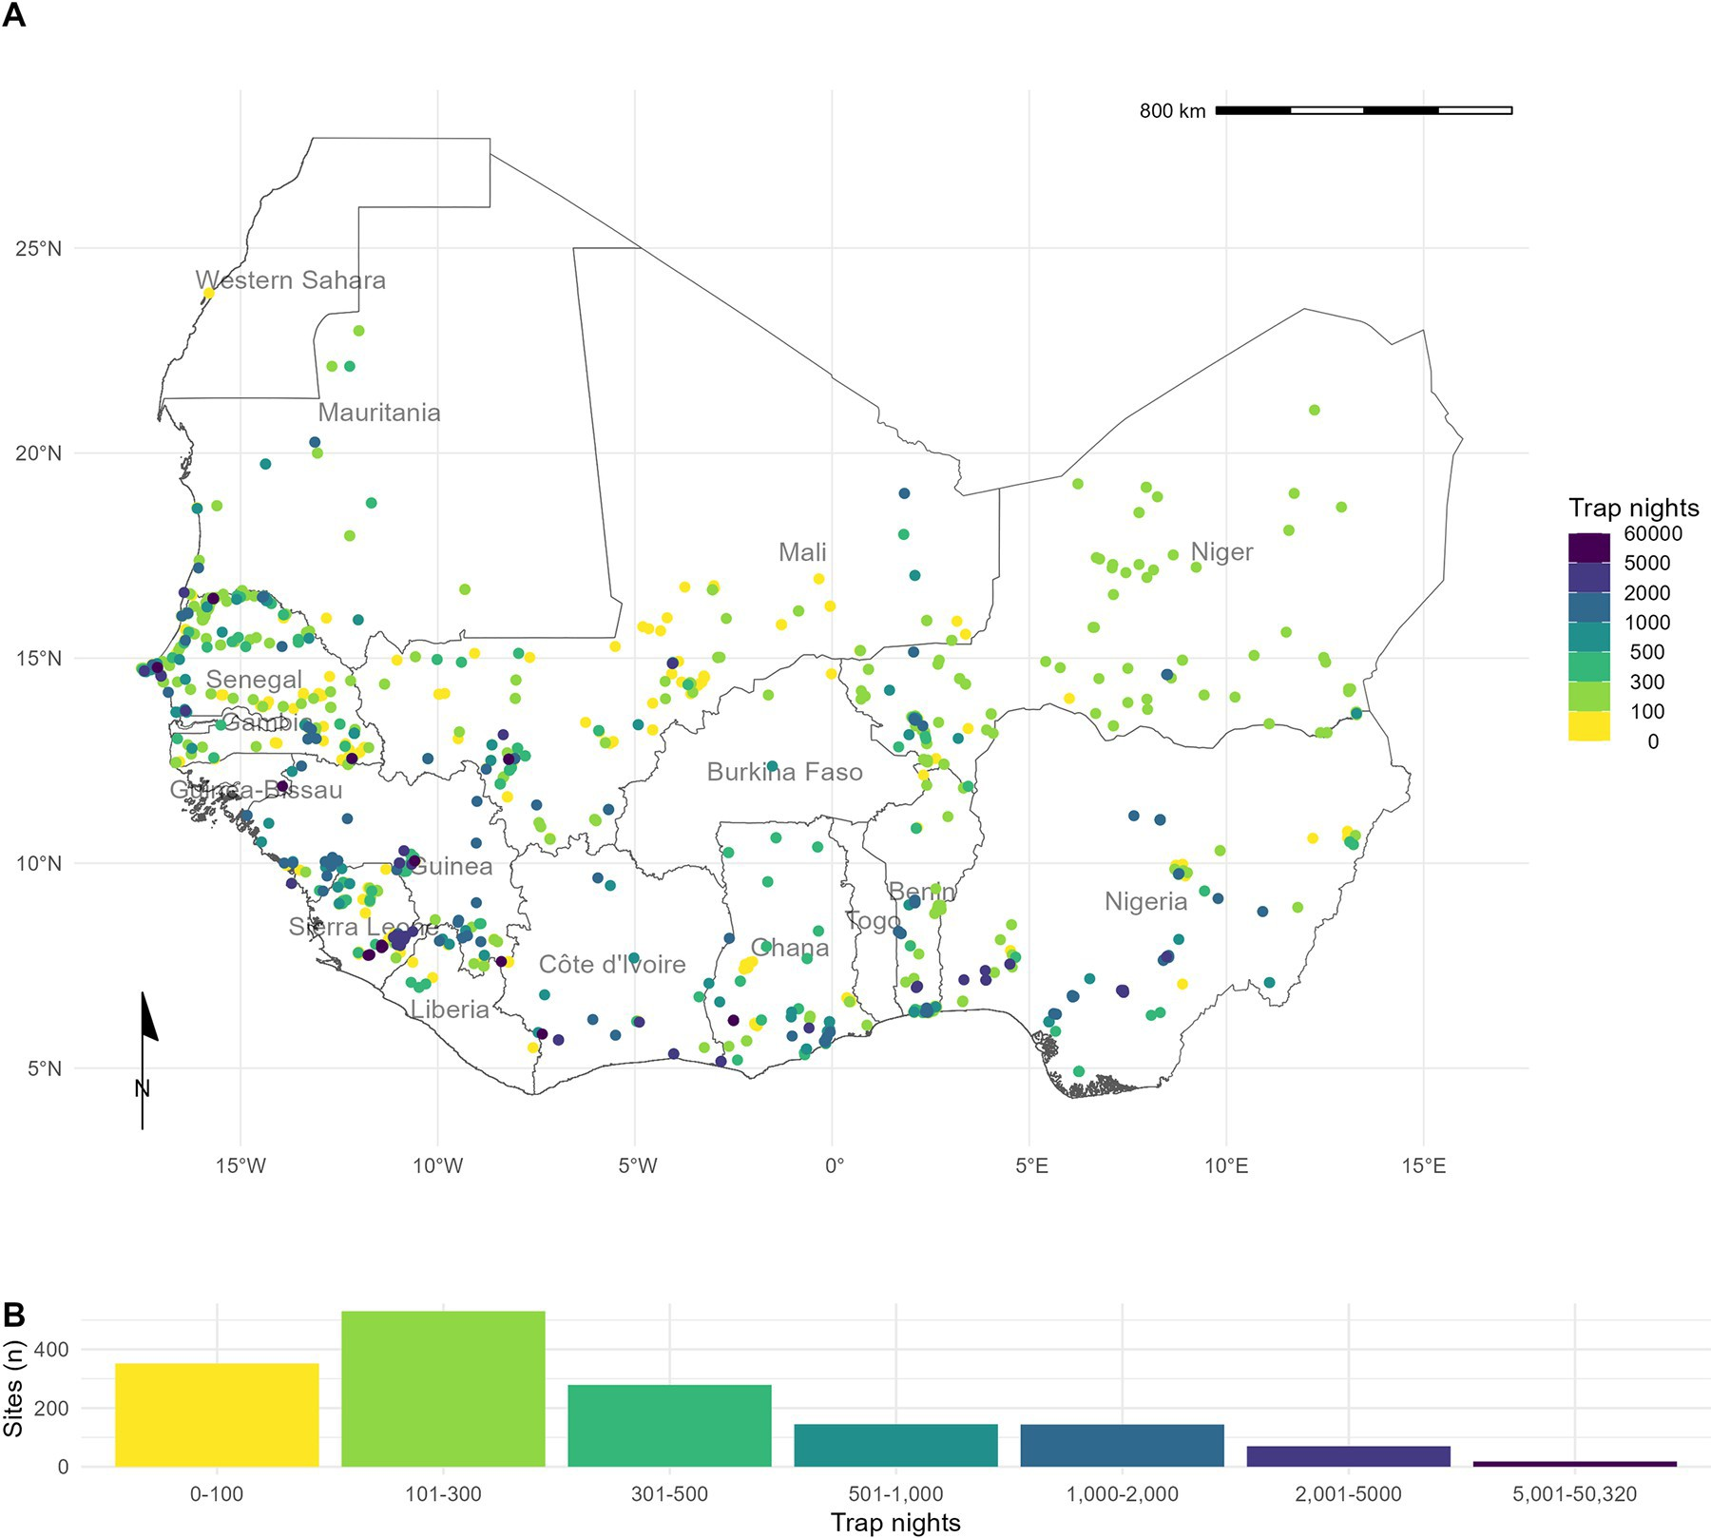

**Fig 1. Rodent trapping sites across West Africa.** A) The location of trapping sites in West Africa. No sites were recorded from Togo or The Gambia. Heterogeneity is observed in the coverage of each country by trap night (colour) and location of sites. For example, Senegal, Mali and Sierra Leone have generally good coverage compared to Guinea and Burkina Faso. B) Histogram of trap nights performed at each study site, a median of 248 trap nights (IQR 116–500) was performed at each site. A labelled map of the study region is attached in S5 Fig. Basemap shapefile obtained from GADM 4.0.4 [38].

https://doi.org/10.1371/journal.pntd.0010772.g001

region (Pdensity). Land cover classification was obtained from the Copernicus climate change service at ~300m resolution [40]. The proportion of cropland, shrubland, tree cover (*ψ*tree) and urban land cover (*ψ*urban) within a level-2 administrative region in 2005 was calculated.

We investigated the association between relative trapping effort, measured as TN density, and the proportion of urban, cropland, tree cover and human population density using Gener- alised Additive Models (GAM) incorporating a spatial interaction term (longitude and lati- tude, *X* and *Y*) [41]. Spatial aggregation of relative trapping effort was modelled using an exponential dispersion distribution (Tweedie) [42]. The models were constructed in the mgcv package [43]. Selection of the most parsimonious model was based on Deviance explained and the Akaike Information Criterion for each model (Eqs 1–5 below). Relative trapping effort was then predicted across West Africa using these covariates. We performed two sensitivity analy- ses, first, by removing sites with imputed trapping effort, second, by associating trap locations

to ~1km pixels rather than level-2 administrative areas.

TNdensity � Tweedieð*X* � *Y*Þ ð1Þ

TNdensity � TweedieðPdensity þ ð*X* � *Y*ÞÞ ð2Þ TNdensity � TweedieðPdensity þ Rarea þ ð*X* � *Y*ÞÞ ð3Þ TNdensity � TweedieðPdensity þ ctree þ curban þ ð*X* � *Y*ÞÞ ð4Þ

TNdensity � TweedieðPdensity þ Rarea þ curban þ ð*X* � *Y*ÞÞ ð5Þ

* + 1. **What is the difference in rodent host distributions between curated datasets and rodent trapping studies?.** We assessed the concordance of curated rodent host distributions from IUCN and GBIF with observed rodent detection and non-detection from rodent trap- ping studies for seven species with the most trap locations (*M*. *natalensis*, *R*. *rattus*, *M*. *erythro- leucus*, *M*. *musculus*, *A*. *niloticus*, *Praomys daltoni* and *Cricetomys gambianus*). We obtained rodent species distribution maps as shapefiles from the IUCN red list and translated these to a

~20km resolution raster [44]. Distributions were cropped to the study region for globally dis- tributed rodent species. We obtained rodent presence locations from GBIF as point data lim- ited to the study region [45]. Presence locations were associated to cells of raster with a ~20km resolution produced for the study region.

For each of the seven species, we first calculated the area of the IUCN expected range, and then the percentage of this range covered by presence detections in GBIF, and from detections in the rodent trapping data. We then calculated the area of both GBIF and rodent trapping detections outside of the IUCN expected range. For rodent trapping data, we additionally cal- culated the area of non-detections within the IUCN expected area. Finally, we calculated the combined area of detection from both GBIF and rodent trapping data.

* + 1. **Are rodent trapping derived host-pathogen associations present in a consolidated zoonoses dataset?.** To examine the usefulness of rodent trapping studies as an additional source of data we compared identified host-pathogen associations from trapping studies inves- tigating zoonoses with a consolidated zoonoses dataset (CLOVER) [11,46]. CLOVER is a syn- thesis of four host-pathogen datasets (GMPD2, EID2, HP3 and Shaw, 2020) and was released in 2021, it contains more than 25,000 host-pathogen associations for Bacteria, Viruses, Hel- minth, Protozoa and Fungi. We compared the host-pathogen networks across the two datasets, where the CLOVER data was subset for host species present in the rodent trapping data.

For host-pathogen pairs with assay results consistent with acute or prior infection, we cal- culated the proportion positive and identify those absent from CLOVER. We expand the anal- ysis to host-pathogen pairs with pathogens identified to genus level in S4 Fig.

* + 1. **What is the spatial extent of pathogen testing within host ranges?.** We use the sampled area of three pathogen groups and two pathogens (Arenaviridae, Borreliaceae, Leptos- piraceae, *Lassa mammarenavirus* and *Toxoplasma gondii*) to quantify the bias of sampling within their hosts ranges. For each pathogen, we first describe the number of host species assayed, for the five most commonly tested species we associate the locations of sampled indi- viduals to ~20km pixels and calculate the proportion of the IUCN range of the host in which sampling has occurred. We compare this figure to the total area in which the host has been detected to produce a measure of relative completeness of sampling within the included rodent trapping studies.

Data and code to reproduce all analyses are available in an archived Zenodo repository [32].

###### Results

* 1. **What is the extent of spatial bias in the rodent trapping data?**

We found non-random, spatial clustering of rodent trapping locations across the study region, suggestive of underlying bias in the sampling of rodents across West Africa. Trap sites were sit- uated in 256 of 1,450 (17.6%) level-2 administrative regions in 14 West African nations. The regions with the highest TN density included the capitals and large cities of Niger (Niamey), Nigeria (Ibadan), Ghana (Accra), Senegal (Dakar), and Benin (Cotonou). Outside of these cit- ies, regions in, Northern Senegal, Southern Guinea, Edo and Ogun States in Nigeria and East- ern Sierra Leone had the greatest TN density (Fig 1A.).

The most parsimonious GAM model (adjusted R2 = 0.3, Deviance explained = 48.7%) reported significant non-linear associations between relative trapping effort bias and human population densities (Effective Degrees of Freedom (EDF) = 7.13, *p* < 0.001), proportion of urban landscape (EDF = 1.92, *p* < 0.002) and region area (EDF = 3.63, *p* < 0.001), alongside significant spatial associations (EDF = 27.3, *p* < 0.001) (Supplementary table 3.1). Greatest trapping effort bias peaked at population densities between 5,000–7,500 individuals/km2, pro- portion of urban landscape >10% and region areas < 1,000km2. Increased trapping effort was found in North West Senegal, North and East Sierra Leone, Central Guinea and coastal regions of Nigeria, Benin and Ghana; in contrast South East Nigeria, Northern Nigeria and Burkina Faso had an observed bias towards a reduced trapping effort (Fig 2). In sensitivity analysis, excluding sites with imputed trap nights, Mauritania, Northern Senegal and Sierra Leone remained as regions trapped at higher rates, with Nigeria being trapped at lower than expected rates (S3A Fig.). In pixel-based sensitivity analysis spatial coverage was reduced with similar patterns of bias observed to the primary analysis (S3B Fig.).

###### What is the difference in rodent host distributions between curated datasets and rodent trapping studies?

We found that for six of the seven most frequently detected rodent species (*M*. *natalensis*, *R*. *rattus*, *M*. *erythroleucus*, *M*. *musculus*, *A*. *niloticus* and *P*. *daltoni*), trapping studies provided more distinct locations of detection and non-detection than were available from GBIF. For the endemic rodent species (*M*. *natalensis*, *M*. *erythroleucus*, *A*. *niloticus*, *P*. *daltoni* and *C*. *gambia- nus*) IUCN ranges had good concordance to both trapping studies and GBIF, however, indi- viduals of *A*. *niloticus* and *P*. *daltoni* were detected outside of IUCN ranges. In contrast, the non-native species *R*. *rattus* and *M*. *musculus* were detected across much greater ranges than were expected from IUCN distributions. Comparisons for *M*. *natalensis*, *R*. *rattus* and *M*. *mus- culus* are shown in Fig 3, the remaining species are shown in S4 Fig.

Comparison of the proportion of a species IUCN range in which detections and non-detec- tions occurred showed that sampling locations of these seven species within GBIF covered between 0.09–0.26% of expected ranges (Table 1.), compared to 0.03–0.24% for rodent trap- ping data. Detections occurred outside IUCN ranges for all species in both the GBIF and rodent trapping data, most noticeably for *A*. *niloticus* and *R*. *rattus*. Combining GBIF and rodent trapping data increased the sampled area by a mean of 1.6 times compared to the GBIF area alone, demonstrating limited overlap between the locations providing information to either dataset. Non-detection of a species occurred across species ranges (mean = 0.11%,

SD = 0.03%), suggestive of spatial heterogeneity of presence within IUCN ranges.

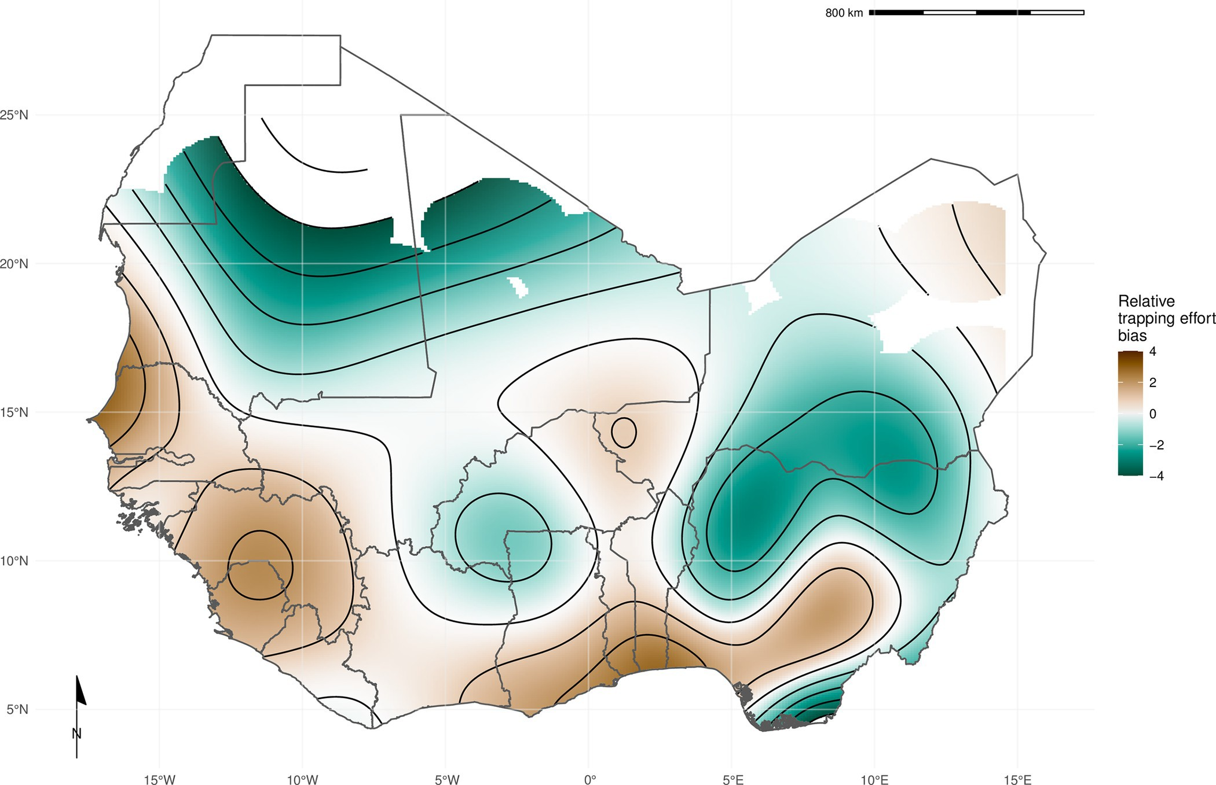

**Fig 2. Relative trapping effort bias across West Africa.** Modelled relative trapping effort bias adjusted for human population density, proportion urban land cover and area of the administrative region. Brown regions represent areas with a bias towards increased trapping effort (e.g., North West Senegal), Green regions represent areas with a bias towards reduced trapping effort (e.g., Northern Nigeria). Basemap shapefile obtained from GADM 4.0.4 [38].

https://doi.org/10.1371/journal.pntd.0010772.g002

###### Are rodent trapping derived host-pathogen associations present in a consolidated zoonoses dataset?

We found potentially important differences between the host-pathogen networks produced from included rodent trapping studies and the consolidated CLOVER dataset. When limited to taxonomic classification of both pathogen and host to species level we identified 25 host- pathogen pairs among 14 rodent and 6 pathogen species (Figs 4 and 5). We identified negative associations (non-detection through specific assays) for 45 host-pathogen pairs among 35 rodent and 7 pathogen species. CLOVER contained 10 (40%) of our identified host-pathogen associations, the remaining 15 (60%) were not found to be present in CLOVER, additionally CLOVER recorded positive associations for 4 (9%) of the negative associations produced from the rodent trapping data.

CLOVER included an additional 492 host-pathogen associations we do not observe in rodent trapping studies. The majority of these 392 (80%) pairs are from species with global dis- tributions (*M*. *musculus*, *R*. *rattus* and *R*. *norvegicus*), or from those with wide ranging distribu- tions in sub-Saharan Africa (38, 8%) (i.e., *A*. *niloticus*, *M*. *natalensis* and *Atelerix albiventris*).

For pathogens not identified to species level (i.e. family or higher taxa only), we identified 148 host-pathogen pairs among 32 rodent species and 25 pathogen families (S4 Fig.), with CLOVER containing 66 (45%) of these associations.

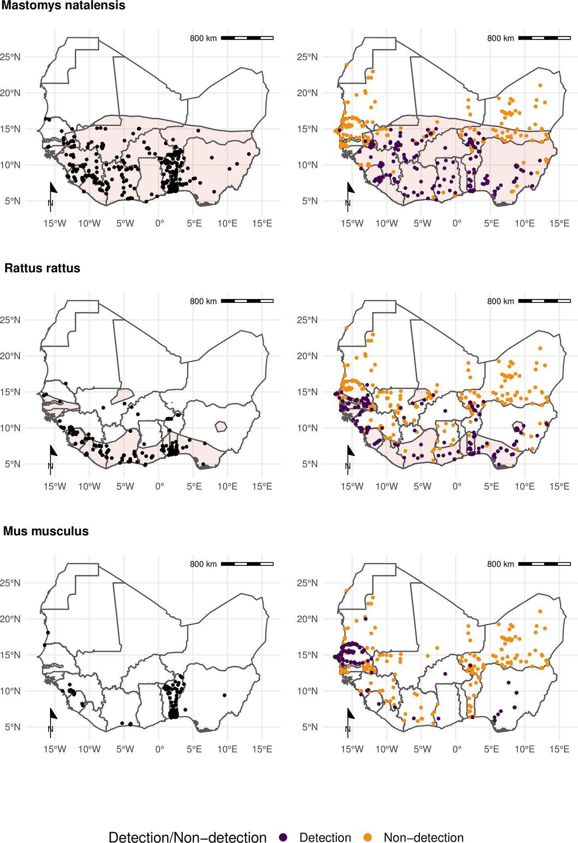

**Fig 3. Locations of detection and non-detection sites for rodent species in West Africa Each row corresponds to a single rodent species.** L) Presence recorded in GBIF (black points) overlaid on IUCN species range (red-shaded area).

R) Detection (purple) and non-detection (orange) from rodent trapping studies overlaid on IUCN species ranges. M. musculus has no IUCN West African range. Basemap shapefile obtained from GADM 4.0.4 [38].

https://doi.org/10.1371/journal.pntd.0010772.g003

Rodent trapping studies identified additional rodent host species for six pathogens; *Lassa mammarenavirus* (5), *Toxoplasma gondii* (4), Usutu virus (2), *Coxiella burnetii* (2), *Escherichia coli* and *Klebsiella pneumoniae* (both 1), that were not present in this consolidated host-patho- gen association dataset.

**Table 1. Comparison of IUCN, GBIF and rodent trapping ranges for the 7 most detected rodent species.**

|  |  |  |  |  |  |  |  |
| --- | --- | --- | --- | --- | --- | --- | --- |
|  | **IUCN** | **GBIF** | | **Trapping studies** | | | **Combined** |
| Species | Range (1,000  km2) | Area inside range (1,000 km2) (% of  IUCN range) | Area outside range (1,000  km2) | Detection area inside range (1,000 km2) (% of IUCN  range) | Species | Range (1,000  km2) | Area inside range (1,000 km2) (% of IUCN range) |
| *Mastomys natalensis* | 3,257 | 6.83 (0.21%) | 0.19 | 4.4 (0.14%) | *Mastomys natalensis* | 3,257 | 6.83 (0.21%) |
| *Rattus rattus* | 1,019 | 2.61 (0.26%) | 0.52 | 2.42 (0.24%) | *Rattus rattus* | 1,019 | 2.61 (0.26%) |
| *Mastomys erythroleucus* | 3,735 | 4.48 (0.12%) | 0.04 | 3.24 (0.09%) | *Mastomys erythroleucus* | 3,735 | 4.48 (0.12%) |
| *Mus musculus* |  |  | 2.15 |  | *Mus musculus* |  |  |
| *Arvicanthis niloticus* | 1,829 | 1.69 (0.09%) | 2.41 | 1.98 (0.11%) | *Arvicanthis niloticus* | 1,829 | 1.69 (0.09%) |
| *Praomys daltoni* | 2,658 | 4.03 (0.15%) | 0.29 | 2.03 (0.08%) | *Praomys daltoni* | 2,658 | 4.03 (0.15%) |
| *Cricetomys gambianus* | 2,476 | 5 (0.2%) | 0.17 | 0.75 (0.03%) | *Cricetomys gambianus* | 2,476 | 5 (0.2%) |

https://doi.org/10.1371/journal.pntd.0010772.t001

###### What is the spatial extent of microorganism testing within a host’s range?

The five most widely sampled microorganism species/families in included studies were Arena- viridae, Borreliaceae, *Lassa mammarenavirus*, Leptospiraceae and *Toxoplasma gondii*

(Table 2.). Assays to identify Arenaviridae infection were performed in 44 rodent species with evidence of viral infection in 15 species. Studies that reported Arenaviridae infection did not identify the microorganism to species level and were distinct from those reporting *Lassa mam- marenavirus* infection. *Lassa mammarenavirus* was specifically tested for in 43 species with 10 showing evidence of viral infection. The most commonly infected species for both Arenaviri- dae, generally, and *Lassa mammarenavirus* specifically, were *M*. *natalensis* and *M*. *erythroleu- cus*. These species were assayed across between 10–20% of their trapped area, equating to

~0.02% of their IUCN range (Table 2.).

Infection with species of Borreliaceae was assessed in 42 species, with evidence of infection in 17 rodent species. The greatest rates of infection were among *A*. *niloticus* (16%), *Mastomys huberti* (11%) and *M*. *erythroleucus* (9%). Testing was more widespread than for Arenviruses with coverage between 15–34% of their trapped area, however, this remains a small area in relation to their IUCN ranges (<0.05%). Leptospiraceae and *Toxoplasma gondii* was assessed in 8 species, with evidence of infection in 5 and 6 rodent species respectively. The spatial cover- age of testing for these microorganisms was more limited within IUCN host species ranges (~0.01%).

###### Discussion

Endemic rodent zoonoses and novel pathogen emergence from rodent hosts are predicted to have an increasing burden in West Africa and globally [10]. Here we have synthesised data from 126 rodent trapping studies containing information on more than 72,000 rodents, from at least 132 species of small mammals (Rodentia = 102, Soricidae = 28, Erinaceidae = 2), across 1,611 trap sites producing an estimated 942,669 trap nights from 14 West African countries.

Locations studied are complementary to curated datasets (e.g., IUCN, GBIF), incorporation of our synthesised dataset when assessing zoonosis risk based on host distributions could coun- teract some of the biases inherent to these curated datasets [18]. Most assayed rodents were not found to be hosts of known zoonotic pathogens. We identified 25 host-pathogen pairs reported from included studies, 15 of these were not included in a consolidated host-pathogen

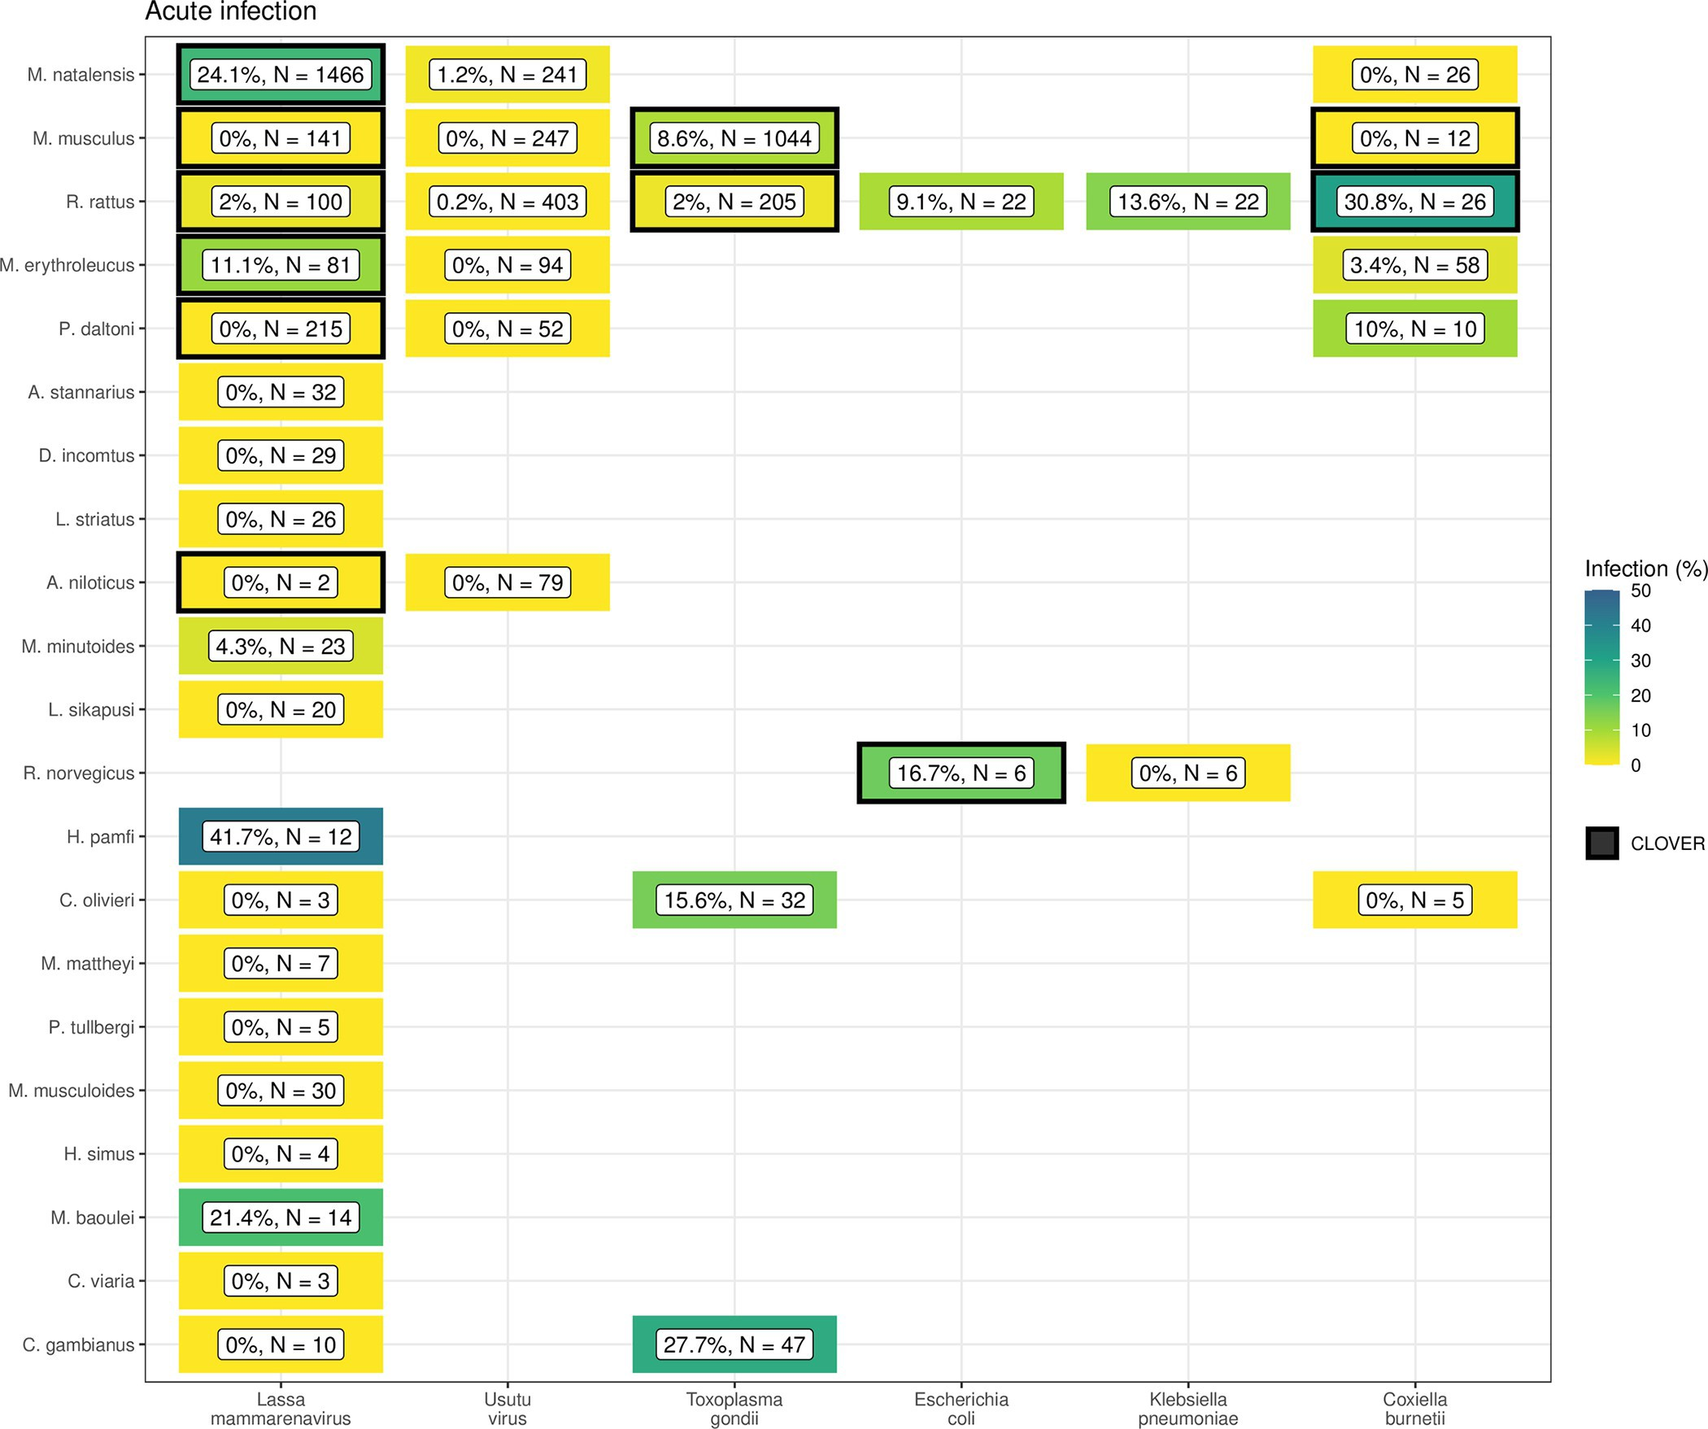

**Fig 4. Host-Pathogen associations detected through acute infection.** A) Identified species level host-pathogen associations through detection of acute infection (i.e. PCR, culture). Percentages and colour relate to the proportion of all assays that were positive, the number of individuals tested for the pathogen is labelled N. Associations with a black border are present in the CLOVER dataset.

https://doi.org/10.1371/journal.pntd.0010772.g004

dataset. Generally, the number of different species tested for a microorganism and the spatial extent of these sampling locations were limited. These findings highlight a number of sampling bias, supporting calls for further microorganism sampling across diverse species in zoonotic hotspots [47].

We found that rodent trapping data, like biodiversity data, showed important spatial biases [20]. Relative trapping effort bias was greater in Benin, Guinea, Senegal and Sierra Leone driven by long-standing research collaborations investigating the invasion of non-native rodent species (*M*. *musculus* and *R*. *rattus*) and the hazard of endemic zoonosis outbreaks (e.g., *Lassa mammarenavirus*). In addition to identifying point locations of prior rodent and pathogen sampling (Fig 1.), additional information on the trapping effort (density of trap- nights), human population density and land use type have been incorporated to produce a value of relative effort that will assist researchers in identifying specific locations where

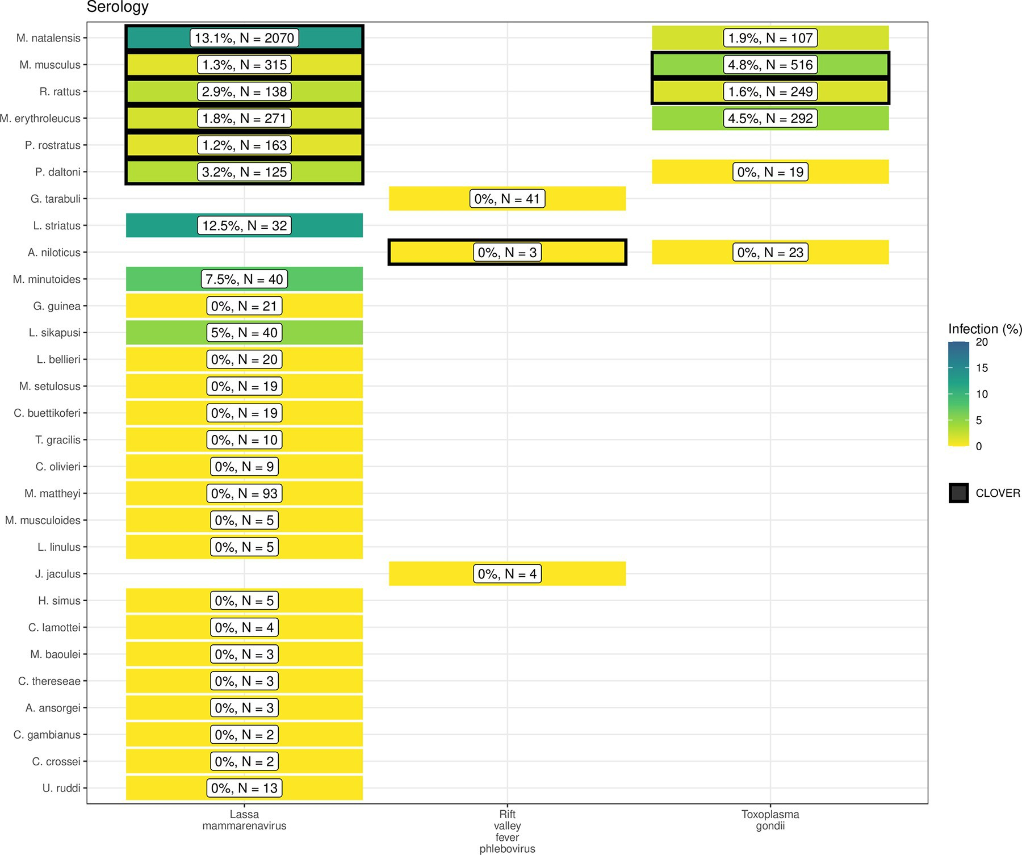

**Fig 5. Host-Pathogen associations detected through evidence of prior infection.** B) Identified species level host-pathogen associations through serological assays (i.e. ELISA). Percentages and colour relate to the proportion of all assays that were positive, the number of individuals tested for the pathogen is labelled N. Associations with a black border are present in the CLOVER dataset.

https://doi.org/10.1371/journal.pntd.0010772.g005

predictions based on these underlying data sources may suffer from effects of sampling bias. This approach improves the ease of identifying under sampled locations, for example, Fig 1. may suggest that South East Senegal, Southern Mali and Southern Niger are well sampled based on locations of trapping sites. When the number of trap nights, human population den- sity and land use of these regions are taken into account (Fig 2.) and compared with better sampled locations (i.e., Western Senegal, Eastern Sierra Leone) these areas are found to be rela- tively under sampled and would benefit from further sampling effort. This contrasts to North West Nigeria where no trapping has occurred (Fig 1.), our modelling approach has perhaps highlighted this region as an immediate priority for sampling of rodents and their pathogens given high human population densities and a human dominated landscape.

Much of West Africa remains relatively under sampled, particularly Burkina Faso, Coˆte

d’Ivoire, Ghana and Nigeria, despite these countries facing many of the same challenges. For example, annual outbreaks of Lassa fever are reported in Nigeria and there are potentially 60,000 unrecognised cases of Lassa fever every year in Coˆte d’Ivoire and Ghana [48]. Our esti- mates of the proportion of a rodent species range that have been sampled, along with pathogen testing within their sampled range, are sensitive to our choice of raster cell size. Smaller area

**Table 2. Comparison of microorganism sampling ranges for the 5 most widely sampled microorganisms and the 5 most sampled rodent host species (**� **no IUCN range in West African).**

|  |  |  |  |  |  |  |
| --- | --- | --- | --- | --- | --- | --- |
| ***Microorganism*** | **Host species** | **Tested (N)** | **Positive (N (%))** | ***Microorganism* testing area (1,000 km2)** | ***Microorganism* testing area within trapped area (%)** | ***Microorganism* testing area within IUCN range (%)** |
| Arenaviridae sp. |  |  |  |  |  |  |
|  | *Mastomys natalensis* | 2,841 | 104 (4%) | 0.61 | 13.45% | 0.02% |
|  | *Praomys daltoni* | 854 | 6 (1%) | 0.42 | 19.43% | 0.02% |
|  | *Mastomys erythroleucus* | 398 | 20 (5%) | 0.40 | 11.97% | 0.01% |
|  | *Rattus rattus* | 396 | 4 (1%) | 0.38 | 10.5% | 0.04% |
|  | *Praomys rostratus* | 310 | 5 (2%) | 0.13 | 12.53% | 0.02% |
| Borrelia sp. |  |  |  |  |  |  |
|  | *Mastomys erythroleucus* | 1,586 | 140 (9%) | 1.14 | 33.94% | 0.03% |
|  | *Arvicanthis niloticus* | 1,551 | 253 (16%) | 0.66 | 28.48% | 0.03% |
|  | *Mastomys natalensis* | 733 | 54 (7%) | 0.69 | 15.08% | 0.02% |
|  | *Mastomys huberti* | 731 | 83 (11%) | 0.23 | 29.83% | 0.04% |
|  | *Mus musculus* | 686 | 26 (4%) | 0.45 | 24.54% | � |
| Lassa mammarenavirus |  |  |  |  |  |  |
|  | *Mastomys natalensis* | 3,199 | 580 (18%) | 1.03 | 22.65% | 0.03% |
|  | *Mastomys erythroleucus* | 352 | 14 (4%) | 0.36 | 10.63% | 0.01% |
|  | *Rattus rattus* | 177 | 2 (1%) | 0.34 | 9.26% | 0.03% |
|  | *Praomys rostratus* | 163 | 2 (1%) | 0.27 | 27.02% | 0.04% |
|  | *Mus musculus* | 147 | 0 (0%) | 0.04 | 2.29% | � |
| Leptospira sp. |  |  |  |  |  |  |
|  | *Rattus rattus* | 646 | 65 (10%) | 0.40 | 11.1% | 0.04% |
|  | *Arvicanthis niloticus* | 221 | 10 (5%) | 0.02 | 0.9% | <0.01% |
|  | *Crocidura olivieri* | 141 | 14 (10%) | 0.34 | 25.16% | � |
|  | *Mastomys natalensis* | 136 | 26 (19%) | 0.36 | 7.91% | 0.01% |
|  | *Rattus norvegicus* | 79 | 19 (24%) | 0.21 | 40.08% | � |
| Toxoplasma gondii |  |  |  |  |  |  |
|  | *Mus musculus* | 1,548 | 115 (7%) | 0.62 | 33.64% | � |
|  | *Rattus rattus* | 428 | 8 (2%) | 0.36 | 9.77% | 0.03% |
|  | *Mastomys erythroleucus* | 292 | 13 (4%) | 0.37 | 11.06% | 0.01% |
|  | *Mastomys natalensis* | 107 | 2 (2%) | 0.08 | 1.83% | <0.01% |
|  | *Cricetomys gambianus* | 47 | 13 (28%) | 0.06 | 7.6% | <0.01% |

https://doi.org/10.1371/journal.pntd.0010772.t002

cells will reduce the reported coverage while larger cells will have the opposite effect. Despite this, the observed patterns are unlikely to importantly change, with the finding of sparse sam- pling of both rodents and their pathogens remaining present across cell scales. Rodent sam- pling should be targeted towards currently under sampled regions to reduce the potential impact of current biases and improve our understanding of both the distribution of rodent

hosts and the prevalence of pathogens within their populations. This will allow for better esti- mation of risk from endemic and novel zoonoses.

Rodent trapping studies provide geographic and temporally contextualised data on both species detection and non-detection which are not available from curated datasets. Non-detec- tion data can improve models of species distributions, unfortunately, high levels of missing data on trapping effort will continue to confound the allocations of non-detections as true absences [49]. Models of host species occurrence and abundance, improved by incorporating species absence, are important to assess the effect of land use and climate change on endemic zoonosis spillover to human populations and direct limited public health resources towards regions at greatest risk [50,51].

Currently available consolidated datasets on host-pathogen associations (e.g., CLOVER, EID2 and GMPD2) do not include spatial or temporal components [52]. The current synthesis of rodent trapping studies has highlighted that pathogens have been sparsely sampled within a host’s range. Current zoonosis risk models dependent on these sources of data are therefore not able to incorporate spatial heterogeneity in pathogen prevalence across the host range.

Additional uncertainty in current models of zoonotic disease risk arises from host-pathogen associations that have not been reported in these consolidated datasets. For example, *Hylomys- cus pamfi* infected with *Lassa mammarenavirus* and *R*. *rattus* infected with *Coxiella burnetii*, will not be included when solely based on consolidated host-pathogen datasets. Further, detec- tion of zoonotic pathogens in multiple, co-occurring, host species supports the adoption of multi-species approach to better understand the potential range of endemic zoonoses [53].

Few studies stratified detection and non-detection of hosts or pathogen prevalence by time, therefore limiting inference of temporal changes in host and pathogen dynamics. This limita- tion prevents calculation of incidence of infection and the abundance of infectious rodents which potentially varies by both time and space [54]. Understanding temporal changes in viral burden and shedding for endemic zoonoses is required to accurately predict current and future risk of pathogen spillover.

Finally, due to data sparsity, we were unable to account for temporal change over the six decades of rodent trapping studies. Land use change and population density have changed dra- matically over this period in West Africa [55]. We attempted to mitigate against this by using the median year of trapping to understand the spatial and land use biases in trapping activity. It is possible that land use and population density at trapping sites varied importantly between when rodent trapping was conducted and the conditions in 2005. Despite this limitation, the finding that trapping is biased towards high density, human dominated landscapes is unlikely to substantially change.

We have shown that synthesis of rodent trapping studies to supplement curated rodent dis- tributions can counteract some of the inherent biases in these data and that they can add fur- ther contextual data to host-pathogen association data. Together this supports their inclusion in efforts to model endemic zoonotic risk and novel pathogen emergence. Contribution of rodent trapping studies as data sources can be improved by adopting reporting standards and practices consistent with Open Science, namely sharing of disaggregated datasets alongside publication [56].

Future rodent trapping studies should be targeted towards regions that are currently under- studied. Further information on rodent presence and abundance across West Africa will aid the modelling of changing endemic zoonosis risk and the potential for novel pathogen emer- gence. Sharing of disaggregated data alongside research publications should be promoted with adoption of data standards to support ongoing data synthesis. Specifically, inclusion of exact locations of trapping sites, trapping effort and the dates at which trapping occurred would sup- port more detailed inference of the spatio-temporal dynamics of host populations and the risk

of endemic zoonosis spillover events. Despite these challenges we propose that rodent trapping studies can provide an important source of data to supplement curated datasets on rodent dis- tributions to quantify the risk of endemic zoonosis spillover events and the hazard of novel pathogen emergence.

###### Supporting information

**S1 Table. Data extraction tool for studies meeting inclusion criteria.**

(DOCX)

**S2 Table. Included studies.**

(DOCX)

**S3 Table. GAM outputs for the association of relative trapping effort and covariates of interest.**

(DOCX)

**S1 Fig. Timeline of included studies.** Green points represent the start date of rodent trapping studies, blue points representing the final trapping activity. Red points indicate the publication of studies. Increasing numbers of studies have been published since 2000 with more studies being conducted over repeated visits.

(DOCX)

**S2 Fig. Relative trapping effort bias across West Africa from the subset of included studies reporting trapping effort, adjusted for proportion urban land cover and proportion tree cover.** Brown regions represent areas with higher than expected trapping effort, green regions represent areas lower than expected trapping effort. Basemap shapefile obtained from GADM

4.0.4 [38]. (DOCX)

**S3 Fig. Pixel based analysis of relative trapping effort bias across West Africa adjusted for habitat type and human population density.** Brown regions represent areas with higher than expected trapping effort, green regions represent areas lower than expected trapping effort.

Basemap shapefile obtained from GADM 4.0.4 [38]. (DOCX)

**S4 Fig.** A) Identified host-pathogen associations at pathogen family level through detection of acute infection (i.e. PCR, culture). B) Identified host-pathogen associations at pathogen family level through serological assays (i.e. ELISA). Percentages and colour relate to the proportion of all assays that were positive. Associations with a black border are present in the CLOVER data- set.

(DOCX)

**S5 Fig. A map of the study region with capital cities and areas discussed in the manuscript highlighted.** Basemap shapefile obtained from GADM 4.0.4 [38].

(DOCX)

**S6 Fig. Locations of detection and non-detection sites for rodent species in West Africa.** Each row corresponds to a single rodent species. L) Presence recorded in GBIF (black points) overlaid on IUCN species range (red-shaded area). R) Detection (purple) and non-detection (orange) from rodent trapping studies overlaid on IUCN species ranges. M. musculus has no IUCN West African range. Basemap shapefile obtained from GADM 4.0.4 [38].

(DOCX)

**Author Contributions Conceptualization:** David Simons, Kate E. Jones. **Data curation:** David Simons, Lauren A. Attfield. **Formal analysis:** David Simons.

**Funding acquisition:** Deborah Watson-Jones, Richard Kock. **Supervision:** Kate E. Jones, Deborah Watson-Jones, Richard Kock. **Validation:** Lauren A. Attfield.

**Writing – original draft:** David Simons.

**Writing – review & editing:** Lauren A. Attfield, Kate E. Jones, Deborah Watson-Jones, Richard Kock.

###### References

1. Bernstein AS, Ando AW, Loch-Temzelides T, Vale MM, Li BV, Li H, et al. The costs and benefits of pri- mary prevention of zoonotic pandemics. Science Advances. 2022; 8: eabl4183. https://doi.org/10.1126/ sciadv.abl4183 PMID: 35119921
2. Allen T, Murray KA, Zambrana-Torrelio C, Morse SS, Rondinini C, Di Marco M, et al. Global hotspots and correlates of emerging zoonotic diseases. Nature Communications. 2017; 8: 1124. https://doi.org/ 10.1038/s41467-017-00923-8 PMID: 29066781
3. Hassell JM, Begon M, Ward MJ, Fèvre EM. Urbanization and disease emergence: Dynamics at the wildlife–livestock–human interface. Trends in Ecology & Evolution. 2017; 32: 55–67. https://doi.org/10. 1016/j.tree.2016.09.012 PMID: 28029378
4. Garc´ıa-Peña GE, Rubio AV, Mendoza H, Ferna´ndez M, Milholland MT, Aguirre AA, et al. Land-use change and rodent-borne diseases: Hazards on the shared socioeconomic pathways. Philosophical Transactions of the Royal Society B: Biological Sciences. 2021; 376: 20200362. https://doi.org/10. 1098/rstb.2020.0362 PMID: 34538146
5. McMahon BJ, Morand S, Gray JS. Ecosystem change and zoonoses in the anthropocene. Zoonoses and Public Health. 2018; 65: 755–765. https://doi.org/10.1111/zph.12489 PMID: 30105852
6. Maudlin I, Eisler MC, Welburn SC. Neglected and endemic zoonoses. Philos Trans R Soc Lond B Biol Sci. 2009; 364: 2777–2787. https://doi.org/10.1098/rstb.2009.0067 PMID: 19687045
7. Halliday JEB, Allan KJ, Ekwem D, Cleaveland S, Kazwala RR, Crump JA. Endemic zoonoses in the tropics: A public health problem hiding in plain sight. Vet Rec. 2015; 176: 220–225. https://doi.org/10. 1136/vr.h798 PMID: 25722334
8. Molyneux D, Hallaj Z, Keusch GT, McManus DP, Ngowi H, Cleaveland S, et al. Zoonoses and margina- lised infectious diseases of poverty: Where do we stand? Parasites & Vectors. 2011; 4: 106. https://doi. org/10.1186/1756-3305-4-106 PMID: 21672216
9. Judson SD, Rabinowitz PM. Zoonoses and global epidemics. Current Opinion in Infectious Diseases. 2021; 34: 385–392. https://doi.org/10.1097/QCO.0000000000000749 PMID: 34310453
10. Han BA, Schmidt JP, Bowden SE, Drake JM. Rodent reservoirs of future zoonotic diseases. PNAS. 2015; 112: 7039–7044. https://doi.org/10.1073/pnas.1501598112 PMID: 26038558
11. Gibb R, Albery GF, Mollentze N, Eskew EA, Brierley L, Ryan SJ, et al. Mammal virus diversity estimates are unstable due to accelerating discovery effort. Biology Letters. 2021; 18: 20210427. https://doi.org/ 10.1098/rsbl.2021.0427 PMID: 34982955
12. Fischer C, Gayer C, Kurucz K, Riesch F, Tscharntke T, Bata´ry P. Ecosystem services and disservices provided by small rodents in arable fields: Effects of local and landscape management. Journal of Applied Ecology. 2018; 55: 548–558. https://doi.org/10.1111/1365-2664.13016
13. Dobson FS, Oli MK. Fast and slow life histories of rodents. Rodent societies: an ecological and evolu- tionary perspective. 2007; 99–105. Available: [https://www.jstor.org/stable/4290203](http://www.jstor.org/stable/42902037)7
14. Albery GF, Becker DJ. Fast-lived hosts and zoonotic risk. Trends in Parasitology. 2021; 37: 117–129. https://doi.org/10.1016/j.pt.2020.10.012 PMID: 33214097
15. Gibb R, Redding DW, Chin KQ, Donnelly CA, Blackburn TM, Newbold T, et al. Zoonotic host diversity increases in human-dominated ecosystems. Nature. 2020; 584: 398–402. https://doi.org/10.1038/

s41586-020-2562-8 PMID: 32759999

1. Han BA, Kramer AM, Drake JM. Global patterns of zoonotic disease in mammals. Trends in Parasitol- ogy. 2016; 32: 565–577. https://doi.org/10.1016/j.pt.2016.04.007 PMID: 27316904
2. Gibb R, Franklinos LHV, Redding DW, Jones KE. Ecosystem perspectives are needed to manage zoo- notic risks in a changing climate. BMJ. 2020; 371: m3389. https://doi.org/10.1136/bmj.m3389 PMID: 33187958
3. Boakes EH, McGowan PJK, Fuller RA, Chang-qing D, Clark NE, O’Connor K, et al. Distorted views of biodiversity: Spatial and temporal bias in species occurrence data. PLOS Biology. 2010; 8: e1000385. https://doi.org/10.1371/journal.pbio.1000385 PMID: 20532234
4. Bowler DE, Callaghan CT, Bhandari N, Henle K, Benjamin Barth M, Koppitz C, et al. Temporal trends in the spatial bias of species occurrence records. Ecography. 2022;n/a: e06219. https://doi.org/10.1111/ ecog.06219
5. Beck J, Bo¨ ller M, Erhardt A, Schwanghart W. Spatial bias in the GBIF database and its effect on model- ing species’ geographic distributions. Ecological Informatics. 2014; 19: 10–15. https://doi.org/10.1016/j. ecoinf.2013.11.002
6. Plowright RK, Becker DJ, McCallum H, Manlove KR. Sampling to elucidate the dynamics of infections in reservoir hosts. Philos Trans R Soc Lond B Biol Sci. 2019; 374: 20180336. https://doi.org/10.1098/ rstb.2018.0336 PMID: 31401966
7. Carlson CJ, Farrell MJ, Grange Z, Han BA, Mollentze N, Phelan AL, et al. The future of zoonotic risk prediction. Philosophical Transactions of the Royal Society B: Biological Sciences. 2021; 376: 20200358. https://doi.org/10.1098/rstb.2020.0358 PMID: 34538140
8. Wille M, Geoghegan JL, Holmes EC. How accurately can we assess zoonotic risk? Dobson AP, editor. PLoS Biol. 2021; 19: e3001135. https://doi.org/10.1371/journal.pbio.3001135 PMID: 33878111
9. Redding DW, Lucas TCD, Blackburn TM, Jones KE. Evaluating bayesian spatial methods for modelling species distributions with clumped and restricted occurrence data. PLOS ONE. 2017; 12: e0187602. https://doi.org/10.1371/journal.pone.0187602 PMID: 29190296
10. Grace D, Mutua F, Ochungo P, Kruska R, Jones K, Brierley L, et al. Mapping of poverty and likely zoo- noses hotspots. 2012.
11. Meerburg B, Singleton G, Kijlstra A. Rodent-borne diseases and their risks for public health. Critical reviews in microbiology. 2009; 35: 221–70. https://doi.org/10.1080/10408410902989837 PMID:

19548807

1. Galeh TM, Sarvi S, Montazeri M, Moosazadeh M, Nakhaei M, Shariatzadeh SA, et al. Global status of toxoplasma gondii seroprevalence in rodents: A systematic review and meta-analysis. Frontiers in Vet- erinary Science. 2020; 7. Available: [https://www.frontiersin.org/article/10.3389/fvets.2020.004](http://www.frontiersin.org/article/10.3389/fvets.2020.00461)61 PMID: 32851037
2. Bovendorp RS, MCCleery RA, Galetti M. Optimising sampling methods for small mammal communities in neotropical rainforests. Mammal Review. 2017; 47: 148–158. https://doi.org/10.1111/mam.12088
3. Fichet-Calvet E, Lecompte E, Veyrunes F, Barrière P, Nicolas V, Koule´mou K. Diversity and dynamics in a community of small mammals in coastal guinea, west africa. Belgian Journal of Zoology. 2009; 139: 93–102. Available: <http://www.vliz.be/nl/open-marien-archief?module=ref&refid=204614>
4. Catalano S, Leger E, Fall CB, Borlase A, Diop SD, Berger D, et al. Multihost transmission of schisto- soma mansoni in senegal, 2015–2018. Emerging Infectious Diseases. 2020; 26: 1234–1242. https://

doi.org/10.3201/eid2606.200107 PMID: 32441625

1. USAID. One health surveillance. PREDICT project. 2021 [cited 27 Sep 2021]. Available: https://p2. predict.global/surveillance
2. Simons D. DidDrog11/scoping\_review: Repository to accompany submission. Zenodo; 2022. https:// doi.org/10.5281/zenodo.7022637
3. GBIF: The Global Biodiversity Information Facility. The global biodiversity information facility. 2021 [cited 25 Apr 2021]. Available: [https://www.gbif.org/](http://www.gbif.org/)
4. National Geospatial-Intelligence Agency. NGA: GNS home. [cited 22 Mar 2021]. Available: https:// geonames.nga.mil/gns/html/
5. CDC. Emerging and Zoonotic Infectious Disease Laws. 2022 [cited 31 Oct 2022]. Available: https:// [www.cdc.gov/phlp/publications/topic/zoonotic.html](http://www.cdc.gov/phlp/publications/topic/zoonotic.html)
6. Pebesma E. Simple features for r: Standardized support for spatial vector data. The R Journal. 2018; 10: 439–446. Available: https://journal.r-project.org/archive/2018/RJ-2018-009/index.html
7. R Core Team. R: A language and environment for statistical computing. Vienna, Austria: R Foundation for Statistical Computing; 2020. Available: [https://www](http://www.R-project.org/).R-proje[ct.org/](http://www.R-project.org/)
8. Database of Global Administrative Areas. GADM. 2022 [cited 25 Apr 2021]. Available: https://gadm.org/ index.html
9. Socioeconomic Data and Applications Center. Gridded population of the world (GPW), v4 SEDAC. 2021 [cited 4 Feb 2021]. Available: https://sedac.ciesin.columbia.edu/data/collection/gpw-v4
10. European Space Agency Climate Change Initiative. Land cover classification gridded maps from 1992 to present derived from satellite observations. 2022 [cited 3 Mar 2022]. Available: https://cds.climate. copernicus.eu/cdsapp#!/dataset/satellite-land-cover?tab=overview
11. Pedersen EJ, Miller DL, Simpson GL, Ross N. Hierarchical generalized additive models in ecology: An introduction with mgcv. PeerJ. 2019; 7: e6876. https://doi.org/10.7717/peerj.6876 PMID: 31179172
12. Kendal W. Spatial aggregation of the Colorado potato beetle described by an exponential dispersion model. Ecological Modelling. 2002; 151: 261–269. https://doi.org/10.1016/S0304-3800(01)00494-X
13. Wood SN. Generalized additive models: An introduction with r. 2nd ed. Chapman; Hall/CRC; 2017.
14. IUCN. The IUCN red list of threatened species. 2021. Available: [www.iucnredlist.org](http://www.iucnredlist.org/)
15. GBIF: The Global Biodiversity Information Facility. Occurrence download. The Global Biodiversity Infor- mation Facility; 2021. https://doi.org/10.15468/DL.S52MEH
16. Gibb R, Carlson CJ, Farrell MJ. Viralemergence/clover: Preprint + zenodo. Zenodo; 2021. https://doi. org/10.5281/zenodo.4435128
17. Harvey E, Holmes EC. Diversity and evolution of the animal virome. Nat Rev Microbiol. 2022; 20: 321–

334. https://doi.org/10.1038/s41579-021-00665-x PMID: 34983966

1. Basinski AJ, Fichet-Calvet E, Sjodin AR, Varrelman TJ, Remien CH, Layman NC, et al. Bridging the gap: Using reservoir ecology and human serosurveys to estimate lassa virus spillover in west africa. Wesolowski A, editor. PLoS Comput Biol. 2021; 17: e1008811. https://doi.org/10.1371/journal.pcbi. 1008811 PMID: 33657095
2. Va´clav´ık T, Meentemeyer RK. Invasive species distribution modeling (iSDM): Are absence data and dispersal constraints needed to predict actual distributions? Ecological Modelling. 2009; 220: 3248– 3258. https://doi.org/10.1016/j.ecolmodel.2009.08.013
3. Zeimes CB, Olsson GE, Ahlm C, Vanwambeke SO. Modelling zoonotic diseases in humans: Compari- son of methods for hantavirus in sweden. Int J Health Geogr. 2012; 11: 39. https://doi.org/10.1186/ 1476-072X-11-39 PMID: 22984887
4. Judson SD, LeBreton M, Fuller T, Hoffman RM, Njabo K, Brewer TF, et al. Translating predictions of zoonotic viruses for policymakers. EcoHealth. 2018; 15: 52–62. https://doi.org/10.1007/s10393-017-

1304-3 PMID: 29230614

1. Gibb R, Albery GF, Becker DJ, Brierley L, Connor R, Dallas TA, et al. Data proliferation, reconciliation, and synthesis in viral ecology. BioScience. 2021; 71: 1148–1156. https://doi.org/10.1093/biosci/ biab080
2. Wilkinson DP, Golding N, Guillera-Arroita G, Tingley R, McCarthy MA. A comparison of joint species distribution models for presence–absence data. Methods in Ecology and Evolution. 2019; 10: 198–211. https://doi.org/10.1111/2041-210X.13106
3. Fichet-Calvet E, O¨ lschla¨ ger S, Strecker T, Koivogui L, Becker-Ziaja B, Camara AB, et al. Spatial and temporal evolution of lassa virus in the natural host population in upper guinea. Sci Rep. 2016; 6: 21977. https://doi.org/10.1038/srep21977 PMID: 26911443
4. Herrmann SM, Brandt M, Rasmussen K, Fensholt R. Accelerating land cover change in west africa over four decades as population pressure increased. Commun Earth Environ. 2020; 1: 1–10. https://doi.org/ 10.1038/s43247-020-00053-y
5. Foster ED, Deardorff A. Open science framework (OSF). J Med Libr Assoc. 2017; 105: 203–206. https://doi.org/10.5195/jmla.2017.88
   1. **Published article in *International Health***

*International Health* 2022; 0: 1–3

https://doi.org/10.1093/inthealth/ihac076 Advance Access publication 0 2022

# Lassa fever cases suffer from severe underreporting based on reported fatalities

SHORT COMMUNICATION

David Simonsa,b,**∗**

Downloaded from https://academic.oup.com/inthealth/advance-article/doi/10.1093/inthealth/ihac076/6840000 by guest on 04 July 2023

*aRoyal Veterinary College, Department of Pathology and Infectious Diseases, Centre for Emerging, Endemic and Exotic Diseases, 4 Royal College St., London, UK; bLondon School of Hygiene and Tropical Medicine, Department of Clinical Research,*

*Keppel Street, London, UK*

∗Corresponding author: Tel: +447779276016; E-mail: [dsimons19@rvc.ac.uk](mailto:dsimons19@rvc.ac.uk)

*Received 22 September 2022; revised 20 October 2022; editorial decision 31 October 2022; accepted 3 November 2022*

Background: Lassa fever is a viral haemorrhagic fever endemic to eight West African countries. Symptomatic disease is expected to occur in 20% of those infected and transmission typically occurs from viral spillover from rodent hosts. The combination of limited access to diagnostics and healthcare means the true burden of this disease is unknown.

Methods: The case fatality rate among confirmed, probable and possible cases of Lassa fever in endemic regions is expected to be ≈15%. Here, annual reported cases and deaths have been used to estimate the case fatality rate, using three subsets of available data, to understand the scale of underreporting of severe human cases.

Results: The literature review produced 38 records of cases and fatalities, comprising 5230 reported cases and 1482 reported deaths in seven countries. The estimated case fatality rate ranges from 16.5 to 25.6% (stan- dard deviation 11.5–32.2). The expected number of severe cases between 2012 and 2022 is 8995, with current reported numbers 58% of what is expected.

Conclusion: This analysis highlights current uncertainty and systemic underreporting of the morbidity and mortality burden of Lassa fever in its endemic region and must be considered when discussing the epidemi- ology of this neglected tropical disease.

Introduction

Lassa fever, caused by *Lassa mammarenavirus*, is an endemic zoonotic infectious disease, with outbreaks of human infection regularly recorded in eight West African countries.1 Direct or indi- rect transmission from the primary zoonotic reservoir, the Natal multimammate mouse (Mastomys natalensis), is thought to be the source of most cases in endemic regions, with limited human- human transmission. Sporadic human cases are detected in non- endemic countries due to infected travellers. Most infections (≈80%) produce minimal symptoms, while symptomatic disease can lead to severe symptoms requiring hospitalisation and lead- ing to death.

The number of individuals at risk of Lassa fever is projected to increase due to increasing human populations, land-use changes and climate change.2 Our understanding of the current impact across the endemic region is lacking due to limited diagnos- tics, surveillance and reporting. The degree of underreporting of cases presenting to healthcare is unknown, while the reporting of deaths associated with notifiable diseases such as Lassa fever

is typically more complete. The case fatality rate (CFR) of Lassa fever is estimated at 15%, with wide variability. Two recent stud- ies of hospitalised populations in Nigeria recorded CFRs of 14% and 31%, with a study in Sierra Leone estimating a CFR of 69%.3–5 The scale of underreporting can be estimated from the num- ber of cases that would be expected to produce the number of reported deaths, under the assumption that these suffer from fewer limitations in reporting. The number of estimated cases can then be compared with the reported cases to produce a propor- tion of expected cases that are reported. This approach has been adopted during the current coronavirus disease 2019 (COVID-19) pandemic by organisations such as the World Health Organiza- tion (WHO) and can help to estimate the unrecognised burden of

a disease.

Methods

Reported Lassa fever cases were identified from a search of ProMED-mail, WHO Weekly Bulletin on Outbreaks and Other

*© The Author(s) 2022. Published by Oxford University Press on behalf of Royal Society of Tropical Medicine and Hygiene. This is an Open Access article distributed under the terms of the Creative Commons Attribution License (https://creativecommons.org/licenses/by/4.0/), which permits unrestricted reuse, distribution, and reproduction in any medium, provided the original work is properly cited.*

**A B**

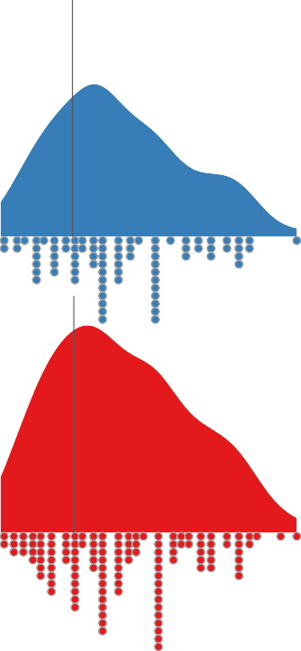

Nigeria: 63%

Liberia: 30%

Sierra leone: 57%

Benin: 12%

Togo: 38%

6000

4000

2000

400

300

Downloaded from https://academic.oup.com/inthealth/advance-article/doi/10.1093/inthealth/ihac076/6840000 by guest on 04 July 2023

200

100

Method 3 0 0

Edo and Ondo CFR

Method 2 NCDC CFR

600

400

200

0

Cases

400

300

200

100

0

60

Ghana: 17%

Guinea: 25%

30

40 20

20 10

Method 1

Combined CFR 0 0

15

10 Reported cases

Expected cases Method 3 CFR

5

0.00 0.25 0.50 0.75

Case Fatality Rate 0

Figure 1. (A) CFR of Lassa fever following development of symptomatic disease and presenting to healthcare using three data sources for estimation. Method 1 uses all reported cases and deaths where the CFR is not equal to 0% or 100%. Method 2 uses all reported cases and deaths provided by NCDC data prior to 2021 where the CFR is not equal to 0% or 100%. Method 3 uses all reported cases and deaths from Edo and Ondo states from 2017 to 2021. The black line represents the weighted mean CFR. (B) The difference between reported cases and expected cases derived from the number of reported deaths divided by the CFR (note that the *y*-axis scale varies by country).

2 184

Emergencies, Nigeria Centre for Disease Control and Prevention (NCDC) situation reports and academic publications between 2012 and 2022. Where available, information on the number of suspected cases, confirmed cases and deaths among confirmed cases was extracted.

Three CFRs were calculated using the number of reported deaths as the numerator and cases as the denominator, weighted by the number of reported cases. First, across all re- ports obtained, if the number of deaths exceeded the number of confirmed cases, suspected cases were used as the denominator. Second, only NCDC data were used. This data includes prospec- tive follow-up of confirmed cases and contact tracing, due to

The CFR of Lassa fever has been treated as spatially non-varying, while the impacts of the known different viral strains on disease severity are currently unknown.

Conclusions

The number of observed cases of Lassa fever is significantly un- derreported. This analysis has been performed to draw attention to the limitations of using reported case numbers when estimat- ing the risk of disease in endemic countries and the risk of cases being exported from endemic countries.

Downloaded from https://academic.oup.com/inthealth/advance-article/doi/10.1093/inthealth/ihac076/6840000 by guest on 04 July 2023

the impact of COVID-19 on healthcare-seeking only data prior to

2021 is included. Third, NCDC data limited to Edo and Ondo states

between 2017 and 2021. The expected number of cases was cal- culated for reported deaths and compared with the number of reported cases. CFR values of 0% and 100% were removed prior to calculating weighted mean CFRs.

Results

The literature review produced 38 records of cases and fatal- ities from seven countries between 2012 and 2022. These in- cluded 5230 reported cases and 1482 reported deaths. A simi- lar CFR was estimated using the first two approaches (method 1: mean = 25.6% [standard deviation {SD} 16.6%]; method 2: mean = 25.2% [SD 16.2%]). Limiting the Nigerian states con- tributing data to those with higher surveillance (method 3) re- sulted in an estimated CFR of 16.5% (SD 5%; (Figure 1A). For the years 2018–2022, the number of reported cases from Nigeria was greater than the expected cases based on CFR estimates from methods 1 and 2, suggestive that a CFR of 16.5% (±5%) using method 3 is more representative of mortality following develop- ment of clinically severe disease. Estimates of CFR from method

Authors’ contributions: DS conceptualised the work, obtained and analysed the data and wrote up the manuscript for submission.

Acknowledgements: I would like to acknowledge two anonymous re- viewers, the editor and commenters on the pre-print version of this article for their suggestions on improvement.

Funding: DS is supported by a PhD studentship from the UK Biotechnol- ogy and Biological Sciences Research Council (BB/M009513/1).

Competing interests: None declared.

Ethical approval: Not required.

Data availability: All data are available from open access sources. Analysis code and data to reproduce this analysis are available from https://github.com/DidDrog11/lassa\_underreporting. Publication sources for included data are included in the supplemental dataset and at the above repository.

3 show less variability than those including all outbreaks or all

states, leading to greater confidence in this estimate. Applying

this method of case estimation to other settings based on re- ported deaths found that between 17 and 63% of expected cases are reported (Figure 1B).

As expected, underreporting is greatest in countries in which Lassa fever surveillance is not routine and there are few reported deaths, i.e. Ghana, Guinea and Togo (17%, 25% and 38%, respec- tively). Conversely, in Nigeria and Sierra Leone, where surveillance is greater, underreporting was estimated at 63% and 57%, re- spectively. The lowest proportion of expected cases was reported from Benin (12%), which reports sporadic outbreaks based on identified deaths but has no routine surveillance. During the last decade, 5230 cases of Lassa fever have been reported, with 8995 expected cases, and with an estimated 3765 unreported cases.

These results are sensitive to the number of reported deaths due to Lassa fever, which is likely to suffer from variable reporting by country. As deaths are associated with individuals who present to clinical settings following symptoms, this method is unable to estimate the absolute number of cases in a given community.

References

1. Balogun OO, Akande OW, Hamer DH. Lassa fever: an evolving emer- gency in West Africa. Am J Trop Med Hyg. 2021;104(2):466–73. https:// doi.org/10.4269/ajtmh.20-0487.
2. Redding DW, Gibb R, Dan-Nwafor CC, et al. Geographical drivers and climate-linked dynamics of Lassa fever in Nigeria. Nat Commun. 2021;12(1):5759. https://doi.org/10.1038/s41467-021-25910-y.
3. Duvignaud A, Jaspard M, Etafo IC, et al. Lassa fever outcomes and prognostic factors in Nigeria (LASCOPE): a prospective cohort study. Lancet Glob Health. 2021;9(4):e469–78. https://doi.org/10. 1016/S2214-109X(20)30518-0.
4. Shaffer JG, Grant DS, Schieffelin JS, et al. Lassa fever in post-conflict Sierra Leone. PLoS Negl Trop Dis. 2014;8(3):e2748. https://doi.org/10. 1371/journal.pntd.0002748.
5. Strampe J, Asogun DA, Speranza E, et al. Factors associated with pro- gression to death in patients with Lassa fever in Nigeria: an observa- tional study. Lancet Infect Dis. 2021;21(6):876–86. https://doi.org/10. 1016/S1473-3099(20)30737-4.

## Appendix B

##### Images representative of trapping grid locations

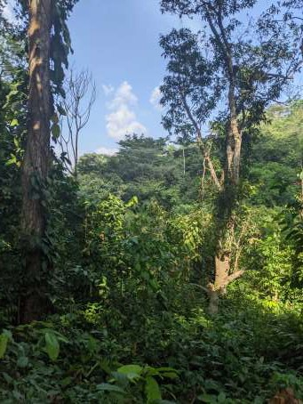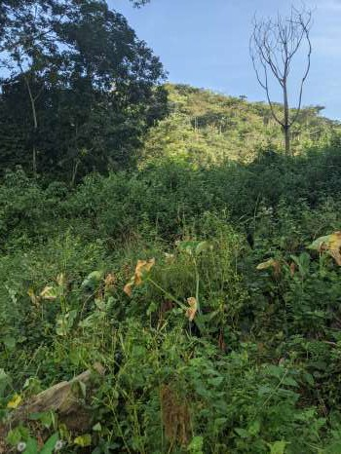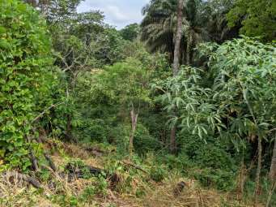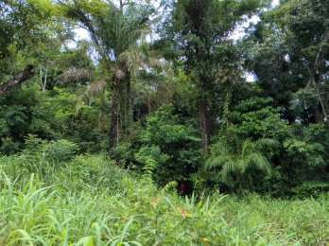

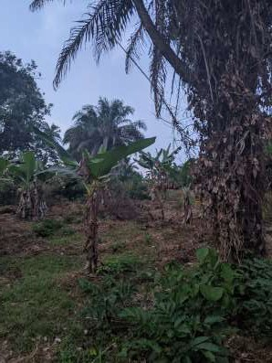

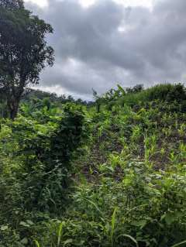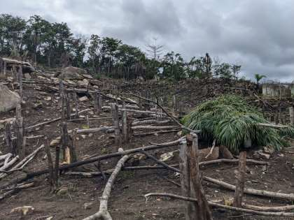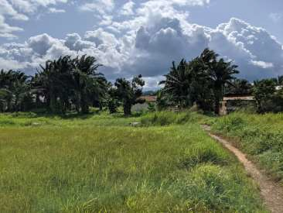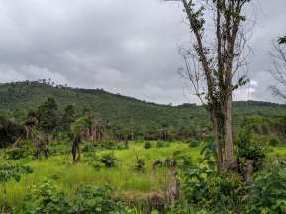

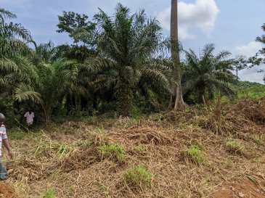

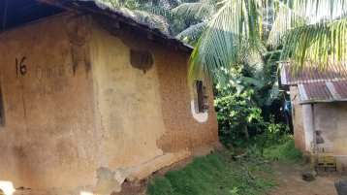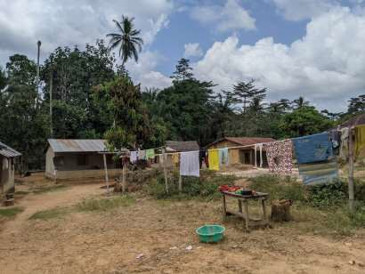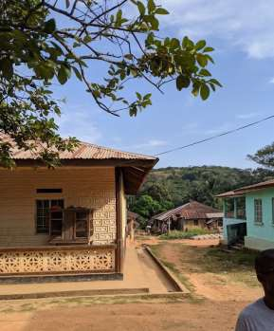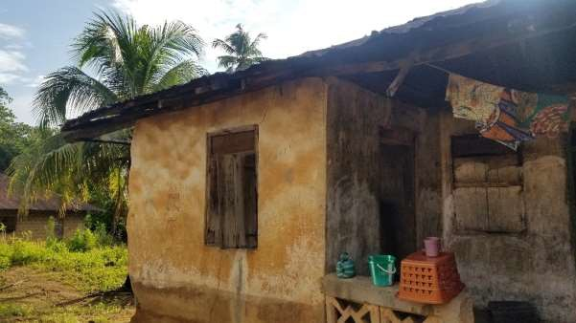

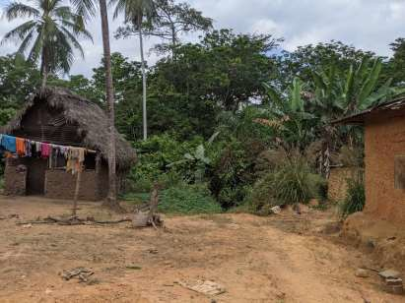

189

##### Trapping effort within each trapping grid

* + 1. Baiama

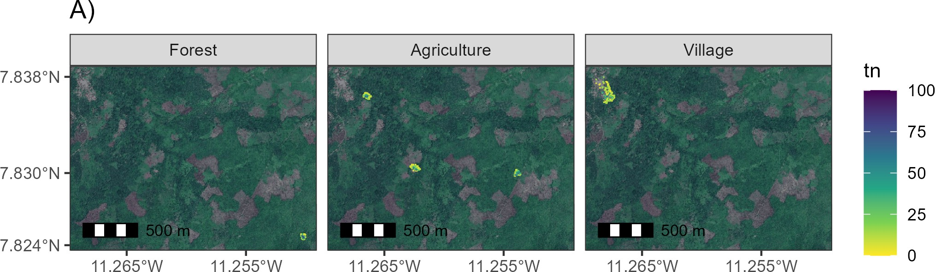

Figure B.1: A) Trapping effort within 49m2 grid cells in Baiama. Facets show the locations of trapping grids placed in different land use types. Darker colours are associated with an increased number of trap nights within the grid cell.

* + 1. Lalehun

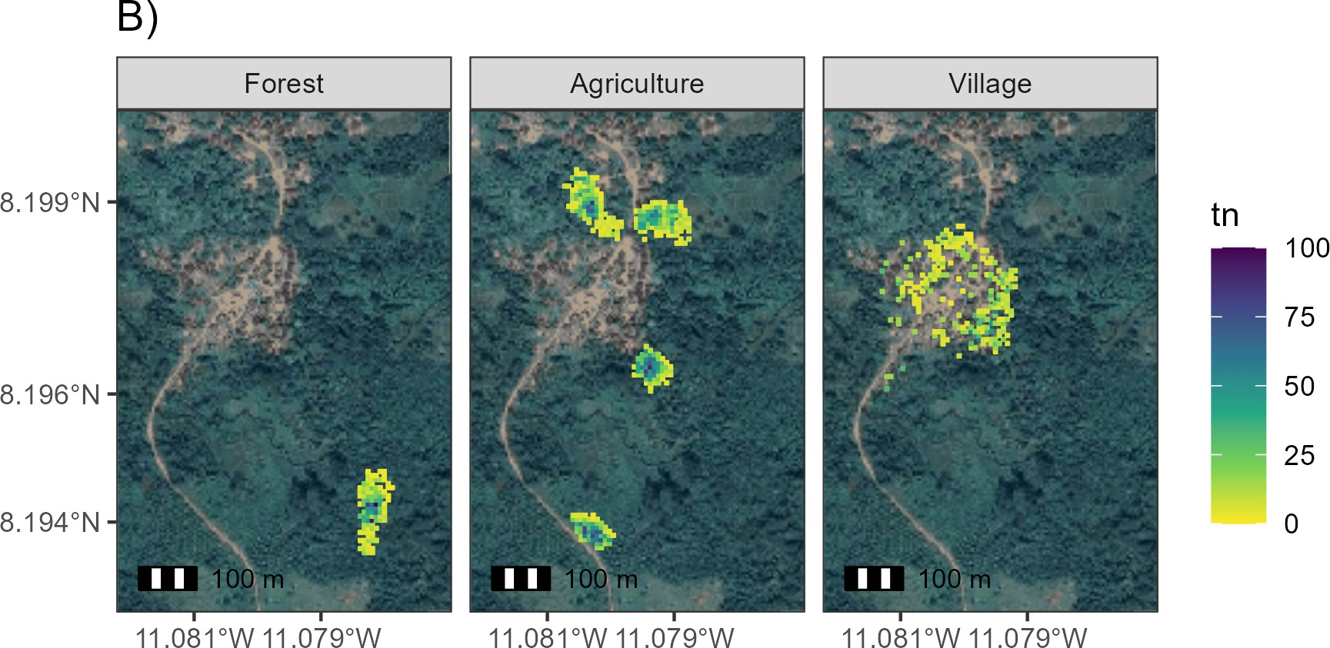

Figure B.2: B) Trapping effort within 49m2 grid cells in Lalehun. Facets show the locations of trapping grids placed in different land use types. Darker colours are associated with an increased number of trap nights within the grid cell.

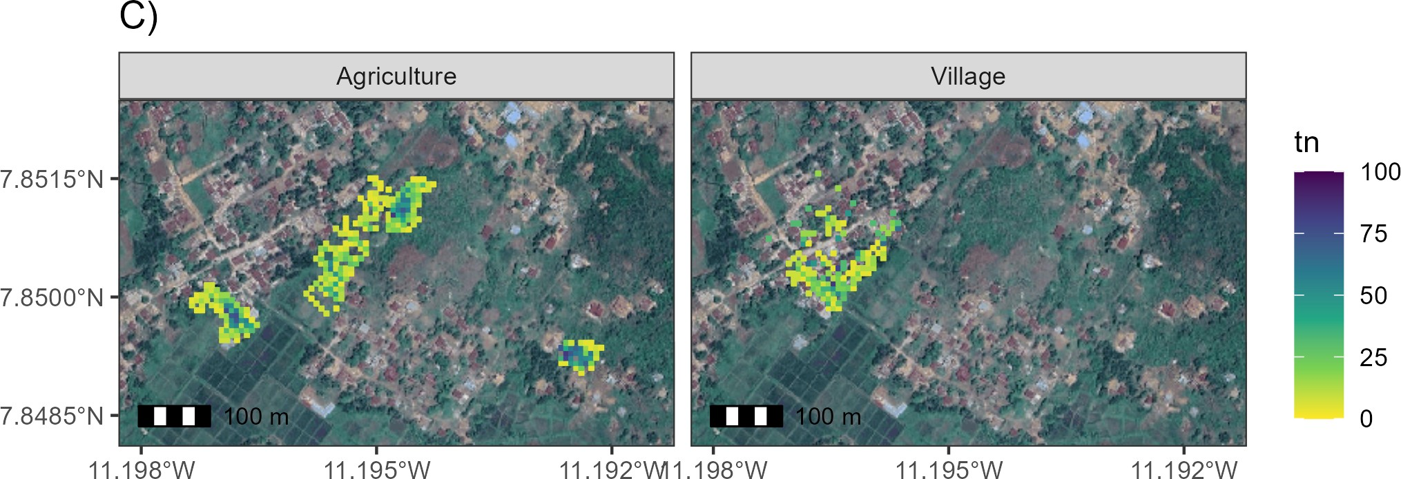

Figure B.3: C) Trapping effort within 49m2 grid cells in Lambayama. Facets show the locations of trapping grids placed in different land use types. Lambayama was a peri-urban village with no nearby forest. Darker colours are associated with an increased number of trap nights within the grid cell.

* + 1. Seilama

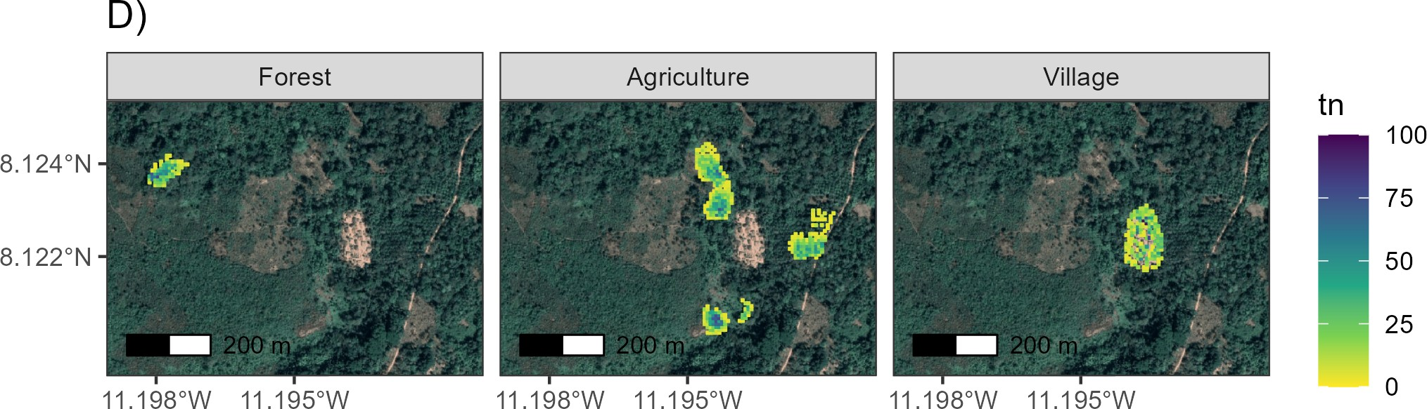

Figure B.4: D) Trapping effort within 49m2 grid cells in Seilama. Facets show the locations of trapping grids placed in different land use types. Darker colours are associated with an increased number of trap nights within the grid cell.

Rodent trapping and lab processing protocol

2023-01-25

## Contents

Preparation for field work 1

**Trapping protocol** **1**

Trap placement 2

Rodent processing 2

Locating trap sites 3

Baiama 3

Lalehun 3

Lambayama 4

Seilama 5

Data collection 6

Trap setup 6

Trap check 6

Rodent sampling 6

Data collection details 7

Direct ODK entry 7

Sample storage 8

**Laboratory protocols** **8**

DNA extraction 8

Kit contents 8

Protocol 9

Sequence processing 12

**References** **13**

###### Preparation for field work

Before going to the field the following must be checked.

* + - 1. Adequate number of clean and functioning Sherman traps are brought. You will need at least **324** to set up the correct number of grids.
      2. Adequate sample pots and filter paper for rodent specimens.
      3. Personal protective equipment for 16 sessions of sample processing.
      4. Spare batteries for GPS devices.
      5. Battery packs for electronic devices.
      6. Portable freezer for rodent specimens, to be stored at Panguma Hospital Lab.
      7. Paper copies of the data entry forms.

## Trapping protocol

This trapping protocol is based on previous rodent trapping studies conducted in Eastern Sierra Leone (Leski et al. 2015; Bangura et al. 2021). The approach has been modified to use trapping grids rather than lines.

###### Trap placement

Rodents are being trapped for an ongoing study of rodent population structures and assemblages in a Lassa fever endemic region of Eastern Sierra Leone. The study will occur over 2 years (November 2020 - February 2023). The primary outputs of the rodent trapping will be to identify to species level the small mammals in different land use types at different times of the year in addition to the presence of antibodies to Lassa fever virus. Trapping will occur in pre-specified study site locations every 4 months. Trapping is described at multiple spatial levels. The highest order is the study village, followed by a trapping grid and finally a trap location. Four study villages have been selected for ongoing work. The villages are Baiama, Lalehun, Lambayama and Seilama (Baiama; lat = 7.8375, long = -11.2683, Lalehun; lat = 8.1973, long = -11.0803, Lambayama; late = 7.8505, long = -11.1969, and Seilama; lat = 8.1224, long = -11.1936). At each village site up to 7 trapping grids have been designated. A trap grid contains 49 traps, in non-household settings each grid is a 7 x 7 regular grid of Sherman traps set up to 7 metres apart (Figure 1.). Within household settings four traps will be placed within each home. The land use of the grid and more specifically the trap location and its habitat structure will be noted at each study site visit. The coordinates of each trapping location are recorded to record the location at which each individual rodent was detected. At dusk all traps are baited and traps are primed, traps are checked each morning with traps containing rodents brought to the field processing site. The location of the trap is marked to allow replacement following processing of the rodent. All traps are closed during the day for re-baiting during the afternoon. Traps are set for four consecutive nights at each visit.

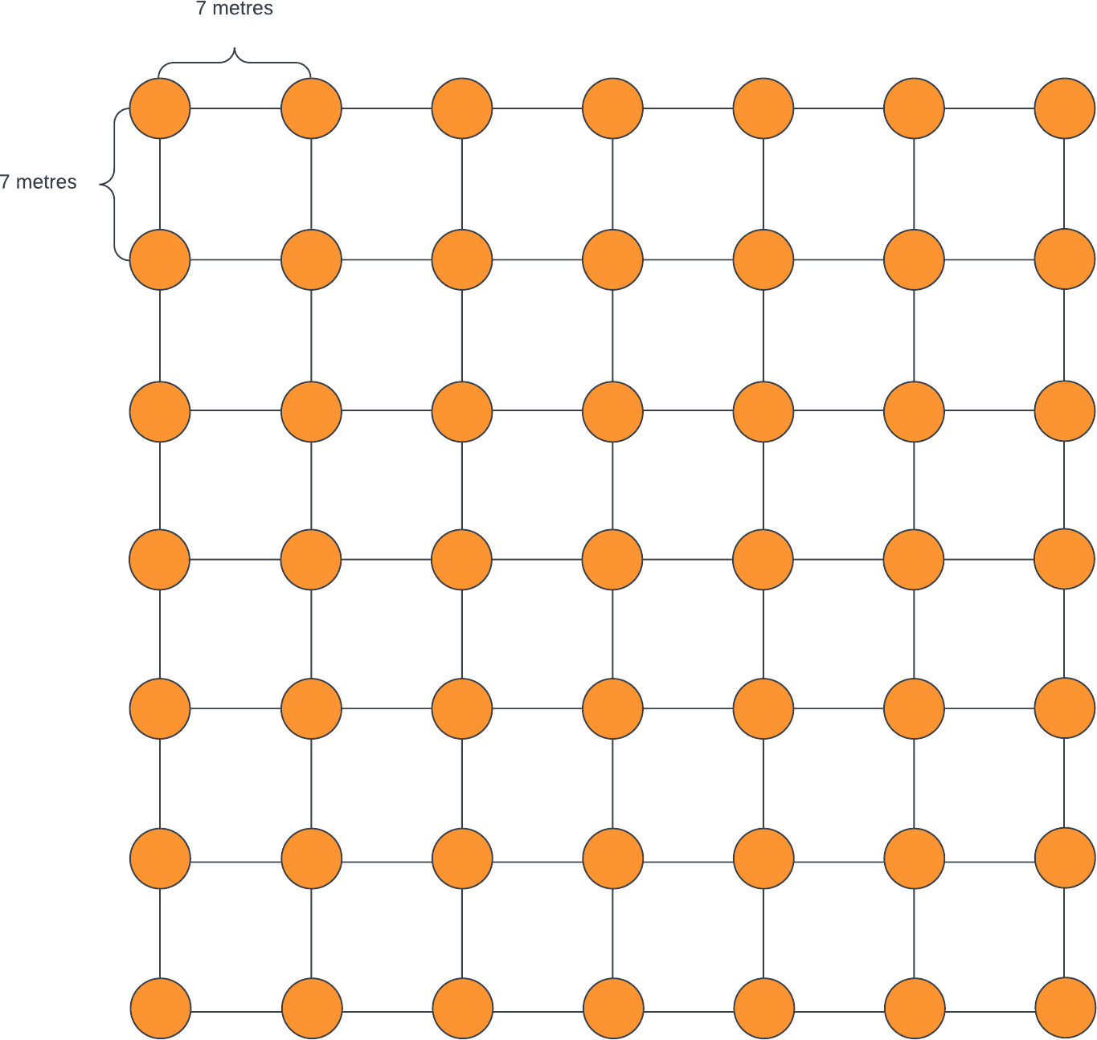

Figure 1: Structure of a 49 trap grid. Individual traps are placed 7 metres apart in a regular grid 7 by 7 grid. A solid orange circle represents the location of a single Sherman trap.

###### Rodent processing

Trapped rodents are brought to the processing table contained within a trap following capture. The rodents are euthanised following recommended procedures with halothene and cervical dislocation by trained personnel. Kevlar gloves and personal protective equipment are used during this process. Rodents are placed on a processing mat where photos are obtained during the data collection process with the rodents unique identifier. Morphometric measurements are then recorded alongside biological samples for subsequent molecular identification to species level and assay for Lassa fever virus antibodies or acute infection. Rodent carcasses are then safely disposed of on site to reduce the risk of any infectious material remaining in the study environment. All data is collected in the field electronically using Open Data Kit questionnaires with

photographic records collected as required. Samples are then returned to the study laboratory at Mercy Hospital, Bo, Sierra Leone where they remain in storage until analysis can be performed.

###### Locating trap sites

The GPS devices can be used to precisely locate the trapping grids within the villages. First turn on the device and press the find button on the front above mark. Use the direction buttons to select Coordinates and press enter. This takes to a screen that asks you to enter the location. The left and right arrows at the bottom of the screen move across the numbers. Select the value to change using the directional buttons and enter to select. This will then produce a purple line that will guide you to the coordinates. Tie some ribbon to a plant to identify this corner of the grid and then perform the same for the 3 other corners.

Coordinates below are given in degrees decimal minutes (DdM), this is consistent with the GPS devices used by the field team.

**Baiama**

We have set **six** trapping grids in Baiama.

1. **Grid 1**: Forested site
   * Point 1 = 7° 49.4867 N and 11° 15.0235 W
   * Point 2 = 7° 49.4867 N and 11° 15.0235 W
   * Point 3 = 7° 49.4708 N and 11° 15.0098 W
   * Point 4 = 7° 49.4840 N and 11° 15.0161 W
2. **Grid 2**: Fallow land, new rice field
   * Point 1 = 7° 49.8157 N and 11° 15.235 W
   * Point 2 = 7° 49.8086 N and 11° 15.2235 W
   * Point 3 = 7° 49.7903 N and 11° 15.2436 W
   * Point 4 = 7° 49.7885 N and 11° 15.2318 W
3. **Grid 3**: This site lies near the old Baiama village
   * Point 1 = 7° 49.8151 N and 11° 15.7421 W
   * Point 2 = 7° 49.8179 N and 11° 15.729 W
   * Point 3 = 7° 49.8245 N and 11° 15.7529 W
   * Point 4 = 7° 49.8386 N and 11° 15.7509 W
4. **Grid 4**: Banana plantation
   * Point 1 = 7° 50.1875 N and 11° 15.9803 W
   * Point 2 = 7° 50.1968 N and 11° 15.9904 W
   * Point 3 = 7° 50.1785 N and 11° 15.9953 W
   * Point 4 = 7° 50.1844 N and 11° 16.0042 W
5. **Grid 5**: Village, outside households
   * Point 1 = 7° 50.2663 N and 11° 16.132 W
   * Point 2 = 7° 50.2555 N and 11° 16.0783 W
   * Point 3 = 7° 50.18 N and 11° 16.043 W
   * Point 4 = 7° 50.171 N and 11° 16.093 W
6. **Grid 6**: Village, within households
   * 4 traps per home

**Lalehun**

We have set **seven** trapping grids in Lalehun.

1. **Grid 2**: Within and near a wet rice field
   * Point 1 = 8° 11.921 N and 11 4.771 W
   * Point 2 = 8° 11.94 N and 11 4.758 W
   * Point 3 = 8° 11.923 N and 11 4.727 W
   * Point 4 = 8° 11.908 and 11 4.739 W
2. **Grid 3**:
   * Point 1 = 8° 11.9417 N and 11 4.811 W
   * Point 2 = 8° 11.92 N and 11 4.822 W
   * Point 3 = 8° 11.967 N and 11 4.826 W
   * Point 4 = 8° 11.953 N and 11 4.838 W
3. **Grid 4**: Forest area
   * Point 1 = 8° 11.644 N and 11° 4.699 W
   * Point 2 = 8° 11.687 N and 11° 4.696 W
   * Point 3 = 8° 11.644 N and 11° 4.681 W
   * Point 4 = 8° 11.687 N and 11° 4.68 W
4. **Grid 5**: Cassava plantation
   * Point 1 = 8° 11.619 N and 11 4.811 W
   * Point 2 = 8° 11.633 N and 11 4.831 W
   * Point 3 = 8° 11.647 N and W 11 4.832 W
   * Point 4 = 8° 11.635 N and 11 4.806 W
5. **Grid 6**: Village, outside households
   * Point 1 = 8° 11.911 N and 11° 4.797 W
   * Point 2 = 8° 11.819 N and 11° 4.79 W
   * Point 3 = 8° 11.872 N and 11° 4.828 W
   * Point 4 = 8° 11.809 N and 11° 4.818 W
6. **Grid 7**: Village, within households
   * 4 traps per home

**Lambayama**

We have set **six** trapping grids in Lambayama.

1. **Grid 1**: Rice fields
   * Point 1 = 7° 51.042 N and 11° 11.739 W
   * Point 2 = 7° 51.038 N and 11° 11.7072 W
   * Point 3 = 7° 51.001 N and 11° 11.755 W
   * Point 4 = 7° 50.99 N and 11° 11.73 W
2. **Grid 2**: Cassava field
   * Point 1 = 7° 51.085 N and 11° 11.658 W
   * Point 2 = 7° 51.08 N and 11° 11.691 W
   * Point 3 = 7° 51.0579 N and 11° 11.6698 W
   * Point 4 = 7° 51.055 N and 11° 11.689 W
3. **Grid 4**: Vegetable gardens
   * Point 1 = 7° 50.9958 N and 11° 11.8425 W
   * Point 2 = 7° 50.9989 N and 11° 11.8126 W
   * Point 3 = 7° 50.979 N and 11° 11.792 W
   * Point 4 = 7° 50.9659 N and 11° 11.8175 W
4. **Grid 5**: Village, outside households
   * Point 1 = 7° 51.064 N and 11° 11.741 W
   * Point 2 = 7° 50.9901 N and 11° 11.7869 W
   * Point 3 = 7° 51.018 N and 11° 11.824 W
   * Point 4 = 7° 51.0953 N and 11° 11.7993 W
5. **Grid 6**: Village, within households
   * 4 traps per home

**Seilama**

We have set up **six** sites in Seilama.

1. **Grid 1**: Palm plantation, near the village and main road
   * Point 1 = 8° 7.33498 N and 11° 11.5399 W
   * Point 2 = 8° 7.318 N and 11° 11.531 W
   * Point 3 = 8° 7.3181 N and 11° 11.5578 W
   * Point 4 = 8° 7.338 N and 11° 11.568 W
2. **Grid 2**: Cacao and Coffee plantation
   * Point 1 = 8° 7.378 N and 11° 11.649 W
   * Point 2 = 8° 7.4 N and 11° 11.643 W
   * Point 3 = 8° 7.413 N and 11° 11.653 W
   * Point 4 = 8° 7.384 N and 11° 11.67 W
3. **Grid 3**: Dry rice field
   * Point 1 = 8° 7.424 N and 11° 11.657 W
   * Point 2 = 8° 7.446 N and 11° 11.66 W
   * Point 3 = 8° 7.467 N and 11° 11.672 W
   * Point 4 = 8° 7.443 N and 11° 11.685 W
4. **Grid 4**: Wet rice plantation
   * Point 1 = 8° 7.2507 N and 11° 11.6773 W
   * Point 2 = 8° 7.2568 N and 11° 11.6191 W
   * Point 3 = 8° 7.2287 N and 11° 11.6747 W
   * Point 4 = 8° 7.2376 N and 11° 11.6266 W
5. **Grid 5**: Forest
   * Point 1 = 8° 7.441 N and 11° 11.84 W
   * Point 2 = 8° 7.4434 N and 11° 11.8737 W
   * Point 3 = 8° 7.422 N and 11° 11.89 W
   * Point 4 = 8° 7.4149 N and 11° 11.869 W

5

197

1. **Grid 7**: Village, within households
   * 4 traps per home

###### Data collection

Three questionnaires have been developed in the ODK app for data collection. The first, trap setup must be completed during the process of setting the traps as we collect information on the location of each trap. The second, trap check, is completed on each morning of the trapping session to record whether a rodent was trapped. The third, rodent sampling, is conducted alongside the measurement and biopsy of each individual.

It is advised that a single field worker is responsible for data input alongside the person or people placing traps, checking traps and conducting biopsies. If there are any difficulties with data entry onto the digital devices paper versions of the questionnaires are available.

**Trap setup**

Mark the extent of the trapping grid by placing ribbons at the locations of the above coordinates. Place traps in a 7 by 7 grid spaced 10 metres apart within the grid. For each trap record its coordinates in the ODK questionnaire on the mobile phone app. If required take a photo of the trap location if you are unable to decide the specific habitat type of the trap. Place bait in the trap and close it. Once all traps have been set and recorded the traps can be opened at dusk for the first trap night. During the trap check in the morning, traps are closed for the day prior to refreshing the bait. On each subsequent day the bait is refreshed with traps opened again at dusk.

**Trap check**

Each morning every trap is checked for the presence/absence of bait, whether the trap has snapped shut over night and whether a rodent has been trapped. The weather overnight is also collected on this data entry form on the ODK app.

###### Rodent sampling

Trapped rodents are located at the trap check. The traps are placed in plastic bags and brought to the autopsy site. Rodents are euthanised prior to morphological measurements and sampling. Processes for rodent handling and measurements were conducted as outlined in previously published guidance (Mills et al. 1995; Fichet-Calvet 2014).

1. Identification
   * Rodent unique number
   * Trap number
   * Trap night
   * Initial species/genus identification
2. Morphological measures
   * Weight in grams
   * Length of head to base of tail (head body) in mm
   * Length of the tail in (note whether tail is cut) mm
   * Length of the hind foot (not including claws) in mm
   * Diameter of the ear measured from the pinna to the edge of the ear in mm
   * Length of the skull from the occiput to the tip of the nose, for shrews measure to the end of the projecting teeth in mm
3. Autopsy measures
   * Rodent sex (M/F)
   * Presence of internal or external testes for males
   * Development of seminal vesicles for males
   * The identification of a perforate vagina for females
   * The presence of visible teats for females and the number of pairs of nipples
   * The number of developing embryos for females
4. Sample collection
   * Document whether the following samples have been successfully obtained
     + Photo of rodent
     + Serum sample, in vial and on filter paper
     + Tissue sample of liver and spleen
     + Tissue sample of ear
     + Eye of rodent

The first step of rodent sampling is to set up the biopsy table, clean the area and ensure adequate personal protective equipment is available. Assign one team member to perform the rodent euthanisation. Assign another to conduct real-time data entry. Two team members are required for the biopsy process.

First, rodents are euthanised and assigned a unique identifier based on the study visit, the study village and the order in which they are being processed. This is written on a piece of paper and photographed alongside a dorsal (place the rodent belly down) and ventral (place the rodent belly up) image of the rodent. The trap number the rodent was found in is and the trap night is then recorded. The field identification of the species is then recorded, the identification key is used for reference (Rodent Identification), this is based on two published taxonomic keys (Happold and Happold 2013; Monadjem et al. 2015). Next we obtain external measurements of the rodents.

Samples are placed in labelled cryovials. Formalin is added to eye and skin tag samples to aid preservation. Ethanol is added to liver and spleen samples.

###### Data collection details

**Direct ODK entry**

There are three forms you can access through ODK connect on your mobile phone or the study team tablets. The forms, once saved, will automatically be sent to the ODK server once they can connect to the internet. There is a sim card in the tablet that can be loaded with credit.

1. site\_setup\_v2: This sheet is completed for each site on the first day of trapping. It is important to ensure you correctly write the trap number and it’s coordinates. If you make any errors you can edit the file or notify Dianah/David and they can amend it. You will describe each site, the habitat and surroundings of each trap and the coordinates for each trap. Photos can be taken if you are having difficulty completing the questions.
2. trap\_check\_v1: This sheet is used to collect information about the number of traps missing bait, if they have been sprung shut or if they contain rodents the next morning. It may be easier to note the traps on a piece of paper first and then to enter the data into ODK.
3. rodent\_v1: This sheet is used to collect information about the trapped rodent. Ensure that the trap number and rodent number are correct. The trap number is important to know where the rodent came from. The rodent number should be made by putting the number of the visit, then the 3 letters of the village and then the number this rodent is for this visit.

For example:

* + The 12th rodent trapped in the 2nd visit in Seilama would be 2SEI-012
  + The 3rd rodent trapped on the 1st visit in Baiama would be 1BAI-003

###### Sample storage

Samples are collected in sterile cryovials. Eyes and ear snips are stored in Formalin, while liver and spleen samples are stored in Ethanol. Whole blood is aspirated onto filter papers which are stored in single use bags with dessicant. 1-2ml of whole blood is stored in a cryovial.The rodent identifier is written onto the cryovials in indelible ink and they are collected by sample type for each study village and visit in containers. At the end of each day samples are transferred into field freezers for storage prior to transport to -20°C storage at the laboratory.

## Laboratory protocols

###### DNA extraction

This is the protocol to identify rodents to species level using PCR for use in Sierra Leone. Three kits are required in addition to consumables for each run.

1. QIAgen DNeasy Blood and Tissue kit. This protocol will be performed on spleen or liver tissue. However, in case of issues purchase an additional buffer AL as this protocol can also be run on blood samples as long as AL hasn’t been pre-diluted with ethanol. This step extracts DNA from the sample.
2. Invitrogen Platinum *Taq* DNA Polymerase. This is used to produce the mastermix that will amplify the DNA bound to the primers.
3. Primers, obtained from Eurofins (Bangura et al. 2021):
   * *M. natalensis* specific primer
     1. F-607: 5’ CGG GCT CTA ATA ACC CAA CG 3’
     2. R-813: 5’ TTC TGG TTT GAT ATG GGG AGG T 3’
   * *M. erythroleucus* specific primer
     1. F-49: 5’ CAT TCA TTG ACC TAC CTG CT 3’
     2. R-505: 5’ AGA ATC CCC CTC AAA TTC AC 3’
   * Rodent *CytB* for subsequent sequencing
     1. L-7: 5’ ACC AAT GAC ATG AAA AAT CAT CGT T 3’
     2. H-15915: 5’ TCT CCA TTT CTG GTT TAC AAG AC 3’

**Kit contents**

**QIAgen DNeasy 250 samples**

|  |  |  |
| --- | --- | --- |
| Component | Supplied amount/packaging | Storage requirements |
| DNeasy mini spin columns | 250 tubes | room temperature |
| Collection tubes | 500 tubes | room temperature |
| Buffer ATL | 50ml | room temperature |
| Buffer AL | 2 x 33ml | room temperature |
| Buffer AW1 (concentrate) | 98ml | room temperature |
| Buffer AW2 (concentrate) | 66ml | room temperature |
| Buffer AE | 2 x 60ml | room temperature |
| Proteinase K | 6ml | room temperature |

Additional consumables Pipette tips, microcentrifuge tubes 1.5ml, chlorine tablets, PBS tablets, 96-100% EtOH.

Additional equipment Pipettes, scalpel, tile, tweezers, microcentrifuge, thermomixer, vortex.

**Invitrogen Platinum *Taq* DNA Polymerase 600 reactions**

Component Supplied amount/packaging Storage requirements Platinum *Taq* DNA polymerase 120µl -20°C (freezer)

10x PCR buffer 3 x 1.2ml -20°C (freezer)

50mM Magnesium Chloride 1ml -20°C (freezer)

Additional reagents

Component Supplied amount/packaging Storage requirements

dNTP mix 100µl -20°C (freezer)

nuclease free water 10 x 1.5ml -20°C (freezer)

DNA ladder 250µg -20°C (freezer)

Midori green agarose 100 tablets room temperature

TAE buffer 50x concentrate -4°C (fridge)

DNA loading dye 5 x 1ml room temperature

Additional consumables Pipette tips, microcentrifuge tubes 1.5ml, PCR tubes.

Additional equipment Pipettes, microcentrifuge, thermomixer, vortex, PCR cycler, gel electrophloresis tray, gel combs, gel reader.

**Primers**

Component Supplied amount/packaging Storage requirements

*M. natalensis* specific primer NA -20°C (freezer)

*M. erythroleucus* specific primer NA -20°C (freezer)

Rodent *CytB* NA -20°C (freezer)

Additional reagents Nuclease free water for dilution to working solution

**Protocol**

The majority of this protocol will be conducted in Sierra Leone, unfortunately due to no available sequencing in country purified, stable, DNA products will be transferred to Germany for commercial sequencing.

**Sample selection** Samples will be batch processed. Each gel can contain 14 rodent samples, a negative extract and a DNA ladder. All samples should undergo DNA extraction, the subsequent testing will need to be selected based on the field identification. We will be performing confirmatory testing on all identified *Mastomys sp.* and testing for all individuals that may be confused with this species.

Species identified in the field as *Crocidura sp.*, *Lophuromys sp.* and *Lemniscomys sp.* do not need testing with *Mastomys* specific primers. For other samples they will first be tested with *M. natalensis* specific primers, if these are positive those samples do not need to be tested further. All remaining samples will be tested with

*M. erythroleucus* specific primers. Those that are positive for either of the *Mastomys* primers will be stored but do not need further testing. All samples except those identified as *M. natalensis* or *M. erythroleucus* will then be processed for rodent specific *CytB* for subsequent sequencing. Once *CytB* PCR amplification has been confirmed through gel electrophoresis these samples can be stored for transfer to the UK. Any samples that failed to produce a single band confirmatory for *CytB* amplification will need to be re-processed.

The same DNA extract if there is no evidence of cross contamination can be used for all three PCR reactions.

**DNA extraction**

1. Remove samples from the freezer, organise them and ensure that each is uniquely labelled.
2. If formalin fixed tissue is being used rinse the sample twice in PBS to remove the fixative.
3. Cut up to 10mg of tissue into small pieces on a clean tile with clean instruments, place into a labelled microcentrifuge tube.
4. Decontaminate equipment and tile, repeat for all samples being processed.
5. Add 180µl of buffer ATL to each tube, ensure that samples are covered by liquid reagent.
6. Add 20µl of proteinase K to each vial and vortex thoroughly.
7. Place tubes into a thermomixer at 56°C until the tissue is completely lysed ~ 1-3 hours.
8. Once lysed vortext the samples
9. Prepare a 1:1 mix of buffer AL and ethanol 96-100% and vortex. 400µl of reagent are added to each sample tube so calculate the volumes required prior to mixing AL and ethanol. For example 14 sample and a negative extract will require 6ml of the combined solution so make up 6.2ml
10. Vortex tubes after addition of the combined AL/ethanol.
11. A gelatinous layer may form, ensure adequate mixing by shaking the vials vigorously.
12. Pipette this mixture into a labelled spin column. Set the pipette to withdraw 620µl to ensure all volume is withdrawn.
13. Centrifuge at 6,000g (8000rpm) for 1 minute in the spin column and discarge the collection tube.
14. Place the spin column in a new, clean collection tube.
15. Add 500µl of buffer AW1 and centrifuge at 6,000g (8000rpm) for 1 minute. The flow through can be discarded and the collection tube re-used.
16. Label 1.5ml microcentrifuge tubes according to the samples in preparation for step 17.
17. Add 500µl of buffer AW2 and centrifuge at 20,000g (14000rpm) for 3 minute. The flow through can be discarded, ensure that there is no contact between the flow through and the membrane as the purpose of this step is to dry the membrane. If contact occurse, empty the collection tube and centrifuge again at 20,000g (14000rpm) for 1 minute. Place spin column in corresponding microcentrifuge tube.
18. Pipette 200µl buffer AE directly onto the membrane and incubate for 1 minute.
19. Centrifuge at 6,000g (8000rpm) for 1 minute. The spin column can now be discarded, the labelled microcentrifuge tube now contains the extracted DNA.
20. Place tubes into a sealed bag with a label for the date of extraction. These tubes can be stored in the freezer for subsequent PCR and downstream sequencing.

**Preparing mastermix and combine with samples**

1. An excel document for each of the primers is available to calculate the proportions of reagents in the mastermix. Print this out after entering the number of samples being run for each primer set.
2. Take out the DNA extract samples from the freezer.
3. Take out the *Taq* DNA Polymerase kit from the freezer.
4. Take out the primers from the freezer.
5. Produce a working dilution of the relevant primers according to manufacturers guidance in 2 microcen- trifuge tubes, 1 for each primer direction. Dilute using DNAse free water.
6. Combine the reagents for the mastermix as guided by the excel sheet. Ensure tube is vortexed and then centrifuged for good mixing.
7. Place the PCR tubes into the cold PCR tube holder.
8. Place the required volume of the mastermix into each PCR tube, the same pipette tip can be used for this.
9. Arrange samples as they will be placed in the PCR tubes.
10. Place the required volume of sample into each PCR tube. The pipette tip needs to be changed between samples.
11. Close the tube lids as you add in sample to ensure you don’t wrongly combine samples.
12. Label the tubes as per the earlier arrangement.

**PCR amplification**

1. Set up the cycler as per the temperature profile guidance in the excel spreadsheet or below.
2. Spin PCR tubes to ensure good mixture of sample and mastermix.
3. Place tubes in the cycler and run the programme.
4. This will take around 2-3 hours.

|  |  |  |  |
| --- | --- | --- | --- |
| PCR method | Temperature | Time | Cycles |
| *M natalensis* | 94°C | 3 minutes | - |
| - | 94°C | 30 seconds | x35 |
| - | 55°C | 30 seconds | x35 |
| - | 72°C | 30 seconds | x35 |
| - | 72°C | 10 minutes | - |
| - | -4°C | ongoing | - |
| *M erythroleucus* | 94°C | 3 minutes | - |
| - | 94°C | 30 seconds | x35 |
| - | 55°C | 30 seconds | x35 |
| - | 72°C | 45 seconds | x35 |
| - | 72°C | 10 minutes | - |
| - | -4°C | ongoing | - |
| *CytB* | 95°C | 3 minutes | - |
| - | 94°C | 30 seconds | x35 |
| - | 52°C | 40 seconds | x35 |
| - | 72°C | 90 seconds | x35 |
| - | -4°C | ongoing | - |

**Gel preparation**

1. We will use Midori green agarose to identify locations of DNA bands.
2. Each gel is made up of 2% agarose and 30ml is required to provide a 2 row gel.
3. Dissolve get tablets in water and heat if required to ensure crystals dissolved.
4. Pour 30ml into a gel tray.
5. Allow to set ~ 30mins, remove combs and can then be stored in TAE in the fridge until required.

**Run gel**

1. Arrange samples in PCR tubes in the order they will be loaded on the gel.
2. Place 4µl of the DNA ladder in the first well.
3. Place ~1µl of loading dye onto a paraffin sheet.
4. Pipette 4µl of sample into the loading dye bubble, withdraw to mix the dye and sample and place directly into the well. Change pipette tips between samples.
5. In the last well place the negative extract control.
6. Once gel is loaded place into an electrophoresis bath and set to 80 V, 400 mA and run for 40 minutes.

**Interpreting gel**

1. Take gel to the reader.
2. Take a photo of the gel, interpret as follows.
   1. *M. natalensis* specific primer: Bands seen should all align along a similar mass on the ladder. If this is the case the samples have been adequately amplified with good specificity. In addition the negative extract must be negative. Together these results will mean the gel is interpretable. If the negative extract shows a band this is indicative of contamination at an earlier point of the process and the DNA extraction would need to be repeated for these samples. Document the results of the gel as follows:
      * Species confirmed as *M. natalensis*
      * Species confirmed as not *M. natalensis*
   2. *M. erythroleucus* specific primer: Bands seen should all align along a similar mass on the ladder. If this is the case the samples have been adequately amplified with good specificity. In addition the negative extract must be negative. Together these results will mean the gel is interpretable. If the negative extract shows a band this is indicative of contamination at an earlier point of the process and the DNA extraction would need to be repeated for these samples. Document the results of the gel as follows:
      * Species confirmed as *M. erythroleucus*
      * Species confirmed as not *M. erythrolecus*
   3. *CytB* specific primer: Bands seen should all align along a similar mass on the ladder. If this is the case the samples have been adequately amplified with good specificity. In addition the negative extract must be negative. Together these results will mean the gel is interpretable. If the negative extract shows a band this is indicative of contamination at an earlier point of the process and the DNA extraction would need to be repeated for these samples. Document the results of the gel as follows:
      * Adequate *CytB* amplification, suitable for sequencing
      * Inadequate *CytB* amplification, not-suitable for sequencing. Needs to be repeated potentially starting from DNA extraction stage.

**Preparing samples for sequencing**

1. Samples with confirmed *CytB* can now be transferred to Germany for sequencing.
2. Samples can be transported at room temperature, in safelock sample tubes as DNA products are stable and non-infectious.
3. For the first transfer we will trial adding the PCR primers into the products in Sierra Leone and compare to the results when PCR primers are added in the UK.

**Sequence processing**

Eurofins provide a FASTA file via email for all attempted sequences. These are downloaded and saved for analysis using NCBI BLAST.

1. Log in to BLAST
2. Select Nucleotide BLAST
3. The FASTA file can be copied into the query sequence box, BLAST will recognise the number of distinct samples
4. Enter a descriptive title for the job, i.e., the number of sequences and date of file
5. Set the following for the search set
   * Standard databases, nucleotide collection
   * Organism; Rodentia (taxid: 9989) AND Soricomorpha (taxid: 9362)
6. Program selection is set as highly similar sequences (megablast)
7. Algorithm parameters
   * Max target sequences 100
   * Short queries selected
   * Expect threshold 0.05
   * Word size 28
   * Scoring parameters, match/mismatch scores 1,-2, gap costs linear
   * Filter low complexity regions selected and mask for lookup table only
8. Run BLAST
9. Complete the sequencing.csv record by entering the rodent\_uid and PCR\_id associated with the Eurofins barcode and enter the rodent species identified by BLAST
10. For failed sequences the program selection can be changed to somewhat similar sequences (blastn)
11. Failed sequences at this stage will need to be repeated

## References

Bangura, Umaru, Jacob Buanie, Joyce Lamin, Christopher Davis, Gédéon Ngiala Bongo, Michael Dawson, Rashid Ansumana, et al. 2021. “Lassa Virus Circulation in Small Mammal Populations in Bo District, Sierra Leone.” *Biology* 10 (1): 28.

Fichet-Calvet, Elisabeth. 2014. “Chapter 5 - Lassa Fever: A Rodent-Human Interaction.” In *The Role of Animals in Emerging Viral Diseases*, edited by Nicholas Johnson, 89–123. Boston: Academic Press. https://doi.org/https://doi.org/10.1016/B978-0-12-405191-1.00005-3.

Happold, Meredith, and David DC Happold. 2013. *Mammals of Africa*. Vol. 3. Bloomsbury London. Leski, Tomasz A, Michael G Stockelman, Lina M Moses, Matthew Park, David A Stenger, Rashid Ansumana,

Daniel G Bausch, and Baochuan Lin. 2015. “Sequence Variability and Geographic Distribution of Lassa Virus, Sierra Leone.” *Emerging Infectious Diseases* 21 (4): 609.

Mills, James N, James E Childs, Tom G Ksiazek, Clarence James Peters, and Wallis M Velleca. 1995. “Methods for Trapping and Sampling Small Mammals for Virologic Testing.”

Monadjem, Ara, Peter J. Taylor, Christiane Denys, and Fenton P. D. Cotterill. 2015. *Rodents of Sub- Saharan Africa: A Biogeographic and Taxonomic Synthesis*. Berlin, München, Boston: DE GRUYTER. https://doi.org/10.1515/9783110301915.

##### Schematic of trap location harmonisation

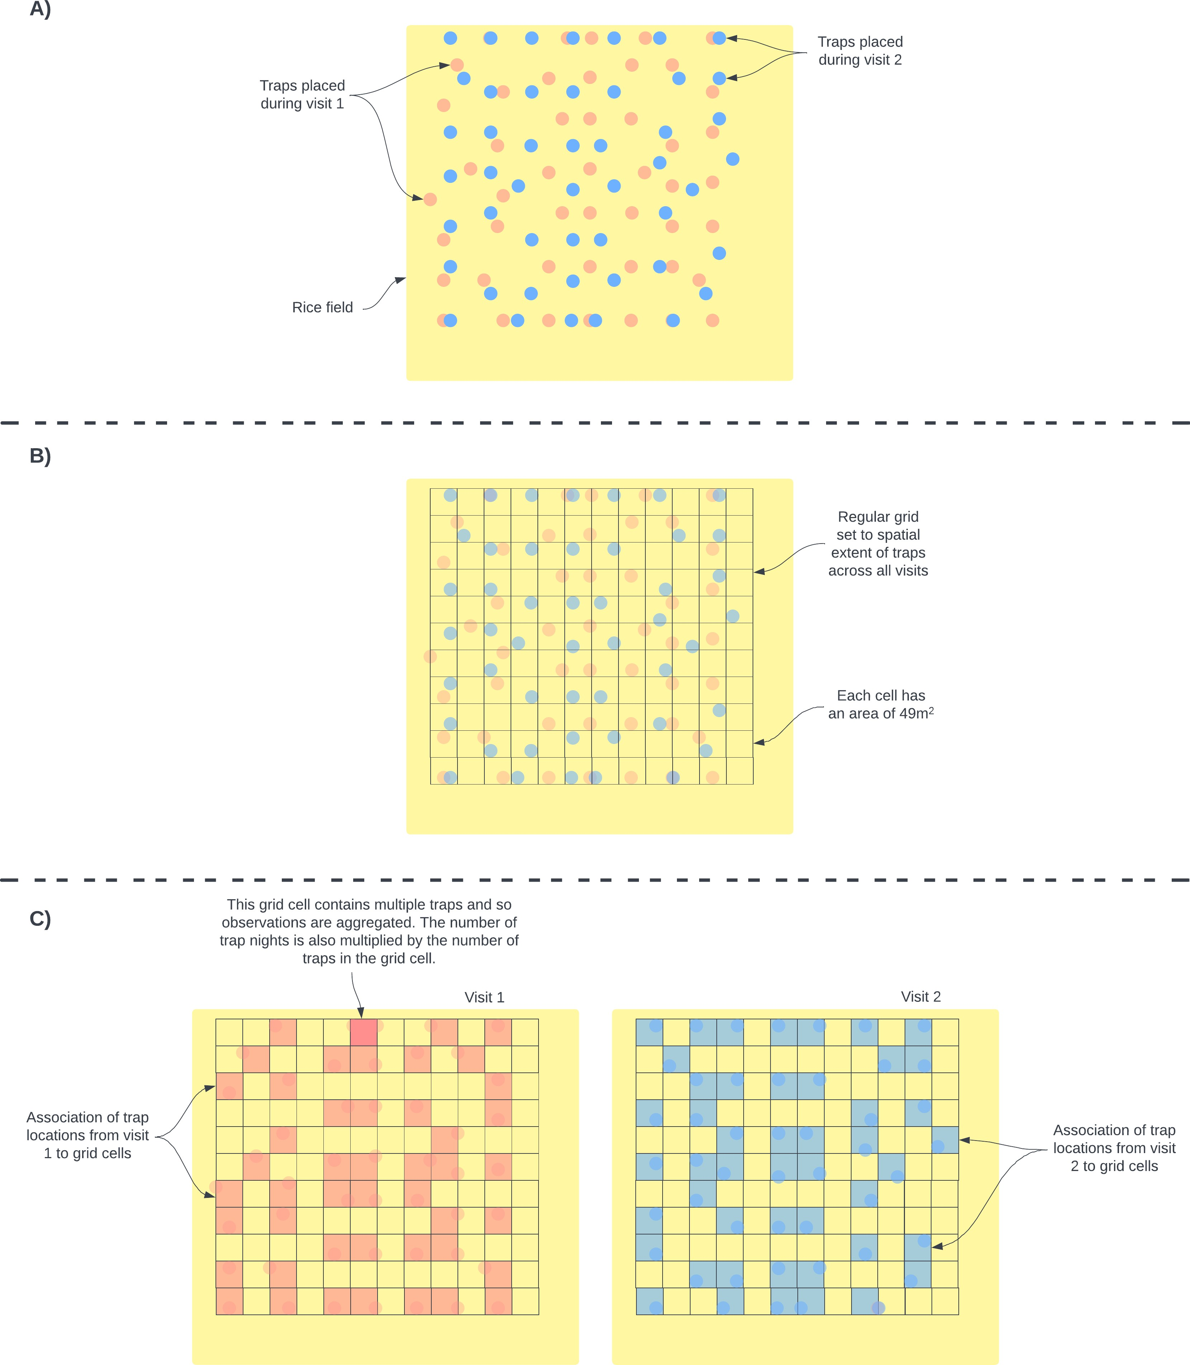

Figure B.5: Schematic diagram of conversion from trap locations to grids. A) Individual traps were placed in a grid structure in a pre-specified location. While attempts were made to keep trap locations over repeated visits individual traps were often placed in slightly different locations. This is shown in the schematic using different colours to represent different visits. B) To harmonize the locations of traps to coordinates that could be used in the spatial occupancy model we aligned a regular grid with grid cell sizes of 49m^2 over the trapping area and assigned individuals traps to these cells. C) The number of traps and therefore the number of trap nights within each grid cell was aggregated for each visit. The number of trap nights informed the detection component of the species occupancy model. Detection histories were produced for each grid cell that was sampled for each species. Grid cells were assigned a 1 if any trap within the grid cell detected the species and 0 otherwise.

##### Small mammal taxonomic key

# Small mammal identification key – November 2020

HB = head and body

GLS = greatest length of skull HF = hind foot

# Squirrels

#### Epixerus ebii (Temminck, 1853) – Western palm squirrel

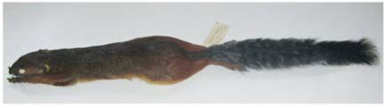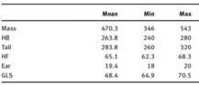Generally large, squirrel-shaped. Generally dark brown pelage. Long ears. 5 digits hindfoot, 4 forefoot. 4 pairs of nipples. Feeds on hard shelled nuts and fruit. Primarily active in the morning.

#### Funisciurus pyrropus (F.Cuvier, 1833) – Fire footed rope squirrel

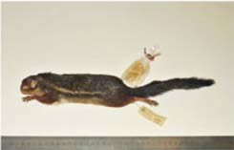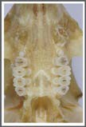Smaller than most other squirrels (100-300g). Short legs and long tail. Moderate sized ears and rounded. 2 pairs of nipples.

Carcass and upper cheek teeth, note the small premolar. Typically small home range 1-5 ha. Frugivorous diet. Identified by presence of single pale flank stripe, without conspicuous black border stripes, which may or may not be broken into spots and with or without a single dark border stripe above or below but not both. Bright orange or red on the side of the face, the limbs and a conspicuous white flank stripe.

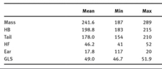

#### Heliosciurus

3 species believed endemic in SL. Typically 150-390g, long legs and tail. Relatively small ears and rounded. The tail is always longer than the body length and very bushy. 3 pairs of nipples. Primarily frugivorous.

#### Heliosciurus gambianus (Ogilby, 1835) – Gambian sun squirrel

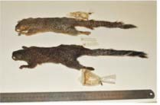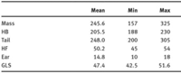No mid-ventral white stripe, dull light grey coat, GLS <51mm. Typically in savannah.

#### Heliosciurus punctatus (Temminck, 1853) – Small sun squirrel

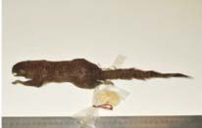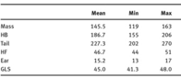No mid-ventral white stripe, dull dark grey-brown coat, GLS <51mm. Typically in forest.

#### Heliosciurus rufobrachium (Waterhouse, 1842) – Red-legged sun squirrel

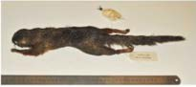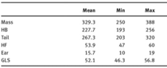Red or reddish-brown on limbs, contrasting with duller dorsal coat

#### Paraxerus poensis (A.Smith, 1830) – Green bush squirrel

Slender body, long legs and long tail. Dull olive green coat. Small rounded ears. 3 pairs of nipples. Small GLS <40, HF <36. No stripe, dull coat, no orange or red colouration.

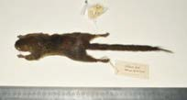 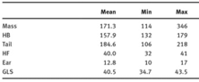

#### Protoxerus aubinnii (Gray, 1873) – Slender-tailed squirrel

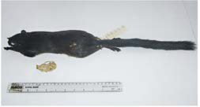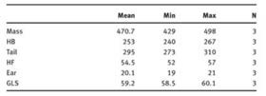Large squirrel 400-500g, uniform dark brown coat with long slender tail. Long ears. Non-bushy tail can be 1.25 times HB length. Four pairs of nipples.

#### Protoxerus stangeri (Waterhouse, 1842) – Forest giant squirrel

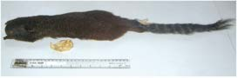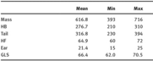550-750g, slender body with relatively short legs. Large head and long tail. Hairs of the head are white tipped. Tail is slightly longer than the body with alternating black and white (narrow) bands. 4 pairs of nipples.

# Dormice

Small, resembles squirrel shaped body.

#### Graphiurus crassicaudatus (Jentink, 1888) – Jentink’s dormouse

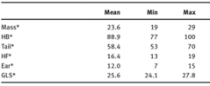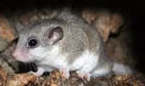Larger than GLS >24mm but < 32mm, upper incisors pro-odont. Nasals parallel-sided; dorsal coat rufous or with rufous hue. Rufous coat, pro-odont upper incisors. Parallel-sided nasals with strong supraorbital ridges.

#### Graphiurus lorraineus (Dollman, 1910) – Lorrain dormouse

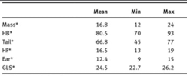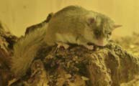Dorsal and ventral coat not clearly demarcated. Smaller than GLS <25mm, nasals broaden out distally. Coat brown or rufous. Upper incisors orthodont or opisthodont.

#### Graphiurus nagtglasii (Jentink, 1888) – Nagtglas’s African dormouse

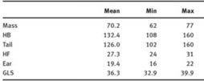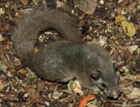GLS >32mm, facial mask inconspicuous or absent, tail not white tipped.

# Cricetomys

Very large rodents (HB 320-350). Long two coloured tail, small feet and large ears. Large skull GLS 65-75mm. Nocturnal rodent, omnivorous. Difficult to distinguish these species morphologically so distribution is used. C. emini is the only one present in Guinea and Sierra Leone but also consists of 4 sub-species.

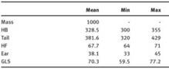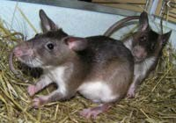Cricetomys emini (Wroughton, 1910) – Emin’s pouched rat

# Lophuromys

Small to large HB 90-180, relatively short tail 50-85% of HB. Terrestrial and nocturnal genus. Omnivorous

#### Lophuromys sikapusi (Temminck, 1853) – Rusty-bellied brush-furred rat

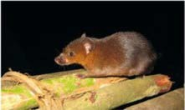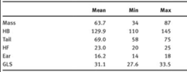Only species of the genus in West Africa west of the Sanaga River. Likely contains several cryptic species.

# Uranomys

Small genus HB ~105mm, short tail relative to body. Small skull. Terrestrial, nocturnal, live in deep burrows. Partly insectivorous but also feeds on cultivated crops.

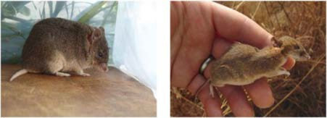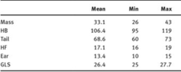Uranomys ruddi (Dollman, 1909) – Rudd’s mouse

# Gerbillinae (subfamily)

Two species of the genus gerbilliscus are identified in SL. Relatively large 90-130g, HB 130-169mm and heavily built. Hindfoot soles are naked. Nocturnal and terrestrial. Diet is omnivorous and opportunistic.

#### Gerbilliscus guineae (Thomas, 1910) – Guinean gerbil

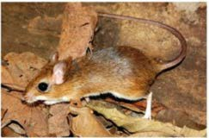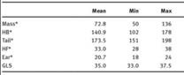Smaller size GLS 35mm, tail 90-100% of HB with a pencil, brown tail, paler below. 2n = 50. Difficult to distinguish from co-occuring species in W. Africa without chromosomal/molecular diagnosis.

#### Gerbilliscus kempi (Wroughton, 1906) – Kemp’s gerbil

Longer ear 20mm. Longer tail 110-120% of HB. 2n = 36.

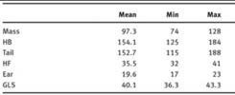 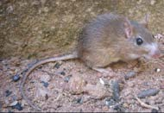

# Arvicanthis – Grass rats

Medium to large-sized rodents (35-130g, HB 100-160mm), sparsely haired, coarse scaled tail, shorter than head and body length (65-95% of HB). 6 nipples. Diurnal rodents, specialised herbivores.

#### Arvicanthis niloticus (É.Geoffroy, 1803) – African grass rat

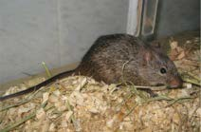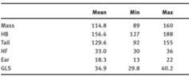No morphological species that can be used to confidently distinguish this species. Possible species complex.

#### Arvicanthis rufinus (Temminck, 1853) – Guinean grass rat

Previously described as a synonym of A. niloticus.

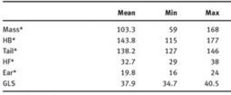

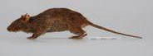

# Dasymys

Medium large rodents (mass 80-120g, HB 130-170mm). Characterised by a flat, disc like face with small eyes, shaggy soft, long haired coat. Tail is shorter in length than head and body 73-95% of HB. Herbivorous and good swimmers. Prefer marshy habitats.

#### Dasymys rufulus (Miller, 1900) – West African shaggy rat

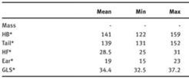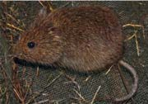Only Dasymys species in W. Africa.

# Dephomys

Medium sized rodent, reddish brown coat. Long and sleek fur with sparse black tipped guard hairs. Ventral hairs, white tipped with grey base. Tail is 160% of HB, black in colour with rings of small scales and bristle.

#### Dephomys defua (Miller, 1900) – Defua rat

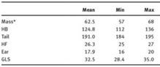2n 54. Distinguished from D. eburneae by the presence of t3 on upper molar or chromosomal grounds.

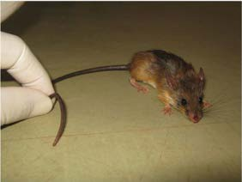

# Grammomys

Small to medium sized rats HB 85-140mm, long tail 120-163% of HB, inconspicuous but visible tuft. Relatively small feet with 5 digits. Skull is small. Genus is arboral and nocturnal. Frugivorous or vegetarian.

#### Grammomys buntingi (Thomas, 1911) – Bunting’s thicket rat

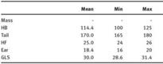May overlap with G. macmillani in Ivory Coast.

# Hybomys

Forest mice, medium sized (Mass 50-65g, HB 110-165mm) sleek and soft coat. 1-3 black dorsal stripes. Tail is black and appears naked. Digits 1 and 5 highly reduced compared to most murines. Associated with primary and secondary tropical rainforest. Terrestrial, primarily nocturnal. Insectivorous diets.

#### Hybomys planifrons (Miller, 1900) – Miller’s striped mouse

Narrow and tapering rostrum, 2 pairs of nipples. Cranial profile flat anteriorly. Single

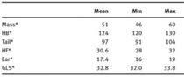mid-dorsal stripe extending from the head to the base of the tail. Co-occurs with trivirgatus. 2n = 35-39.

#### Hybomys trivirgatus (Temminck, 1853) – Temminck’s striped mouse

Narrow and tapering rostrum, 2 pairs of nipples. Cranial profile flat anteriorly. Three

mid-dorsal stripes present. 2 lateral stripes shorter and sometimes inconspicuous. 2n = 40-43.

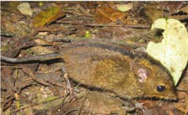

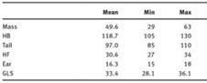

# Hylomyscus

Small to very small (mass 10-35g, HB 70-120mm). Soft furred arboreal mice lacking guard hairs. Tail typically 120-165% of HB. Widespread in lowland and montane tropical rainforest. Arboreal, nocturnal and omnivorous.

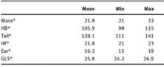Hylomyscus baeri (Heim de Balsac & Aellen, 1965) – Baer’s wood mouse Supraorbital ridges present, ventral coat pure white, tip of tail without obvious hairs. Four pairs of nipples.

#### Hylomyscus simus (G.M.Allen & Coolidge, 1930)

Supraorbital ridges absent, incisors opisthodont (pointing backwards) GLS > 22m, incisors orthodont or slightly pro-odont. Can only be identified with certainty on molecular grounds.

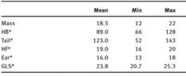Typically found in rainforest.

# Lemniscomys

Medium sized rodents (mass 40-80g, HB 90-140mm), short, tawny-furred ears. Short haired, sleek coat which has three characteristic dorsal colour patterns. The tail is white ventrally, marked with sparse black hairs and small concentric scales dorsally and may be similar or

longer than the HB length 100-125%. Medium sized skull, 25-35mm, long and narrow. Typically occur in savannas and forest clearings. Terrestrial and crepuscular. Diet varies seasonally.

Lemniscomys bellieri (Van der Straeten, 1975) – Bellier’s striped grass mouse Dorsal coat with multiple lines broken into spots. Midline flanked by 8 rows of spots not arranged into neat lines and/or spots in lower rows tending to connect to form lines; GLS

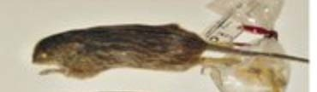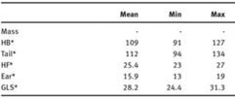<29mm. Occurs in grasslands, particularly moist savanna, avoiding forest and forest edge habitats.

#### Lemniscomys striatus (Linnaeus, 1758) – Typical striped grass mouse

Dorsal coat with multiple lines broken into spots. Midline flanked by 8 rows of spots. GLS

>29mm.

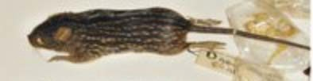

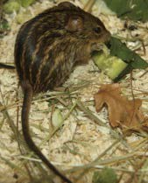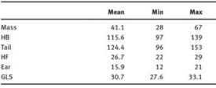

#### Lemniscomys linulus (Thomas, 1910)

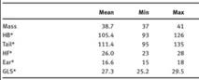Dorsal coat has a single mid-dorsal stripe. Found in drier savanna habitats, likely not in SL.

# Malacomys

Large (mass 60-80g. HB 130-160mm), large naked ears, short, soft, fine fur, lacking guard hairs. Tail is bicoloured, relatively long 130-136% of HB. Long slender pale-coloured hindfoot, >31mm 25% of HB. Terrestrial, nocturnal and feed on slugs, earthworms and plant parts.

#### Malacomys edwardsi (Rochebrune, 1885) – Edward’s swamp rat

HF <35mm 2 pairs of nipples.

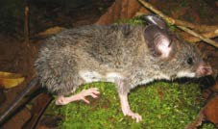

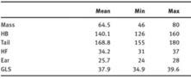

# Mastomys

Females of these rodents are recognisable by having 16-24 pairs of mammae. Wide distribution in savannas, grasslands and agricultural habitats. Terrestrial and nocturnal, granivorous and omnivorous.

#### Mastomys erythroleucus (Temminck, 1853) – Guinea multimammate mouse

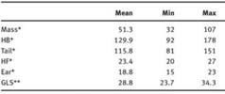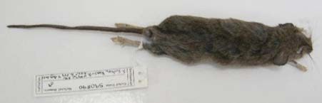Can only be distinguished with certainty from other species of Mastomys on chromosomal or molecular grounds. 2n = 38, FN = 50-60.

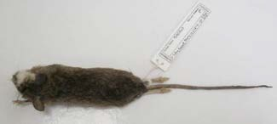

#### Mastomys natalensis (A.Smith, 1834) – Natal multimammate mouse

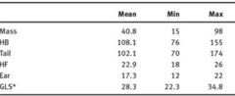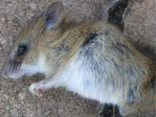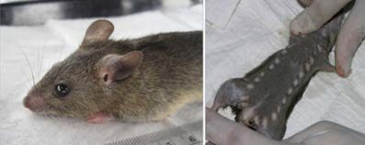Can only be distinguished with certainty from other mastomys species on chromosomal and molecular grounds. 9-12 equally spaced pairs of nipples are present in this species. 2n = 32, FN = 52-53. Typically associated with agricultural fields and homes, but also in savannas and grasslands, noted population abundance surges after disturbance such as fire.

# Mus

Easily identified by their very small to small body size (2-18g, HB 37-97mm for nannomys, 13-30g, HB 72-92mm in mus). They have naked tail. Their dorsal coats are comprised of short sleek fur.

#### Mus baoulei (Vermeiren & Verheyen, 1980) – Baolule’s mouse

Red markings close to the ear openings. Short tail 50-65% of HB. 2n = 2-/21. Typically found in savanna habitats.

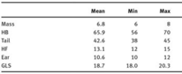

#### Mus mattheyi (F.Petter, 1969)

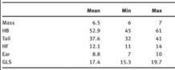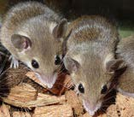2n = 36, associated with savanna habitats.

#### Mus minutoides (A.Smith, 1834) – African pygmy mouse

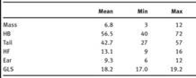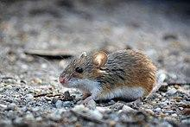Short tail 75% of HB, pure white belly, brownish-buff to brownish orange coat. 2n = 18-36. Typically savanna and grassland habitats. GLS <20mm, upper incisors orthodont or opisthodont.

#### Mus musculoides (Temminck, 1853)

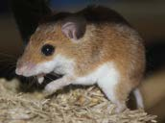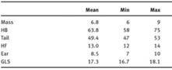Cannot be diagnosed morphologically from minutoides. 2n 18-19.

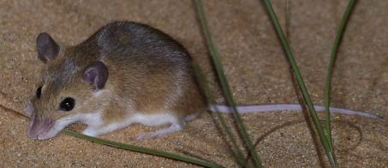

#### Mus musculus (Linnaeus, 1758)

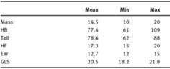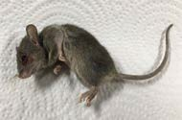Only member of subgenus mus in SSA. Typically commensal species. No stripes, upper incisors have posterior notch, upper 3rd molar has two laminae.

#### Mus setulosus (Peters, 1876) – Peters’s mouse

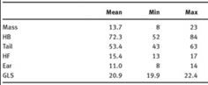White belly, small, GLS <23mm>20mm, upper incisors orthodont or opisthodont, dorsal coat without stripes. Largest of the subgenus Nannomys. Dorsal coat is dull blackish-brown, not as bright as in minutoides or musculoides. Possibly a species complex.

# Oenomys

Medium to large-sized rats, 90-110g, HB 140-160mm. Have a sparsely haired tail, bicoloured tail, relatively long 110% HB. Small, densely furred ears. Coat is soft with long guard hairs and typically greyish brown to bright reddish, prominently darker orange around the nose, rump and anal area. Occur in grassy clearings within or at the edge of rainforests. Terrestrial, both diurnal and nocturnal. Diet is herbivorous.

#### Oenomys ornatus (Thomas, 1911) – Ghana rufous-nosed rat

Tail 130% of HB, 2n = 46.

# Praomys

Small to medium sized mice 25-60g, HB 100-130mm, soft coat which is greyish buffy to almost black to reddish brown dorsally and greyish to white ventrally. Ears are large and rounded. The tail is finely scaled, appears naked and is longer than the HB 110-130%. Fewer nipples than the similarly sized mastomys. Mostly associated with forest and woodland, more numerous in disturbed forests. Nocturnal terrestrial rodents.

#### Praomys daltoni (Thomas, 1892)

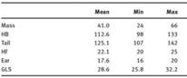7 palatal ridges, shorter hindfoot. Pure white ventral coat which is pure white (hairs with white bases).

#### Praomys rostratus (Miller, 1900)

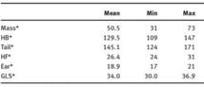Can be distinguished from tullbergi on molecular grounds, but is also slightly larger with significant overlap. 2n = 34, FN = 32.

#### Praomys tullbergi (Thomas, 1894)

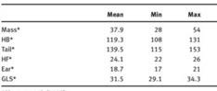9 palatal ridges.

# Rattus

Large to very large (100-200g, HB 160-210mm). Characteristic coarse blackish-brown to brown coat. Multiple guard hairs and ventral coat which is usually grey or white. Long and thin tail 115-120% of HB. HF >30mm. Large and transluscent ears. 5-6 pairs of nipples.

Nocturnal and terrestrial, predominantly commensal.

#### Rattus rattus (Linnaeus, 1758)

GLS <45mm, tail >100% of HB, ears longer ~22mm

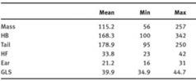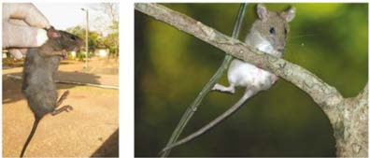

# Crocidura

#### Crocidura buettikoferi (Jentink, 1888) – Buettikofer’s shrew

Medium sized, dark coloured shrew. Dorsal coat dark chocolate brown. Ventral coat paler, greyinsh brown. Dark limbs. Tail 70% of HB, dark, sparsely covered with hairs and bristles. Typically found in grassland habitats, forest relicts in derived savanna, secondary growth, cocoa plantations and cleared land. Feeds on insects.

|  |  |  |  |
| --- | --- | --- | --- |
| HB | 72-100mm | Weight |  |
| Tail | 51-62mm | CI | 21.4-22.7mm |
| HF | 12-15mm | GLS |  |
| Ear | 7-9.5mm | GWS | 9.2-9.9mm |

#### Crocidura crossei (Thomas, 1895) – Crosse’s shrew

2n = 44, FN = 66. Small shrew. Dorsal coat slaty-grey or greyish brown to chocolate brown. Ventral coat greyish and paler. Chin white. Limbs usually dark. Tail relatively long >84% of HB, quite stout, grey-brown above and pale below. Slender rostrum. Rainforest individuals are generally darker than those in forest-savanna habitats. Forest habitats, including lowland rainforest, relic forests in savanna.

|  |  |  |  |
| --- | --- | --- | --- |
| HB | 54-80mm | Weight | 6.3-8g |
| Tail | 48-57mm | CI | 18.5-19.9mm |
| HF | 10-12mm | GLS |  |
| Ear | 6-8mm | GWS | 7.8-8.5 |

#### Crocidura denti (Dollman, 1915) – Dent’s shrew

Perhaps includes multiple species. Small dark brown shrew with hairy tail. Dorsal coat dark brown, ventral coat slate grey. Tail relatively long, 65-70% of HB, brown above, pale below, hair on 66-75%.

|  |  |  |  |
| --- | --- | --- | --- |
| HB | 63mm | Weight | 10.5g (8-12) |

|  |  |  |  |
| --- | --- | --- | --- |
| Tail | 46mm | CI | 20.6mm |
| HF | 13mm | GLS |  |
| Ear | 8mm | GWS | 9.3mm |

#### Crocidura fuscomurina – Bicolored musk shrew

Very small, predominantly grey-brown shrew grizzled with grey. Dorsal coat grey-brown, hairs slaty-grey at base with a fawn subterminal band and brown or buffy-brown tip. Ventral coat grey, with sometimes yellow tinge. Dorsal and ventral colours clearly delineated. Fore and hindfeet pale brown to off-white. Tail ~65% of HB, pale to dark brown above, paler below. Found in woodland savannas and semi-arid regions.

|  |  |  |  |
| --- | --- | --- | --- |
| HB | 57.9 (48-75) mm | Weight | 3.7g (2-5) |
| Tail | 38.5 (27.5-48)mm | CI | 16.2mm (15.1-17.4) |
| HF | 9.8 (8-11)mm | GLS |  |
| Ear | 7.6 (6.5-9)mm | GWS | 7.2mm (6.7-7.7) |

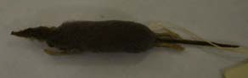

#### Crocidura lamottei (Heuglin, 1865) – Lamotte’s shrew

Medium sized shrew with relatively pale coloured coat. Dorsal coat pale brown to

grey-brown, without flecking. Ventral coat grey or silvery grey washed with yellow tint, hairs medium grey at base, creamy-grey at tip. Ears conspicuous and naked, not concealed by coat. Hindfoot relatively short. Fore and hindlimbs flesh coloured, covered with short pale brown hairs. Medium length tail (53% of HB), thick, broad at base narrowing towards tip, flesh coloured with reddish blotches. Found primarily in dry forest, grasslands in savanna, rocky hillside and grassy clearings.

|  |  |  |  |
| --- | --- | --- | --- |
| HB | 85-90 mm | Weight | 18-23g |
| Tail | 35.5-55 mm | CI | 24.7-26mm |
| HF | 14-16 mm | GLS |  |
| Ear | 11-12 mm | GWS | 10.1-10.6mm |

#### Crocidura muricauda (Miller, 1900) – West African long-tailed shrew

Small shrew, large ears and a long tail. Soft coat. Dorsal coat greyish brown, hairs grey at base, brown at tip. Ventral coat white-grey, hairs grey at base, white at tip. Ears large in relation to head, more or less naked. Fore and hindfeet flesh-coloured, minimally covered with short white hairs. Tail pale brown, extremely long (120-150% of HB), not bicoloured, tail hairs tend to be short and less visible. Skull long and narrow. Found in rainforest and secondary forest.

|  |  |  |  |
| --- | --- | --- | --- |
| HB | 61 (56-66) mm | Weight | 4.4 (3-8) g |
| Tail | 77 (62-95) mm | CI | 18.2 (17.8-18.8) mm |
| HF | 12.2 (11.8-13) mm | GLS |  |
| Ear | 9 (8.5-10) mm | GWS | 8.4 mm |

#### Crocidura nimbae (Heim de Balsac, 1956) – Nimba shrew

Medium-sized dark shrew with relatively short tail. Coat short and dense with silky sheen, hairs 3mm. Dorsal coat, dark brownish-grey to grey with sparse flecking, hairs dark grey at base becoming browner towards the tip. Ventral coat slightly paler and greyer and greyer than dorsal coat. Ears conspicuous, not concealed by coat. Flank gland visible as small oval patch of bare skin. Fore and hindfeet flesh coloured with short brown hairs on the upper surface, whitish hairs on the toes. Tail relatively short 40% of HB, bicoloured, dark brownish grey above, paler ventrally. Habitat, submontane and lowland rainforest.

|  |  |  |  |
| --- | --- | --- | --- |
| HB | 81.7 (75-90) mm | Weight | 12.5 (8-19) g |
| Tail | 53 (50-70) mm | CI | 26 (25.5-26.5) mm |
| HF | 16.5 (16-17) mm | GLS |  |
| Ear |  | GWS | 10 mm |

#### Crocidura obscurior (Heim de Balsac, 1958) – West African pygmy shrew

Minute to very small dark brown shrew. Soft coat, dense and velvety. Dorsal coat dark brown with slight russet tinge and silky sheen, hairs almost unicoloured, some with a dark brown tip. Ventral coat greyish brown. Head similar to doral coat. Ears darkly pigmented and not covered by coat. Chin and throat similar to ventral coat. Tail 60-70% of HB, dark brown above and paler below, long white hairs on tail.

|  |  |  |  |
| --- | --- | --- | --- |
| HB | 45-50 mm | Weight | 2.5-4 g |
| Tail | 30-35 mm | CI | 15.6-15.9 mm |
| HF | 10 mm | GLS |  |
| Ear | 6-8 mm | GWS | 7.1-7.3 mm |

#### Crocidura olivieri (Lesson, 1827) – African giant shrew

Very large shrew, variable in colour. Dorsal coat, reddish brown to dark brown or black. Ventral coat buffy brown to dark grey. Tail relatively long (70-80% of HB). Thick with many short bristles. 6 nipples. Nocturnal, with peaks of activity around dawn.

|  |  |  |  |
| --- | --- | --- | --- |
| HB | 110-140 mm | Weight | 36-65 g |
| Tail | 85-100 mm | CI | 32-34.3 mm |
| HF | 21-23 mm | GLS |  |
| Ear | 12-14 mm | GWS | 13.2-14.4 mm |

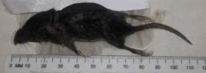

#### Crocidura poensis (Fraser, 1843) – Fraser’s musk shrew

Medium sized mush shrew. Dorsal coat dark brown to black. Ventral coat paler, greyish brown. Ear prominent. Limbs dark. Tail relatively long (75% of HB), thin and dark, covered with short bristles.

|  |  |  |  |
| --- | --- | --- | --- |
| HB | 75-98 mm | Weight | 9-17 g |
| Tail | 48-64 mm | CI | 23.7-24.5 mm |
| HF | 15-18 mm | GLS |  |
| Ear | 9-11 mm | GWS | 10.1-10.5 mm |

#### Crocidura theresae (Heim de Balsac, 1968) – Therese’s shrew

Medium to large shrew. Dorsal coat grey to brown. Ventral coat paler. Fore and hindfeet brown. Tail medium to long (39-62% of HB), thickset with sparse brown hairs.

|  |  |  |  |
| --- | --- | --- | --- |
| HB | 91.3 (78-101) mm | Weight | 13.3 (7-18.4) g |
| Tail | 47.5 (34-55) mm | CI | 22.8 (21.3-24.4) mm |
| HF | 14.8 (13-16) mm | GLS |  |
| Ear |  | GWS | 9.6 (8.8-10.2) mm |

# Suncus

#### Suncus megalura (Jentink, 1888) – Climbing dwarf shrew

Small shrew, with an extremely long, thin tail and long hindfeet. Coat soft and moderately dense. Dorsal coat greyish with brown tinge, hairs grey on basal two third, brown on terminal third. Ventral coat off-white to pale. Head slender with long, narrow, pointed muzzle, small eyes and rounded ears. Fore and hindfeet brown, slender and relatively long (25% of HB).

Tail extremely long (118% of HB). 6 nipples.

|  |  |  |  |
| --- | --- | --- | --- |
| HB | 60.8 (50-65) mm | Weight | 5.5 (3-8) g |
| Tail | 88.8 (82-97) mm | CI | 18 (16.8-18.6) mm |
| HF | 15.5 (14-17) mm | GLS |  |
| Ear | 8.3 (6-10) mm | GWS | 8.2 (7.8-8.5) mm |

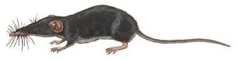

Reference:

Information for rodent species obtained from: Monadjem, Ara, Peter Taylor, and Christiane Denys.

*Rodents of Sub-Saharan Africa: A Biogeographic and Taxonomic Synthesis*. Walter de Gruyter, 2015.

Information for shrew species obtained from: Kingdon, Jonathan, and David Happold. ‘Mammals of Africa’ 4 (2013).

##### Conceptual model of the association of land use change and rodent species communities

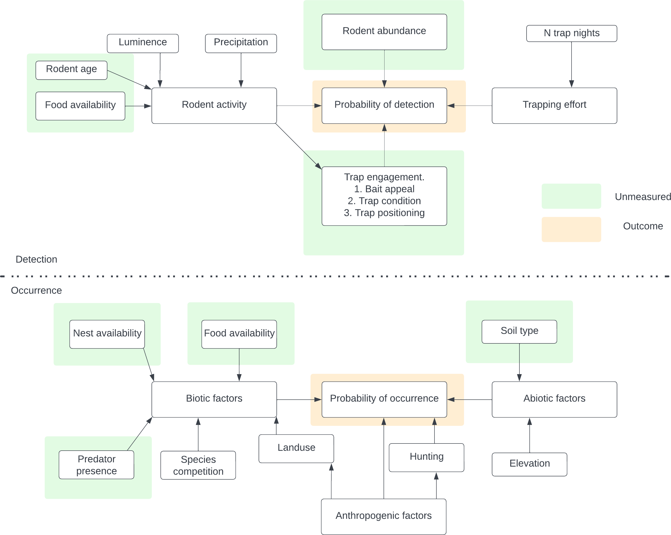

Figure B.6: Conceptual model used to identify potential causal pathways for inclusion of variables for the occupancy and detection model specification.

## Appendix C

##### Species detection rate by season

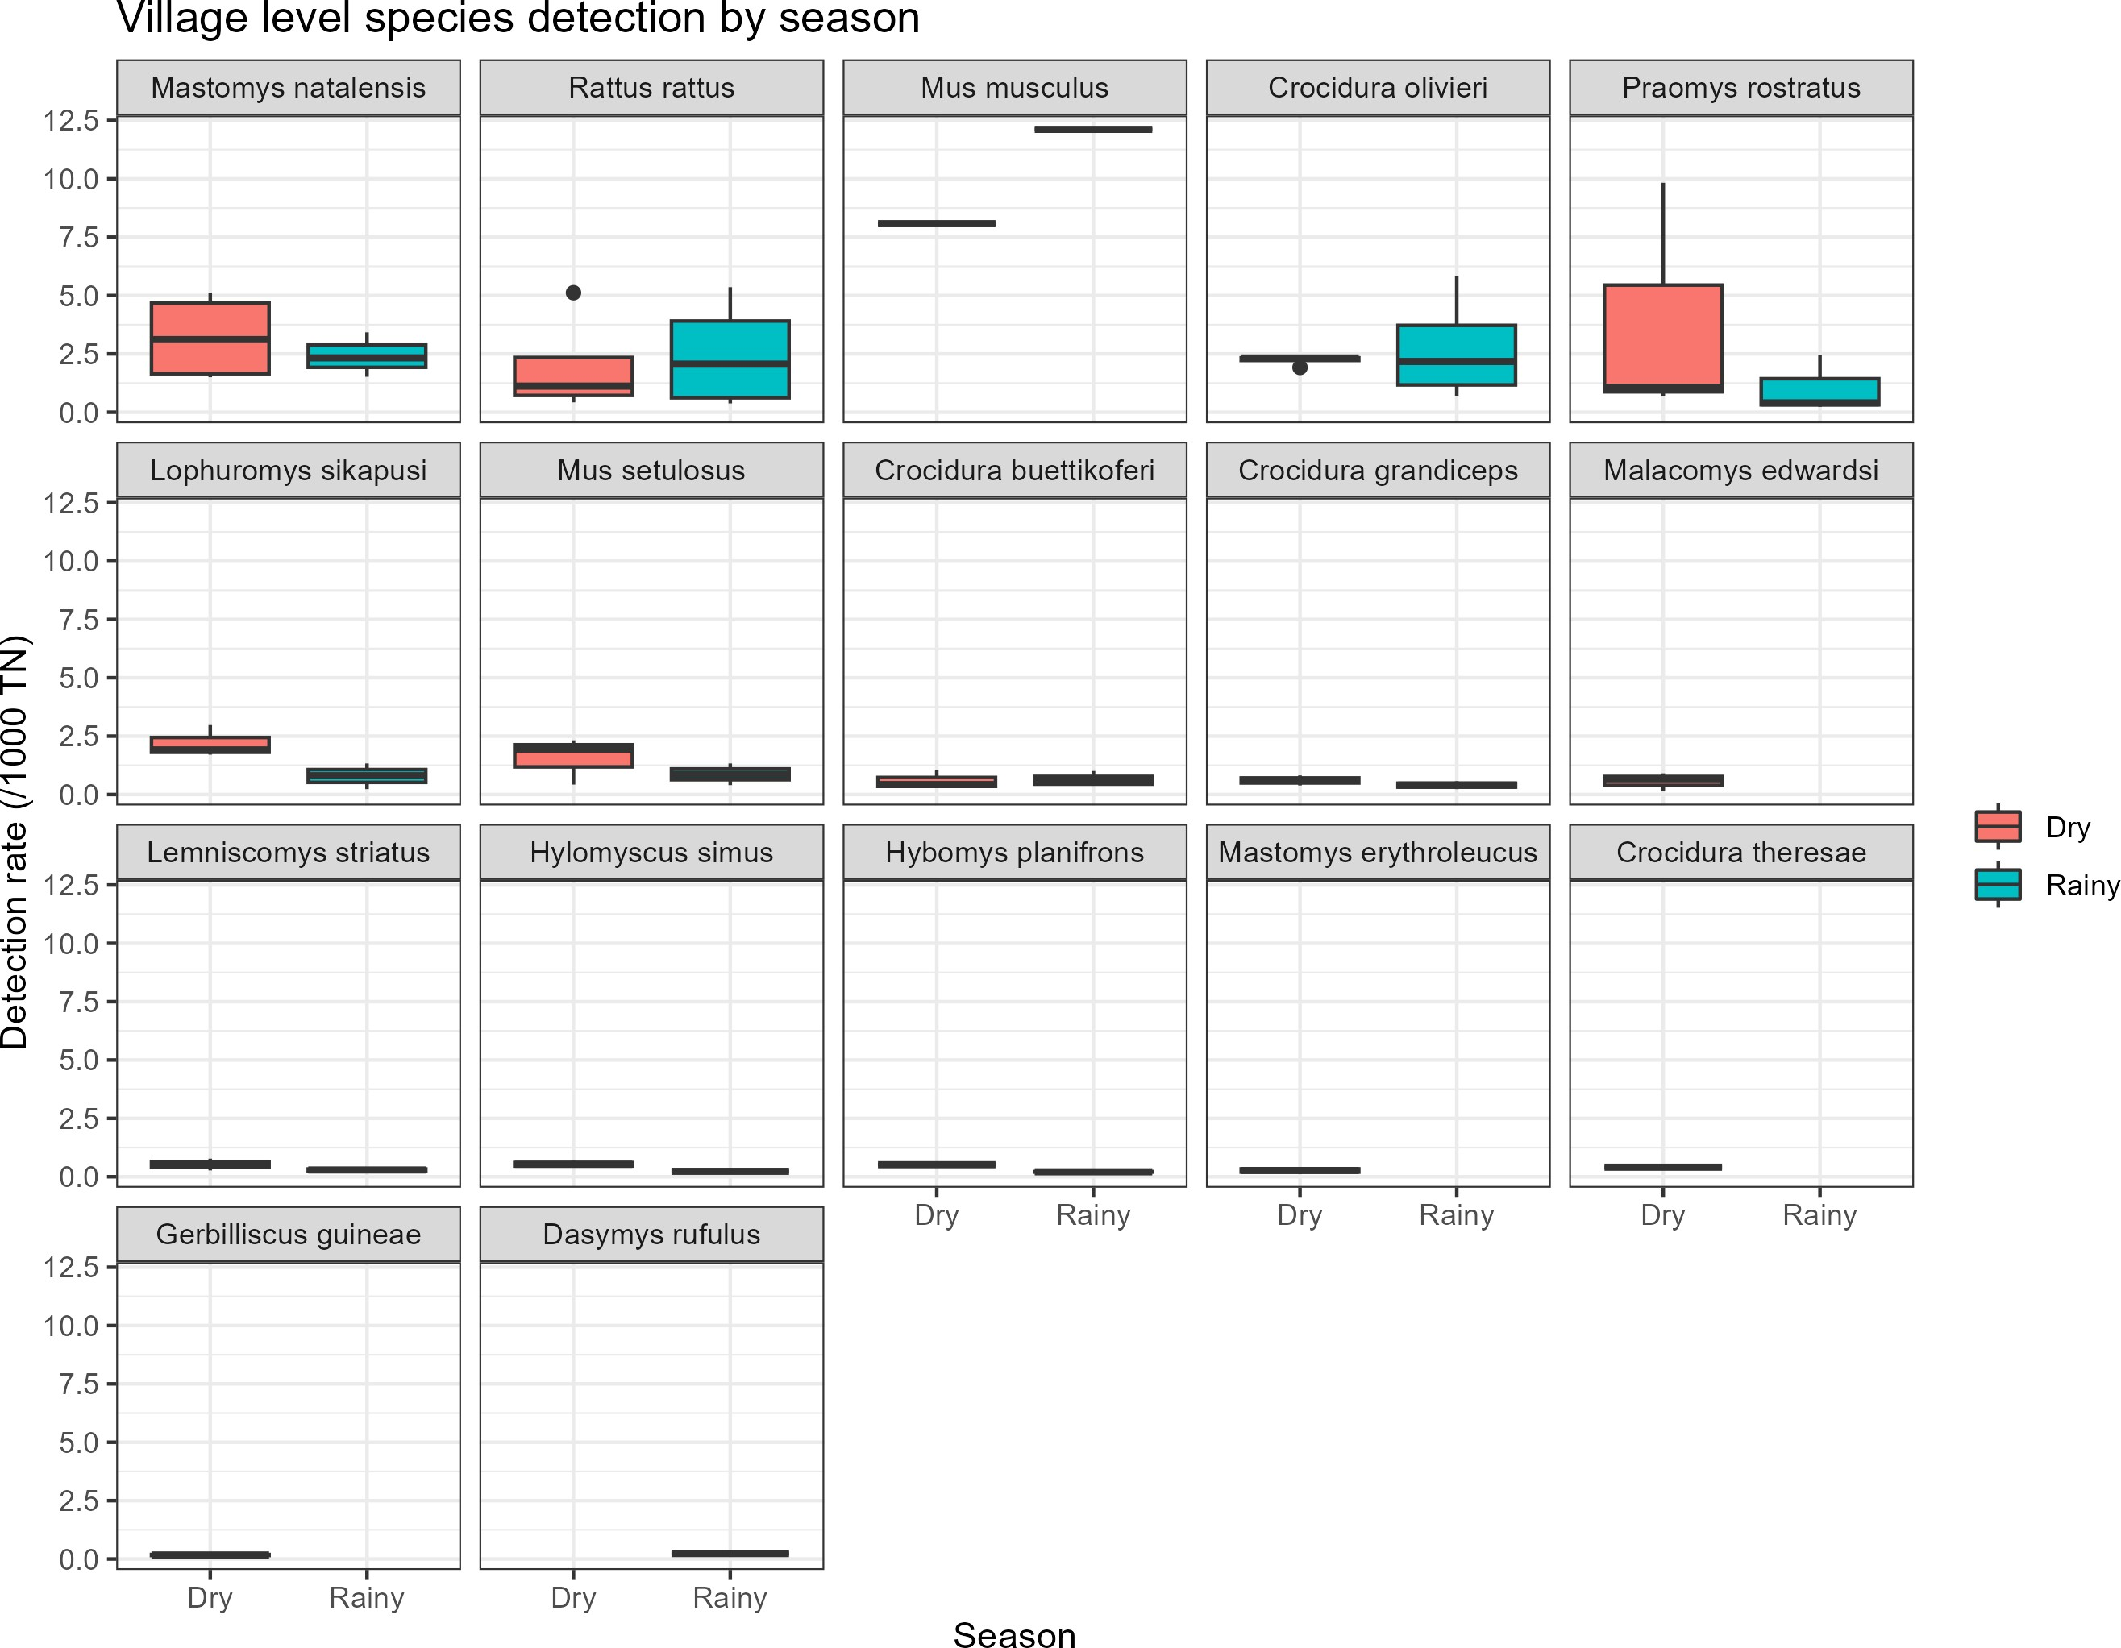

Figure C.1: Mean detection rate per 1,000 trap nights, aggregated at the village level for each species comparing the detection rate between the dry and rainy season.

##### Marginal effects of detection parameters

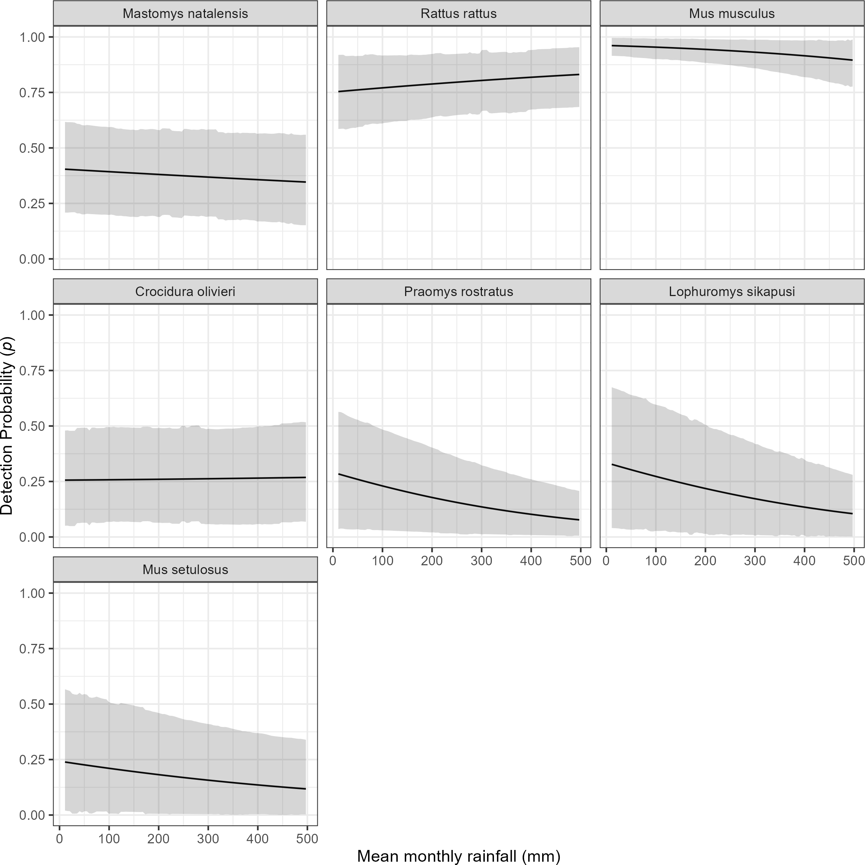

Figure C.2: The marginal effect of mean monthly rainfall on the probability of detection of a species in a grid cell. The black line shows the mean modelled probability of detection for the amount of monthly rainfall, the shaded grey region represents the 95% Credible Interval (CrI). Probability of detection varies by species with higher values for the invasive rodent species *M. musculus* and *R. rattus*, than the native rodent species. There is a general response of decreasing probability of detection with increasing rainfall.

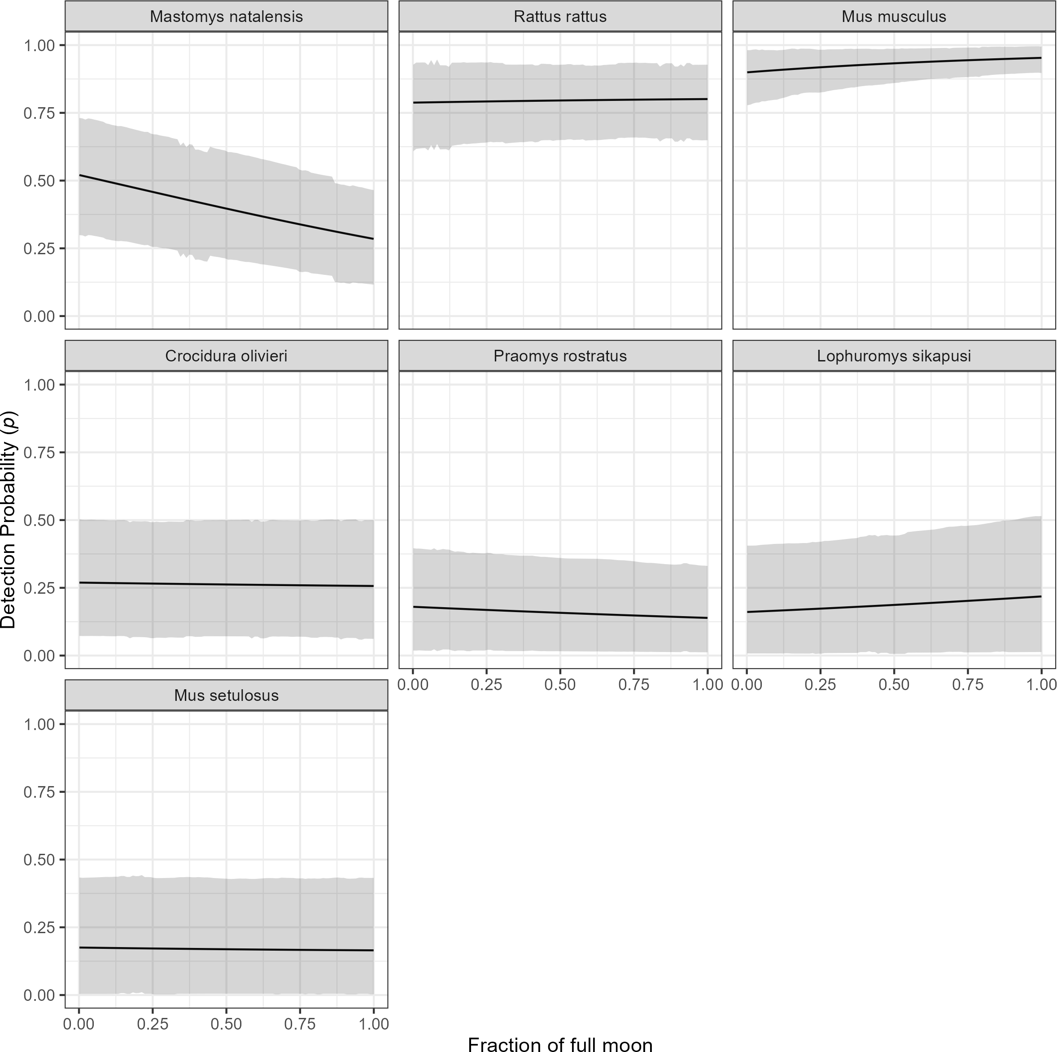

Figure C.3: The marginal effect of the fraction of the full moon on the probability of detection of a species in a grid cell. The black line shows the mean modelled probability of detection for the moon phase, the shaded grey region represents the 95% CrI. Probability of detection varies by species with higher values for the invasive rodent species *M. musculus* and *R. rattus*, than the native rodent species. There is no important response to moon phase for most species. The probability of detection appears to fall for *M. natalensis* with increasing moon phase but the credible intervals overlap for the entire range.

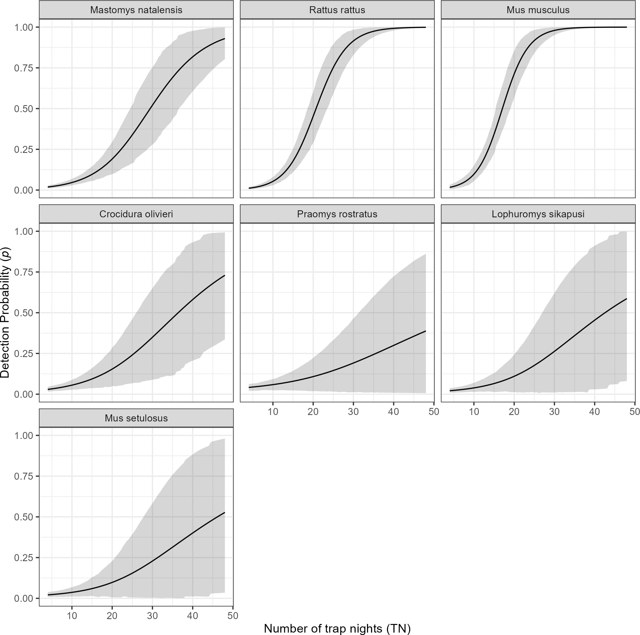

Figure C.4: The marginal effect of trapping effort (TN) on the probability of detection of a species in a grid cell. The black line shows the mean modelled probability of detection trapping effort, the shaded grey region represents the 95% CrI. Probability of detection is low for all species at low levels of TN. The probability of detection with increasing TN varies by species. The invasive rodent species *M. musculus* and *R. rattus* show a sinusoidal response over the range of TNs that were observed in this study with the probability of detection being greater than 50% at relatively low numbers of TN (17 and 22 respectively). Much greater trapping effort were required to obtain the same probability of detection for the native rodent species. Only

*M. natalensis* requiring 29 TN to reach a probability of 50% detection.

## Appendix D

##### Constructed networks from rodent trapping data

* + 1. Forest networks

**1 2 3**

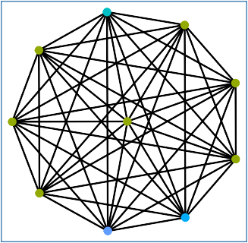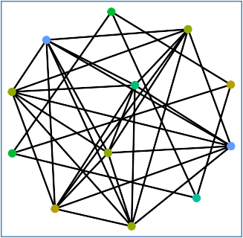

**4 5 6**

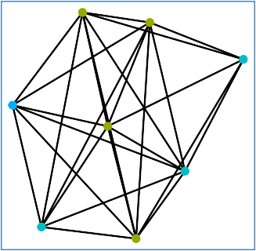

**7 9 10**

Species

Mastomys natalensis Rattus rattus

Mus musculus Crocidura olivieri Praomys rostratus

Lophuromys sikapusi Mus setulosus Crocidura buettikoferi Crocidura grandiceps Malacomys edwardsi

Lemniscomys striatus Hylomyscus simus Hybomys planifrons Mastomys erythroleucus Crocidura theresae

Gerbilliscus guineae Dasymys rufulus Other

* + 1. Agriculture networks

**1 2 3**

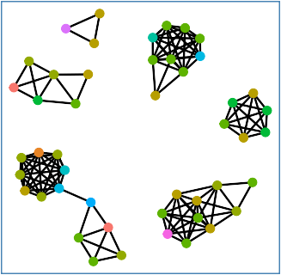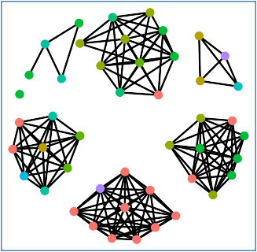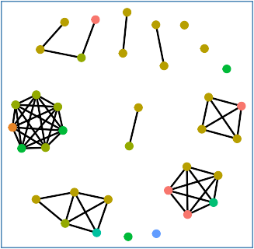

**4 5 6**

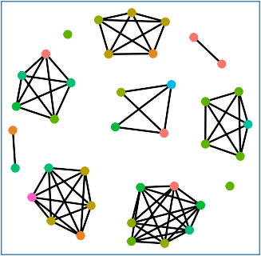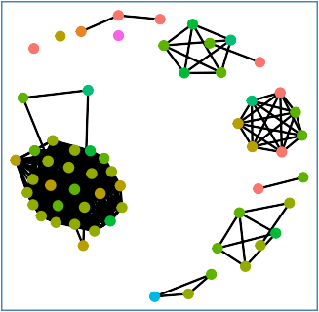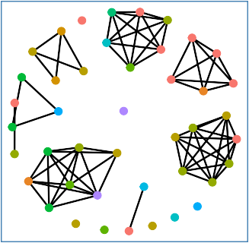

**7 8 9**

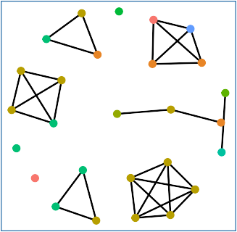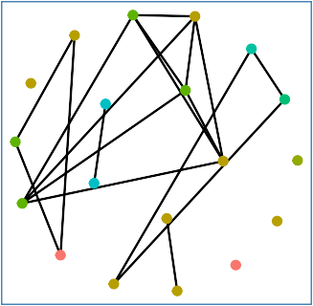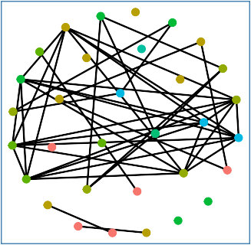

**10** Mastomys natalensis

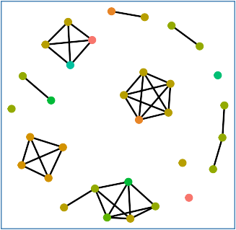Rattus rattus Mus musculus Crocidura olivieri

Praomys rostratus Lophuromys sikapusi Mus setulosus

Crocidura buettikoferi236 Crocidura grandiceps

Malacomys edwardsi Lemniscomys striatus Hylomyscus simus Hybomys planifrons Mastomys erythroleucus Crocidura theresae Gerbilliscus guineae Dasymys rufulus

Other

* + 1. Village networks

237

**1 2 3**

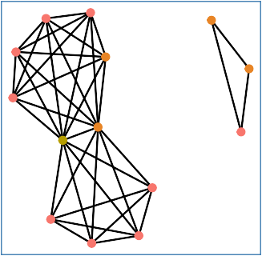

**4 5 6**

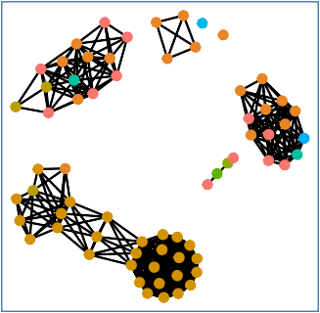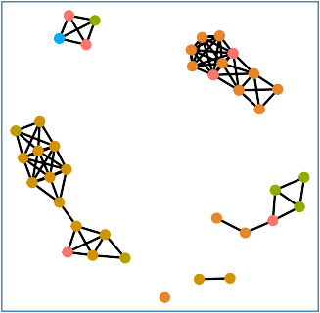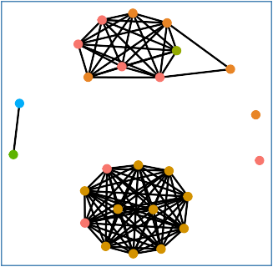

**7 8 9**

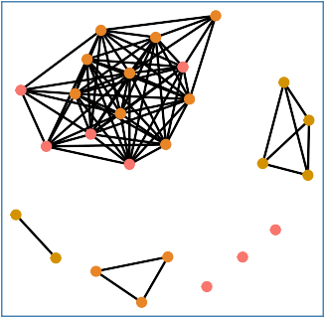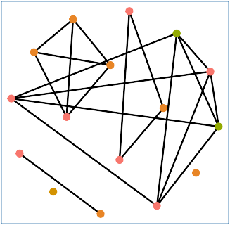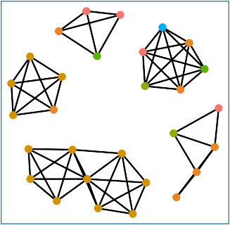

**10** Mastomys natalensis

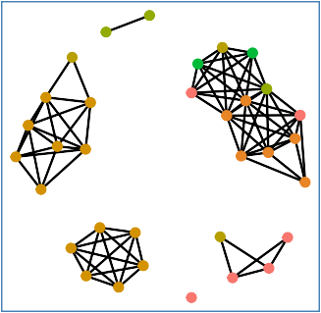Rattus rattus Mus musculus Crocidura olivieri

Praomys rostratus Lophuromys sikapusi Mus setulosus

Crocidura buettikoferi238 Crocidura grandiceps

Malacomys edwardsi Lemniscomys striatus Hylomyscus simus Hybomys planifrons Mastomys erythroleucus Crocidura theresae Gerbilliscus guineae Dasymys rufulus

Other

##### Contact matrices inferred from rodent community networks

* + 1. Forest contact matrix

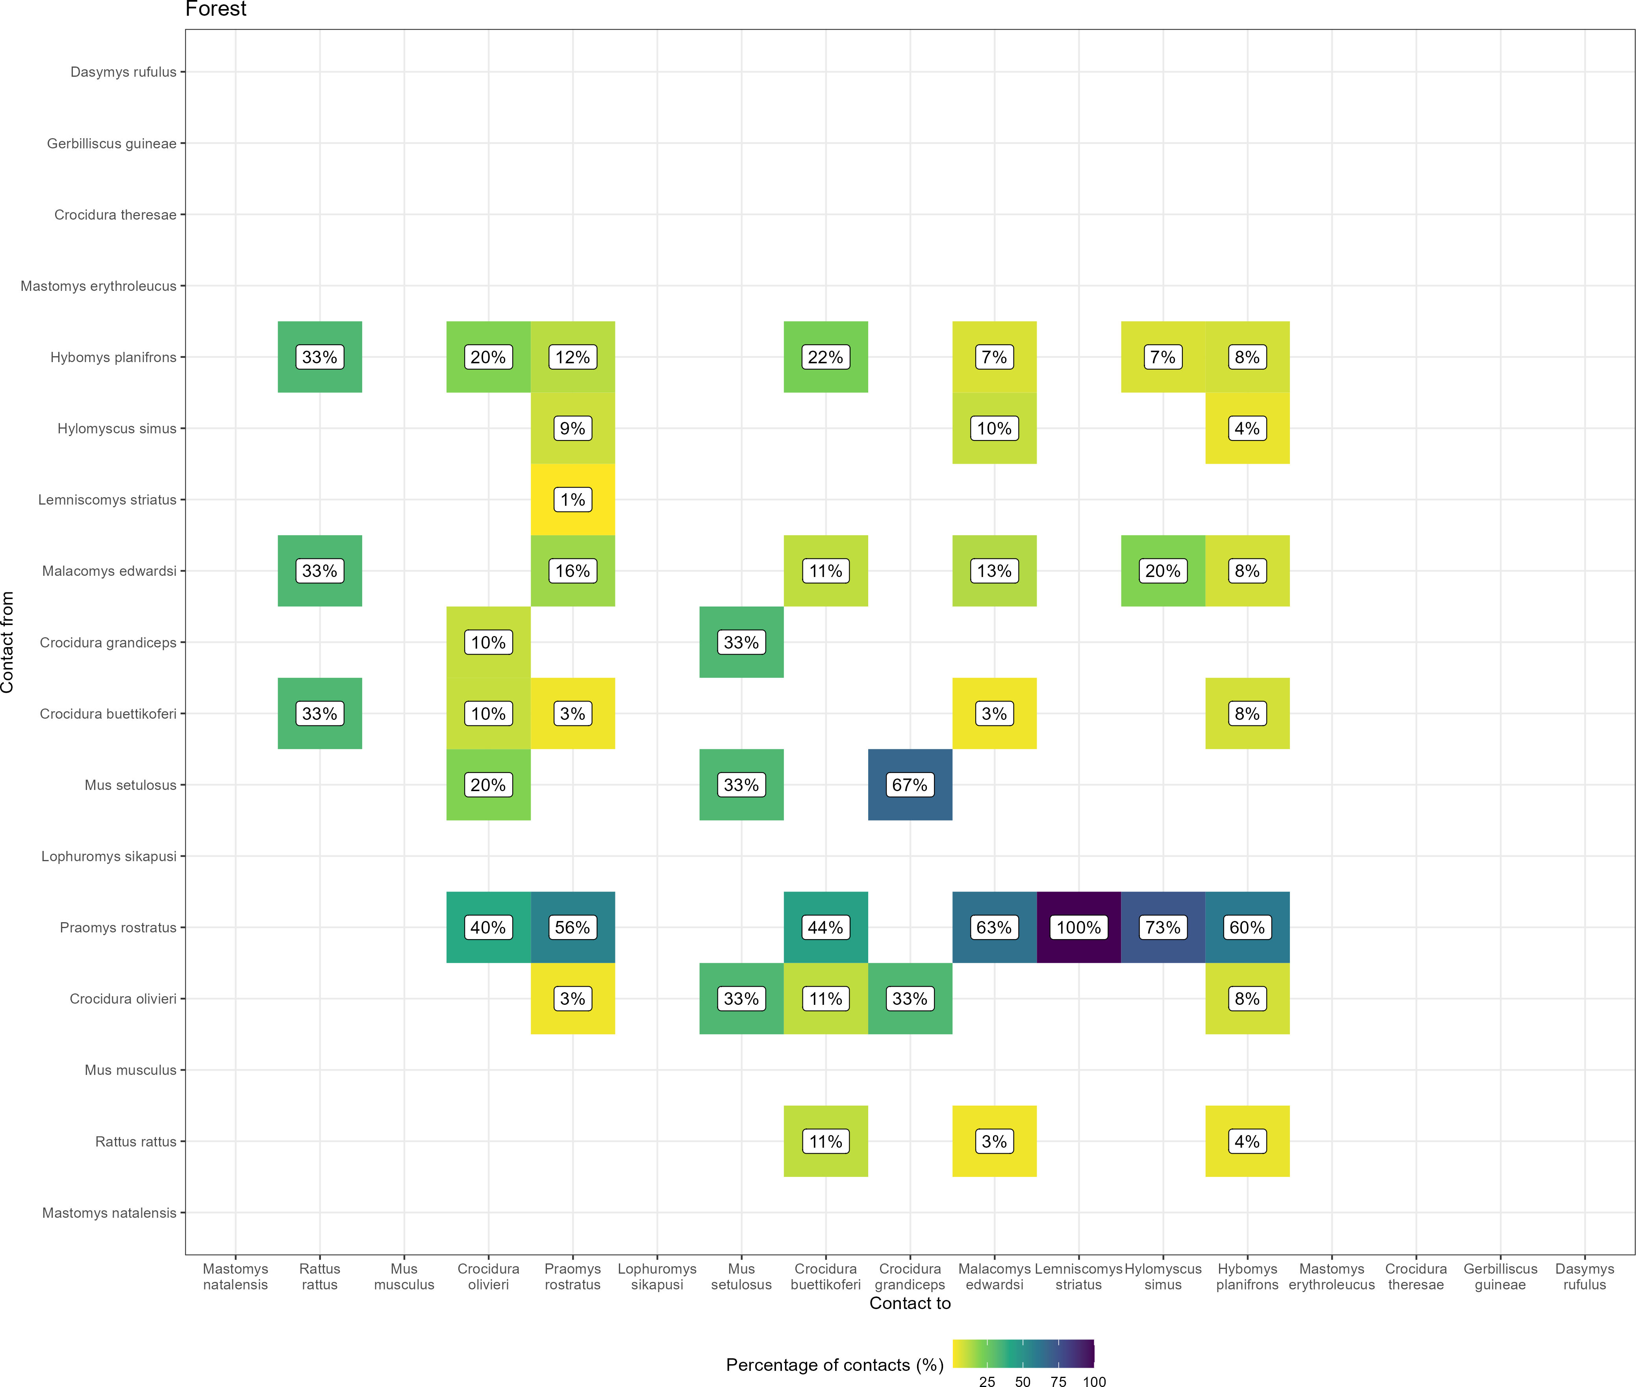

Figure D.1: The proportion of contacts between small mammal species in forest land use. Darker colours indicate increasing proportions of observed contacts to a species from named a species. Percentages in the cells correspond to the proportion of contacts to a species from a named species.

* + 1. Village contact matrix

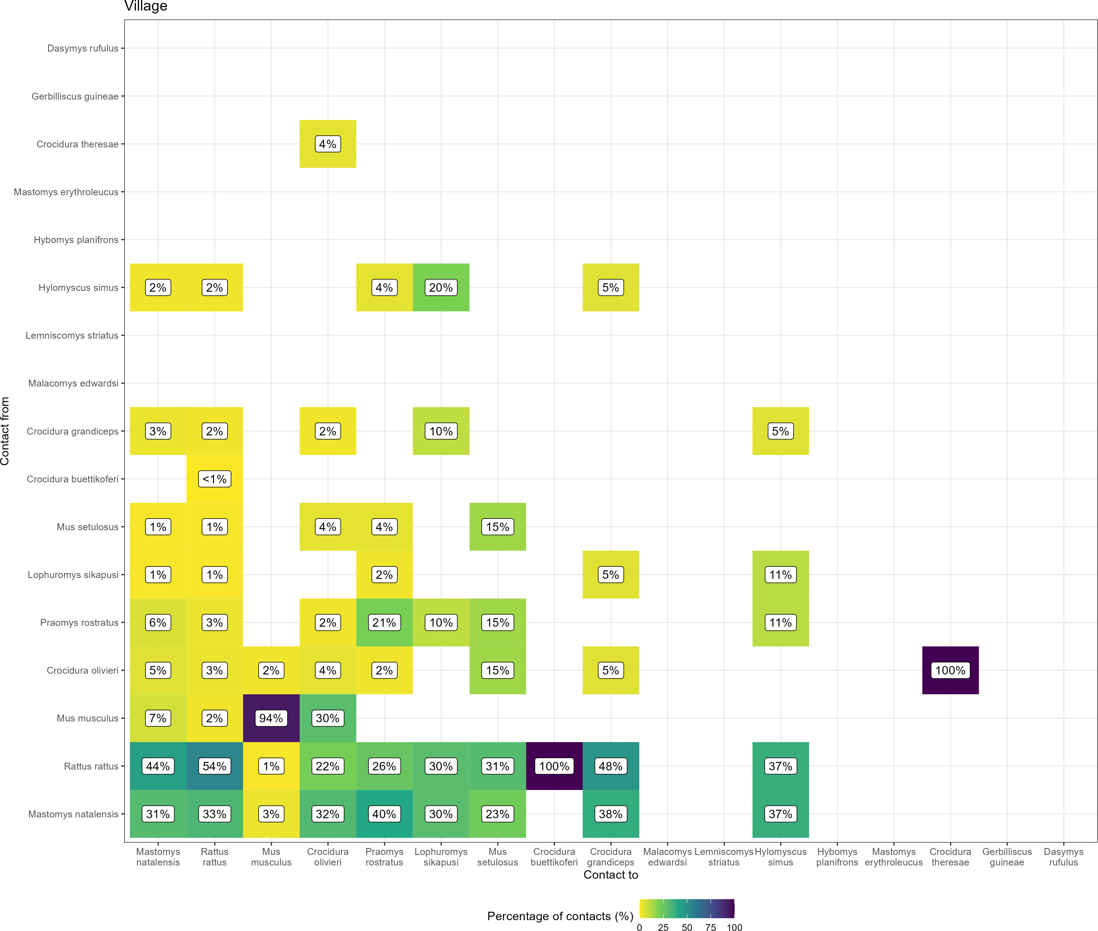

Figure D.2: The proportion of contacts between small mammal species in village land use. Darker colours indicate increasing proportions of observed contacts to a species from named a species. Percentages in the cells correspond to the proportion of contacts to a species from a named species.